ESD-lab3

Name:Gan Ming ID: 192050221

Description of task

1.Create a new project

2. Create two task

3. Create one queue

4. One of the tasks flashes briefly LED when receiving information from the queue.

5. The second task writes any number to the queue and delayed 1 sec.

My work

1. Create a new project in the STM32CubeIDE software.

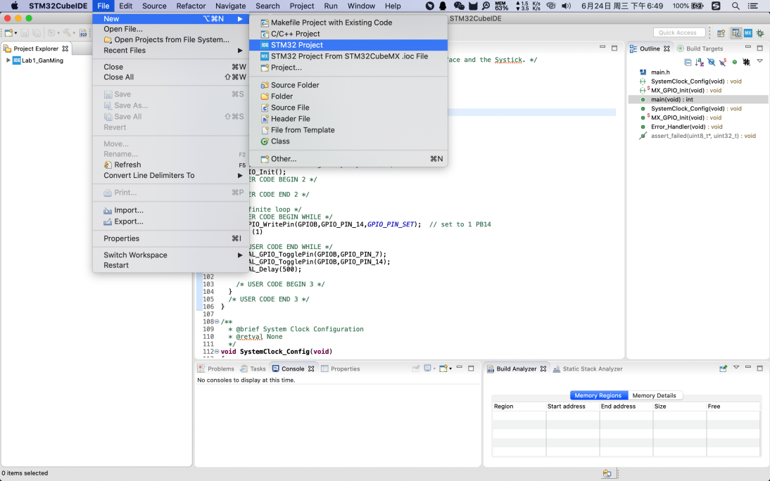

2. Find stm32F429zi to choose our board type,

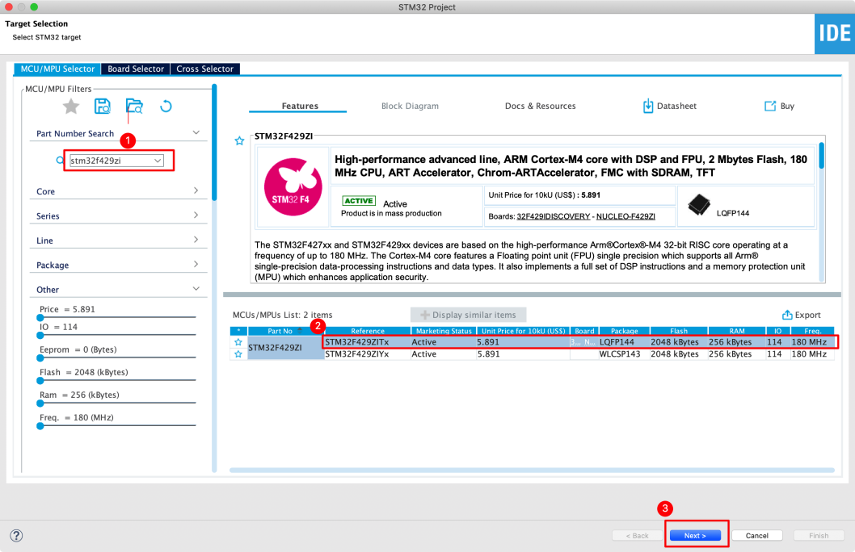

1. Take the project name, and automatically download the selected software packages. 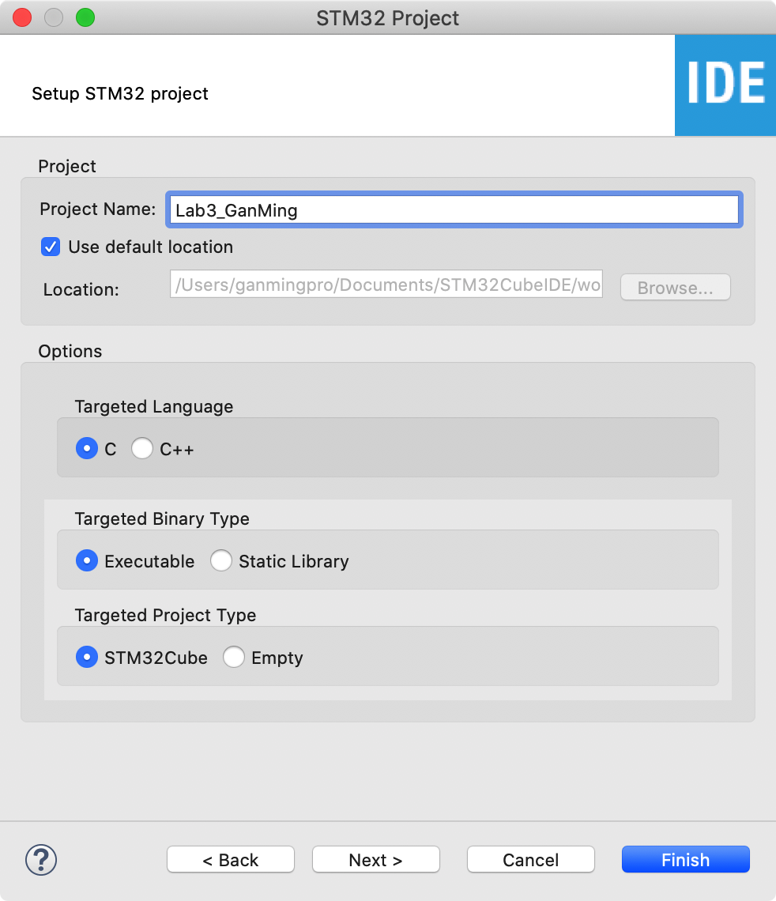

4. Query STM32 Nucleo-144 boards User manual to determine the functional pin of LD2 led, switch it to the output.

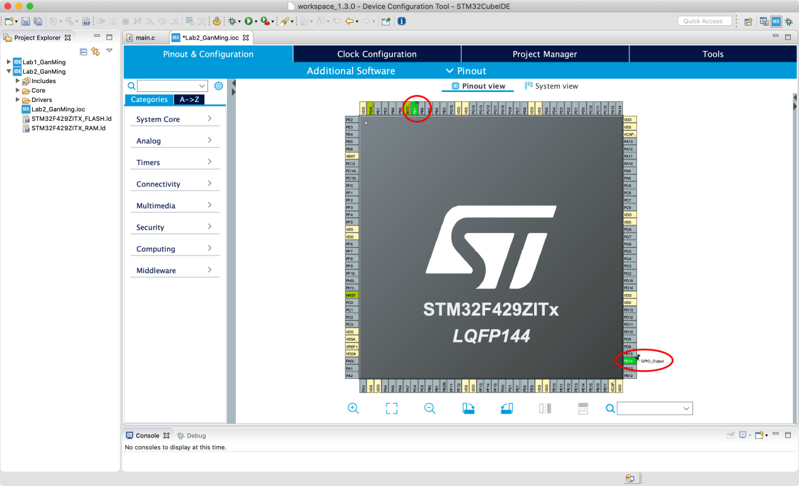

1. Create the first default task:DefaultTask.

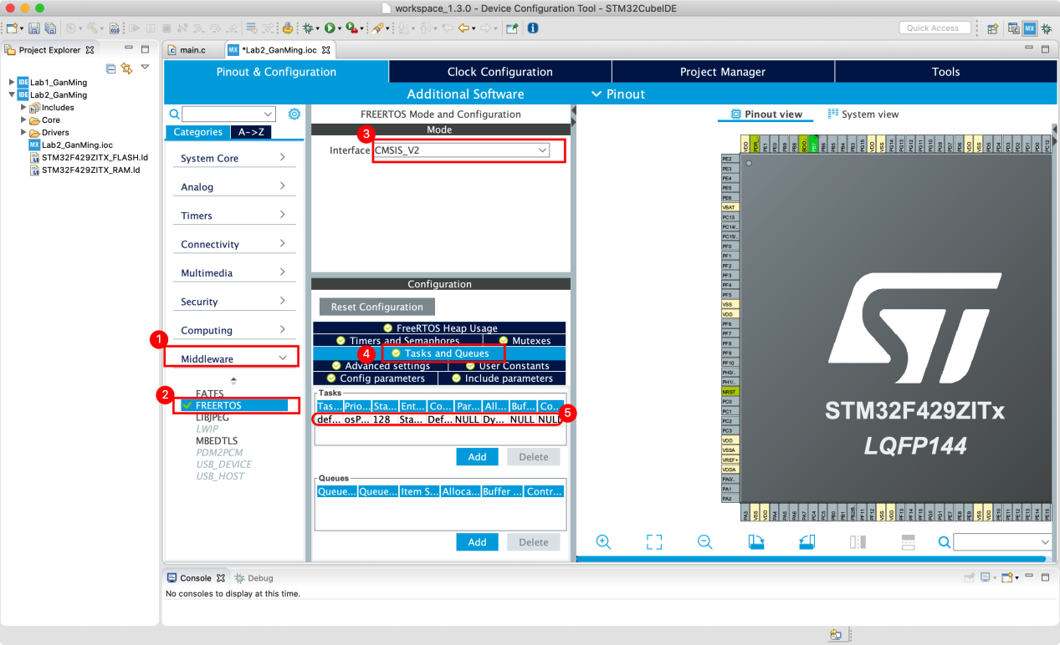

1. Add a second task:myTask02 and queue.

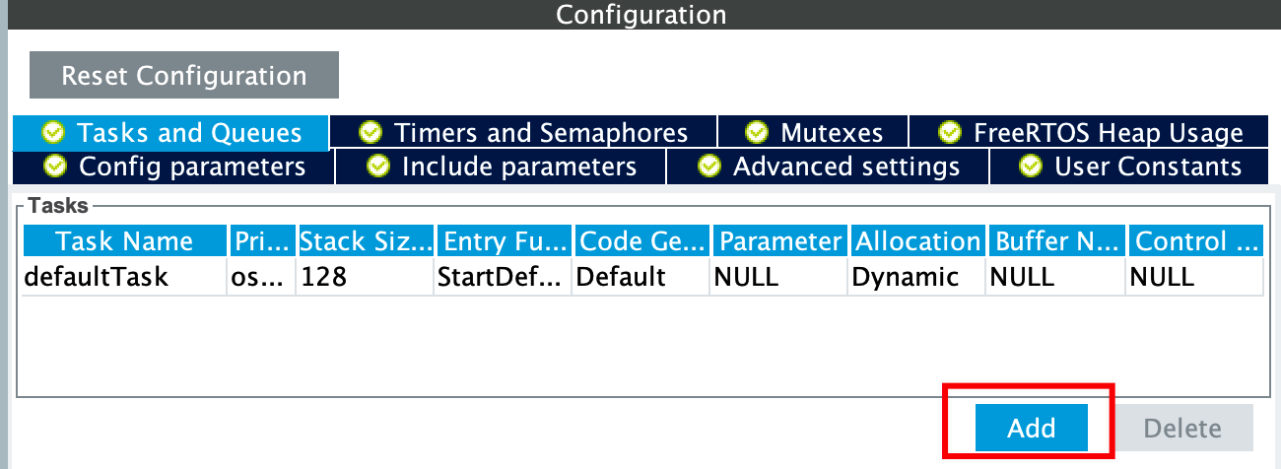

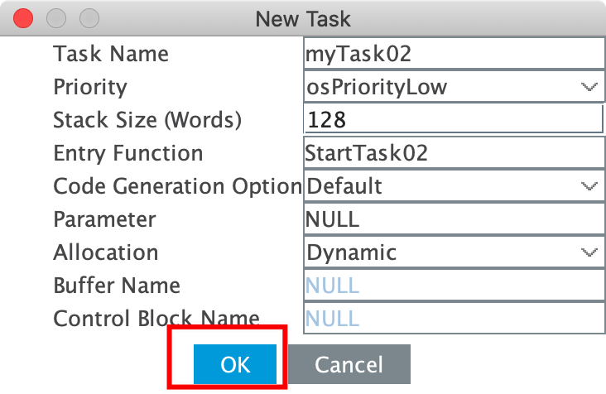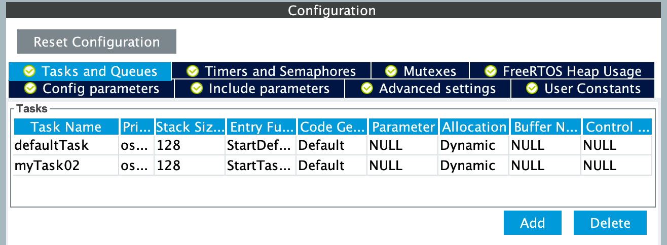

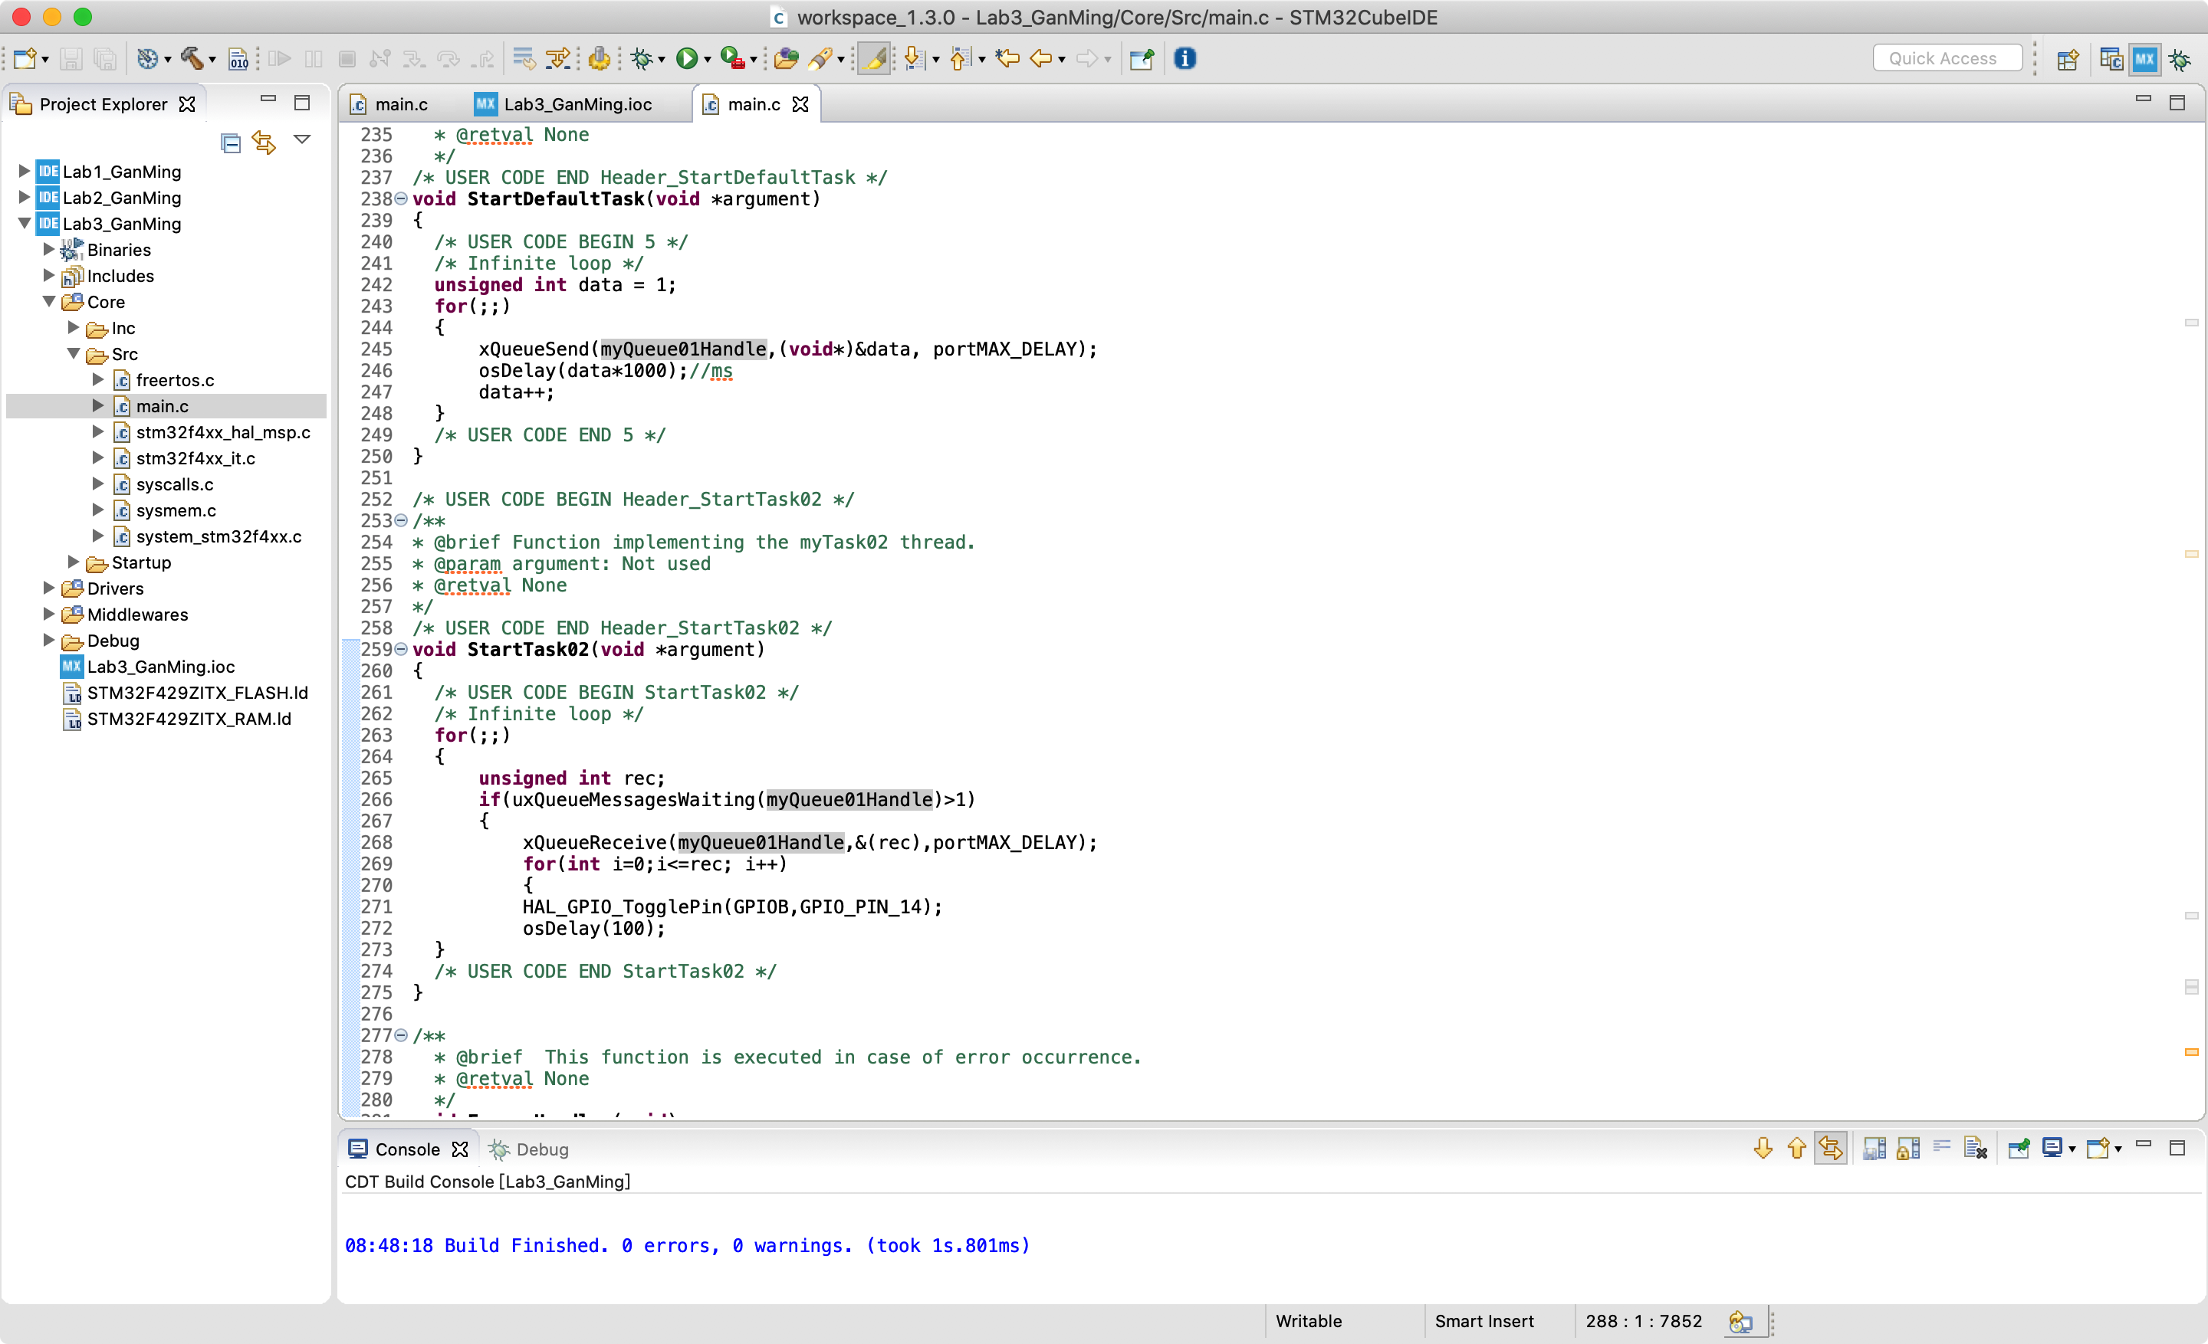

1. Build all to Generate the code.

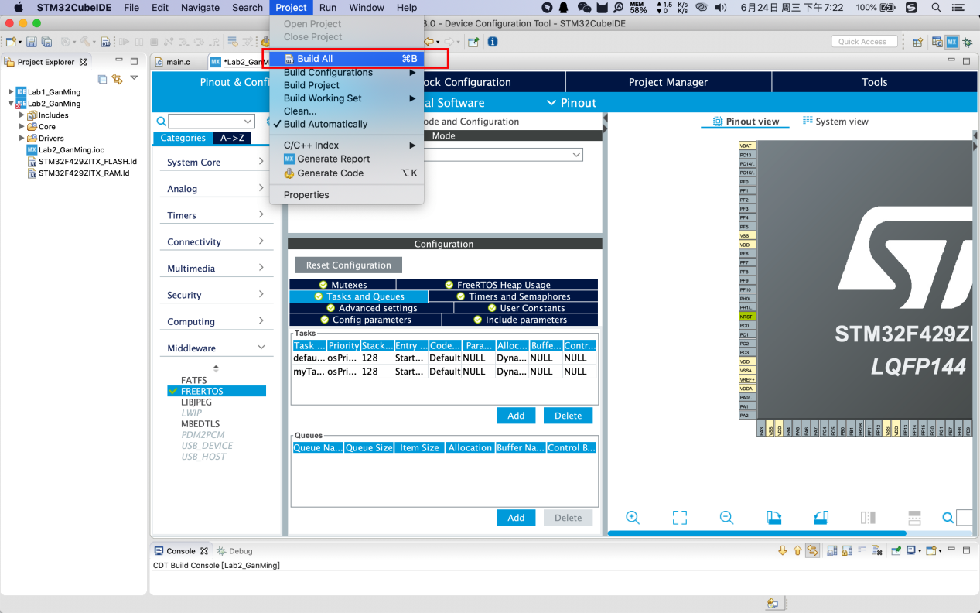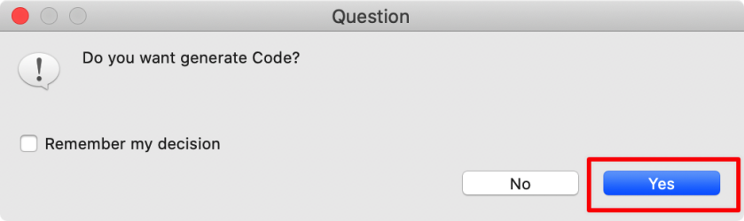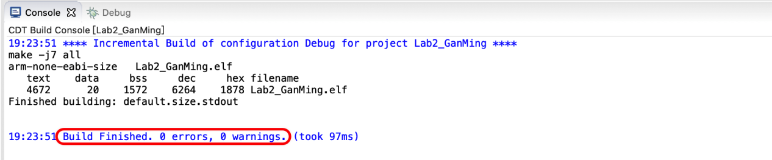

1. Insert the code to control.



1. Then build the project again.Run the project.