ESD-lab4

Name:Gan Ming ID: 192050221

Description of task

1. Create three tasks.

2. Create two queues. The size of queues is 7 integer numbers. The first queue should

be used to transmit data from Task 1 to Task 2. The second queue should be used to

transmit data from Task 1 to Task 3.

3. Task 1 should increment the local integer variable “counter” once per second.

Task 1 sends the “counter” value to Task 2 once per second and to Task 3 once per two seconds. The incrementing of “counter” variable should be paused if the corresponding queue is full and resumed if the corresponding queue is not full.

1. Task 2 and Task 3 should toggle LED LD2 once per 500 ms. The number of toggling is equal “counter” variable received using queue from Task 1. The LED is shared resource between Task 2 and Task 3. Task 2 or Task 3 should work with the shared LED using a counting semaphore.

My work

1. Create a new project in the STM32CubeIDE software.

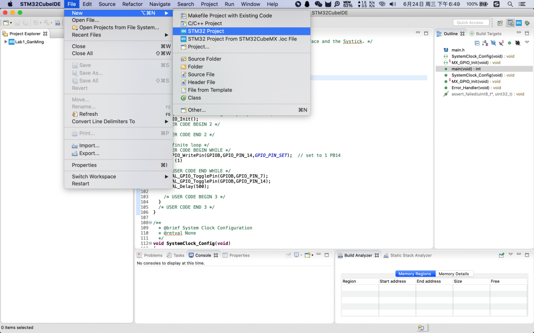

2. Find stm32F429zi to choose our board type,

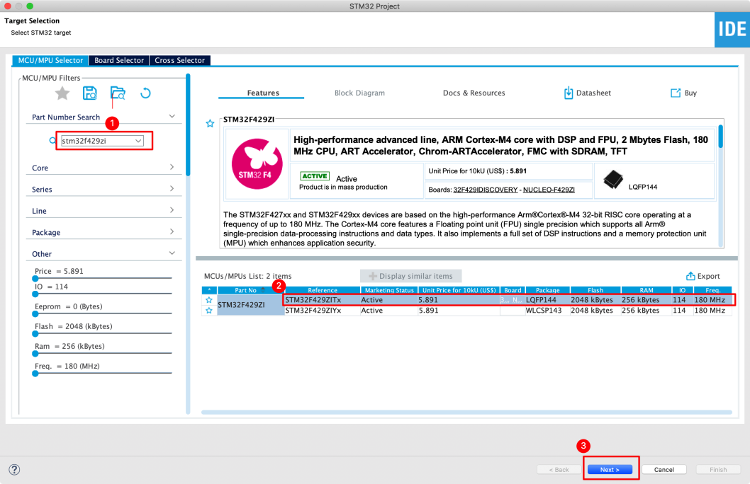

1. Take the project name, and automatically download the selected software packages.

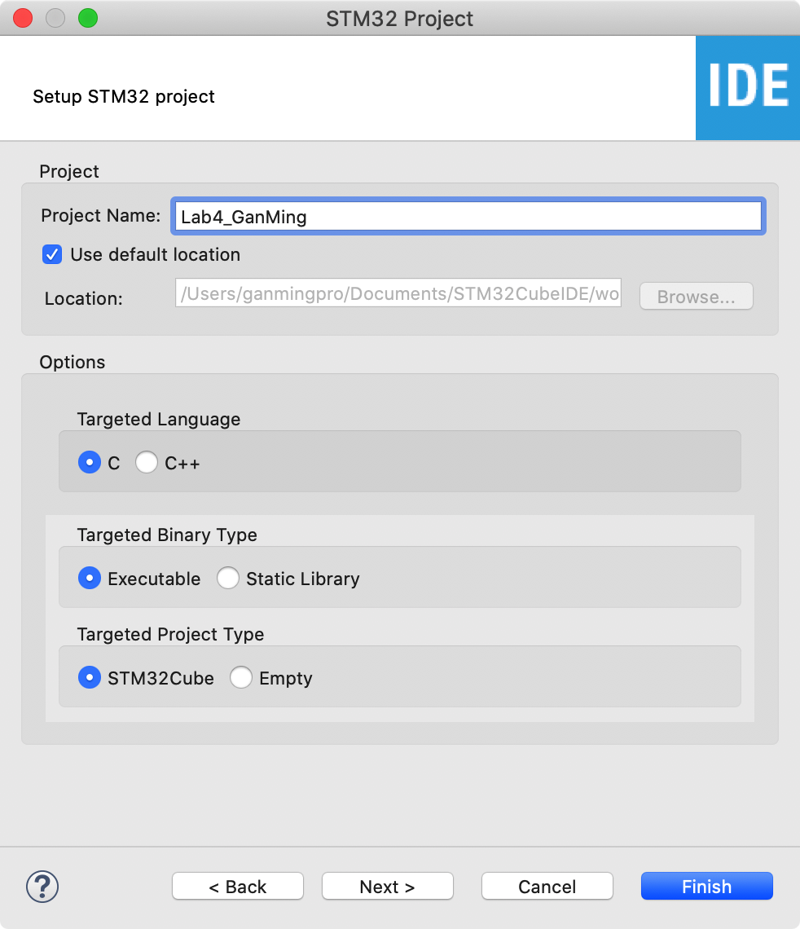

4. Query STM32 Nucleo-144 boards User manual to determine the functional pin of LD2 led, switch it to the output.

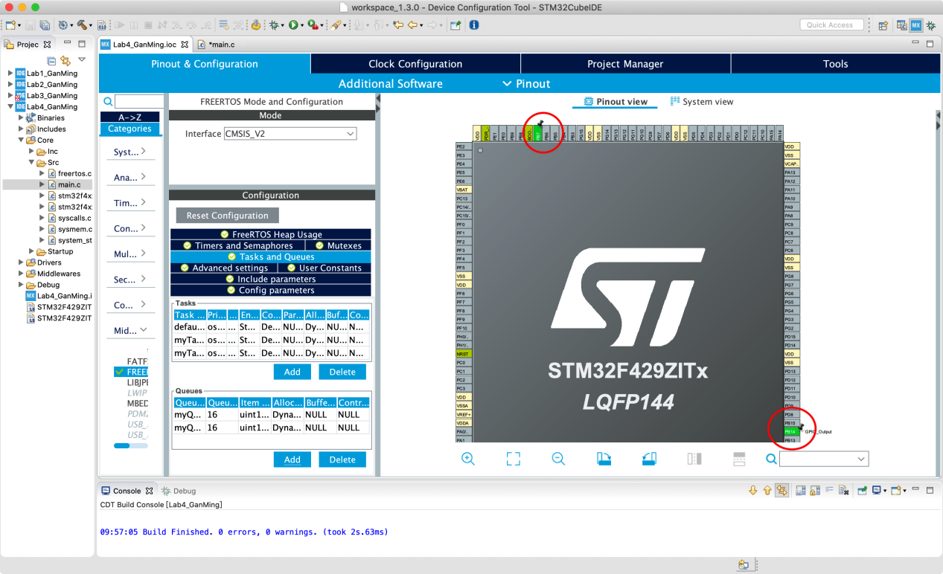

1. Create three tasks.

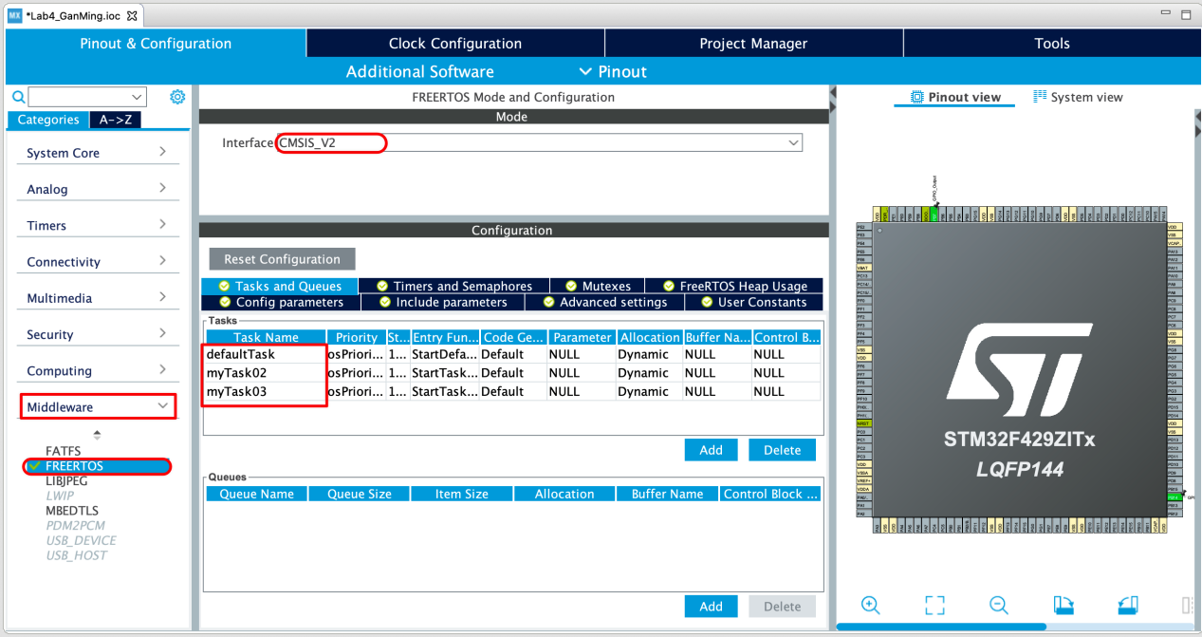

1. Create two queues.

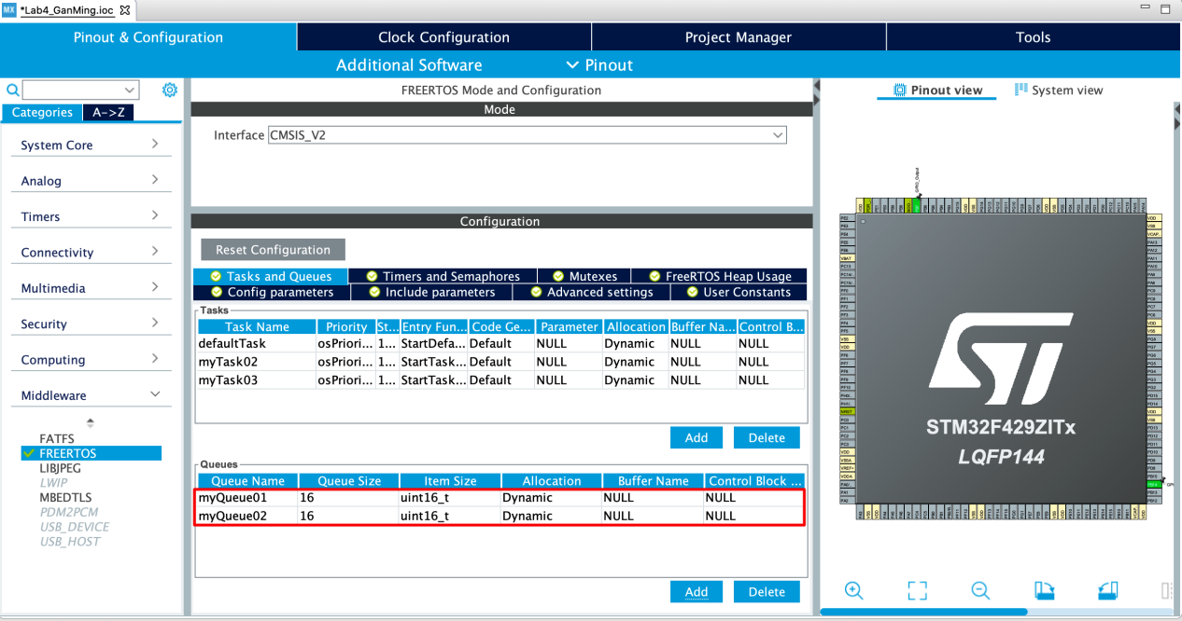

1. Code according to my corresponding task number 1.

