**Version History**

|  |  |  |
| --- | --- | --- |
| V0 | F. Dentener-draft outline | 15.04.2012 |
| V2 | F. Dentener | 22.10.2012 |
| V3 | T. Keating | 22.10.2012 |
| V4a | F. Dentener/D. Guizzardi | 20.04.2013 |

**Work Package 2.1: Common set of regions**

**Objective:**

The objective of this document is to discuss and define a common global mask defining source and receptor regions. These regions are to be used in reporting emissions and scenarios, to calculate source/receptor relationships, to perform impact assessments, and to perform integrated analysis of measurements.

**Introduction:**

The HTAP 2010 report used a set of 4 source regions approximating North America (NA), Europe (EU), South Asia (SA), and East Asia (EA) complemented by a global (GL) source region for the purpose of source-receptor modeling and analysis.

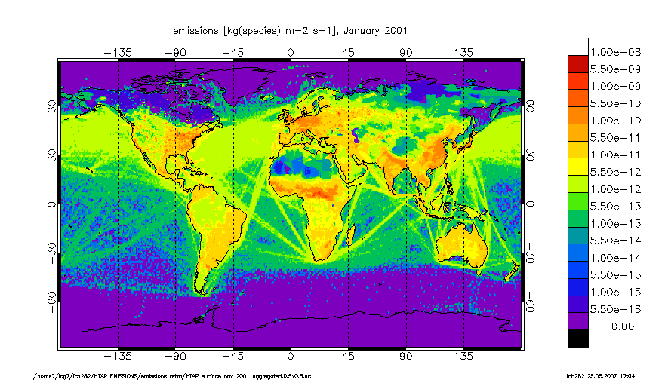

NA

EU

EA

SA

These regions were chosen to get a first overview of impacts of intercontinental transport from major source regions. The region definition was deliberately chosen to be simple, and not too close to resembling individual countries. The 4 regions represented together 60-70 % of anthropogenic emissions, with NA, EU, and EA being about equal size (and as a consequence expected to have about an equal ‘signal’). A number of disadvantages of this particular choice were noted during the HTAP phase 1.

* Initially a global region was not defined, which was needed for a complete attribution of regional signals.
* Especially for receptor studies these large regions were less useful, because of heterogeneity of sub-regions in these larger regions.
* Some important sources (dust; biomass burning) missed adequate regional definition.

During the HTAP meeting in 2012 in Pasadena a first step towards a new HTAP region definition for an updated set of source and receptor regions was presented. The following principles were identified:

* HTAP should keep its focus on the Northern Hemisphere
* 4 (5) source regions do not sufficiently resolve the diversity of source regions.
* HTAP source/receptor calculations may address not only source location, but also differentiate source types, which requires keeping the number of source regions to a manageable number.
* Greater resolution of receptors should be achieved by subdividing the source regions.
* Targeting about 10 source and 20 receptor regions, a set of practical boundaries should be defined for use throughout the HTAP work plan, maximizing the correspondence with regional definitions used on other relevant projects.

These regions were subsequently discussed in 2012 and 2013. During the TF HTAP meeting in March 2013, it was noted that in the tiered approach is not fully consistent with the RERER (Response to Extra-Regional Emission Reduction) metric.



R= concentration response to 20% emission decrease

It was considered advisable to use the terminology tiered regions definitions, where tier 1 regions are both source and receptor, and tier 2 regions can also be used in particular cases as source regions, and as well be used for analysis purpose beyond the RERER approach.

**Tiered Regions.**

Below is a proposed two-tiered set of regional definitions. There are 17 Tier 1 regions, which include the whole globe, the oceans, Arctic, Antarctic, and 13 land mass regions. The Arctic and Antarctic are defined roughly as the regions north of 66°N and south of 60°S, respectively. The Tier 1 regions are subdivided into 60 receptor regions. Note that most regions follow national or provincial boundaries. For the purpose of impact assessments, we have also defined a Himalaya receptor region that is comprised of sub-regions of the South, East, and Central Asian Tier 1 regions and where the elevation is greater than 1500m. A mask has been produced in digital form (netCDF) at 0.1°x0.1° resolution, as well as derived maps on 0.5°x0.5° and 1°x1° resolution, attributing a region classification number to the largest area fraction contributed by individual regions. We recommend for emission perturbation experiments to convolute the emissions at the highest possible resolution (i.e. 0.1°x0.1° for HTAP_v1) to avoid numerical errors occurring when aggregating emissions (as demonstrated in Table 1 and Table 2).

|  |  |  |  |  |  |
| --- | --- | --- | --- | --- | --- |
|  | **Tier 1** | | **Tier 2** | **Remark** | |
| 01 | **GLO\*** | **World** |  | | Not provided as separate mask | |
| 02 | OCN | Non-arctic/Antarctic Ocean | 020 Baltic Sea  021 North Atlantic  022 South Atlantic  023 North Pacific  024 South Pacific  025 Indian Ocean  026 Hudson Bay  027 Mediterranean Sea  028 Black and Caspian Sea | | 150 Arctic seas are included in the Arctic receptor region  160 Antartic seas are included in Antartic receptor as Southern Ocean | |
| 03 | **NAM\*** | US+Canada (upto 66 N; polar circle) | 031 NE US  032 SE US  033 NW US  034 SW US  035 E. Canada  036 W. Canada + Alaska up to 66 N. | | Division along state lines. Emissions North of 66 N are marginal. | |
| 04 | **EUR\*** | Western + Eastern EU+Turkey (upto 66 N polar circle) | 041 NW Europe  042 SW Europe (France follows province borders at ca. 46 N).  043 Eastern Europe  044 Greece+Turkey+Cyprus | |  | |
| 05 | **SAS\*** | South Asia: India, Nepal, Pakistan, Afghanistan, Bangadesh, Sri Lanka | 051 North India +Nepal +Bangladesh +Afghanistan +Pakistan (ex. Himalaya)  052 South India+Sri Lanka  053 Indian Himalaya | | Himalaya defined as regions above 1500 m altitude | |
| 06 | **EAS\*** | East Asia: China, Korea, Japan | 061 North East China  062 South East China  063 West China +Mongolia (excl. Himalaya)  064 North/South Korea  065 Japan  066 China/Tibet Himalaya | | Himalaya defined as regions above 1500 m altitude | |
| 07 | SEA | South East Asia | 071 Indonesia+Malaysia+Singapore  072 Thailand+Myanmar+Vietnam | |  | |
| 08 | PAN | Pacific, Australia+ New Zealand | 081 Pacific  082 Australia  083 New Zealand | |  | |
| 09 | NAF | Northern Africa+Sahara+Sahel | 091 Egypt  092 Rest of Northern Africa  093 Sahel | | Sahel identified as important dust source region. | |
| 10 | SAF | Sub Saharan/sub Sahel Africa | 101 West and Central Africa:  Côte d’Ivoire, Angola, Benin, Burkina Faso, Cameroon, Cape Verde, Chad, Congo Brazzaville, Democratic Republic of Congo, Equatorial Guinea, Gambia, Ghana, Guinea, Guinea Bissau, Liberia, Mali, Niger, Nigeria, Senegal, Sierra Leone and Togo (excluding Sahel)  102 East Africa: Burundi, Djibouti, Eritrea, Ethiopia, Kenya, Sudan, Rwanda, Uganda, Somalia and Tanzania.  103 Southern Africa: Angola, Botswana, Lesotho, Madagascar, Malawi, Mauritius, Mozambique, Namibia, South Africa, Swaziland, Tanzania, Zambia, and Zimbabwe | | Parts of these countries included in Sahel region. | |
| 11 | **MDE\*** | **Middle East: S. Arabia, Oman, etc, Iran, Iraq** | 111 Lebanon, Israel, Jordan, Syria.  112 Saudi Arabia; Yemen; Oman; Emirates, Quatar, Bahrein.  113 Iran, Iraq | |  | |
| 12 | MCA | Mexico, Central America, Caribbean, Guyanas, Venezuela, Columbia | 121 Mexico  122 Central America  123 Caribbean  124 Guyanas, Columbia, Venezuela | |  | |
| 13 | SAM | S. America | 131 South Brazil  132 Rest of Brazil  133 Uruguay, Paraguay, Argentina, Chile  134 Peru, Ecuador | |  | |
| 14 | **RBU\*** | **Russia, Belarussia, Ukraine** | 141 Russia West  142 Russia East  143 Belarussia+Ukraine | |  | |
| 15 | CAS | Central Asia | 151 Uzbekistan, Kazakhstan, Kyrgyzstan, Tajikistan, Turkmenistan | | Pamir mountains not included in Himalaya | |
| 16 | NPO | Arctic Circle (North of 66 N)+Greenland | 150 Arctic (includes ocean and all of Greenland) | | Defined as Tier 1; but mainly relevant as receptor | |
| 17 | SPO | Antarctic | 160 Antarctic  161 Southern Ocean, south of 60S | | Defined as Tier 1; but mainly relevant as receptor | |

**\***Regions in bold characters defined as priority regions for TF HTAP Phase 2 simulations.

The figures below show the distribution Tier 1 and Tier 2 regions

|  |
| --- |
|  |
|  |

In Table 1 an overview of area (km2) and integrated CO emissions (tons/year) (source EDGAR4.2; <http://edgar.jrc.ec.europa.eu>; including large scale biomass burning) for Tier 1 regions is given on 3 resolutions: 0.1° x0.1°, 0.5° x0.5° and 1° x1°. Aggregation errors can be substantial.

Table 1:

|  |  |  |  |  |  |  |  |
| --- | --- | --- | --- | --- | --- | --- | --- |
| Region  code | Region # | area (Km2) 0.1x0.1 | area (Km2) 0.5x0.5 | area (Km2) 1x1 | CO_emi  2008_tons 0.1x0.1 | CO_emi  2008_tons 0.5x0.5 | CO_emi  2008_tons 1x1 |
| OCN | 2 | 3.2856E+08 | 3.2927E+08 | 3.2925E+08 | 1.5620E+07 | 3.2677E+07 | 4.7830E+07 |
| NAM | 3 | 1.6938E+07 | 1.6858E+07 | 1.6895E+07 | 5.5161E+07 | 5.3513E+07 | 4.9229E+07 |
| EUR | 4 | 5.5447E+06 | 5.4544E+06 | 5.4931E+06 | 2.9904E+07 | 2.8020E+07 | 2.7444E+07 |
| SAS | 5 | 5.0838E+06 | 5.1105E+06 | 5.0583E+06 | 7.0684E+07 | 6.9667E+07 | 6.7818E+07 |
| EAS | 6 | 1.1599E+07 | 1.1560E+07 | 1.1556E+07 | 1.2046E+08 | 1.1726E+08 | 1.1659E+08 |
| SEA | 7 | 4.9494E+06 | 4.7709E+06 | 4.7650E+06 | 8.3332E+07 | 7.9528E+07 | 7.4480E+07 |
| PAN | 8 | 8.0780E+06 | 8.0061E+06 | 7.9943E+06 | 7.6702E+06 | 7.5256E+06 | 6.9458E+06 |
| NAF | 9 | 1.2096E+07 | 1.2089E+07 | 1.2094E+07 | 1.8425E+07 | 1.8102E+07 | 1.8524E+07 |
| SAF | 10 | 1.7971E+07 | 1.7915E+07 | 1.7943E+07 | 3.8652E+08 | 3.8559E+08 | 3.8447E+08 |
| MDE | 11 | 5.1792E+06 | 5.1559E+06 | 5.1571E+06 | 6.5050E+06 | 6.3512E+06 | 6.0994E+06 |
| MCA | 12 | 5.2202E+06 | 5.1482E+06 | 5.0861E+06 | 3.6854E+07 | 3.4483E+07 | 3.2904E+07 |
| SAM | 13 | 1.5333E+07 | 1.5312E+07 | 1.5315E+07 | 4.3685E+07 | 4.1914E+07 | 4.2204E+07 |
| RBU | 14 | 1.3986E+07 | 1.3906E+07 | 1.3901E+07 | 1.4077E+07 | 1.4317E+07 | 1.4400E+07 |
| CAS | 15 | 4.0087E+06 | 3.9917E+06 | 4.0257E+06 | 4.0419E+06 | 4.0007E+06 | 4.0101E+06 |
| NPO | 16 | 2.2418E+07 | 2.2416E+07 | 2.2414E+07 | 5.5056E+05 | 5.4914E+05 | 5.4477E+05 |
| SPO | 17 | 3.4244E+07 | 3.4244E+07 | 3.4244E+07 | 4.8977E+02 | 4.8977E+02 | 4.8977E+02 |
| GLO | 1 | 5.1121E+08 | 5.1120E+08 | 5.1119E+08 | 8.9349E+08 | 8.9349E+08 | 8.9349E+08 |

In Table 2 an overview of area (km2) and integrated CO emissions (tons/year) (source EDGAR4.2; http://edgar.jrc.ec.europa.eu) for Tier 2 regions is given on 3 resolutions: 0.1° x0.1°, 0.5° x0.5° and 1° x1°. Aggregation errors can be substantial.

|  |  |  |  |  |  |  |
| --- | --- | --- | --- | --- | --- | --- |
| region # | area (Km2) 0.1x0.1 | area (Km2) 0.5x0.5 | area (Km2) 1x1 | CO_emi_2008  tons 0.1x0.1 | CO_emi_2008  tons 0.5x0.5 | CO_emi_2008  tons 1x1 |
| 20 | 3.8321E+05 | 3.9360E+05 | 3.8121E+05 | 2.3275E+05 | 3.9273E+05 | 3.3408E+05 |
| 21 | 4.3040E+07 | 4.3145E+07 | 4.3140E+07 | 2.8322E+06 | 6.4256E+06 | 1.0997E+07 |
| 22 | 4.0416E+07 | 4.0489E+07 | 4.0385E+07 | 4.7885E+05 | 2.1991E+06 | 1.4509E+06 |
| 23 | 8.5074E+07 | 8.5181E+07 | 8.5251E+07 | 6.6960E+06 | 1.2712E+07 | 1.7609E+07 |
| 24 | 9.8636E+07 | 9.8893E+07 | 9.8714E+07 | 1.9537E+06 | 3.7419E+06 | 6.6461E+06 |
| 25 | 5.6812E+07 | 5.6910E+07 | 5.7131E+07 | 1.8471E+06 | 4.5467E+06 | 7.3823E+06 |
| 26 | 8.3524E+05 | 8.3498E+05 | 8.4600E+05 | 8.6687E+02 | 8.4387E+02 | 1.3152E+03 |
| 27 | 2.5164E+06 | 2.5630E+06 | 2.5397E+06 | 1.0577E+06 | 2.2401E+06 | 2.5297E+06 |
| 28 | 8.4513E+05 | 8.6183E+05 | 8.6513E+05 | 5.2082E+05 | 4.9261E+05 | 8.7996E+05 |
| 31 | 2.8764E+06 | 2.8856E+06 | 2.8896E+06 | 2.6097E+07 | 2.6104E+07 | 2.2254E+07 |
| 32 | 2.0023E+06 | 1.9676E+06 | 2.0206E+06 | 1.1452E+07 | 1.0582E+07 | 1.1380E+07 |
| 33 | 1.2761E+06 | 1.2830E+06 | 1.2720E+06 | 2.1314E+06 | 2.1604E+06 | 2.1623E+06 |
| 34 | 1.8190E+06 | 1.8186E+06 | 1.8174E+06 | 9.3441E+06 | 8.4826E+06 | 7.2012E+06 |
| 35 | 3.3481E+06 | 3.3288E+06 | 3.3174E+06 | 3.6833E+06 | 3.7521E+06 | 3.7712E+06 |
| 36 | 5.6159E+06 | 5.5744E+06 | 5.5785E+06 | 2.4523E+06 | 2.4317E+06 | 2.4601E+06 |
| 41 | 1.9855E+06 | 1.9538E+06 | 1.9752E+06 | 1.0143E+07 | 9.7913E+06 | 9.5362E+06 |
| 42 | 1.2964E+06 | 1.2657E+06 | 1.3106E+06 | 6.8171E+06 | 5.6541E+06 | 6.0817E+06 |
| 43 | 1.3397E+06 | 1.3331E+06 | 1.3319E+06 | 8.3055E+06 | 8.3218E+06 | 8.0383E+06 |
| 44 | 9.2303E+05 | 9.0360E+05 | 8.7534E+05 | 4.6383E+06 | 4.2575E+06 | 3.7880E+06 |
| 51 | 2.8866E+06 | 2.9587E+06 | 2.8557E+06 | 4.4492E+07 | 4.4966E+07 | 4.4304E+07 |
| 52 | 1.3707E+06 | 1.3576E+06 | 1.3583E+06 | 2.3989E+07 | 2.2853E+07 | 2.0823E+07 |
| 53 | 8.2655E+05 | 7.9422E+05 | 8.4424E+05 | 2.2030E+06 | 1.8475E+06 | 2.6918E+06 |
| 61 | 2.9245E+06 | 2.9397E+06 | 2.9635E+06 | 3.4581E+07 | 3.3922E+07 | 3.4456E+07 |
| 62 | 2.5346E+06 | 2.5218E+06 | 2.5082E+06 | 6.8763E+07 | 6.5432E+07 | 6.4283E+07 |
| 63 | 3.1728E+06 | 3.1765E+06 | 3.1401E+06 | 2.0900E+06 | 2.1012E+06 | 2.0560E+06 |
| 64 | 2.2443E+05 | 2.1520E+05 | 2.1319E+05 | 5.1164E+06 | 4.6072E+06 | 2.9397E+06 |
| 65 | 3.7306E+05 | 3.3927E+05 | 3.4500E+05 | 7.3795E+06 | 6.4352E+06 | 7.8485E+06 |
| 66 | 2.3698E+06 | 2.3644E+06 | 2.3863E+06 | 2.5286E+06 | 4.7489E+06 | 5.0036E+06 |
| 71 | 3.0161E+06 | 2.8358E+06 | 2.8482E+06 | 3.8057E+07 | 3.4853E+07 | 3.1957E+07 |
| 72 | 1.9333E+06 | 1.9348E+06 | 1.9167E+06 | 4.5275E+07 | 4.4617E+07 | 4.2524E+07 |
| 81 | 8.9484E+04 | 3.2540E+04 | 4.7067E+04 | 3.5444E+04 | 9.9833E+03 | 5.5067E+03 |
| 82 | 7.7190E+06 | 7.7030E+06 | 7.6802E+06 | 7.3927E+06 | 7.2607E+06 | 6.7015E+06 |
| 83 | 2.6952E+05 | 2.7055E+05 | 2.6703E+05 | 2.4206E+05 | 2.5484E+05 | 2.3874E+05 |
| 91 | 9.8800E+05 | 9.7972E+05 | 9.7523E+05 | 2.4022E+06 | 2.3604E+06 | 1.9125E+06 |
| 92 | 8.5041E+06 | 8.5073E+06 | 8.5045E+06 | 2.9342E+06 | 2.9521E+06 | 2.9257E+06 |
| 93 | 2.6030E+06 | 2.6019E+06 | 2.6143E+06 | 1.3088E+07 | 1.2789E+07 | 1.3686E+07 |
| 101 | 6.9112E+06 | 6.9158E+06 | 6.8921E+06 | 2.7499E+08 | 2.7210E+08 | 2.6721E+08 |
| 102 | 4.4673E+06 | 4.4586E+06 | 4.4498E+06 | 9.6668E+07 | 9.8694E+07 | 1.0131E+08 |
| 103 | 6.5944E+06 | 6.5408E+06 | 6.6008E+06 | 1.4864E+07 | 1.4797E+07 | 1.5955E+07 |
| 111 | 3.1452E+05 | 3.0891E+05 | 3.0896E+05 | 8.3965E+05 | 7.7668E+05 | 7.4809E+05 |
| 112 | 2.7915E+06 | 2.7875E+06 | 2.7870E+06 | 3.0357E+06 | 2.8167E+06 | 2.5819E+06 |
| 113 | 2.0732E+06 | 2.0595E+06 | 2.0612E+06 | 2.6297E+06 | 2.7578E+06 | 2.7694E+06 |
| 121 | 1.9587E+06 | 1.9378E+06 | 1.9178E+06 | 1.0743E+07 | 1.0411E+07 | 1.0178E+07 |
| 122 | 5.2130E+05 | 5.1481E+05 | 5.2998E+05 | 5.2419E+06 | 4.9616E+06 | 4.5772E+06 |
| 123 | 2.3550E+05 | 2.0328E+05 | 1.8586E+05 | 3.1615E+06 | 2.4654E+06 | 1.9060E+06 |
| 124 | 2.5046E+06 | 2.4923E+06 | 2.4525E+06 | 1.7707E+07 | 1.6646E+07 | 1.6243E+07 |
| 131 | 1.4937E+06 | 1.4931E+06 | 1.5134E+06 | 1.6545E+07 | 1.5691E+07 | 1.6338E+07 |
| 132 | 7.0535E+06 | 7.0452E+06 | 7.0435E+06 | 1.1950E+07 | 1.1329E+07 | 1.1325E+07 |
| 133 | 4.1235E+06 | 4.1332E+06 | 4.1124E+06 | 1.1817E+07 | 1.1658E+07 | 1.1476E+07 |
| 134 | 2.6627E+06 | 2.6375E+06 | 2.6461E+06 | 3.3731E+06 | 3.2268E+06 | 3.0646E+06 |
| 141 | 3.6427E+06 | 3.6297E+06 | 3.6479E+06 | 6.9011E+06 | 6.8930E+06 | 6.9656E+06 |
| 142 | 9.5349E+06 | 9.4665E+06 | 9.4456E+06 | 3.7073E+06 | 3.6625E+06 | 3.6851E+06 |
| 143 | 8.0793E+05 | 8.0821E+05 | 8.0735E+05 | 3.4689E+06 | 3.7586E+06 | 3.7495E+06 |
| 151 | 4.0087E+06 | 3.9917E+06 | 4.0257E+06 | 4.0419E+06 | 4.0007E+06 | 4.0101E+06 |
| 160 | 2.2418E+07 | 2.2416E+07 | 2.2414E+07 | 5.5056E+05 | 5.4914E+05 | 5.4477E+05 |
| 170 | 1.3969E+07 | 1.4057E+07 | 1.4044E+07 | 2.6649E+01 | 1.3897E+02 | 1.2622E+02 |
| 171 | 2.0275E+07 | 2.0187E+07 | 2.0199E+07 | 4.6312E+02 | 3.5079E+02 | 3.6355E+02 |
| 1 | 5.1121E+08 | 5.1120E+08 | 5.1119E+08 | 8.9349E+08 | 8.9349E+08 | 8.9349E+08 |

**Appendix:**

**Aggregation of regions used in other international projects**

**A1 Global Burden of Disease**

For the 2012 GBD exercise following 21 world regions have been defined. http://www.globalburden.org/GBD_Study_Operations_Manual_Jan_20_2009.pdf

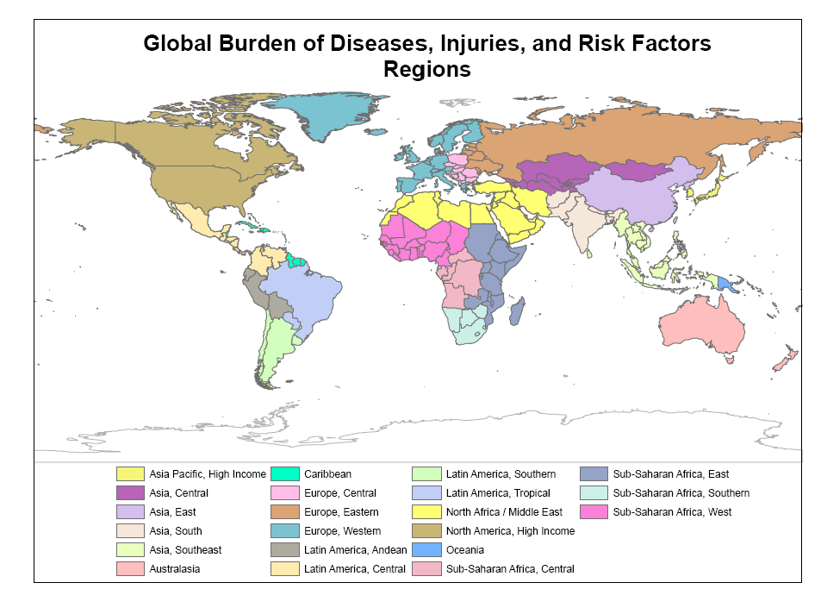

**A2 ECCAD and GFED**

<http://eccad.sedoo.fr/eccad_extract_interface/JSF/page_login.jsf>

ECCAD displays and analyzes global emission inventories in either 14 or 26 regions, for biomass burning GFED regions.

|  |  |  |
| --- | --- | --- |
| GFED region (biomass burning) | ECCAD 26 | ECCAD 14 |
|  |  |  |

**A3 Representative Concentration Pathways Region definition**

<http://www.iiasa.ac.at/web-apps/tnt/RcpDb/dsd?Action=htmlpage&page=compare>

The RCP database aggregates regions into:

**OECD90** = Includes the OECD 90 countries, therefore encompassing the countries included in the regions **Western Europe** (Austria, Belgium, Denmark, Finland, France, Germany, Greece, Iceland, Ireland, Italy, Luxembourg, Netherlands, Norway, Portugal, Spain, Sweden, Switzerland, Turkey, United Kingdom), **Northern America** (Canada, United States of America) and **Pacific OECD** (Australia, Fiji, French Polynesia, Guam, Japan, New Caledonia, New Zealand, Samoa, Solomon Islands, Vanuatu) .

**REF** = Countries from the **Reforming Ecomonies** region (Albania, Armenia, Azerbaijan, Belarus, Bosnia and Herzegovina, Bulgaria, Croatia, Cyprus, Czech Republic, Estonia, Georgia, Hungary, Kazakhstan, Kyrgyzstan, Latvia, Lithuania, Malta, Poland, Republic of Moldova, Romania, Russian Federation, Slovakia, Slovenia, Tajikistan, TFYR Macedonia, Turkmenistan, Ukraine, Uzbekistan, Yugoslavia).

**ASIA** = The countries included in the regions **China +** (China, China Hong Kong SAR, China Macao SAR, Mongolia, Taiwan) , **India +** (Afghanistan, Bangladesh, Bhutan, India, Maldives, Nepal, Pakistan, Sri Lanka) and **Rest of Asia** (Brunei Darussalam, Cambodia, Democratic People's Republic of Korea, East Timor, Indonesia, Lao People's Democratic Republic, Malaysia, Myanmar, Papua New Guinea, Philippines, Republic of Korea, Singapore, Thailand, Viet Nam) are aggregated into this region.

**MAF** = This region includes the **Middle East** (Bahrain, Iran (Islamic Republic of), Iraq, Israel, Jordan, Kuwait, Lebanon, Oman, Qatar, Saudi Arabia, Syrian Arab Republic, United Arab Emirates, Yemen) and **Africa**n (Algeria, Angola, Benin, Botswana, Burkina Faso, Burundi, Cote d'Ivoire, Cameroon, Cape Verde, Central African Republic, Chad, Comoros, Congo, Democratic Republic of the Congo, Djibouti, Egypt, Equatorial Guinea, Eritrea, Ethiopia, Gabon, Gambia, Ghana, Guinea, Guinea-Bissau, Kenya, Lesotho, Liberia, Libyan Arab Jamahiriya, Madagascar, Malawi, Mali, Mauritania, Mauritius, Morocco, Mozambique, Namibia, Niger, Nigeria, Reunion, Rwanda, Senegal, Sierra Leone, Somalia, South Africa, Sudan, Swaziland, Togo, Tunisia, Uganda, United Republic of Tanzania, Western Sahara, Zambia, Zimbabwe) countries.

**LAM** = This region includes the **Latin America**n countries (Argentina, Bahamas, Barbados, Belize, Bolivia, Brazil, Chile, Colombia, Costa Rica, Cuba, Dominican Republic, Ecuador, El Salvador, Guadeloupe, Guatemala, Guyana, Haiti, Honduras, Jamaica, Martinique, Mexico, Netherlands Antilles, Nicaragua, Panama, Paraguay, Peru, Puerto Rico, Suriname, Trinidad and Tobago, Uruguay, Venezuela).

A4: IMAGE region definition

The integrated Assessment Model IMAGE is one of the more widely used models for impact analysis. It has 26 regions.

