Deciphering Immune Dysregulation in Sepsis
Through Single-Cell Transcriptomics
A Single-Cell RNA Sequencing Analysis of Whole-Blood Immune Populations
Gannah Sayed Saleh
Datasets: GEO Accessions GSE163668 and GSE157789
Research Question
How does sepsis alter immune-cell composition and transcriptional states, and which immune populations and pathways are associated with disease severity?

Abstract
Sepsis is characterized by a dysregulated host immune response to infection, yet the precise cellular and molecular alterations driving this dysregulation remain incompletely defined. Here, we analyzed single-cell RNA sequencing (scRNA-seq) data from whole-blood immune cells of 46 individuals (28 sepsis/COVID-19 patients and 18 healthy controls; GEO accession GSE163668) to characterize how sepsis reshapes immune-cell composition and transcriptional programs, and to identify populations and pathways associated with disease severity. Following stringent quality control, doublet removal, batch integration (Harmony), and unsupervised clustering, we resolved 14 well-defined immune populations spanning myeloid and lymphoid lineages. Sepsis patients exhibited a pronounced myeloid-to-lymphoid compositional shift, marked by a dramatic expansion of neutrophils (~37% of cells versus <1% in controls; χ² = 14,404, df = 13, p < 2.2 × 10⁻¹⁶) alongside a reduction of naive and memory T-cell populations, consistent with sepsis-induced lymphopenia and emergency granulopoiesis. Differential expression analysis across eight major cell types revealed widespread upregulation of interferon-stimulated genes (e.g., IFITM3, IFI6, IFI44L, XAF1), particularly in classical monocytes. Pathway enrichment analysis showed that monocytes were dominated by antiviral and innate-immune signaling pathways, whereas neutrophils were enriched for detoxification and oxidative/metabolic stress-response pathways — indicating that distinct myeloid subsets adopt qualitatively different functional states during sepsis. Critically, neutrophil proportion scaled with disease severity, rising from 24% in mild/moderate cases to 43% in severe cases (χ² = 4,191.1, df = 13, p < 2.2 × 10⁻¹⁶), identifying neutrophil expansion as the immune population most robustly associated with severity in this cohort. Together, these findings provide a single-cell resolution map of immune dysregulation in sepsis and nominate neutrophil-driven myeloid expansion and monocyte interferon signaling as candidate axes of disease severity.

1. Introduction
Sepsis remains a leading cause of morbidity and mortality worldwide, driven not by pathogens alone but by a maladaptive and dysregulated host immune response. This response involves complex, time-dependent shifts across innate and adaptive immune compartments, including altered myeloid cell activation, lymphocyte depletion, and broad transcriptional reprogramming of circulating immune cells. Bulk transcriptomic approaches have identified sepsis-associated gene signatures, but they average signal across heterogeneous cell populations and cannot resolve which specific immune subsets drive observed changes.
Single-cell RNA sequencing (scRNA-seq) overcomes this limitation by profiling gene expression at individual-cell resolution, enabling simultaneous characterization of cell-type composition and cell-type-specific transcriptional states. In this study, we leverage a publicly available whole-blood scRNA-seq dataset (GEO: GSE163668) comprising both pooled and individually indexed 10x Genomics libraries from sepsis/COVID-19 patients and healthy controls to address the following research question:
How does sepsis alter immune-cell composition and transcriptional states, and which immune populations and pathways are associated with disease severity?
To answer this question, we implemented a standard scRNA-seq analytical pipeline — quality control, normalization, feature selection, dimensionality reduction, batch integration, clustering, and cell-type annotation — followed by compositional analysis, differential expression testing, and pathway enrichment analysis, stratified by both infection status (patient vs. control) and, where available, clinical severity (mild/moderate vs. severe).

2. Data and Methods

2.1 Dataset
Data were obtained from GEO accession GSE163668, comprising 38 GEO samples (GSM records). Six samples were pooled multiplexed 10x libraries containing cells from multiple patients, genetically demultiplexed via freemuxlet-based cluster assignments provided with the dataset; the remaining 32 samples were individually indexed libraries, each corresponding to a single donor. After demultiplexing, this yielded scRNA-seq profiles for 46 unique individuals: 28 sepsis/COVID-19 patients and 18 healthy controls. For the 32 individually indexed donors, clinical metadata additionally distinguished mild/moderate (M/M, n = 18 patients) from severe (SEVERE, n = subset of patients) disease phenotypes; severity annotation was not available for patients contained within pooled samples.

2.2 Preprocessing and Demultiplexing
Raw feature-barcode matrices were downloaded via GEOquery. For pooled samples, cells were assigned to donors using provided freemuxlet cluster assignments, retaining only high-confidence singlets. Gene expression matrices from all 46 donors were merged on their shared gene set (8,515 genes) into a single Seurat object.

2.3 Quality Control
Cells were filtered to retain those with 200–6,000 detected genes (nFeature_RNA) and less than 10% mitochondrial transcript content (percent.mt), removing low-quality and dying cells. Doublets were identified and removed using scDblFinder, run per-patient (samples = "patient") to account for batch-specific doublet rates. This pipeline retained 74,739 high-quality singlet cells across all 46 individuals.

2.4 Normalization, Feature Selection, and Dimensionality Reduction
Gene expression was log-normalized (LogNormalize, scale factor = 10,000). The top 2,000 highly variable genes were identified (vst method) and used for scaling and principal component analysis (PCA). The first 15 principal components were retained for downstream analysis based on elbow-plot inspection of explained variance.

2.5 Batch Integration and Clustering
To correct for inter-individual (batch) effects across the 46 donors while preserving true biological cell-type structure, Harmony integration was applied to the PCA embedding (group.by.vars = "patient"), converging after 7 iterations. UMAP embedding and graph-based clustering (Louvain algorithm, resolution = 0.5) were performed on the Harmony-corrected embedding, yielding 18 clusters. Cluster-specific marker genes were identified (FindAllMarkers, Wilcoxon rank-sum test), and clusters were annotated to canonical immune cell types based on established marker genes. Four clusters (n = 4,946 cells, 6.6% of QC-passing cells) lacked coherent marker signatures on manual review (weak or contaminating markers only) and were excluded from downstream analysis, yielding a final annotated dataset of 69,793 cells across 14 immune populations.

2.6 Statistical and Differential Expression Analysis
Differences in cell-type proportions between groups (patient vs. control; mild/moderate vs. severe) were assessed using Pearson's chi-squared test on cell-type-by-group contingency tables. Differential gene expression between patients and controls was tested within each major cell type using the Wilcoxon rank-sum test (Seurat::FindMarkers; min.pct = 0.25, logFC threshold = 0.25), with Bonferroni-adjusted p-values. Pathway enrichment (Gene Ontology, Biological Process) was performed on significantly upregulated genes (adjusted p < 0.05, log2FC > 0.5) per cell type using clusterProfiler with the org.Hs.eg.db annotation database.

3. Results

3.1 Cell-Type Landscape of Circulating Immune Cells
Unsupervised clustering of 69,793 quality-controlled, Harmony-integrated cells resolved 14 immune populations spanning both myeloid and lymphoid lineages, including neutrophils, classical and non-classical monocytes, dendritic cells, naive T cells, memory CD4⁺ T cells, CD8⁺ cytotoxic T cells, NK cells, B cells, plasma cells, platelets, erythrocytes, and a population of proliferating cells. UMAP visualization showed clear separation of myeloid (neutrophil/monocyte) and lymphoid (T/NK/B-cell) compartments, consistent with known transcriptional divergence between these lineages, and cells from all 46 individuals were well-mixed within each cluster, confirming successful batch correction (Figure 1).
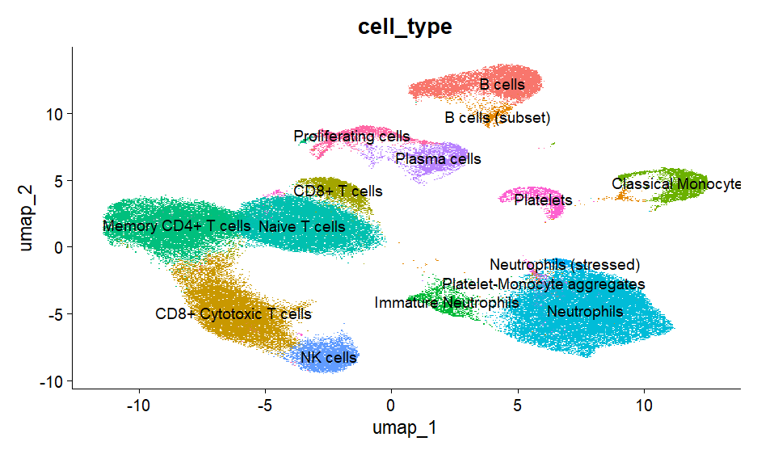
Figure 1. UMAP projection of 69,793 integrated immune cells, colored by annotated cell type. Distinct clustering of myeloid (neutrophils, monocytes) and lymphoid (T, NK, B) compartments is observed.

3.2 Sepsis Drives a Myeloid-Dominant Shift in Immune-Cell Composition
Comparing cell-type proportions between patients and controls revealed a highly significant shift in immune-cell composition (χ² = 14,404, df = 13, p < 2.2 × 10⁻¹⁶). The most striking change was a dramatic expansion of neutrophils, comprising approximately 37% of patient cells versus less than 1% of control cells — consistent with sepsis-associated emergency granulopoiesis. This expansion was accompanied by a marked contraction of lymphoid populations: naive T cells decreased from ~25% to ~7%, memory CD4⁺ T cells from ~18% to ~8%, and CD8⁺ cytotoxic T cells from ~19% to ~6.5% of cells, consistent with sepsis-induced lymphopenia. Platelet proportion also increased (~2.5% to ~9%), reflecting a broader activated, pro-inflammatory hematological state (Table 1, Figure 2).
Table 1. Selected immune-cell proportions in patients versus controls.
Cell Type | Control (%) | Patient (%) | Direction
Neutrophils | < 1 | ~37 | ↑↑↑
Naive T cells | ~25 | ~7 | ↓↓
Memory CD4+ T cells | ~18 | ~8 | ↓↓
CD8+ Cytotoxic T cells | ~19 | ~6.5 | ↓↓
Platelets | ~2.5 | ~9 | ↑

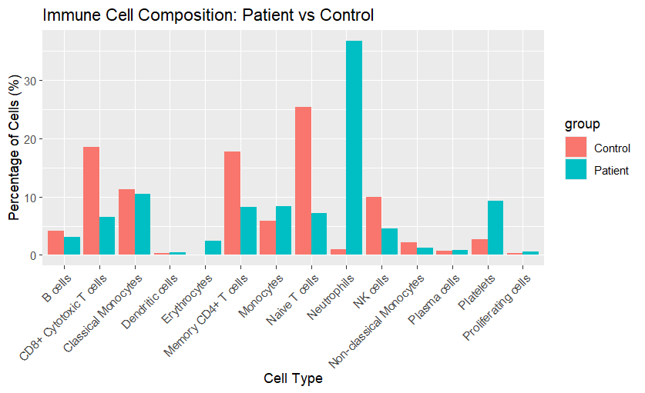
Figure 2. Immune-cell composition (percentage of cells) by cell type, compared between patients and healthy controls.

3.3 Cell-Type-Specific Transcriptional Reprogramming
To characterize transcriptional states beyond compositional shifts, differential expression was tested within each of eight major cell types between patients and controls. All cell types showed extensive transcriptional divergence, ranging from 195 differentially expressed genes in neutrophils to 1,536 genes in memory CD4⁺ T cells (Table 2). A recurrent signature of interferon-stimulated genes — including IFITM3, IFITM2, IFI6, IFI44L, and XAF1 — was upregulated across nearly all lymphoid and myeloid subsets, indicating a systemic antiviral transcriptional program active across the circulating immune compartment. Concurrently, ribosomal protein genes (e.g., RPL36A, RPS2P5) were broadly downregulated, consistent with a shift away from baseline protein-synthesis programs under inflammatory stress.
Table 2. Number of significantly differentially expressed genes per cell type (patient vs. control; adjusted p < 0.05).
Cell Type | DE Genes (n)
Memory CD4+ T cells | 1,536
Classical Monocytes | 1,274
CD8+ Cytotoxic T cells | 1,180
Naive T cells | 1,056
NK cells | 1,024
B cells | 980
Monocytes | 235
Neutrophils | 195

3.4 Distinct Functional Pathways Distinguish Myeloid Subsets
Gene Ontology enrichment analysis of upregulated genes revealed strikingly distinct functional programs between the two dominant myeloid populations. In classical monocytes, the top enriched pathways were overwhelmingly antiviral and innate-immune in nature — "response to virus," "defense response to virus," "regulation of innate immune response," and "response to type II interferon" — indicating a coordinated antiviral transcriptional program. In contrast, neutrophils were enriched for detoxification and metabolic stress-response pathways, including "response to metal ion," "detoxification," "cellular oxidant detoxification," and "response to toxic substance," alongside modest platelet-activation and interferon-alpha signatures. This divergence suggests that monocytes and neutrophils adopt qualitatively distinct functional states during sepsis — monocytes engaging direct antiviral defense, while neutrophils manage the metabolic and oxidative burden of a hyperactivated, high-turnover inflammatory state (Figure 3).
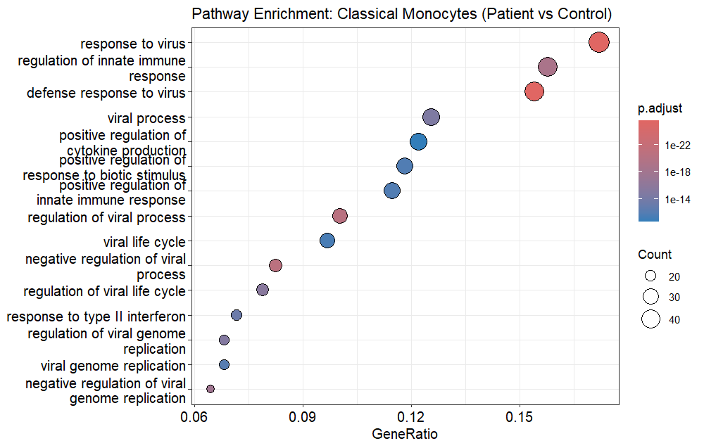
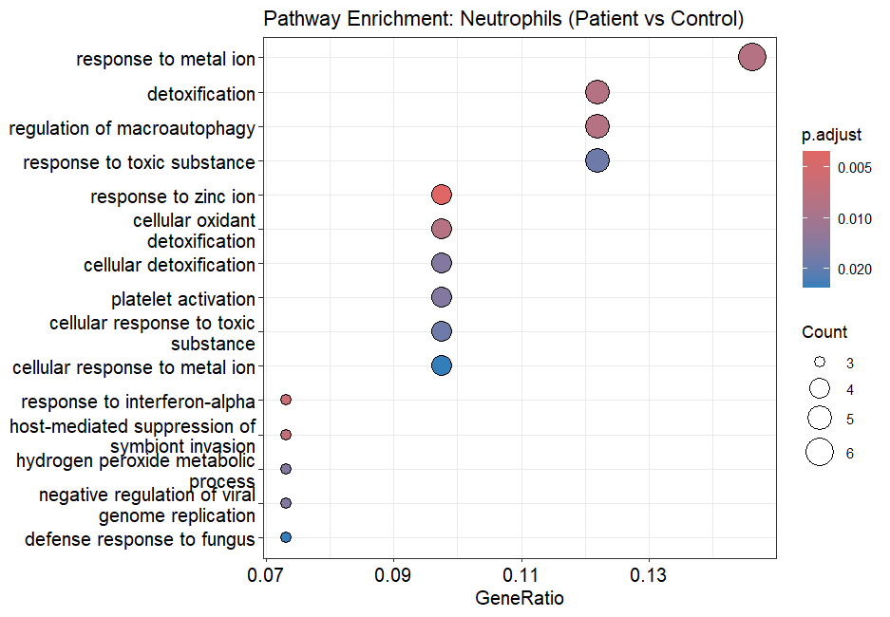
Figure 3. Gene Ontology (Biological Process) enrichment dot plots for upregulated genes in classical monocytes (top; antiviral/innate immune dominant) versus neutrophils (bottom; detoxification/metabolic stress dominant).

3.5 Neutrophil Expansion Tracks with Disease Severity
Restricting analysis to the 32 individually indexed donors with documented clinical severity (mild/moderate, M/M, versus severe, SEVERE), cell-type composition differed significantly by severity (χ² = 4,191.1, df = 13, p < 2.2 × 10⁻¹⁶). Neutrophil proportion increased from approximately 24% of cells in mild/moderate patients to approximately 43% in severe patients, while nearly all other populations — including B cells, CD8⁺ T cells, classical monocytes, memory CD4⁺ T cells, NK cells, and naive T cells — showed further proportional decline with increasing severity (Figure 4). This dose-dependent relationship identifies neutrophil expansion as the immune population most robustly associated with sepsis severity in this cohort.
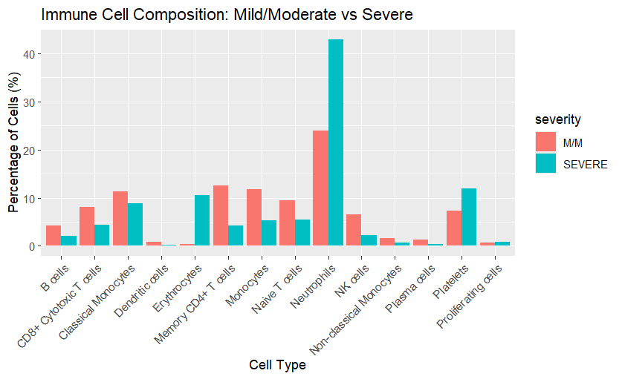
Figure 4. Immune-cell composition stratified by clinical severity (mild/moderate vs. severe), showing progressive neutrophil expansion and lymphoid contraction with increasing severity.

4. Cross-Cohort Validation: COVID versus Non-COVID Sepsis (GSE157789)

4.1 Rationale and Dataset
To test whether the myeloid-dominant dysregulation observed above reflects a generic feature of severe sepsis or a COVID-19-specific phenomenon, and to examine how immune composition evolves across disease stages, we analyzed a second independent whole-blood scRNA-seq dataset (GEO: GSE157789). This cohort comprises 30 individually indexed 10x Genomics libraries (filtered feature-barcode matrices) spanning four clinical groups: Severe COVID-ARDS (n = 21, sampled at 72 hours and 7 days post-admission, with and without dexamethasone treatment), Severe non-COVID ICU (n = 3, bacterial ARDS), Healthy Control (n = 5), and COVID Recovered (n = 2). One sample flagged as excluded by the original submitters was removed prior to analysis. The same analytical pipeline described in Section 2 was applied independently to this cohort — quality control (200–6,000 genes/cell, <15% mitochondrial content), per-sample doublet removal (scDblFinder), normalization, Harmony integration (by sample), and graph-based clustering — yielding 129,958 quality-controlled singlet cells resolved into 15 annotated immune populations after exclusion of two low-confidence clusters (Figure 5).
Figure 5. UMAP projection of the GSE157789 cohort, colored by annotated cell type, showing 15 resolved immune populations including a graded neutrophil axis (immature, mature, and stressed neutrophils).

4.2 Immune Composition Varies by Disease Stage, Not Only by Diagnosis
Cell-type composition differed significantly across the four clinical groups (χ² = 11,844, df = 42, p < 2.2 × 10⁻¹⁶). Unexpectedly, neutrophil proportion was highest not in acute Severe COVID-ARDS (~13%) but in the COVID Recovered group (~41%), while Healthy Controls showed intermediate levels (~12%) and Severe non-COVID ICU the lowest (~1%, based on only 3 donors) (Figure 6). Naive T-cell proportion was lowest in COVID Recovered (~16%) relative to Healthy Controls (~28%), mirroring the lymphopenia observed in the primary cohort. These patterns suggest that neutrophil expansion in this cohort tracks with disease stage — potentially reflecting a post-acute reparative granulopoietic response during convalescence — rather than being confined to the acute severe phase, complementing the severity-dependent relationship established in the primary GSE163668 cohort. Given the small size of the non-COVID ICU group, this comparison is reported as a preliminary, hypothesis-generating observation.
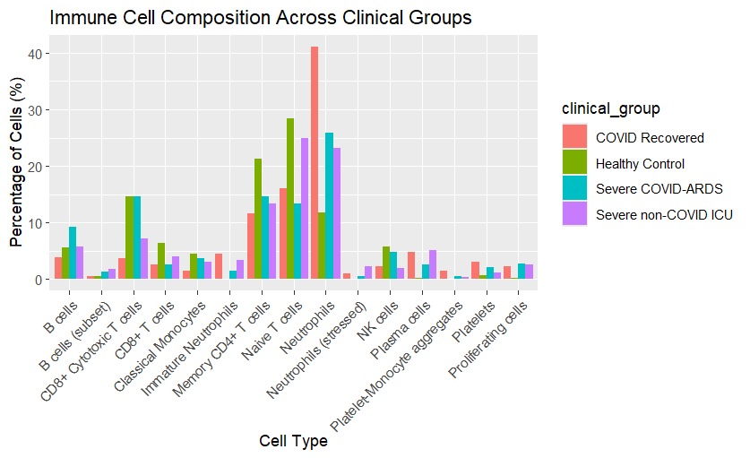
Figure 6. Immune-cell composition across the four clinical groups (Healthy Control, COVID Recovered, Severe COVID-ARDS, Severe non-COVID ICU).

4.3 Distinct Etiology-Specific Transcriptional Programs in Neutrophils and Monocytes
To directly isolate transcriptional features specific to COVID-19 from those common to severe sepsis generally, we compared Severe COVID-ARDS against Severe non-COVID ICU (bacterial ARDS) within each of two key myeloid populations. In neutrophils, 434 genes were differentially expressed; genes upregulated in COVID-ARDS were dominated by interferon-stimulated genes (IFITM1, IFITM3, IFIT1, IFIT2, IFIT3, ISG15, LY6E). In classical monocytes, 1,293 genes were differentially expressed; genes upregulated in non-COVID (bacterial) ARDS were dominated by classical bacterial-response and inflammatory mediators (IL1B, CXCL8, CXCL2, PTGS2, AREG, EREG) (Table 3).
Table 3. Representative genes distinguishing COVID-ARDS from non-COVID (bacterial) ARDS by cell type.
Cell Type | Higher in COVID-ARDS | Higher in Non-COVID ARDS
Neutrophils | IFITM1, IFITM3, IFIT1/2/3, ISG15, LY6E | —
Classical Monocytes | — | IL1B, CXCL8, CXCL2, PTGS2, AREG, EREG

Gene Ontology enrichment confirmed this etiology-specific divergence at the pathway level. Genes upregulated in COVID-ARDS neutrophils were enriched for "response to virus," "regulation of innate immune response," "defense response to virus," and "response to type I interferon" (Figure 7). In contrast, genes upregulated in non-COVID ARDS monocytes were enriched for "response to molecule of bacterial origin," "cellular response to lipopolysaccharide," "interleukin-6 production," and "response to interleukin-1" (Figure 8). These reciprocal, etiology-matched signatures indicate that the immune system retains pathogen-class-specific transcriptional signatures — antiviral/interferon-driven in COVID-19, classical bacterial/LPS-driven inflammation in bacterial sepsis — even as both converge on a clinically similar severe ARDS phenotype.
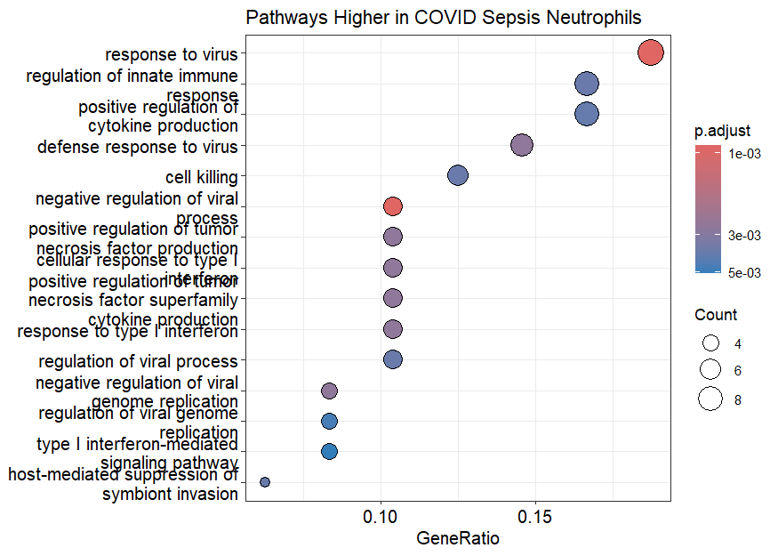
Figure 7. Gene Ontology (Biological Process) enrichment for genes upregulated in neutrophils of Severe COVID-ARDS versus Severe non-COVID ICU patients, dominated by antiviral/type I interferon pathways.
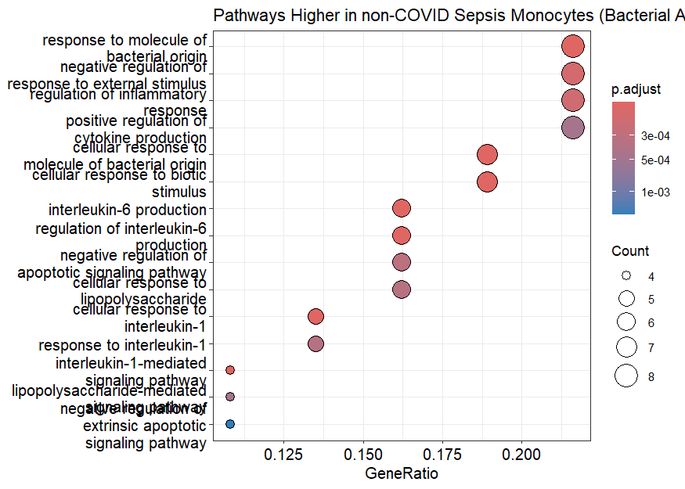
Figure 8. Gene Ontology (Biological Process) enrichment for genes upregulated in classical monocytes of Severe non-COVID ICU versus Severe COVID-ARDS patients, dominated by bacterial/LPS-response and interleukin signaling pathways.

4.4 Synthesis Across Cohorts
Together, the two independent cohorts provide convergent and complementary evidence. Both identify neutrophil-driven myeloid expansion and lymphoid contraction as a recurring hallmark of severe sepsis/ARDS, and both implicate monocytes and neutrophils as carrying distinct functional signals. The GSE157789 cohort further demonstrates that (i) neutrophil expansion is associated with disease stage (acute versus convalescent) in addition to severity, and (ii) the specific transcriptional flavor of myeloid activation — antiviral/interferon versus bacterial/inflammatory — is etiology-specific, tracking with the underlying pathogen class rather than being a generic feature of critical illness alone.

5. Discussion
This single-cell analysis of whole-blood immune cells from 46 individuals provides a granular, cell-type-resolved characterization of immune dysregulation in sepsis. Three main findings emerge. First, sepsis is associated with a profound compositional shift from a lymphoid-balanced to a myeloid-dominant (neutrophil-driven) immune landscape, recapitulating the well-described phenomena of emergency granulopoiesis and sepsis-induced lymphopenia. Second, this compositional shift is accompanied by substantial cell-type-specific transcriptional reprogramming, most notably a broad interferon-stimulated gene signature suggestive of concurrent antiviral immune activation. Third, and most directly relevant to the study's research question, distinct myeloid subsets exhibit qualitatively different functional pathway enrichment — monocytes skewing toward canonical antiviral defense, neutrophils toward detoxification and oxidative-stress management — and neutrophil proportion specifically scales with clinical severity, nominating it as a candidate cellular correlate of sepsis severity in this dataset.
These findings are consistent with, and extend at single-cell resolution, prior bulk transcriptomic and flow-cytometric studies describing neutrophil expansion, lymphopenia, and interferon-driven signatures as hallmarks of sepsis immune dysregulation. The divergent pathway signatures between monocytes and neutrophils further suggest that myeloid dysfunction in sepsis is not monolithic: different myeloid subsets may be responding to, or contributing to, distinct aspects of the septic inflammatory state (direct antiviral defense versus management of self-generated oxidative and metabolic stress from sustained neutrophil hyperactivation).
Several limitations should be noted. Severity annotation was available only for the 32 individually indexed donors, limiting severity-stratified analyses to a subset of the cohort; the 14 patients recovered from pooled, genetically demultiplexed samples could not be assigned a severity label and were excluded from severity-specific comparisons, though they contributed to composition and differential expression analyses versus controls. Additionally, this dataset combines COVID-19-associated and non-COVID sepsis cases under a shared "patient" label in places, and the interferon-dominant signature observed likely reflects a substantial viral/COVID-19 component within the cohort; findings regarding neutrophil-driven myeloid expansion and severity association should be interpreted within this context and would benefit from validation in non-viral sepsis cohorts.

6. Conclusion
Single-cell transcriptomic profiling of whole blood across two independent sepsis/COVID-19 cohorts reveals a coordinated, severity- and stage-dependent reorganization of the circulating immune system, characterized by neutrophil-driven myeloid expansion, lymphoid contraction, and divergent, etiology-specific monocyte and neutrophil transcriptional programs. Within the primary cohort, neutrophil proportion emerges as the immune population most strongly associated with disease severity. Cross-cohort validation further shows that neutrophil expansion also tracks with disease stage, and that its underlying transcriptional character — antiviral/interferon-driven versus bacterial/inflammatory-driven — differs according to the causative pathogen. Together these findings support neutrophil-driven myeloid dysregulation as a robust, generalizable feature of sepsis severity, with an etiology-specific transcriptional signature that merits further mechanistic and therapeutic investigation.

7. Data Availability
Raw and processed single-cell RNA sequencing data are publicly available through the NCBI Gene Expression Omnibus under accession numbers GSE163668 (primary cohort) and GSE157789 (cross-cohort validation, COVID versus non-COVID sepsis/ARDS).

