Deciphering Immune Dysregulation in Sepsis Through Single-Cell Transcriptomics
A single-cell RNA-seq analysis of whole-blood immune populations across two independent cohorts
Gannah Sayed Saleh
Code & analysis pipeline: github.com/gannah-bioinfo/-sepsis-immune-dysregulation-scrnaseq
Datasets: GEO GSE163668 (n = 46) and GSE157789 (n = 30)
Abstract
Sepsis is characterized by a dysregulated host immune response, but which cell populations and transcriptional programs drive it, and how they relate to severity and etiology, remains incompletely resolved. We analyzed whole-blood single-cell RNA-seq data from two independent cohorts — 46 individuals (28 sepsis/COVID-19 patients, 18 healthy controls; GSE163668) and 30 individuals spanning four clinical groups including COVID- and bacterial-driven ARDS (GSE157789) — using a QC → normalization → Harmony integration → clustering → annotation pipeline. Patients showed a pronounced myeloid-dominant shift: neutrophils expanded from <1% to ~37% of cells (χ² = 14,404, p < 2.2×10⁻¹⁶) with parallel lymphopenia (naive T 25%→7%; memory CD4⁺ 18%→8%; CD8⁺ cytotoxic 19%→6.5%). This shift was confirmed at the patient level (n = 46, Wilcoxon, FDR < 0.05 for 9/14 populations), addressing the pseudoreplication inherent to per-cell testing. Differential expression revealed a recurrent interferon-stimulated gene signature (IFITM3, IFI6, IFI44L, XAF1); pathway analysis showed monocytes skewing toward antiviral/interferon signaling and neutrophils toward detoxification/oxidative-stress pathways. Neutrophil proportion rose with clinical severity (24%→43%, mild/moderate vs. severe). In GSE157789 (129,958 cells), neutrophil expansion tracked with disease stage, and a direct COVID- vs. bacterial-ARDS comparison revealed etiology-specific programs: interferon-response genes in COVID neutrophils (IFITM1/3, IFIT1–3, ISG15) versus classical LPS/IL-1 inflammatory genes in bacterial-ARDS monocytes (IL1B, CXCL8, PTGS2). These findings identify neutrophil-driven myeloid expansion as a robust hallmark of sepsis severity whose transcriptional character distinguishes viral from bacterial etiology.
Methods
Data were retrieved with GEOquery and analyzed in Seurat v5. Pooled 10x libraries in GSE163668 were demultiplexed to donors using the provided freemuxlet assignments. Cells were filtered (200–6,000 genes, <10–15% mitochondrial reads) and doublets removed (scDblFinder, per sample). Data were log-normalized, the top 2,000 variable genes selected, PCA computed (15 PCs), donor batch effects corrected with Harmony, and cells clustered and annotated by marker genes (FindAllMarkers). Composition was tested per cell (Pearson’s χ²) and, for GSE163668, at the patient level (per-patient proportions, Wilcoxon, Benjamini–Hochberg FDR). Differential expression used FindMarkers (Wilcoxon); pathway enrichment used clusterProfiler (GO Biological Process).
Results
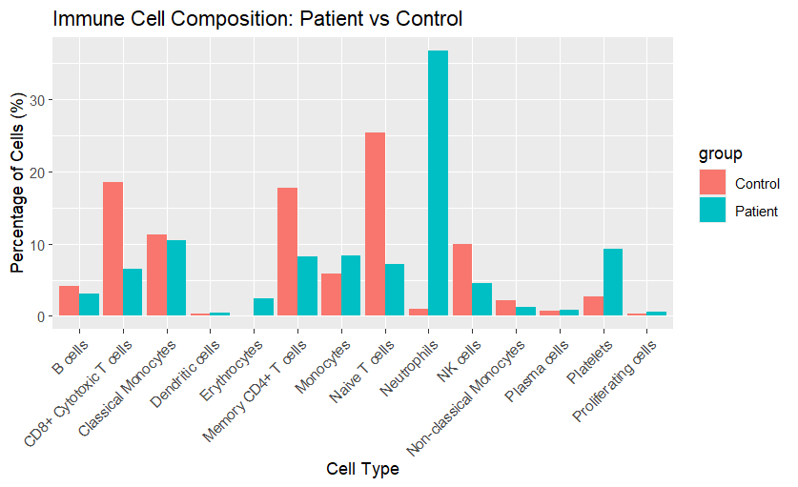 | 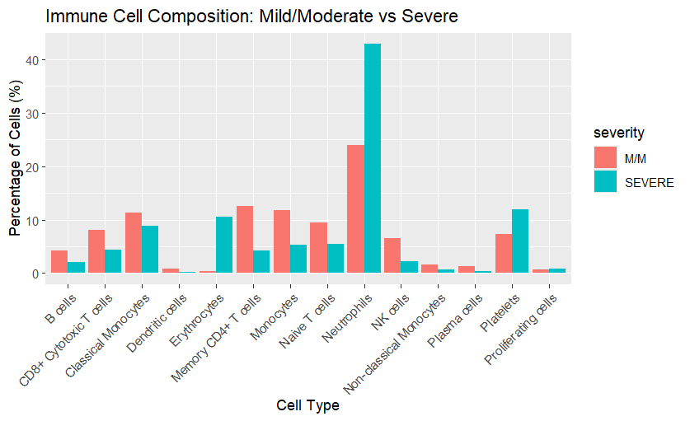
Figure 1. (A) Immune-cell composition in patients vs. healthy controls (GSE163668): neutrophils expand while naive/memory T, CD8⁺ and NK populations contract. (B) Composition by clinical severity (mild/moderate vs. severe): neutrophil proportion rises from ~24% to ~43%.
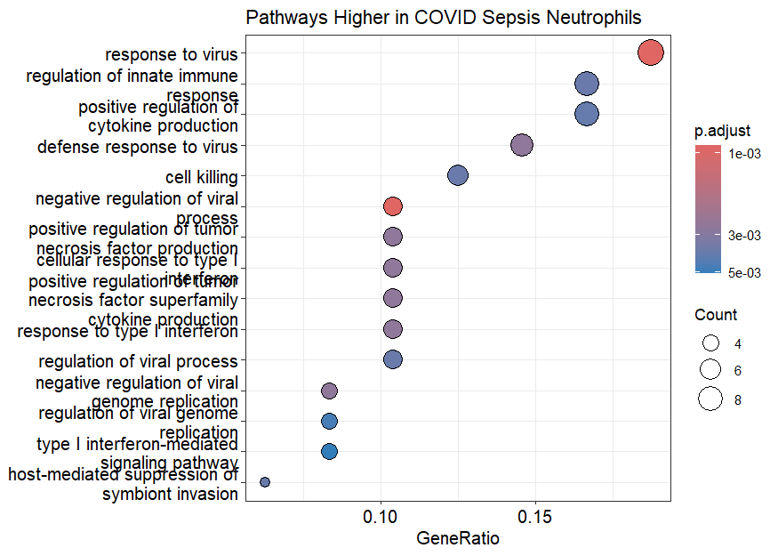 | 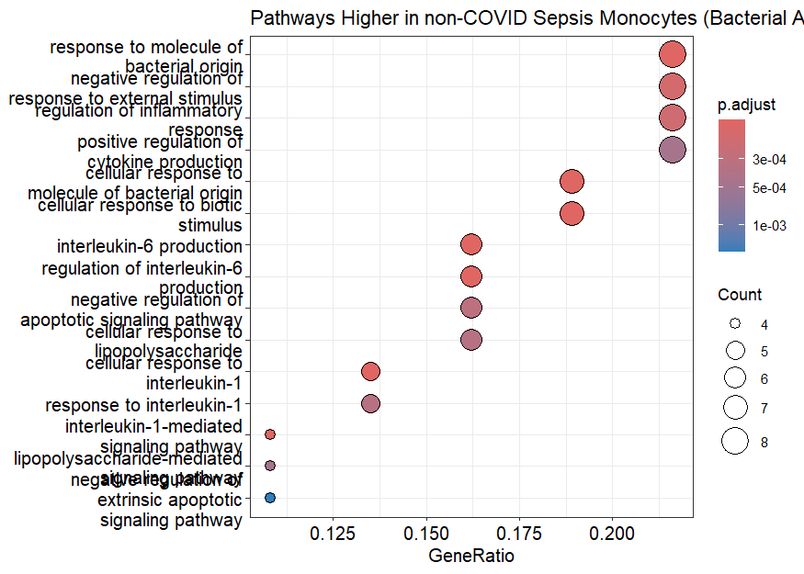
Figure 2. Etiology-specific programs in GSE157789 (Severe COVID-ARDS vs. Severe non-COVID/bacterial ARDS). (A) GO enrichment of genes higher in COVID-ARDS neutrophils: response to virus and type I interferon. (B) GO enrichment of genes higher in bacterial-ARDS monocytes: response to bacterial molecules/LPS and IL-1/IL-6 signaling.
Table 1. Key statistics.
Finding | Statistic
Composition shift, patient vs. control (per-cell, GSE163668) | χ²=14,404, df=13, p<2.2×10⁻¹⁶
Neutrophils, patient level (n=46): mean proportion 1.1% → 30.3% | Wilcoxon FDR=2.0×10⁻⁷
Naive T cells, patient level (n=46): mean proportion 25.5% → 7.0% | Wilcoxon FDR=2.3×10⁻⁸
Neutrophils by severity (mild/moderate vs. severe, per-cell) | χ²=4,191, df=13, p<2.2×10⁻¹⁶
Composition across 4 clinical groups (GSE157789) | χ²=11,844, df=42, p<2.2×10⁻¹⁶
COVID- vs. bacterial-ARDS DE genes (neutrophils / monocytes) | 434 / 1,293
Discussion & Conclusion
Sepsis reshapes circulating immunity toward a myeloid-dominant, neutrophil-driven state with lymphopenia; the compositional shift persists when tested at the patient level rather than per cell. Monocytes and neutrophils adopt distinct functional programs, and direct comparison of COVID- and bacterial-driven ARDS shows this myeloid response retains pathogen-class-specific character (interferon-driven in viral, LPS/IL-1-driven in bacterial sepsis) even as clinical severity converges. Limitations: the severity association was assessed per cell and warrants patient-level confirmation (n = 32), and the non-COVID ARDS group is small (n = 3), so etiology-specific findings are preliminary. Neutrophil expansion and its transcriptional signature are candidate correlates of sepsis severity and etiology that merit validation in larger cohorts.
Data & Code Availability
Raw data: NCBI GEO GSE163668 and GSE157789. Code and pipeline: github.com/gannah-bioinfo/-sepsis-immune-dysregulation-scrnaseq.

