ECE 451-LAB2

Fall 2019

Ram Rohit Gannavarapu

Contents

List of Figures 1

1. List of items completed 2

2. Lab Procedures 2

3. Schematics/Verilog models 2

4. Simulation Results 2

5. Analysis and Explanations 2

6. Conclusion 2

7. Answers to questions posted in the lab 2

# List of Figures

Figure 1: Verilog Code of 3-Bit ALU 2

Figure 2: Verilog code for dispaly module 3

Figure 3: Waveform output of the Logic 3

# List of items completed

* 1. 3-Bit ALU Verilog code
  2. Code to display Output F on 7-Segment Display

# Lab Procedures

# Schematics/Verilog models

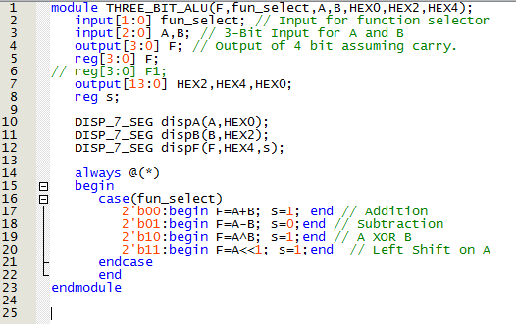

Figure 1: Verilog Code of 3-Bit ALU

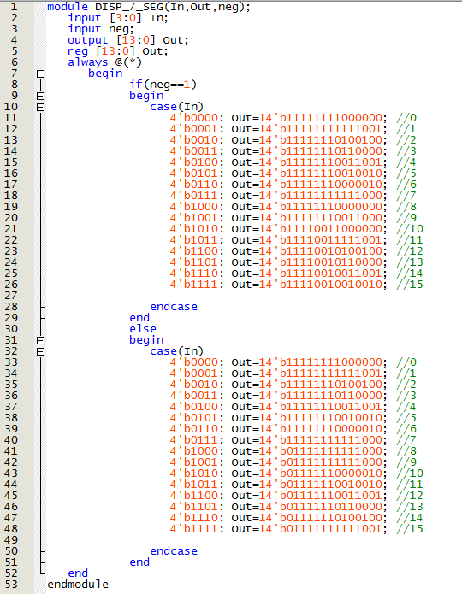

Figure 2: Verilog code for dispaly module

# Simulation Results

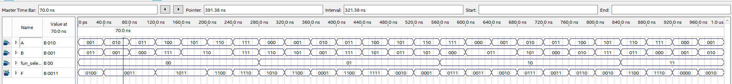

Figure 3: Waveform output of the Logic

# Analysis and Explanations

It is evident from the simulation results that all the operations are working as expected.

# Conclusion

Verilog Code for 3-bit ALU is working as expected and the output is also displayed on the 7-segment display properly.

# Answers to questions posted in the lab

Q) Discuss the advantages of a Hardware Descriptive Language (HDL).

A) It is easier to implement/Model a Design in Verilog. It also saves a lot of time in both Verification through simulation and debugging issues.