Git Url : https://github.com/ganny26/latitude-hack

H:\latitude>git clone git@github.com:ganny26/latitude-hack.git

H:\latitude>npm install

H:\latitude>grunt build –force

H:\latitude>node server.js

Server listening on http://localhost:8000

Application ready to serve requests.

Environment: development

Main UI

<http://localhost:8000/>

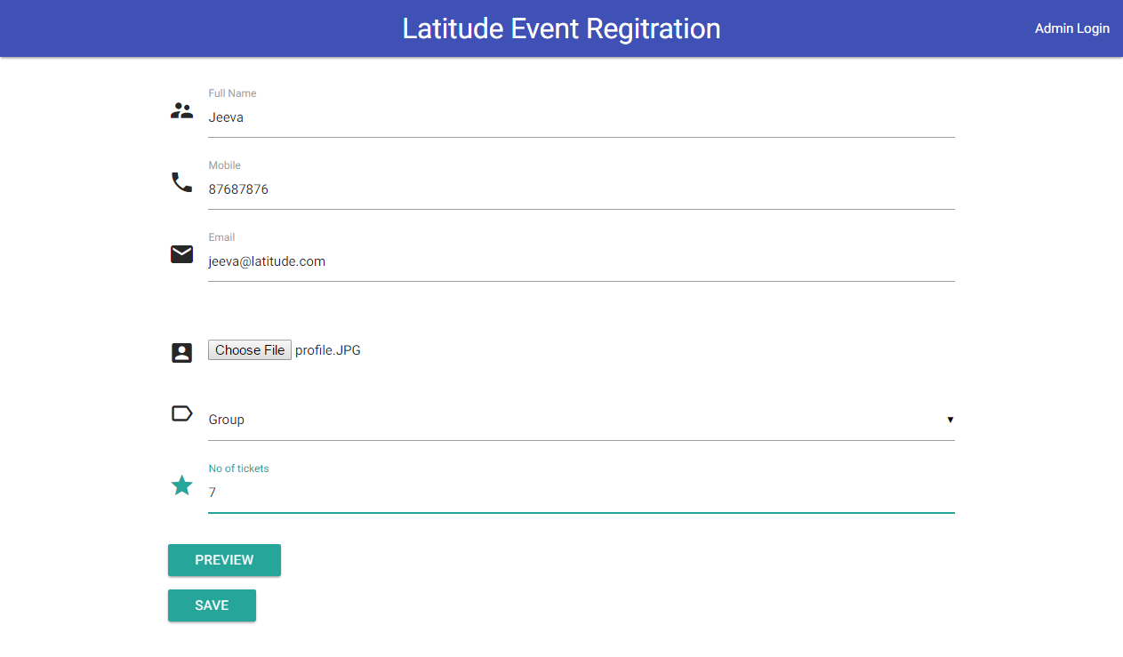

<http://localhost:8000/preview>

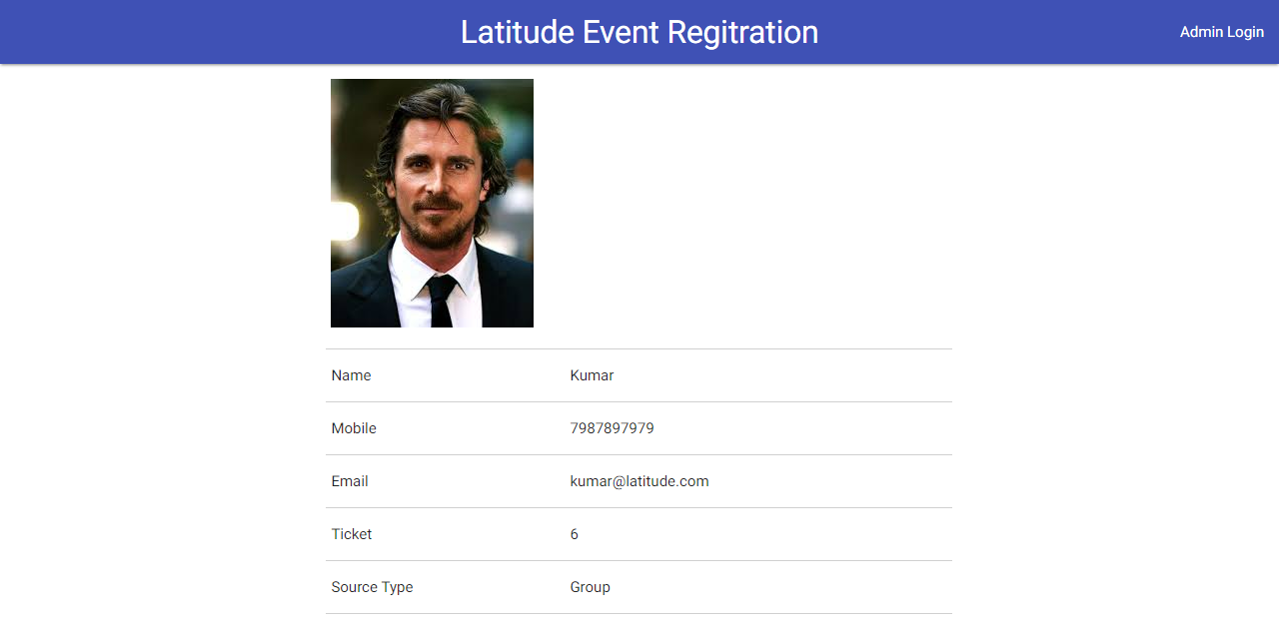

<http://localhost:8000/save>

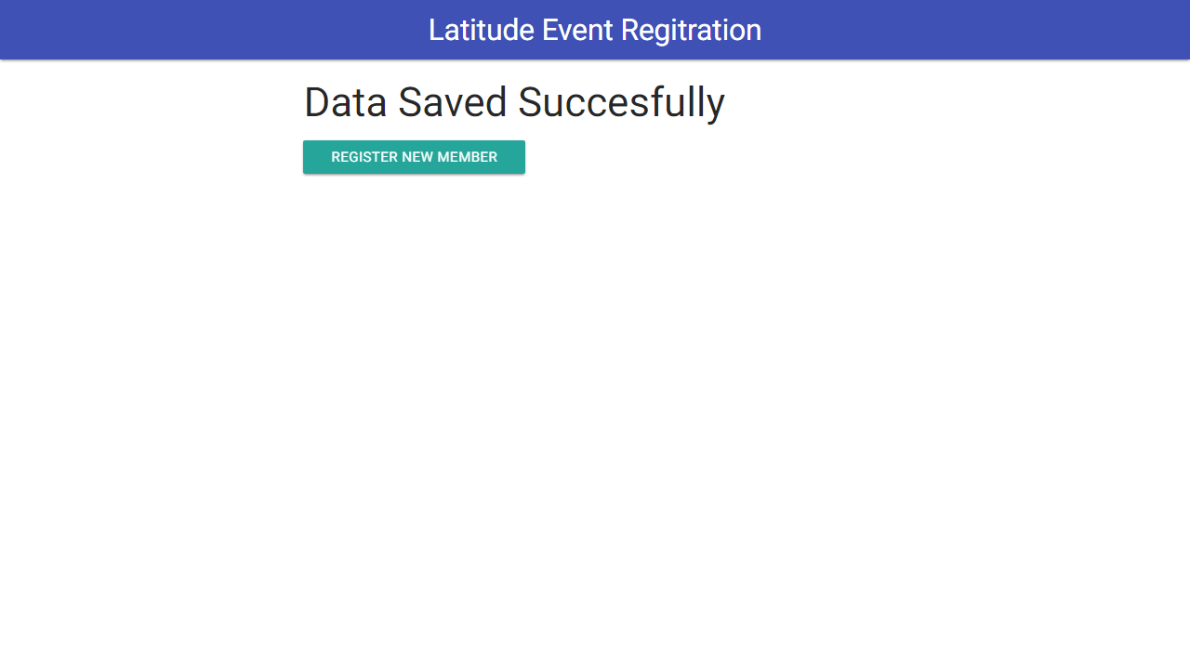

Admin

Summary Page

<http://localhost:8000/summary>

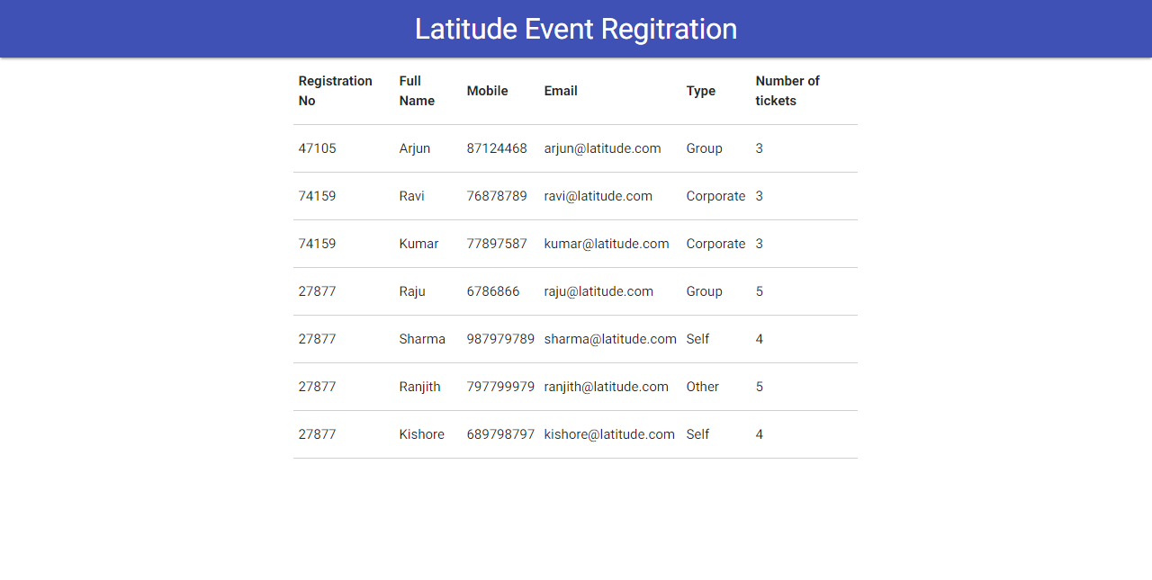

<http://localhost:8000/chart>

