**LAWEASY**

**A Project Report**

***Submitted by:***

**Hit Desai (17162111001)**

**Mukund Prajapati (17162111005)**

**Jayesh Desai (17162111002)**

**Jigar Desai (17162111003)**

***in partial fulfillment for the Application Development Project (SEM-IV)***

***of***

**BACHELOR OF TECHNOLOGY**

**IN**

**COMPUTER SCIENCE AND ENGINEERING (CBA)**

**at**



**2018-2019**

**DECLARATION**

I hereby declare that the project entitled “LAWEASY” submitted for the B. Tech. CSE (MA) Application Development Project is my original work.

**Hit Desai**

**Signature of the Student**

**Place: Ganpat University ICT, Ahmedabad**

**Date: 30th April, 2019**

**DECLARATION**

I hereby declare that the project entitled “LAWEASY” submitted for the B. Tech. CSE (MA) Application Development Project is my original work.

**Mukund Prajapati**

**Signature of the Student**

**Place: Ganpat University ICT, Ahmedabad**

**Date: 30th April, 2019**

**DECLARATION**

I hereby declare that the project entitled “LAWEASY” submitted for the B. Tech. CSE (MA) Application Development Project is my original work.

**Jayesh Desai**

**Signature of the Student**

**Place: Ganpat University ICT, Ahmedabad**

**Date: 30th April, 2019**

**DECLARATION**

I hereby declare that the project entitled “LAWEASY” submitted for the B. Tech. CSE (MA) Application Development Project is my original work.

**Jigar Desai**

**Signature of the Student**

**Place: Ganpat University ICT, Ahmedabad**

**Date: 30th April, 2019**

**CERTIFICATE**

This is to certify that the project titled “LAWEASY” submitted by ***Hit Desai (17162111001)*** of B Tech (CSE)-SEM IV of MA from Institute of Computer Technology, Ganpat University during the academic year 2018-19, in partial fulfillment of the requirements for the Application Development project work.

**Signature of the Guide**

**Place: Ganpat University ICT, Ahmedabad**

**Date: 30th April, 2019**

**CERTIFICATE**

This is to certify that the project titled “LAWEASY” submitted by ***Mukund Prajapati (17162111005)*** of B Tech (CSE)-SEM IV of MA from Institute of Computer Technology, Ganpat University during the academic year 2018-19, in partial fulfillment of the requirements for the Application Development project work.

**Signature of the Guide**

**Place: Ganpat University ICT, Ahmedabad**

**Date: 30th April, 2019**

**CERTIFICATE**

This is to certify that the project titled “LAWEASY” submitted by ***Jayesh Desai (17162111002)*** of B Tech (CSE)-SEM IV of MA from Institute of Computer Technology, Ganpat University during the academic year 2018-19, in partial fulfillment of the requirements for the Application Development project work.

**Signature of the Guide**

**Place: Ganpat University ICT, Ahmedabad**

**Date: 30th April, 2019**

**CERTIFICATE**

This is to certify that the project titled “LAWEASY” submitted by ***Jigar Desai (17162111003)*** of B Tech (CSE)-SEM IV of MA from Institute of Computer Technology, Ganpat University during the academic year 2018-19, in partial fulfillment of the requirements for the Application Development project work.

**Signature of the Guide**

**Place: Ganpat University ICT, Ahmedabad**

**Date: 30th April, 2019**

**Table of Contents**

Content Page

* Title Page ……………………………………………………………………………………………..1
* Declaration of Student …………………………………………………………………………..........2
* Certificate of the Guide ………………………………………………………………………………5
* Acknowledgement …………………………………………………………………………………...11
* Abstract …………………………………………………………………………………………........12
* Introduction …………………………………………………………………………………………..13
  1. Problem Definition …………………………………………………………………………...13

1.2 Project Overview ……………………………………………………………………………..13

1.3 Hardware Specification ………………………………………………………………………13

1.4 Software Specification ……………………………………………………………………….13

* Requirement Analysis ………………………………………………………………………………..14

* Eliciting Requirement ………………………………………………………………………..14

* System Analysis and Design …………………………………………………………………………14

3.1 Requirement Specification …………………………………………………………………...14

3.2 Flowcharts …………………………………………………………………...15

3.3 Design and Test Steps / Criteria ……………………………………………………………...16

3.4 Algorithms and Pseudo Code ………………………………………………………………...16

3.5 Testing Process ……………………………………………………………………………….16

* Results/Output ………………………………………………………………………………………..17
* Conclusions …………………………………………………………………………………………..19
* References ……………………………………………………………………………………………20

**Acknowledgement**

This research was supported by ***Institute of Computer Technology***. We thank our professors and guides who provided insight and guidance that greatly assisted the project.

We thank ***Prof. Nidhi Thacker*** and ***Prof. Angshuman Chatterjee*** for assistance with definition selection and selection of technology to use in project.

We would also like to show our gratitude to the faculties for sharing their pearls of wisdom with us during the course of this project work. We are also greatful to the faculties for encouraging us to learn a new technology and implement its knowledge in our project.

**Abstract**

Laweasy is a legal service portal, which helps user to connect with lawyers easily.

User can ask question to lawyers which are answered by mail, they can book an appointment to meet lawyer and can also get quotations online. Laweasy helps user to get best lawyers nearby their area and specialist in the particular field which they want.

Laweasy also provides details about Indian constitution and IPC. It also lets you know the best lawyers in the field.

**INTRODUCTION**

* 1. **Problem Definition**

Most of people are not aware of law and they have to book appointments for problems which are too simple. It is hard for common man to find affordable lawyer who is special in their particular problem field.

* 1. **Project Overview**

Laweasy is a website that aims to serve purpose of provide lawyer solutions online and ofline both way. Users can ask questions according to their particular problem field, they can find lawyers near their location a d they can get their quotation online also. So people do not have to go one office to another office finding their appropriate lawyer they can find them using laweasy hassle free way.

* 1. **Hardware Specifications**

Minimum:

* Processor: Dual-Core
* 4 GB RAM
* 20 GB Disk Memory
* Intel Graphics

Maximum:

* Processor: Octa-Core
* 6-8 GB RAM
* 50 GB ROM
* Intel Graphics
  1. **Software Specification**

Required Software for Users:

* Windows XP,7,8,10 OS
* Google Chrome/Firefox/Other Browsers

Used Software for Project:

* Xampp Server
* Google Chrome/Firefox Browser
* SQL 2008 Database System
* GitHub for Code Sharing
* Trello for team communication

**REQUIREMENT ANALYSIS**

**2.1 Eliciting Requirements**

Laweasy is a lawyer finding platform. The user can fill up the form if it has question to ask. According to user specifications we can find appropriate lawyer who will reply the E-mail.

If a user wants to find a lawyer or read a quotation he/she needs to submit all information about the query so we can provide information based on that.

**SYSTEM ANALYSIS & DESIGN**

**3.1** **Requirement Specification**

The requirement for this project is listed below;

* Hardware Requirements

-Dual Core Processor

-4 GB RAM

-20 GB Disk Memory

* Software Requirements

-Windows XP,7,8,10 or LINUX

- Xampp/Wampp Server

-PhpMyAdmin

-Google Chrome/Mozilla Firefox/Other browser

-SQL 2008 Database System or later versions

* Technology Used

-PHP

-HTML5

-Javascript

-CSS

**Xampp/Wamp Server**: It is an application which provides the facility of local server on a computer system which provides server environment for websites to run on local systems. This local servers are used as a website can be tested well on a server and a developer cannot put a website that is underdevelopment on an actual server.

Xampp/Wamp server in this project helps to run the PHP coded pages on local server along with other codes.

**SQL 2008 Database System**: This is a SQL (Structured Query Language) system with 2008 version and is used for database connections.

**PhpMyAdmin:** PhpMyAdmin is an application (browser application) and is used for database connection. We have used this application for database connection in our project. This is an local server based application which can be accessed by installing Xampp/Wamp server application on your system.

**3.2** **Flowcharts**

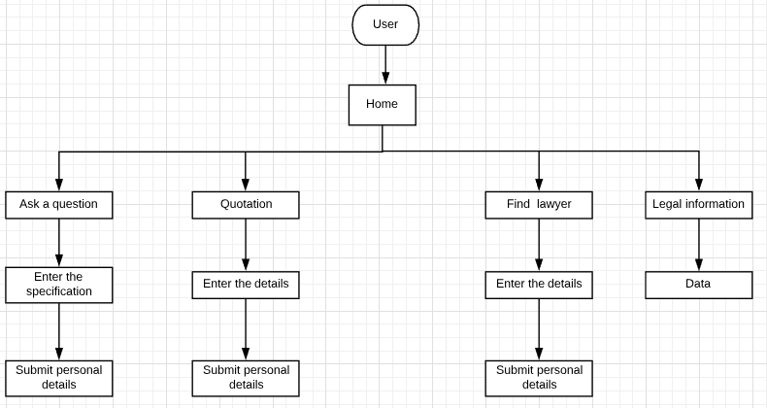

**3.3 Design and Test Steps**

Step1: Open (Initialize) the website by opening the home page file i.e index.php file

Step2: Now for homepage user can redirect to the different pages, which are – Registration Page, Sign-In Page and Contact Us Page.

Step3: After user is on homepage he can select the options for finding lawyer, asking questions etc.

Step4: User will receive the mail according to his/her actions

**3.4 Algorithm and Pseudo Code**

Every functionality of the website has an algorithm.

For database connection: 1.) Connection is established when the application is started.

2.) When data-fields are filled the data is inserted to database based on the type of data to the corresponding database table.

3.) When data is to displayed in the text-fields the data is requested from the database from the database table based on type of data for specific conditions by firing query in methods created.

Pseudo Code for Database connection:

<?php

$servername = "localhost";

$username = "root";

$password = "";

$database = "Laweasy";

if($con -> connect_error)

{

die("Connection falied" . $con->connect_error);

}

?>

**3.5 Testing Process**

We haven’t provided the application to various users for testing but the website has been tested in lab sessions by the respective faculties and by the developers. The website has not been hosted on web servers

**RESULTS/OUTPUTS**

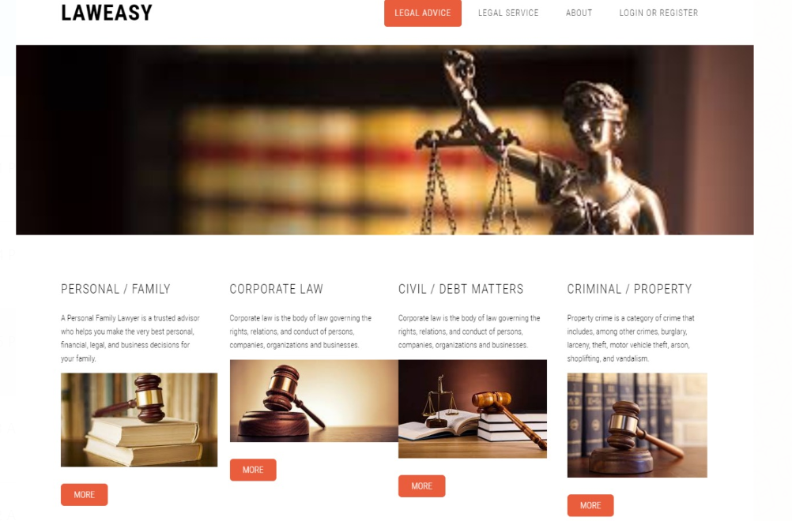

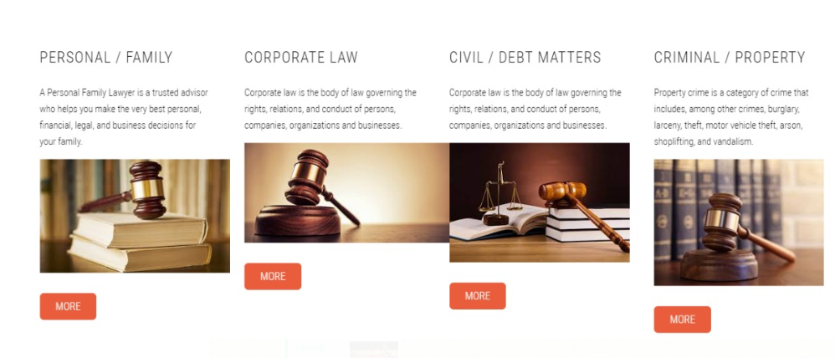

**Conclusion**

LAW EASY is a website which makes law complications easy for user.

**References**

* Stack Overflow
* GeeksForGeeks
* YouTube
* Wikipedia
* Tutorials Point
* Github