

**IBM CAREER EDUCATION**

**MAIN PROJECT**

**DOMAIN NAME: JAVA**



**IMAGE PUZZLE GAME**

**Submitted By,**

Vedant Patel(18162171019)

II Year – (CS) ‘A’ Section Ganpat University, Ahmedabad.

**Submitted To,**

A. Saai Sanjeev Achaarya

IBM Software Technical Trainer

**FLOWCHART**

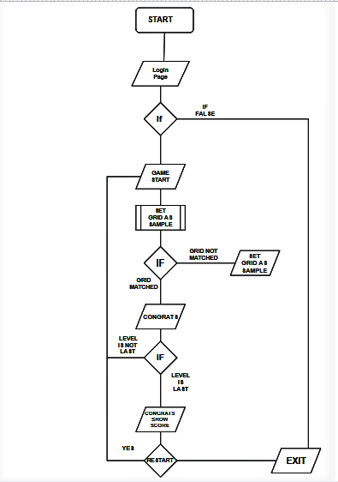

# SOFTWARE SPECIFICATIONS

* OPERATING SYSTEM : Linux / Windows / IOS
* ENVIRONMENT : IBM RAD Software
* JAVA VERSION : JAVA 8

# HARDWARE SPECIFICATIONS

|  |  |  |
| --- | --- | --- |
| ➢ PROCESSOR | : | INTEL i3 @2.30Ghz |
| ➢ RAM | : | 8GB DDR4 |
| ➢ MONITOR | : | 15” COLOR |
| ➢ HARD DISK | : | 1 TB |
| ➢ FLOPPY DRIVE | : | * 1. B |

**INTRODUCTION:**

A puzzle is a game, problem, or toy that tests a person's ingenuity or knowledge. In a puzzle, the solver is expected to put pieces together in a logical way, in order to arrive at the correct or fun solution of the puzzle. There are different genres of puzzles, such as crossword puzzles, word-search puzzles, number puzzles, relational puzzles, or logic puzzles.

**DESCRIPTION:**

The main theme behind developing puzzle game using java is to provide a creative and competitive environment for the players who will use this system and where they can test their image identifying skills, IQ and logic to solve puzzles.

**PROS:**

* Develops IQ of a person to identify different image.
* **Improves problem solving skills.**
* **Improves your attention**
* **Harnesses brain power**
* **Memory improvement**

**CONS:**

* Addiction.
* Time-consuming.
* Distraction.
* Can lead to unbalanced lifestyle
* Responsibility shirking
* Can lead to anxiety

IMAGE PUZZLE GAME

# PICTURES

LOGIN:-



Login page to game

GAME:-

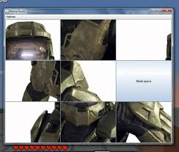

Playing game

SCORECARD:-



Scoreboard

IMAGE PUZZLE GAME

**AIM:**

### To create a picture puzzle game which:-

1. **Has a login page**
2. **Have multiple levels**
3. **Show score**

**PROGRAM:**

import java.awt.event.*;

import java.text.*;

import java.awt.*;

import javax.swing.*;

import java.lang.*;

class picpuzzle3 extends JFrame implements ActionListener{

JButton b1,b2,b3,b4,b5,b6,b7,b8,b9,sample,starB,submit,vb1,vb2,vb3,vb4,vb5,vb6,vb7,vb8,vb9;

Icon star;

Icon ic0=new ImageIcon("pic/starB0.jpg");

Icon ic10=new ImageIcon("pic/starB10.jpg"); //for icons

Icon ic20=new ImageIcon("pic/starB20.jpg");

Icon samicon1=new ImageIcon("pic/main.jpg"); //for sample pic

Icon samicon2=new ImageIcon("pic/main2.jpg");

Icon samicon3=new ImageIcon("pic/main3.jpg");

Icon veri1=new ImageIcon("pic/1.jpg");

Icon veri2=new ImageIcon("pic/2.jpg");

Icon veri3=new ImageIcon("pic/3.jpg");

Icon veri4=new ImageIcon("pic/4.jpg");

Icon veri5=new ImageIcon("pic/5.jpg");

Icon veri6=new ImageIcon("pic/6.jpg");

Icon veri7=new ImageIcon("pic/7.jpg");

Icon veri8=new ImageIcon("pic/8.jpg");

Icon veri9=new ImageIcon("pic/9.jpg");

Icon veri11=new ImageIcon("pic/11.jpg");

Icon veri12=new ImageIcon("pic/12.jpg");

Icon veri13=new ImageIcon("pic/13.jpg");

Icon veri14=new ImageIcon("pic/14.jpg");

Icon veri15=new ImageIcon("pic/15.jpg");

Icon veri16=new ImageIcon("pic/16.jpg");

Icon veri17=new ImageIcon("pic/17.jpg");

Icon veri18=new ImageIcon("pic/18.jpg");

Icon veri19=new ImageIcon("pic/19.jpg");

Icon veri21=new ImageIcon("pic/21.jpg");

Icon veri22=new ImageIcon("pic/22.jpg");

Icon veri23=new ImageIcon("pic/23.jpg");

Icon veri24=new ImageIcon("pic/24.jpg");

Icon veri25=new ImageIcon("pic/25.jpg");

Icon veri26=new ImageIcon("pic/26.jpg");

Icon veri27=new ImageIcon("pic/27.jpg");

Icon veri28=new ImageIcon("pic/28.jpg");

Icon veri29=new ImageIcon("pic/29.jpg");

Icon ic1=new ImageIcon("pic/1.jpg");

Icon ic2=new ImageIcon("pic/5.jpg");

Icon ic3=new ImageIcon("pic/2.jpg");

Icon ic4=new ImageIcon("pic/7.jpg");

Icon ic5=new ImageIcon("pic/4.jpg");

Icon ic6=new ImageIcon("pic/6.jpg"); //pictures to insert

Icon ic7=new ImageIcon("pic/8.jpg");

Icon ic8=new ImageIcon("pic/9.jpg");

Icon ic9=new ImageIcon("pic/3.jpg");

Icon ic11=new ImageIcon("pic/12.jpg");

Icon ic12=new ImageIcon("pic/13.jpg");

Icon ic13=new ImageIcon("pic/16.jpg");

Icon ic14=new ImageIcon("pic/11.jpg");

Icon ic15=new ImageIcon("pic/14.jpg");

Icon ic16=new ImageIcon("pic/19.jpg");

Icon ic17=new ImageIcon("pic/17.jpg");

Icon ic18=new ImageIcon("pic/15.jpg");

Icon ic19=new ImageIcon("pic/18.jpg");

Icon ic21=new ImageIcon("pic/24.jpg");

Icon ic22=new ImageIcon("pic/25.jpg");

Icon ic23=new ImageIcon("pic/21.jpg");

Icon ic24=new ImageIcon("pic/27.jpg");

Icon ic25=new ImageIcon("pic/23.jpg");

Icon ic26=new ImageIcon("pic/29.jpg");

Icon ic27=new ImageIcon("pic/28.jpg");

Icon ic28=new ImageIcon("pic/22.jpg");

Icon ic29=new ImageIcon("pic/26.jpg");

Icon Submit=new ImageIcon("pic/submit_button1.gif");

int i=60;

picpuzzle3(){

super("Picture Puzzle Game by PuzzleKings");

b1=new JButton(ic1);

b1.setBounds(10,80,100,100);

b2=new JButton(ic2);

b2.setBounds(110,80,100,100);

b3=new JButton(ic3);

b3.setBounds(210,80,100,100);

b4=new JButton(ic4);

b4.setBounds(10,180,100,100);

b5=new JButton(ic5);

b5.setBounds(110,180,100,100);

b6=new JButton(ic6);

b6.setBounds(210,180,100,100);

b7=new JButton(ic7);

b7.setBounds(10,280,100,100);

b8=new JButton(ic8);

b8.setBounds(110,280,100,100);

submit=new JButton(Submit);

submit.setBounds(260,400,200,50);

b9=new JButton(ic9);

b9.setBounds(210,280,100,100);

sample=new JButton(samicon1);

sample.setBounds(380,100,200,200);

vb1=new JButton(veri1);

vb2=new JButton(veri2);

vb3=new JButton(veri3);

vb4=new JButton(veri4);

vb5=new JButton(veri5);

vb6=new JButton(veri6);

vb7=new JButton(veri7);

vb8=new JButton(veri8);

vb9=new JButton(veri9);

JLabel l2=new JLabel("Hint:Click one pic then enter position to swap");

l2.setBounds(5,15,500,20);

JLabel l3=new JLabel("Acutal Image");

l3.setBounds(425,320,200,20);

l3.setForeground(Color.red);

starB=new JButton(ic0);

starB.setBounds(330,5,50,50);

star=b9.getIcon();

add(b1);add(b2);add(b3);add(b4);add(b5);add(b6);add(b7);add(b8);add(b9);add(sample);add(l2);add(l3);add(submit);

b1.addActionListener(this); b2.addActionListener(this); b3.addActionListener(this); b4.addActionListener(this); b5.addActionListener(this); b6.addActionListener(this); b7.addActionListener(this); b8.addActionListener(this); b9.addActionListener(this);

sample.addActionListener(this);submit.addActionListener(this);

setLayout(null);

setSize(600,500);

setVisible(true);

setDefaultCloseOperation(JFrame.EXIT_ON_CLOSE);

}

int lvl=1;

int score=0;

public void actionPerformed(ActionEvent e)

{

if(e.getSource()==b1)

{

Icon s=b1.getIcon();

JFrame frame = new JFrame();

Object result = JOptionPane.showInputDialog(frame, "Enter piece number:");

if(result.equals("2"))

{

Icon s1=b2.getIcon();

b2.setIcon(s);

b1.setIcon(s1);

}

else if(result.equals("3"))

{

Icon s1=b3.getIcon();

b3.setIcon(s);

b1.setIcon(s1);

}

else if(result.equals("4"))

{

Icon s1=b4.getIcon();

b4.setIcon(s);

b1.setIcon(s1);

}

else if(result.equals("5"))

{

Icon s1=b5.getIcon();

b5.setIcon(s);

b1.setIcon(s1);

}

else if(result.equals("6"))

{

Icon s1=b6.getIcon();

b6.setIcon(s);

b1.setIcon(s1);

}

else if(result.equals("7"))

{

Icon s1=b7.getIcon();

b7.setIcon(s);

b1.setIcon(s1);

}

else if(result.equals("8"))

{

Icon s1=b8.getIcon();

b8.setIcon(s);

b1.setIcon(s1);

}

else if(result.equals("9"))

{

Icon s1=b9.getIcon();

b9.setIcon(s);

b1.setIcon(s1);

}

}

else if(e.getSource()==b2)

{

Icon s=b2.getIcon();

JFrame frame = new JFrame();

Object result = JOptionPane.showInputDialog(frame, "Enter piece number:");

if(result.equals("1"))

{

Icon s1=b1.getIcon();

b1.setIcon(s);

b2.setIcon(s1);

}

else if(result.equals("3"))

{

Icon s1=b3.getIcon();

b3.setIcon(s);

b2.setIcon(s1);

}

else if(result.equals("4"))

{

Icon s1=b4.getIcon();

b4.setIcon(s);

b2.setIcon(s1);

}

else if(result.equals("5"))

{

Icon s1=b5.getIcon();

b5.setIcon(s);

b2.setIcon(s1);

}

else if(result.equals("6"))

{

Icon s1=b6.getIcon();

b6.setIcon(s);

b2.setIcon(s1);

}

else if(result.equals("7"))

{

Icon s1=b7.getIcon();

b7.setIcon(s);

b2.setIcon(s1);

}

else if(result.equals("8")) //for button 2 from top

{

Icon s1=b8.getIcon();

b8.setIcon(s);

b2.setIcon(s1);

}

else if(result.equals("9"))

{

Icon s1=b9.getIcon();

b9.setIcon(s);

b2.setIcon(s1);

}

}

else if(e.getSource()==b3)

{

Icon s=b3.getIcon();

JFrame frame = new JFrame();

Object result = JOptionPane.showInputDialog(frame, "Enter piece number:");

if(result.equals("1"))

{

Icon s1=b1.getIcon();

b1.setIcon(s);

b3.setIcon(s1);

}

else if(result.equals("2"))

{

Icon s1=b2.getIcon();

b2.setIcon(s); //for button 3 from top

b3.setIcon(s1);

}

else if(result.equals("4"))

{

Icon s1=b4.getIcon();

b4.setIcon(s);

b3.setIcon(s1);

}

else if(result.equals("5"))

{

Icon s1=b5.getIcon();

b5.setIcon(s);

b3.setIcon(s1);

}

else if(result.equals("6"))

{

Icon s1=b6.getIcon();

b6.setIcon(s);

b3.setIcon(s1);

}

else if(result.equals("7"))

{

Icon s1=b7.getIcon();

b7.setIcon(s);

b3.setIcon(s1);

}

else if(result.equals("8"))

{

Icon s1=b8.getIcon();

b8.setIcon(s);

b3.setIcon(s1);

}

else if(result.equals("9"))

{

Icon s1=b9.getIcon();

b9.setIcon(s);

b3.setIcon(s1);

}

}

else if(e.getSource()==b4)

{

Icon s=b4.getIcon();

JFrame frame = new JFrame();

Object result = JOptionPane.showInputDialog(frame, "Enter piece number:");

if(result.equals("1"))

{

Icon s1=b1.getIcon();

b1.setIcon(s);

b4.setIcon(s1);

}

else if(result.equals("2"))

{

Icon s1=b2.getIcon();

b2.setIcon(s);

b4.setIcon(s1);

}

else if(result.equals("3"))

{

Icon s1=b3.getIcon();

b3.setIcon(s);

b4.setIcon(s1);

}

else if(result.equals("5"))

{

Icon s1=b5.getIcon();

b5.setIcon(s);

b4.setIcon(s1);

}

else if(result.equals("6"))

{

Icon s1=b6.getIcon();

b6.setIcon(s);

b4.setIcon(s1); //for button 4 from top

}

else if(result.equals("7"))

{

Icon s1=b7.getIcon();

b7.setIcon(s);

b4.setIcon(s1);

}

else if(result.equals("8"))

{

Icon s1=b8.getIcon();

b8.setIcon(s);

b4.setIcon(s1);

}

else if(result.equals("9"))

{

Icon s1=b9.getIcon();

b9.setIcon(s);

b4.setIcon(s1);

}

}

else if(e.getSource()==b5)

{

Icon s=b5.getIcon();

JFrame frame = new JFrame();

Object result = JOptionPane.showInputDialog(frame, "Enter piece number:");

if(result.equals("1"))

{

Icon s1=b1.getIcon();

b1.setIcon(s);

b5.setIcon(s1);

}

else if(result.equals("2"))

{

Icon s1=b2.getIcon();

b2.setIcon(s);

b5.setIcon(s1);

}

else if(result.equals("3"))

{

Icon s1=b3.getIcon();

b3.setIcon(s);

b5.setIcon(s1);

}

else if(result.equals("4"))

{

Icon s1=b4.getIcon();

b4.setIcon(s);

b5.setIcon(s1);

}

else if(result.equals("6"))

{

Icon s1=b6.getIcon();

b6.setIcon(s);

b5.setIcon(s1);

} //for button 5 from top

else if(result.equals("7"))

{

Icon s1=b7.getIcon();

b7.setIcon(s);

b5.setIcon(s1);

}

else if(result.equals("8"))

{

Icon s1=b8.getIcon();

b8.setIcon(s);

b5.setIcon(s1);

}

else if(result.equals("9"))

{

Icon s1=b9.getIcon();

b9.setIcon(s);

b5.setIcon(s1);

}

}

else if(e.getSource()==b6)

{

Icon s=b6.getIcon();

JFrame frame = new JFrame();

Object result = JOptionPane.showInputDialog(frame, "Enter piece number:");

if(result.equals("1"))

{

Icon s1=b1.getIcon();

b1.setIcon(s);

b6.setIcon(s1);

}

else if(result.equals("2"))

{

Icon s1=b2.getIcon();

b2.setIcon(s);

b6.setIcon(s1);

}

else if(result.equals("3"))

{

Icon s1=b3.getIcon();

b3.setIcon(s);

b6.setIcon(s1);

}

else if(result.equals("4"))

{

Icon s1=b4.getIcon();

b4.setIcon(s);

b6.setIcon(s1);

}

else if(result.equals("5"))

{

Icon s1=b5.getIcon();

b5.setIcon(s); //for button 6 ffrom top

b6.setIcon(s1);

}

else if(result.equals("7"))

{

Icon s1=b7.getIcon();

b7.setIcon(s);

b6.setIcon(s1);

}

else if(result.equals("8"))

{

Icon s1=b8.getIcon();

b8.setIcon(s);

b6.setIcon(s1);

}

else if(result.equals("9"))

{

Icon s1=b9.getIcon();

b9.setIcon(s);

b6.setIcon(s1);

}

}

else if(e.getSource()==b7)

{

Icon s=b7.getIcon();

JFrame frame = new JFrame();

Object result = JOptionPane.showInputDialog(frame, "Enter piece number:");

if(result.equals("1"))

{

Icon s1=b1.getIcon();

b1.setIcon(s);

b7.setIcon(s1);

}

else if(result.equals("2"))

{

Icon s1=b2.getIcon();

b2.setIcon(s);

b7.setIcon(s1);

}

else if(result.equals("3"))

{

Icon s1=b3.getIcon();

b3.setIcon(s);

b7.setIcon(s1);

}

else if(result.equals("4"))

{

Icon s1=b4.getIcon();

b4.setIcon(s);

b7.setIcon(s1);

}

else if(result.equals("5"))

{

Icon s1=b5.getIcon();

b5.setIcon(s);

b7.setIcon(s1);

}

else if(result.equals("6"))

{

Icon s1=b6.getIcon();

b6.setIcon(s); //for button 7 from top

b7.setIcon(s1);

}

else if(result.equals("8"))

{

Icon s1=b8.getIcon();

b8.setIcon(s);

b7.setIcon(s1);

}

else if(result.equals("9"))

{

Icon s1=b9.getIcon();

b9.setIcon(s);

b7.setIcon(s1);

}

}

else if(e.getSource()==b8)

{

Icon s=b8.getIcon();

JFrame frame = new JFrame();

Object result = JOptionPane.showInputDialog(frame, "Enter piece number:");

if(result.equals("1"))

{

Icon s1=b1.getIcon();

b1.setIcon(s);

b8.setIcon(s1);

}

else if(result.equals("2"))

{

Icon s1=b2.getIcon();

b2.setIcon(s);

b8.setIcon(s1);

}

else if(result.equals("3"))

{

Icon s1=b3.getIcon();

b3.setIcon(s);

b8.setIcon(s1);

}

else if(result.equals("4"))

{

Icon s1=b4.getIcon();

b4.setIcon(s);

b8.setIcon(s1);

}

else if(result.equals("5"))

{

Icon s1=b5.getIcon();

b5.setIcon(s);

b8.setIcon(s1);

}

else if(result.equals("6"))

{

Icon s1=b6.getIcon();

b6.setIcon(s);

b8.setIcon(s1); //for button 8 for top

}

else if(result.equals("7"))

{

Icon s1=b7.getIcon();

b7.setIcon(s);

b8.setIcon(s1);

}

else if(result.equals("9"))

{

Icon s1=b9.getIcon();

b9.setIcon(s);

b8.setIcon(s1);

}

}

else if(e.getSource()==b9)

{

Icon s=b9.getIcon();

JFrame frame = new JFrame();

Object result = JOptionPane.showInputDialog(frame, "Enter piece number:");

if(result.equals("1"))

{

Icon s1=b1.getIcon();

b1.setIcon(s);

b9.setIcon(s1);

}

else if(result.equals("2"))

{

Icon s1=b2.getIcon();

b2.setIcon(s);

b9.setIcon(s1);

}

else if(result.equals("3"))

{

Icon s1=b3.getIcon();

b3.setIcon(s);

b9.setIcon(s1);

}

else if(result.equals("4"))

{

Icon s1=b4.getIcon();

b4.setIcon(s);

b9.setIcon(s1);

}

else if(result.equals("5"))

{

Icon s1=b5.getIcon();

b5.setIcon(s);

b9.setIcon(s1);

}

else if(result.equals("6"))

{

Icon s1=b6.getIcon();

b6.setIcon(s); //for button 9 from top

b9.setIcon(s1);

}

else if(result.equals("7"))

{

Icon s1=b7.getIcon();

b7.setIcon(s);

b9.setIcon(s1);

}

else if(result.equals("8"))

{

Icon s1=b8.getIcon();

b8.setIcon(s);

b9.setIcon(s1);

}

}

else if(e.getSource()==submit)

{

if((b1.getIcon().toString().equals(vb1.getIcon().toString()))==true&&(b2.getIcon().toString().equals(vb2.getIcon().toString()))==true&&(b3.getIcon().toString().equals(vb3.getIcon().toString()))==true&&(b4.getIcon().toString().equals(vb4.getIcon().toString()))==true&&(b5.getIcon().toString().equals(vb5.getIcon().toString()))==true&&(b6.getIcon().toString().equals(vb6.getIcon().toString()))==true&&(b7.getIcon().toString().equals(vb7.getIcon().toString()))==true&&(b8.getIcon().toString().equals(vb8.getIcon().toString()))==true&&(b9.getIcon().toString().equals(vb9.getIcon().toString()))==true)

{

lvl=lvl+1;

score=score+25;

JOptionPane.showMessageDialog(null,"CONGRAGULATIONS! Your Score is "+score);

if(lvl==2)

{

sample.setIcon(samicon2);

b1.setIcon(ic11);

b2.setIcon(ic12);

b3.setIcon(ic13);

b4.setIcon(ic14);

b5.setIcon(ic15);

b6.setIcon(ic16);

b7.setIcon(ic17);

b8.setIcon(ic18);

b9.setIcon(ic19);

star=b6.getIcon();

starB.setIcon(ic10);

vb1.setIcon(veri11);

vb2.setIcon(veri12);

vb3.setIcon(veri13);

vb4.setIcon(veri14);

vb5.setIcon(veri15);

vb6.setIcon(veri16);

vb7.setIcon(veri17);

vb8.setIcon(veri18);

vb9.setIcon(veri19);

}

else if(lvl==3){

sample.setIcon(samicon3);

b1.setIcon(ic21);

b2.setIcon(ic22);

b3.setIcon(ic23);

b4.setIcon(ic24);

b5.setIcon(ic25);

b6.setIcon(ic26);

b7.setIcon(ic27);

b8.setIcon(ic28);

b9.setIcon(ic29);

star=b6.getIcon();

starB.setIcon(ic20);

vb1.setIcon(veri21);

vb2.setIcon(veri22);

vb3.setIcon(veri23);

vb4.setIcon(veri24);

vb5.setIcon(veri25);

vb6.setIcon(veri26);

vb7.setIcon(veri27);

vb8.setIcon(veri28);

vb9.setIcon(veri29);

}

else

{

Object[] msg = {

};

int option2 = JOptionPane.showConfirmDialog(null, msg,"Restart", JOptionPane.OK_CANCEL_OPTION);

if (option2 == JOptionPane.OK_OPTION) {

new picpuzzle3();

}

else

{

System.exit(0);

}

}

}

else{

JOptionPane.showMessageDialog(null,"FAIL : ");

score=score-5;

}

}

}//end of actionPerformed

public static void main(String s[])

{

JTextField username = new JTextField();

JTextField password = new JPasswordField();

Object[] message = {

"Username:", username,

"Password:", password

};

int option = JOptionPane.showConfirmDialog(null, message, "Login", JOptionPane.OK_CANCEL_OPTION);

if (option == JOptionPane.OK_OPTION) {

try{

if (username.getText().isEmpty() && password.getText().isEmpty()) {

JOptionPane.showMessageDialog(null,"Login Fail");

System.exit(0);

} else {

JOptionPane.showMessageDialog(null,"Login Success");

}

}catch(NullPointerException l){}

} else {

System.exit(0);

}

new picpuzzle3();

}

}

**EXPLANATION ABOUT PROJECT:**

1. **To make a Login page in Java**

By making the login page a user can start solving the puzzle and play the game.

If user do not enter anything then login fails and program closes.

1. **Make a level selection page**

By making the level selection the user can start the game according to the level he/she wants to play.

As the user completes a level, a new level comes up.

1. **Make a scoreboard**

By making the scoreboard a user can know the score he/she had scored.

The user get +25 score if he/she successfully completes level in a single try and -5 score if he/she fails to complete the level.

**OUTPUT SCREENSHOTS:**

LOGIN PAGE:-

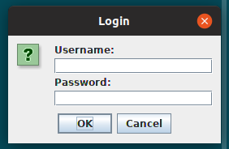

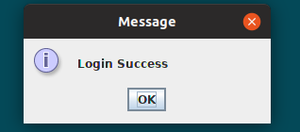

## LEVEL 1:-

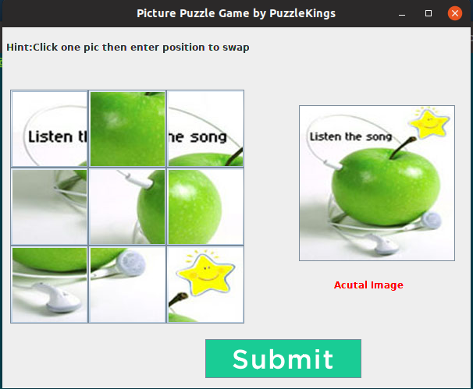

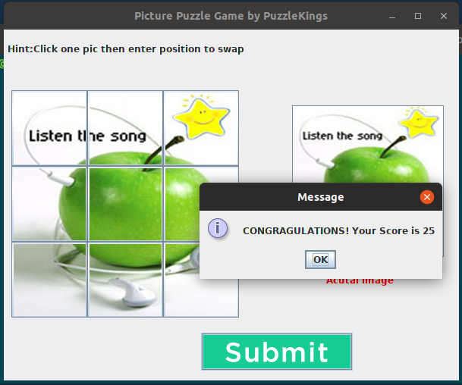

LEVEL 2:-

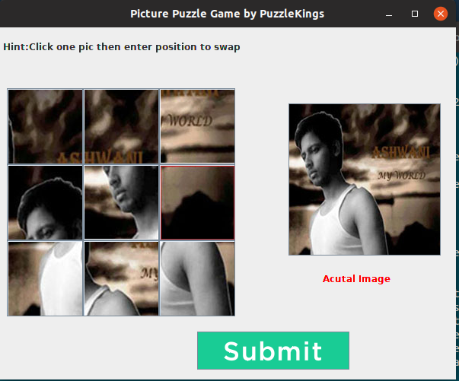

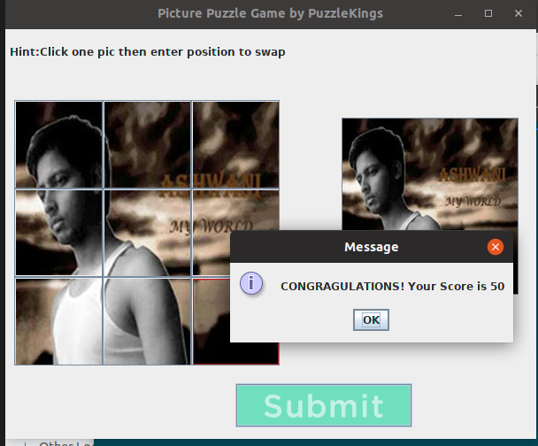

LEVEL 3:-

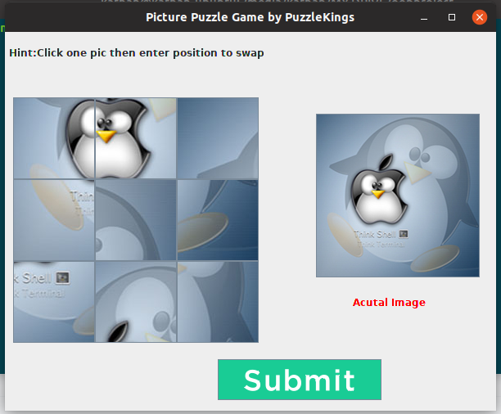

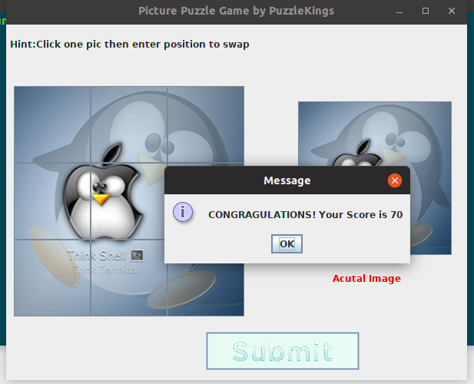

TO RESTART :-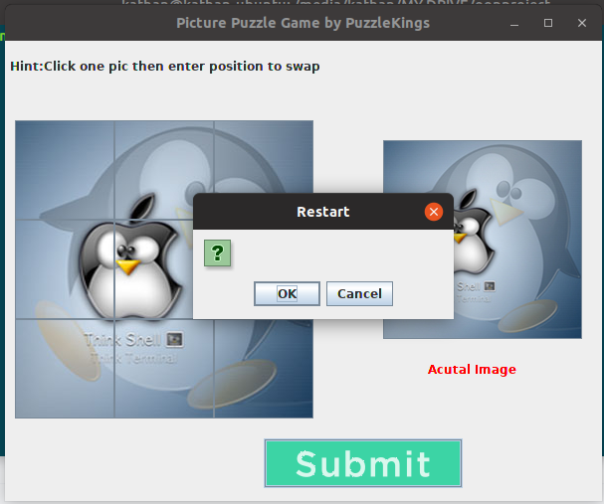

**REFERENCES:**

1. <https://www.javatpoint.com/Pic-Puzzle-Game>
2. <https://en.wikipedia.org/wiki/Puzzle_video_game>
3. <https://www.youtube.com/watch?v=F323mdgscsc>

**CONCLUSION:**

Thus we conclude thatThe main goal of the project was to build a system, which allows the interaction between the system and the canvas.