**IBM CAREER EDUCATION**

**MAIN PROJECT**

**DOMAIN NAME: JAVA**

**E - LEARNING**

SUBMITTED BY :-

Jaspreet Singh Pal (18162121014)

II year – (BDA) ‘B’ Section

Ganpat University, Ahmedabad.

SUBMITTED TO :-

A Saai Sanjeev Achaarya

IBM Software Technical Trainer

**Software Specifications**

* OPERATING SYSTEM : Windows
* ENVIRONMENT : Notepad++

**Flow-charts :-**

**For class books:**

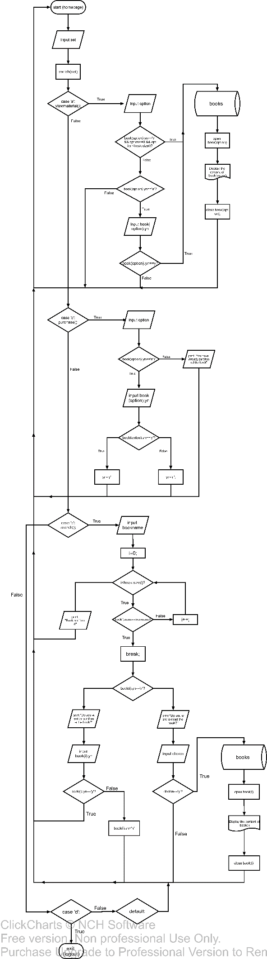

**For class user:**

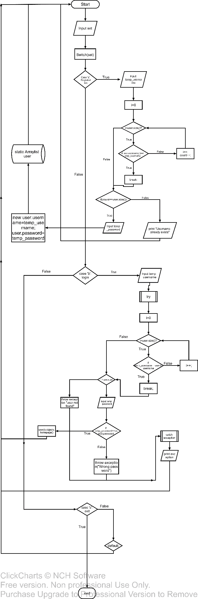

**HARDWARE SPECIFICATIONS**

|  |  |  |
| --- | --- | --- |
| ➢ PROCESSOR | : | Intel core i3 7th gen |
| ➢ RAM | : | 8 GB |
| ➢ MONITOR | : | 15” COLOR |
| ➢ HARD DISK | : | 1 TB |
| ➢ FLOPPY DRIVE | : | 1.44 MB |

# DESCRIPTION

**INTRODUCTION:**

E-Learning is a kind of digital platform where you can actually store and read the book without the book occupying physical space.

**DESCRIPTION:**

It is a kind of system/website where you can purchase, read different types of digital books (also called E-Books). It makes your user account and stores your purchases into the database where you have the access to your purchased books for you to read any of the book.

**ADVANTAGES:**

1. It reduces the physical space where you have to keep all the books in a bookshelf and also the conditions of the physically stored books will tend to degrade as time passes. But in case of E-book, it will remain without bothering about the condition.
2. You have the access of any E-book anywhere weightlessly. (Because some books are too heavy because of length). Because you are only bothered about the weight of the mobile device you are holding.

**DISADVANTAGES:**

* You need to have constant working internet connection in case of some websites/platforms.
* It will only work when the author of the book you are searching for has uploaded digital copy of that book.

**E-Learning Websites**

# PICTURES

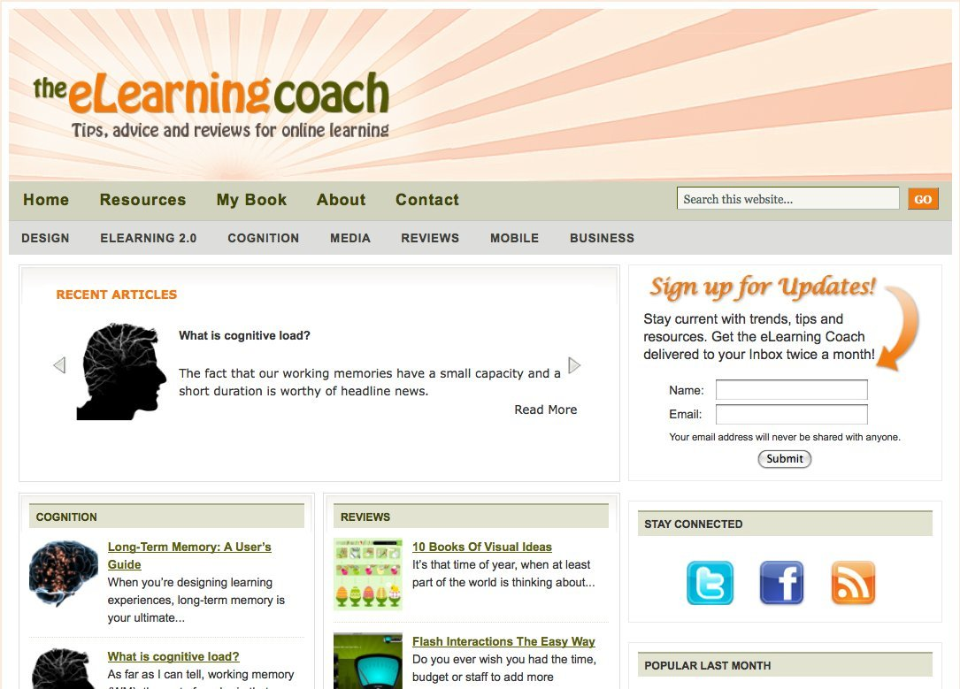

**AIM:**

**To create a computerised E-Learning system which consists of :-**

* **Home Page**
* **Registration Page**
* **Search book**
* **Show the purchased books**
* **View the material**

**PROGRAM:**

**There are 2 modules in the program, 1 is users and 2nd is books.**

1. user.java

import java.io.BufferedReader;

import java.io.BufferedWriter;

import java.io.FileReader;

import java.io.FileWriter;

import java.io.FileNotFoundException;

import java.io.IOException;

import java.util.ArrayList;

import java.util.Scanner;

import Product_classes.books;

class user

{

books objects=new books();

static ArrayList<user> users=new ArrayList<>();

static Scanner sc=new Scanner(System.in);

private String username,password;

static String cat="";

static int push=0;

static boolean iterate=false;

static void getlist()

{

try

{

int i=0;

BufferedReader read_name=new BufferedReader(new FileReader("Database/name.txt"));

BufferedReader read_password=new BufferedReader(new FileReader("Database/password.txt"));

BufferedReader read_yn=new BufferedReader(new FileReader("Database/yn.txt"));

String line,line1,line2,temp_name="admin",temp_password="admin";

char temp_yn='n';

while((line=read_name.readLine())!=null && (line1=read_password.readLine())!=null && (line2=read_yn.readLine())!=null)

{

temp_name=line;

temp_password=line1;

try

{

users.add(new user(temp_name,temp_password));

for(i=0;i<(line2.length());i++)

{

users.get(push).objects.book.get(i).yn=line2.charAt(i);

}

push++;

}

catch(Exception fm)

{

System.out.println("Some users cannot be added because "+fm.getMessage());

}

}

read_name.close();

read_password.close();

}

catch(Exception e)

{

System.out.println(e.getMessage());

}

}

static void setlist(int select)

{

try

{

BufferedWriter write_name=new BufferedWriter(new FileWriter("Database/name.txt",true));

BufferedWriter write_password=new BufferedWriter(new FileWriter("Database/password.txt",true));

write_name.write(users.get(select).getusername());

write_name.append('\n');

write_password.write(users.get(select).getpassword());

write_password.append('\n');

write_name.close();

write_password.close();

}

catch(Exception e)

{

System.out.println(e.getMessage());

}

}

static void writeyn()

{

int i=0,j=0;

try

{

BufferedWriter write_yn=new BufferedWriter(new FileWriter("Database/yn.txt",false));

for(i=0;i<users.size();i++)

{

for(j=0;j<users.get(i).objects.book.size();j++)

{

cat=cat.concat(Character.toString(users.get(i).objects.book.get(j).getyn()));

}

write_yn.write(cat);

write_yn.write('\n');

cat="";

}

write_yn.close();

}

catch(Exception e)

{

System.out.println(e.getMessage());

}

}

public user(String username,String password)

{

setusername(username);

setpassword(password);

}

private void setusername(String username)

{

this.username=username;

}

private String getusername()

{

return username;

}

private void setpassword(String password)

{

this.password=password;

}

private String getpassword()

{

return password;

}

public static void main(String args[])

{

int i=0,count=0,use=-1;

char set;

String temp_username,temp_password;

if(iterate==false)

{

getlist();

iterate=true;

}

System.out.println("+------------------------+\n|Welcome to E-Learning |\n+--------------------+---+\n|Register | a |\n|Login | b |\n|Exit the program | c |\n+--------------------+---+\n");

System.out.print("Enter your choice :- ");

set=sc.next().charAt(0);

switch(set)

{

case 'a':

System.out.print("Enter username :- ");

temp_username=sc.next();

if(users.size()==0)

{

System.out.print("Enter password :- ");

temp_password=sc.next();

try

{

users.add(new user(temp_username,temp_password));

}

catch(Exception fm)

{

System.out.println("User cannnot be created because "+fm.getMessage());

}

}

else

{

for(user obj:users)

{

if(obj.getusername().equalsIgnoreCase(temp_username))

{

System.out.println("Username already exists");

break;

}

count++;

}

if(count==users.size())

{

System.out.print("Enter password :- ");

temp_password=sc.next();

try

{

users.add(new user(temp_username,temp_password));

}

catch(Exception fm)

{

System.out.println("User cannot be created because "+fm.getMessage());

}

}

}

main(args);

break;

case 'b':

System.out.print("Enter username :- ");

temp_username=sc.next();

for(i=0;i<users.size();i++)

{

if(users.get(i).getusername().equalsIgnoreCase(temp_username))

{

use=i;

break;

}

}

try

{

if(use!=-1)

{

System.out.print("Enter password :- ");

temp_password=sc.next();

if(temp_password.equals(users.get(use).getpassword()))

{

System.out.println("Welcome "+users.get(use).getusername());

users.get(use).objects.homepage();

}

else

{

throw new Exception("Wrong Password");

}

}

else

{

throw new Exception("User not found");

}

}

catch(Exception e)

{

System.out.println(e.getMessage());

}

main(args);

break;

case 'c':

for(i=push;i<users.size();i++)

{

setlist(i);

}

writeyn();

break;

default:

System.out.println("Please enter from given choices only");

main(args);

break;

}

}

}

1. books.java

package Product_classes;

import java.util.Scanner;

import java.util.ArrayList;

import java.io.BufferedReader;

import java.io.InputStreamReader;

import java.io.IOException;

import java.io.File;

import java.awt.Desktop;

public class books

{

static Scanner sc=new Scanner(System.in);

private String name,import_name;

private int cost;

public char yn='n';

static int maximum_size=0;

public ArrayList<books> book=new ArrayList<>();

public books()

{

try

{

book.add(new books("Ansi C by Balaguruswamy",650));

book.add(new books("Basic Electrical Engineering by UA Bakshi",540));

book.add(new books("Data structures using C by rema thareja",510));

book.add(new books("Digital electronics by morris manno (2nd edition)",635));

}

catch(Exception fm)

{

System.out.println("We are unable to add a book because "+fm.getMessage());

}

for(books ob:book)

{

maximum_size=ob.name.length()>maximum_size?ob.getname().length():maximum_size;

}

}

public books(String name,int cost)

{

setname(name);

setcost(cost);

setimport_name(name.concat(".pdf"));

}

private void setname(String name)

{

this.name=name;

}

public String getname()

{

return name;

}

private void setimport_name(String import_name)

{

this.import_name="books/";

this.import_name=this.import_name.concat(import_name);

}

public String getimport_name()

{

return import_name;

}

private void setcost(int cost)

{

this.cost=cost;

}

public int getcost()

{

return cost;

}

private void setyn()

{

yn='y';

}

public char getyn()

{

return yn;

}

private void view()

{

int set,count=0,j=0;

char purchase;

System.out.print("\n+");

for(j=0;j<maximum_size;j++)

{

System.out.print("-");

}

System.out.print("+---+");

for(books i:book)

{

if(i.yn=='y')

{

System.out.print("\n|"+i.getname());

for(j=0;j<maximum_size-i.getname().length();j++)

{

System.out.print(" ");

}

System.out.print("| "+count+" |");

}

else

{

System.out.print("\n|Not Purchased");

for(j=0;j<maximum_size-9;j++)

{

System.out.print(" ");

}

System.out.print("|");

}

count++;

}

System.out.print("\n+");

for(j=0;j<maximum_size;j++)

{

System.out.print("-");

}

System.out.print("+---+");

System.out.print("\nEnter your choice :- ");

set=sc.nextInt();

if(set>=0 && set<book.size())

{

if(book.get(set).getyn()=='n')

{

System.out.print("Do you want to purchase this book named '"+book.get(set).getname()+"' worth INR "+book.get(set).getcost()+"? [y/n] :- ");

purchase=sc.next().charAt(0);

if(purchase==('y'))

{

book.get(set).setyn();

read(book.get(set).getimport_name());

}

}

else

{

read(book.get(set).getimport_name());

}

}

}

private void read(String import_name)

{

try

{

File read=new File(import_name);

if(read.exists())

{

if(Desktop.isDesktopSupported())

{

Desktop.getDesktop().open(read);

}

else

{

throw new IOException("Awt Desktop is not supported");

}

}

else

{

throw new IOException("System cannot load the required file");

}

}

catch(Exception ex)

{

System.out.println(ex.getMessage());

}

}

private void purchase()

{

int set,count=0,j=0;

char purchase;

System.out.print("\n+");

for(j=0;j<maximum_size;j++)

{

System.out.print("-");

}

System.out.print("+---+");

for(books i:book)

{

if(i.yn=='n')

{

System.out.print("\n|"+i.getname());

for(j=0;j<maximum_size-i.getname().length();j++)

{

System.out.print(" ");

}

System.out.print("| "+count+" |");

}

else

{

System.out.print("\n|Purchased");

for(j=0;j<maximum_size-5;j++)

{

System.out.print(" ");

}

System.out.print("|");

}

count++;

}

System.out.print("\n+");

for(j=0;j<maximum_size;j++)

{

System.out.print("-");

}

System.out.print("+---+");

System.out.print("\nEnter your choice :- ");

set=sc.nextInt();

if(set>=0 && set<book.size())

{

if(book.get(set).yn=='n')

{

System.out.print("Do you really want to purchase this book worth INR "+book.get(set).cost+"? [y/n] :- ");

purchase=sc.next().charAt(0);

if(purchase==('y'))

{

book.get(set).setyn();

}

}

else

{

System.out.println("You already have the book");

}

}

}

private void search()

{

char set;

String bookname;

int count=0;

int i=0;

try

{

BufferedReader reader=new BufferedReader(new InputStreamReader(System.in));

System.out.print("Enter bookname to search :- ");

bookname=reader.readLine();

for(books ob:book)

{

if(bookname.equalsIgnoreCase(ob.getname()))

{

break;

}

count++;

}

if(count!=book.size())

{

if(book.get(count).getyn()=='n')

{

System.out.print("Do you want to purchase the book? [y/n] :- ");

set=sc.next().charAt(0);

if(set=='y')

{

book.get(count).setyn();

}

}

else

{

System.out.print("Do you want to view the material? [y/n]? :- ");

set=sc.next().charAt(0);

if(set=='y')

{

read(book.get(count).getimport_name());

}

}

}

else

{

throw new IOException("Book Not found......");

}

}

catch(IOException e)

{

System.out.println(e.getMessage());

}

}

public void homepage()

{

char set;

System.out.println("+----------------------------------+\n| Homepage |\n+------------------------------+---+\n|View the material | a |\n|Purchase a book | b |\n|Search book | c |\n|Logout | d |\n+------------------------------+---+\n");

System.out.print("Enter choice :- ");

set=sc.next().charAt(0);

switch(set)

{

case 'a':

view();

break;

case 'b':

purchase();

break;

case 'c':

search();

break;

case 'd':

break;

}

if(set!='d')

{

homepage();

}

}

}

Please use the commands to successfully execute the program :-

javac –d . books.java

javac user.java

java user

**EXPLANATION ABOUT PROJECT:**

**This project basically has 2 entities involved:**

1. Book
2. User

**The 6 functionalities involved are:**

1. Login
2. Register
3. Home
4. Purchase the book
5. View material
6. Search the book

Here, we will use aggregation because in general terms, we say user ‘has a’ book.

Also, we will use java bean convention for setter and getter methods.

We will also use the concept of arraylist to dynamically add users.

To read a book, we will use the concept of file handling.

**OUTPUT SCREENSHOTS:**

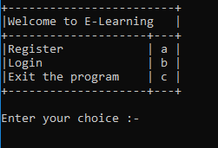

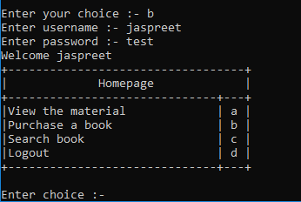

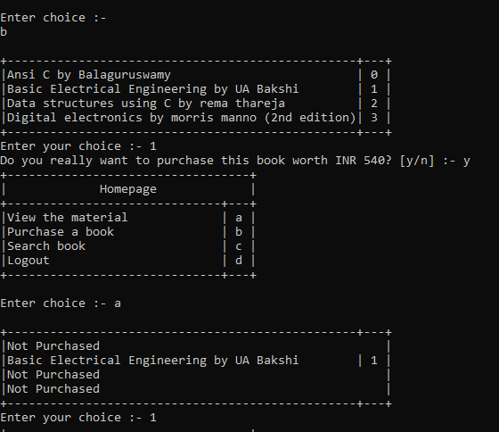

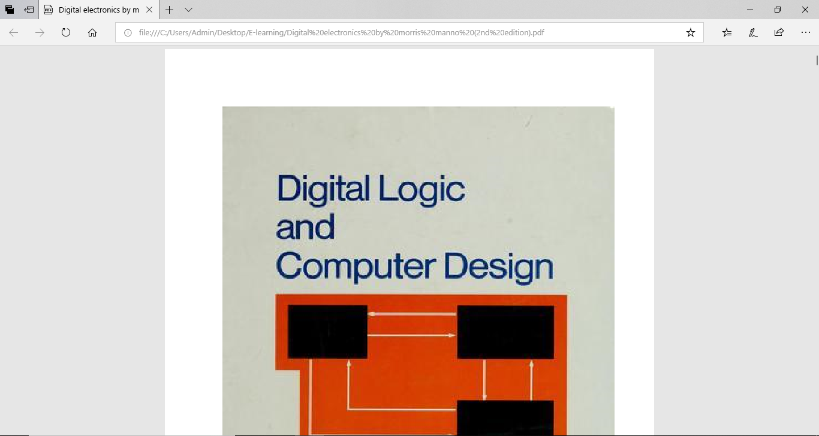

**REFERENCES:**

1. Wikipedia reference:

* E-learning(theory): <https://en.wikipedia.org/wiki/E-learning_(theory)>
* Online learning in higher education: <https://en.wikipedia.org/wiki/Online_learning_in_higher_education>
* Massive open online courses: <https://en.wikipedia.org/wiki/Massive_open_online_course>

1. Some E-learning websites:

* W3Schools (for computer-science students): [https://www.w3schools.com](https://www.w3schools.com/)
* DotSquares: <https://www.dotsquares.com/solutions/web-application-development/e-learning/>

**CONCLUSION:**

1. **E-Learning is a better alternative to regular learning as it has more scope in storing more than one book in a single device or database.**
2. **This project provides an illustration upon how the digital books are handled by the system.**