**If you are using a old site and get a Unsupported Protocol Error then do the following:**

1. Open Run command, then type *inetcpl.cpl* in the run command and click okay as shown in the below Screenshot.

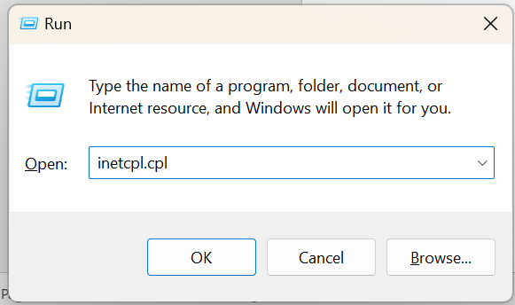

1. Go to advanced section in Internet Properties

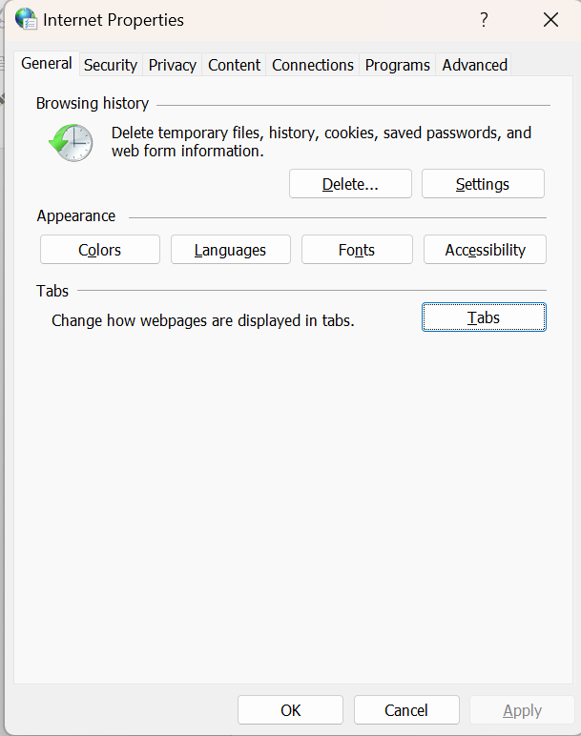

1. Scroll down till you find *Use TLS 1.0*  and *Use TLS 1.1* options as shown in the screenshot below.

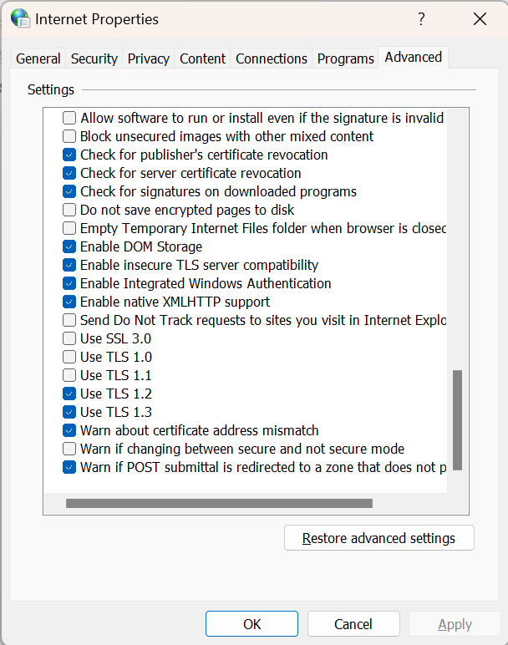

1. Select them both and then click apply.
2. Now refresh the page again in the browser, it should open now.
3. Once the required work is done please unselect them and then close Internet Properties, because *TLS 1.0*  and *TLS 1.1* are protocols that are known to be vulnerable to Man in the Middle attack.