# Requirements

* Usb disable
* Apply Password Policy
* Apply Account Lockout Policy

# Password Policy and Account Policy

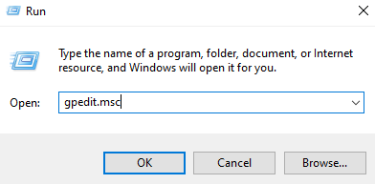

* Type “gpedit.msc” in run command and then click okay

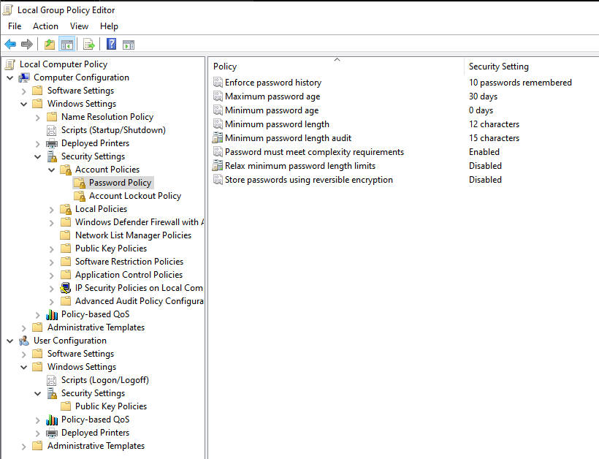

* Now navigate to *Computer Configuration* > *Windows Settings* > *Security settings* > *Account Policies* > *Password Policy.*
* Now setup the policy according to the requirements.
* Recommended settings:
  + Enforce password history: Set to 5-10 previous passwords.
  + Maximum password age: Set to 30-90 days.
  + Minimum password length: Set to 8-12 characters.
  + Password must meet complexity requirements: Enable.

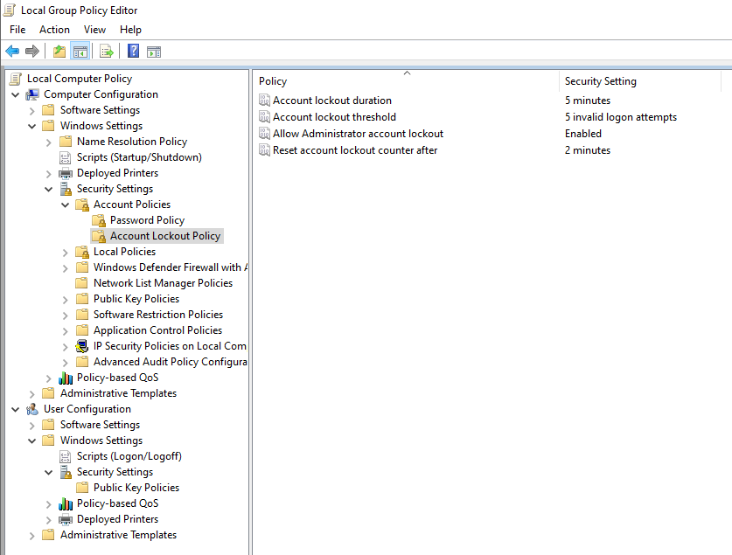

* Now navigate to *Computer Configuration* > *Windows Settings* > *Security settings* > *Account Policies* > *Account Lockout Policy.*
* Now setup the policy according to the requirements.

# Limited User Rights

* We cannot restrict users from installing whatever software they want in the system, but we can ensure that the users account cannot make system wide changes by creating a standard user account for that particular user.
* We can secure it more using EDR solutions like OSSEC,
* The user account can either be created using an official Microsoft account or without one.
* To create a standard user go to *control panel* > *user accounts* > *user accounts* > *manage another user* > *Add a new user in PC settings* > *Add someone else to this PC.*

# USB Disable

A script for that was developed so that any user can do it easily.