**Tree Detection using Deep Learning models and perform spatial temporal analysis**

**CHAPTER: 5 SYSTEM DESIGN**

**CHAPTER: 5 SYSTEM DESIGN**

**5.1 Relational Model Diagram:**

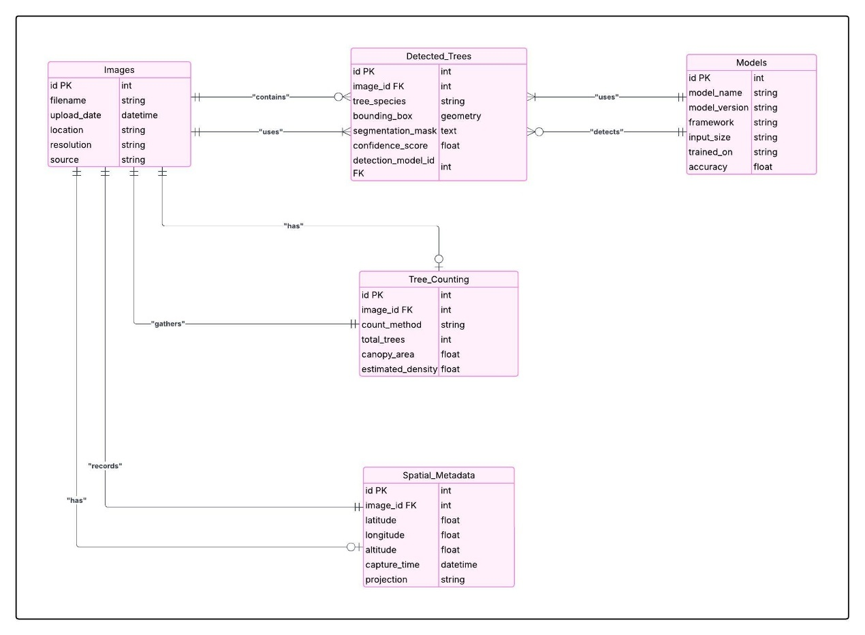

**Figure 5.1: Relational Model Diagram**

**5.2 Use case Diagram:**

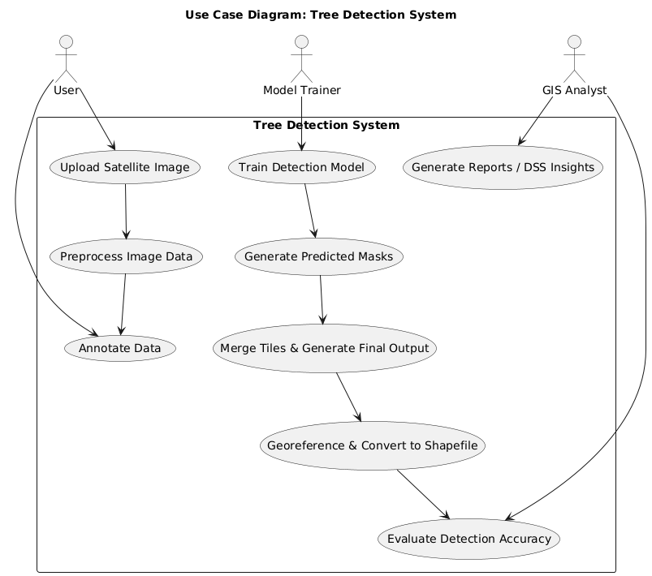

**Figure 5.2: Use-Case Diagram**

**5.3 Activity Diagram:**

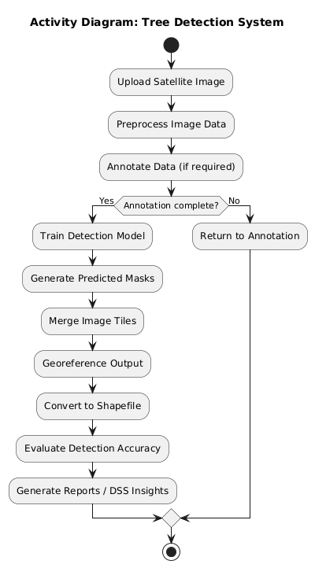

**Figure 5.3: Activity Diagram**

**5.4 Sequence Diagram:**

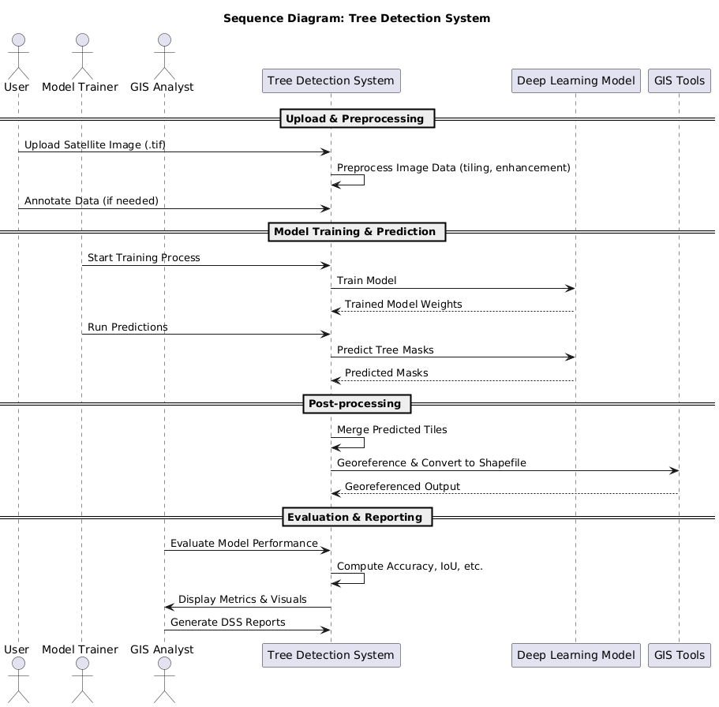

**Figure 5.4: Sequence Diagram**