


webMethods CloudStreams Connector Concepts Guide

October 2022
Contents
1 About this Guide 4
1.1 Document Conventions 4
1.2 Online Information and Support 5
1.2.1 Software AG Documentation Website 5
1.2.2 Software AG Empower Product Support Website 5
1.2.3 Software AG TECHcommunity 5
1.3 Data Protection 6
2 Overview 7
2.1 What Is a Cloud Connection? 7
2.1.1 Connection Pools 8
2.1.2 Run-Time Behavior of Connection Pools 8
2.2 What Is a Cloud Connector Service? 8
3 Installing and Uninstalling CloudStreams Connector 10
3.1 Additional CloudStreams fixes 10
4 Managing Cloud Connectors 11
4.1 Managing Cloud Connector Packages 12
4.2 Managing CloudStreams Connectors 12
4.3 Enabling CloudStreams Connectors 13
4.4 Disabling CloudStreams Connectors 13
4.5 Deleting CloudStreams Connectors 13
4.6 Configuring the Properties of CloudStreams Connectors 14
5 Managing Cloud Connections 15
5.1 Creating Cloud Connections 15
5.2 Viewing Cloud Connections Status 16
5.3 Understanding Cloud Connection Status 16
5.4 Understanding Cloud Connection State Transition 17
5.4.1 Examples 19
5.5 Enabling Cloud Connections 22
5.6 Testing Cloud Connections 22
5.6.1 Examples 23
5.7 Viewing Cloud Connections 25
5.7.1 Sorting and Filtering Connections 25
5.8 Disabling Cloud Connections 26
5.9 Editing Cloud Connections 26
5.10 Dynamically Changing a Cloud Service's Connection at Run Time 27
5.11 Copying Cloud Connections 27
5.12 Deleting Cloud Connections 27
6 Managing Cloud Connector Services 28
6.1 Creating a Cloud Connector Service 28
6.2 Editing a Cloud Connector Service for a SOAP-Based Provider 29
6.3 Editing a Cloud Connector Service for a REST-Based Provider 32
6.3.1 Viewing the Constraints Applied to Variables 36
7 Managing Connector listeners 37
7.1 Creating a Connector Listener 37
7.2 Viewing Connector Listener Runtime Status 38
7.3 Understanding Connector Listener Status 39
7.4 Understanding Connector Listener State Transition 41
7.5 Handling Errors 42
7.6 Editing a Connector Listener 47
7.6.1 Configuring a Subscription 47
7.6.2 Configuring an Action 48
7.6.3 Configuring a Connection 49
7.7 Enabling a Connector Listener 50
7.8 Disabling a Connector Listener 51
8 FAQs 52

About this Guide
This guide describes how to configure and use webMethods CloudStreams Connectors. It contains information for administrators and application developers who work with webMethods CloudStreams Connectors.
To use this guide effectively, you should be familiar with:
- Terminology and basic operations of your operating system
- Setup and operation of the webMethods Integration Server
- Basic concepts and tasks of Software AG Designer

For more information about how to configure and use the CloudStreams connectors with webMethods CloudStreams, see the Administering webMethods CloudStreams document available in the webMethods section of the Software AG Documentation web page and the respective Connector User’s Guide available on Software AG Tech Community.

Document Conventions
Convention | Description
Bold | Identifies elements on a screen.
Narrowfont | Identifies service names and locations in the format folder.subfolder.service, APIs, Java classes, methods, properties.
Italic | Identifies:  Variables for which you must supply values specific to your own situation or environment.  New terms the first time they occur in the text.  References to other documentation sources.
Monospace font | Identifies:  Text you must type in.  Messages displayed by the system.  Program code.
{} | Indicates a set of choices from which you must choose one. Type only the information inside the curly braces. Do not type the { } symbols.
| | Separates two mutually exclusive choices in a syntax line. Type one of these choices. Do not type the | symbol.
[] | Indicates one or more options. Type only the information inside the square brackets. Do not type the [ ] symbols.
… | Indicates that you can type multiple options of the same type. Type only the information. Do not type the ellipsis (...).

Online Information and Support

Software AG Documentation Website
You can find documentation on the Software AG Documentation website at https://documentation.softwareag.com. The site requires credentials for Software AG's Product Support site Empower. If you do not have Empower credentials, you must use the TECHcommunity website.

Software AG Empower Product Support Website
If you do not yet have an account for Empower, send an email to https://empower@softwareag.com/ with your name, company, and company email address and request an account.
You can find product information on the Software AG Empower Product Support website at https://empower.softwareag.com.
To submit feature/enhancementrequests, get information about product availability, and download products, go to Products.
To get information about fixes and to read early warnings, technical papers, and knowledge base articles, go to the Knowledge Center.
If you have any questions, you can find a local or toll-free number for your country in our Global Support Contact Directory at https://empower.softwareag.com/public_directory.asp and give us a call.

Software AG TECHcommunity
You can find documentation and other technical information on the Software AG TECHcommunity website at https://techcommunity.softwareag.com. You can:
- Access product documentation, if you have TECHcommunity credentials. If you do not, you will need to register and specify "Documentation" as an area of interest.
- Access articles, code samples, demos, and tutorials.
- Use the online discussion forums, moderated by Software AG professionals, to ask questions, discuss best practices, and learn how other customers are using Software AG technology.
- Link to external websites that discuss open standards and web technology.

Data Protection
Software AG products provide functionality with respect to processing of personal data according to the EU General Data Protection Regulation (GDPR). Where applicable, appropriate steps are documented in the respective administration documentation.

Overview
A CloudStreams provider is a logical grouping of connectors for a SaaS vendor. A provider is installed on webMethods Integration Server as an Integration Server package.
A CloudStreams connector represents an integration interface to the provider using a specific communication channel. Examples of connectors are Salesforce Partner SOAP API and Bulk REST API. A connector contains connections and services that you use to integrate with the software as a service (SaaS) provider. The CloudStreams connector contains SaaS provider specific information, such as how to connect to a provider and the default and custom groups that you can configure. When you start Integration Server for the first time, Integration Server dynamically creates the Integration Server document types for each of the out-of-the-box CloudStreams connectors installed with CloudStreams.
Each CloudStreams connector contains a CloudStreams Connector Bundle with all the assets required to enable the CloudStreams runtime to connect with the provider's back-end and to perform operations on the back-end. One of these assets is the Cloud Connector Descriptor, which contains:
- A reference to a metadata handler (SOAP or REST) that creates the data model representing the connector for a particular provider.
- Meta information that enables you to create the cloud connector's connections.
- The connector's SOAP operations or REST resources.
The type of a CloudStreams connector depends on the type of SaaS provider with which you communicate. The two types of connectors are as follows:
- If you communicate with a SOAP-based cloud application provider, you create cloud connections using a CloudStreams SOAP connector.
- If you communicate with a REST-based provider, you create cloud connections using a CloudStreams REST connector.
You can use Integration Server Administrator to load, manage, and use the CloudStreams connectors. For a list of tasks that you must do before you can use a CloudStreams connector, see Managing CloudStreams Connectors.
Both SOAP and REST connectors support connectivity with providers that expose Streaming API connectivity.

What Is a Cloud Connection?
You can create one or more connections for a connector at design time to use in integrations. A cloud connection is required for configuring and running a cloud connector service. You must create and enable a cloud connection before you can create cloud connector services. See the respective provider documents for connection configurations and how to configure connections for a connector. Connection configurations vary for each connector.
You can configure connections using Integration Server Administrator. For a list of tasks, you must do before creating connections, see Managing Cloud Connections. For more information about configuring cloud connections, see Creating Cloud Connections.

Connection Pools
Integration Server includes a connection management service that dynamically manages connections and connection pools based on configuration settings that you specify for the connection. By default, connection pooling is enabled for all cloud connections that you create.
A connection pool is a collection of connections with the same set of attributes. Integration Server maintains connection pools in memory. Connection pools improve performance by enabling cloud connector services to reuse open connections instead of opening new connections for every service request. All cloud connector services use connection pooling.

Run-Time Behavior of Connection Pools
When you enable a connection, Integration Server initializes the connection pool, creating the number of connection instances you specified in the connection's Minimum Pool Size field when you configured the connection. Whenever a cloud connector service needs a connection, Integration Server provides a connection from the pool. If no connections are available in the pool, and the maximum pool size has not been reached, the server creates one or more new connections (according to the number specified in the Pool Increment Size field) and adds them to the connection pool. If the pool is full (as specified in the Maximum Pool Size field), the requesting service will wait for Integration Server to obtain a connection, up to the length of time specified in the Block Timeout field, until a connection becomes available. Periodically, Integration Server inspects the pool and removes inactive connections that have exceeded the expiration period that you specified in the Expire Timeout field.
If the connection pool initialization fails because of a network connection failure or some other type of exception, you can enable the system to retry the initialization any number of times, at specified intervals. For information about configuring connection pooling for connections, see Creating Cloud Connections.

What Is a Cloud Connector Service?
A cloud connector service defines an interaction that the connector will perform on the SaaS back end. The cloud connector service is analogous to any other Integration Server service and could be used in a flow service. You call a cloud connector service within a flow service and you can audit them from the audit system of Integration Server.
A cloud connector service has input and output signatures. An input signature describes the data that the service expects to find in the service pipeline at run time. An output signature describes the data that the service expects to add to the pipeline when it has successfully executed. You can view the node signature of a cloud connector service on the Input/Output tab of the cloud connector service editor in Software AG Designer.
Before configuring a cloud connector service, you must assign it a connection that you created earlier. A cloud connector service is based on the interaction definitions defined in the connector and contains appropriate logic for executing the interaction and getting the response from the back end. Based on the connector type, cloud connector service definitions allow you to configure the interactions. For REST, you need to define the Resource, HTTP Headers, and parameters. For SOAP, you need to define the Operation, SOAP Headers, and custom parameters, if any. You can create a cloud connector service using a wizard in Software AG Designer. See the documentation specific to your CloudStreams provider, for example, webMethods CloudStreams Provider for Salesforce.com Installation and User's Guide.
Creating a cloud connector service consists of two high-level steps:
- Create a cloud connector service using a wizard in Software AG Designer. In this step, you give the service a name, select a CloudStreams Connector associated with a cloud provider, specify the cloud connection pool alias, and select the cloud virtual service that you want the cloud connector service to invoke. For details, see Creating a Cloud Connector Service.
- Edit the cloud connector service using the service editor in Software AG Designer. In this step, you specify the operation or REST resource of the service, the headers to include in the service, the input/output signature that determines how the user interacts with the service, and optional parameters to include in the input/output signature. For details about this step, see Editing a Cloud Connector Service for a SOAP-Based Provider and Editing a Cloud Connector Service for a REST-Based Provider.
For more information about each type of CloudStreams connector requests, see the Connector Details section in the respective connector User Guide.

Installing and Uninstalling CloudStreams Connector
For installation instructions, see the webMethods CloudStreams Provider Installation Guide available on the Software AG Documentation website.

Additional CloudStreams fixes
- CloudStreams Server 10.3 Fix 3 or later

Managing Cloud Connectors
After you publish a cloud connector, you must enable it as described below. In addition, you can:
- View its configured connection pool instance(s).
- View other details about the connector.
- View other details about the connector.
- Delete the connector.
Note: When a new connector version is released, in the provider package, the new connector version is enabled, and all older connector versions are disabled. If you still want to work with an older connector version, you can manually enable the older connector version, if available, in the package. To manually enable a cloud connector, from Integration Server Administrator, go to Solutions > CloudStreams > Providers. Select a provider and on the Connector List screen, for the connector you want to enable, click on No in the Enabled
column.
To manage a cloud connector
- In the Integration Server Administrator, click Solutions > CloudStreams > Providers > your_provider_name.
The list of connector(s) that have been defined for that provider will appear in the Connector List.
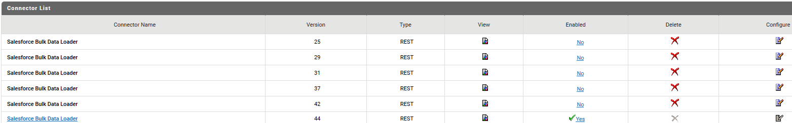

- You can do the following in the Connector List table:
Column | Description
Connector Name | Click the connector name to display the connector's configured connection pool instance(s). To create a new connection pool instance, click Configure New Connection and complete the fields on the Configure Connection page.
View | Click the icon to display details about the connector.
Enabled | Click No or Yes to enable or disable the connector respectively.
Delete | Click the icon to delete the connector. You must disable the connector before you can delete it.
Configure | Click the icon to display the Connector Configuration page, which displays the connector properties you can configure. You must disable the connector before you can edit the properties.

Managing Cloud Connector Packages
In some connectors, document types are shipped as a part of the provider package itself. When you install a provider package, CloudStreams can also optionally generate document types.
Note: Any document type package generated is hidden by default. It is not recommended to modify a document type.
To view the document types in Software AG Designer
- In Integration Server Administrator, click Packages > Management.
- In the Package List table, you can enable/disable the packages, reload them, archive them, or delete them.
- Select Solutions > CloudStreams.
- On the CloudStreams screen, click a provider from the Providers section.
- On the Connectors screen, click Yes in the Enabled column for that connector. For a disabled connector, click Configure.
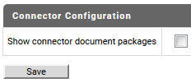
- In the Configure Connector screen, select the Show connector document packages option and click Save.
- Go to the Service Development perspective in Software AG Designer.
The document types will be visible in the Service Development perspective under the selected connector package.

Managing CloudStreams Connectors
You can manage the CloudStreams connectors using Integration Server Administrator. You must perform the following tasks to configure connectors.
To configure a connector
- Install webMethods Integration Server, webMethods CloudStreams server, and webMethods CloudStreams Connector on the same machine. For details, see Installing webMethods and Intelligent Business Operations Products and Installing and Uninstalling CloudStreams Connectors.
- Ensure that you have webMethods administrator privileges so that you can access the CloudStreams connector administrative screens. For information about setting user privileges, see webMethods Integration Server Administrator’s Guide.
- Start Integration Server and Integration Server Administrator if they are not already running.
- Using Integration Server Administrator, ensure that the cloud connector packages are enabled. See webMethods Integration Server Administrator’s Guide for instructions.

Enabling CloudStreams Connectors
You must enable a CloudStreams connector before you can create and manage cloud connections to integrate with the connector's SaaS provider. You enable CloudStreams connectors using Integration Server Administrator.
To enable a cloud connector
- In Integration Server Administrator, go to Solutions > CloudStreams > Providers.
- Click the name of your cloud application provider.
- On the Connectors screen, click No in the Enabled column for the connector you want to enable.
Integration Server Administrator enables the connector and displays Yes in the Enabled column.

Disabling CloudStreams Connectors
You can disable CloudStreams connectors using Integration Server Administrator. You need to disable a connector before you can configure its properties or delete it.
To disable a cloud connector
- In Integration Server Administrator, go to Solutions > CloudStreams > Providers.
- Click the name of your cloud application provider.
- On the Connectors screen, click Yes in the Enabled column for the connector you want to disable.
Integration Server Administrator disables the connector and displays No in the Enabled column.

Deleting CloudStreams Connectors
You can delete CloudStreams connectors using Integration Server Administrator.
Important! If you delete a connector, you can restore it only by reinstalling the connector.
To delete a cloud connector
- In Integration Server Administrator, go to Solutions > CloudStreams > Providers.
- Click the name of your cloud provider.
- On the Connectors screen, ensure that the connector is disabled. To disable the connector, click Yes in the Enabled column.
- Click the icon in the Delete column for the connector you want to delete.
Integration Server Administrator deletes the connector.

Configuring the Properties of CloudStreams Connectors
You can configure optional properties of a connector.
To configure the properties of a connector
- In Integration Server Administrator, go to Solutions > CloudStreams > Providers.
- Click the name of the cloud application provider you require.
- On the Connectors screen, disable the connector you want to configure by clicking Yes in the Enabled column for that connector.
- On the Connectors screen, click the icon in the Configure column.
- On the Connector Configuration screen that appears, set the available properties for the connector as desired and click Save.
The properties are as follows:
Property | Description
Show connector document packages | Hides/shows the document type packages that CloudStreams generated from the provider's WSDL or XSD.  - False (default): Hides the document type packages in the Software AG Designer user interface.  - True: Shows the document type packages in the Software AG Designer user interface. You might want to show the document type packages during the development/testing phase for debugging purposes.
- To view other details about the connector, click the icon in the View column on the Connectors screen.
The property settings take effect immediately.

Managing Cloud Connections
You can create and manage the cloud connections for each CloudStreams connector using Integration Server Administrator. You must do the following tasks to prepare to configure connections.
To prepare to configure a connection
- Install webMethods Integration Server, webMethods CloudStreams, and the CloudStreams connectors on the same machine. For details, see Installing webMethods and Intelligent Business Operations Products and Installing and Uninstalling CloudStreams Connector.
- Ensure that you have webMethods administrator privileges so that you can access the webMethods CloudStreams connector administrative screens. For information about setting user privileges, see webMethods Integration Server Administrator’s Guide.
- Start Integration Server and Integration Server Administrator if they are not already running.
- Using Integration Server Administrator, ensure that the CloudStreams connector packages are enabled. See webMethods Integration Server Administrator’s Guide for instructions.
- Using Software AG Designer, create a user-defined package to contain connections, if you have not already done so. See webMethods Service Development Help for instructions.

Creating Cloud Connections
You can create cloud connections for the installed and enabled CloudStreams connectors using Integration Server Administrator. For information about how to prepare for creating cloud connections, see Managing Cloud Connections.
To create a connection
- In Integration Server Administrator, go to Solutions > CloudStreams > Providers.
- Click the name of the cloud application provider you require.
- In the Connector Name column on the Connectors screen, click the name of the CloudStreams connector for which you want to create a connection.
- On the Connections screen, click Configure New Connection.
- On the Configure Connection screen, select in which view you want to create the connection:
- Basic view: This is the default view. Use this view to configure the standard parameters for a cloud connection.
- Advanced view: Use this view to configure additional and optional parameters for a cloud connection.
Note: For information on the connection parameters and connection fields of the connector, see the respective connector documentation.

Note: Before creating the connection, you can always test the connection credentials such as Username and Password using the Test button. This process is time-saving as it lets you validate the credentials before you fill entire the connection details. For details on testing the cloud connection, refer Testing Cloud Connections.

- Click Save.
You must enable a cloud connection before you can use it. For information about how to enable a connection, see Enabling Cloud Connections.

Viewing Cloud Connections Status
You can view the current status of the configured cloud connection for CloudStreams connectors from the Integration Server Administrator.
To view the current status of a connection for a connector,
In Integration Server Administrator, go to Solutions > CloudStreams > Providers.
- In the Integration Server Administrator, go to Solutions > CloudStreams > Providers.
- Click the name of the cloud application provider you require.
- On the Connectors screen, you will see the status column displaying the connection status for the selected cloud application provider. The status of a cloud connection for a CloudStreams connector can be one of the following:
- Enabled - Indicates that the configured cloud connection for a connector is successful and active.
- Disabled - Indicates that the configured cloud connection for a connector is inactive.
- Suspended - Indicates that one of the following scenarios has occurred:
  - The configured cloud connection for a connector is not yet used for connector service execution.
  - The configured cloud connection has become invalid due to refresh failure in its last usage.

Understanding Cloud Connection Status
The following table describes the behavior of cloud connection statuses for CloudStreams connectors in Integration Server Administrator.
Cloud Connection Status | Behavior
Disabled | Whenever a new cloud connection is created for a CloudStreams connector, the state of the connection is set as Disabled by default. A connection that is Disabled will remain in the same state even after you restart Integration Server or reload the custom package containing the connection. Note: A disabled cloud connection will not be in the usable state until it is re-enabled.  You can manually enable the connection using Integration Administrator.  See “Enabling Cloud Connections” for more information.
Suspended | The cloud connection for a connector can enter the Suspended state due to one of the following reasons:  - You have enabled the Lazy Asset Loading option. In such a case, any cloud connection(s) that was previously Enabled will automatically transit to the Suspended state after restarting Integration Server or reloading the custom package containing the connection. During this time, the connection is initialized but would be suspended until its first usage. The connection will move to the Enabled state after you run the connector service successfully.  - The connection becomes invalid due to refresh failure and current access token error. In such a case, the connection will not move back to the Enabled state until there is a refresh success, or the connector service is run successfully.  - The connection fails because an unexpected error occurred during the refresh session. In such a case, the connection will be moved to the Enabled state during the next refresh session.  - The cloud connection configuration is invalid or incorrect. In such a case, you can manually disable the connection, configure the required parameters, and then enable the connection.  A connection that is Suspended will remain in the same state even after you restart the Integration Server or reload the custom package containing the connection.
Enabled | Whenever the cloud connection for a connector is in Enabled state, it indicates that the connection is active and usable.  You can manually disable the connection using Integration Server Administrator. See “Disabling Cloud Connections” for more information.

Understanding Cloud Connection State Transition
The following diagram provides a high-level overview of how the status of a configured connection for a connector is determined and transitioned in Integration Server Administrator.
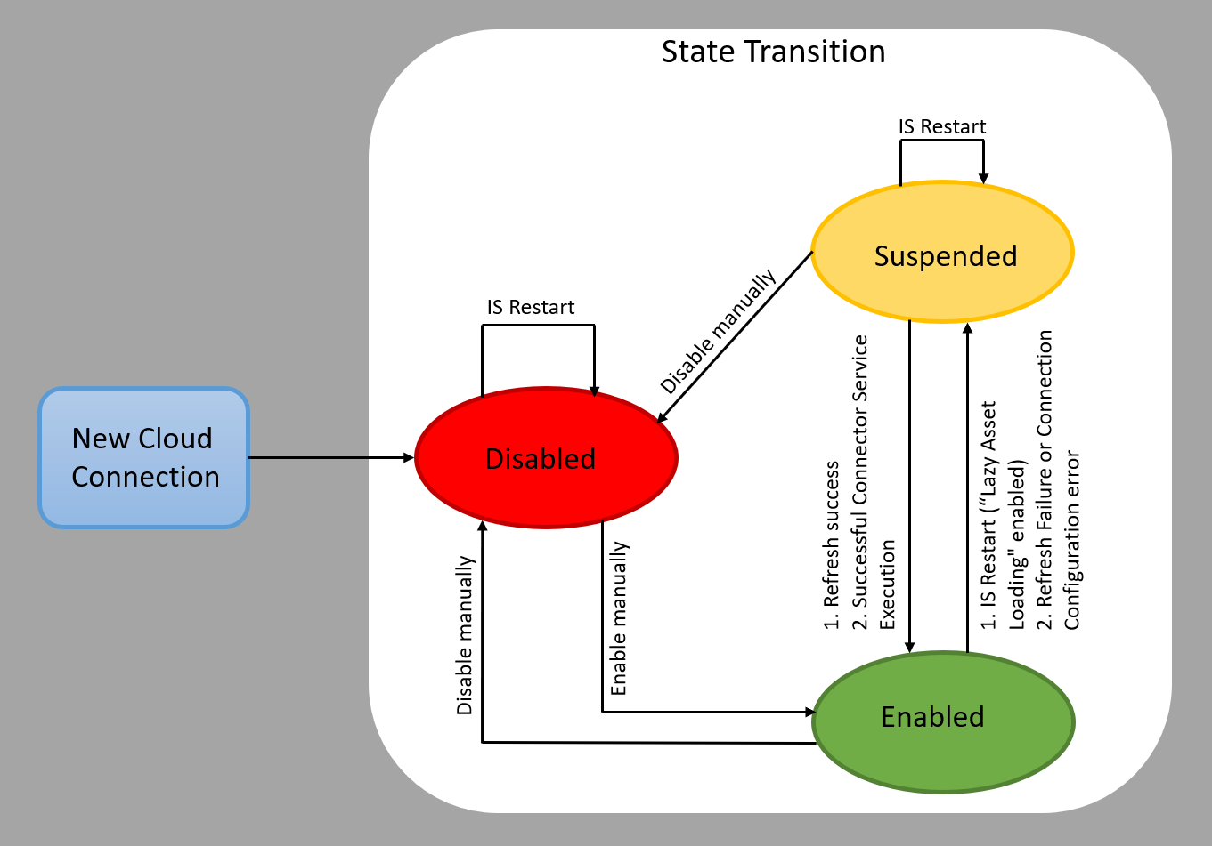
- Whenever a cloud connection for a connector is created, the state of the connection is set as Disabled by default. A connection that is Disabled will remain in the same state even after you restart Integration Server or reload the custom package containing the connection.
Note: A disabled cloud connection will not be in the usable state until it is re-enabled. You can manually enable the connection using Integration Server Administrator. See “Enabling Cloud Connections” for more information.
- After the connection has moved to the Enabled state, if you enable the Lazy Asset Loading option and then restart Integration Server or reload the custom package containing the connection, the connection will automatically enter the Suspended State. Additionally, an enabled cloud connection can also enter the Suspended state if there is a refresh failure or connection configuration error.
- The connection that is Suspended can move to the Enabled State only in two scenarios:
- Refresh failure issue is automatically resolved during its next session.
- Connector service execution is successful.
Let us now understand the state transition of a cloud connection for a connector with the help of an example.

Examples
To check the state transition of a cloud connection, let us first create a cloud connection for a connector. In our example, we will create a connection for Salesforce CRM.
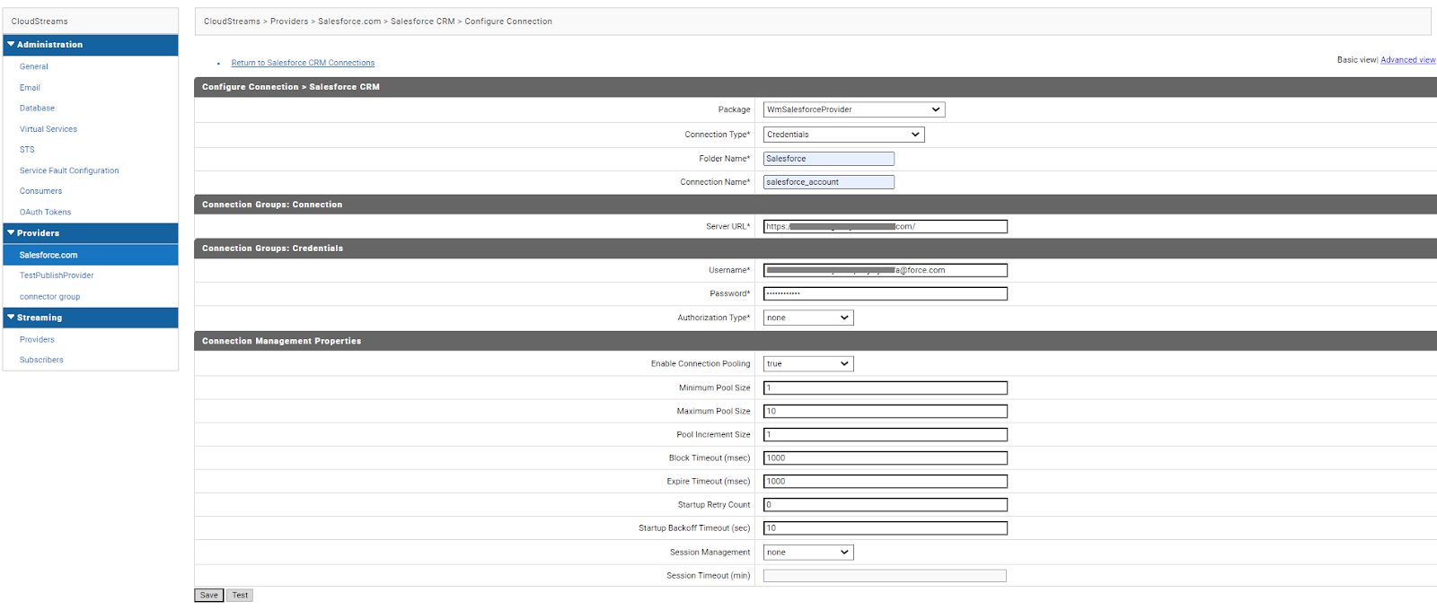

Disabled State
Once you configure a cloud connection, you will be redirected to the Connectors screen. On this page, if the connection configuration is successful, you will see the details of the newly configured connection. Note that the status of the newly configured connection for Salesforce CRM is set to Disabled automatically.
Note: The cloud connection that is in the Disabled state cannot be used to run any CloudStreams connector associated with this connection.
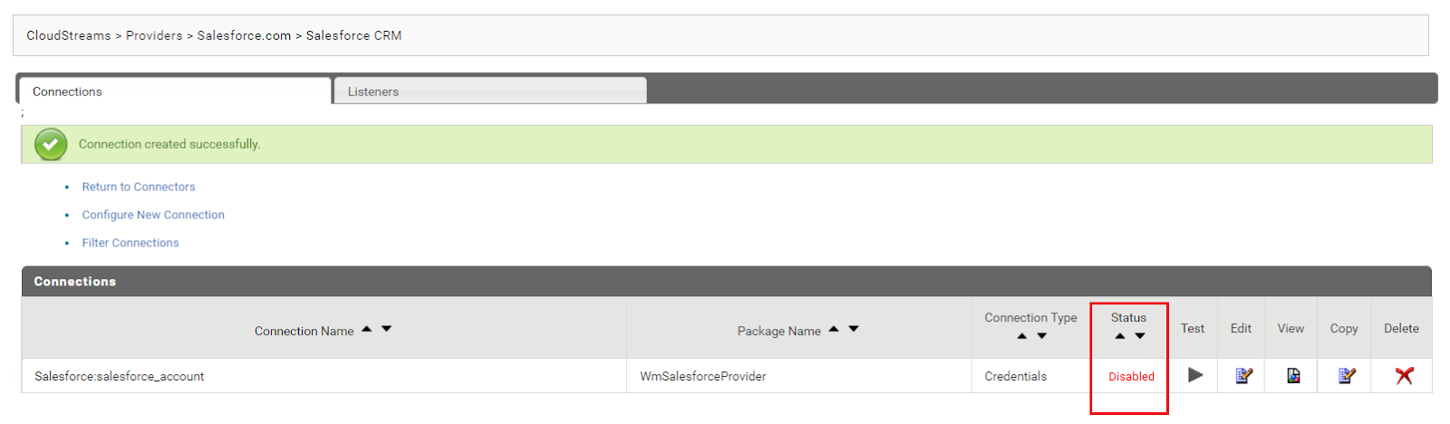

Enabled State
Now, let us say you want to run the Salesforce CRM connector service which is associated with the newly configured connection. However, to use this newly configured connection, you will first need to enable it. You can manually enable the connection by clicking on the Disabled option in the Status column. See “Enabling Cloud Connections” for more information.
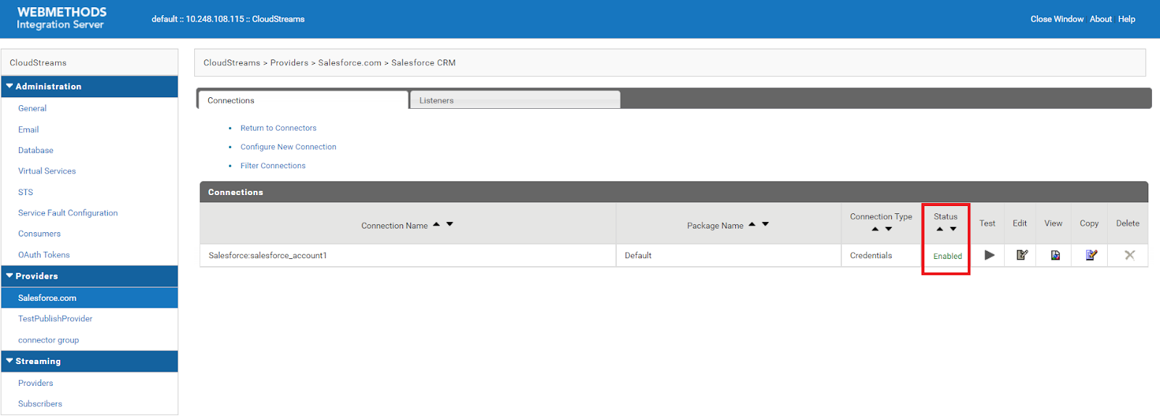
With this, you will now be able to run the Salesforce CRM connector service.

Suspended State
Let us now see how a cloud connection transits to the Suspended State. We already have a connection for Salesforce CRM which is in the Enabled State.
To see the state transition of an enabled connection to Suspended,
- Enable the Lazy Asset Loading option by going to Solutions > CloudStreams > Administration > General. Enabling the Lazy Asset Loading option will defer the initialization of connection assets when you restart Integration Server or reload the custom package containing the connection until its first usage.
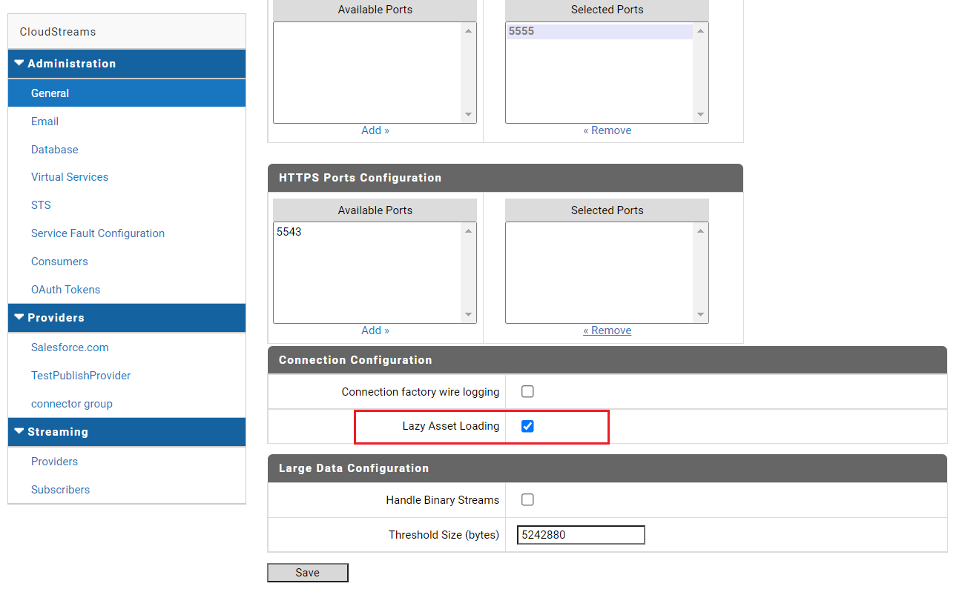
- Restart the Integration Server or reload the package containing the configured connection. In our example, we will be restarting the package named Default as it contains the configured connection - Salesforce_account.
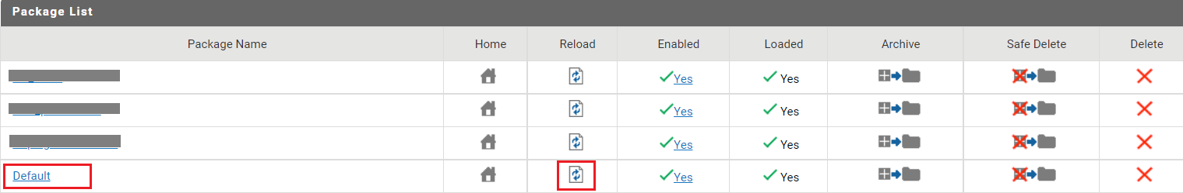
- On the Connectors (Connections Listing page) screen, you will now see the connection that was Enabled, has now automatically moved to the Suspended state. This means that the connection is deferred and can be enabled only after its initial use.
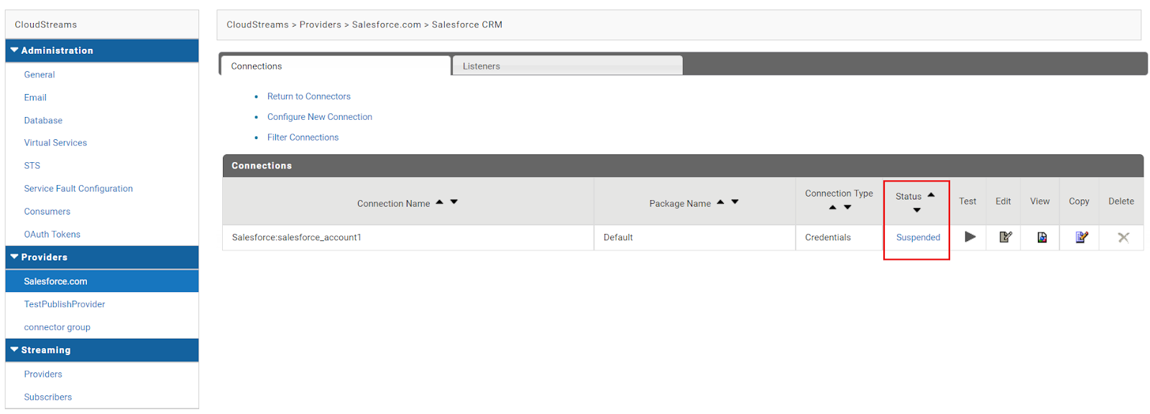
- To enable this connection, you will need to run the Salesforce CRM connector successfully. When you run the connector service successfully, the status of the connection will automatically move to the Enabled state.
Additionally, you may see the connection entering the Suspended State due to a refresh failure or connection configuration error. See “Understanding Cloud Connection Status” for more information.
Note: If you want to manually disable the connection from the Suspended state, click on the Suspended option in the status column. A confirmation dialog box will appear on the screen. Click Disable Connection to disable the connection.
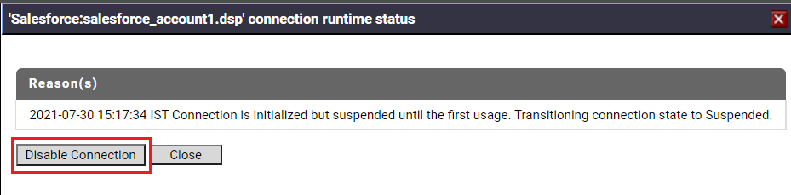

Enabling Cloud Connections
You must enable a cloud connection before you can use the CloudStreams connector associated with the cloud connection to create cloud connector services and integrate with the cloud application provider. You enable cloud connections using Integration Server Administrator.
Note: When you reload a package that contains enabled connections, the connections will automatically be enabled when the package reloads. If the package contains connections that are disabled, they will remain disabled when the package reloads.
To enable a connection
- In Integration Server Administrator, go to Solutions > CloudStreams > Providers.
- Click the name of the cloud application provider you require.
- On the Connectors screen, click the Connector Name for the CloudStreams connector whose connection you want to enable.
- On the Connections screen, click the Disabled option in the Status column to enable the connection.
Integration Server Administrator enables the cloud connection and displays Enabled in the Status column.
Note: If you enable the lazy asset loading option, the cloud connections that are
deferred during initialization displays the connection status as Suspended.
Note: Once you enable the connection, you can test the status of the connection using the Test button. For details on testing the cloud connection, refer Testing Cloud Connections.

Testing Cloud Connections
You can test the cloud connection when you are configuring a new connection, editing an existing connection, or for those connections which are either enabled or disabled. You can always Enable, Disable, Save, or Edit the connection if the test fails.
Note:
- To test a connection that is enabled, the session is refreshed if required and the connection is tested with the refreshed connection parameters.
For example, the Access Token for OAuth authentication and the Session ID for credentials are refreshed while testing an already enabled connection in case the connection has expired already.
- To test a connection that is disabled or for a connection that is yet to be created, the inline values of the connection configuration fields are used.
To test a connection
- In Integration Server Administrator, go to Solutions > CloudStreams > Providers.
- Click the name of the cloud application provider you require.
- On the Connectors screen, click the Connector Name for the CloudStreams connector whose connection you want to test.
- On the Connections screen, click Test button to test the connection.

Examples
- To test while configuring the connection
Let us assume that you are configuring a connection for Salesforce CRM as shown in the below screen. You can always test the connection configuration using the Test button. For instance, you can provide the values for Username and Password fields and click the Test button to test the connection before you save the changes.
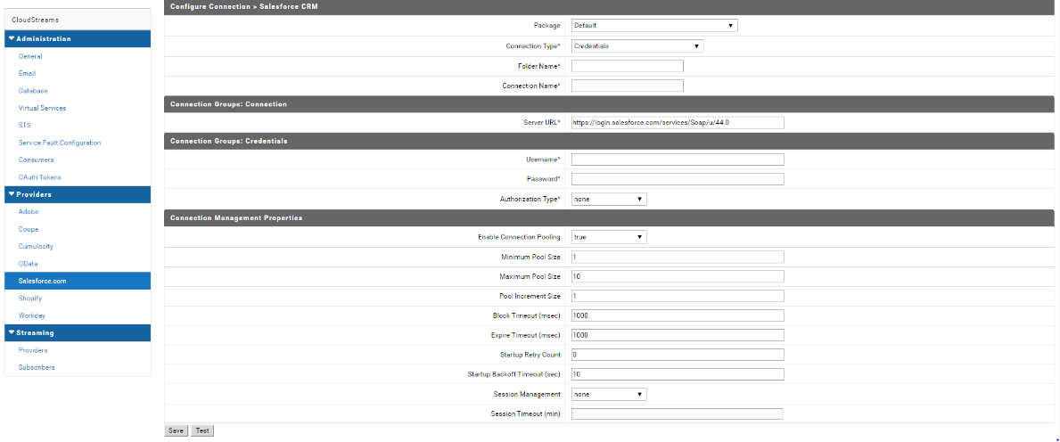

- To test while editing the connection configuration
You can test the connection while editing the existing or current connection details as shown in the screen below. You can click on the Test button to validate the connection before saving the changes.
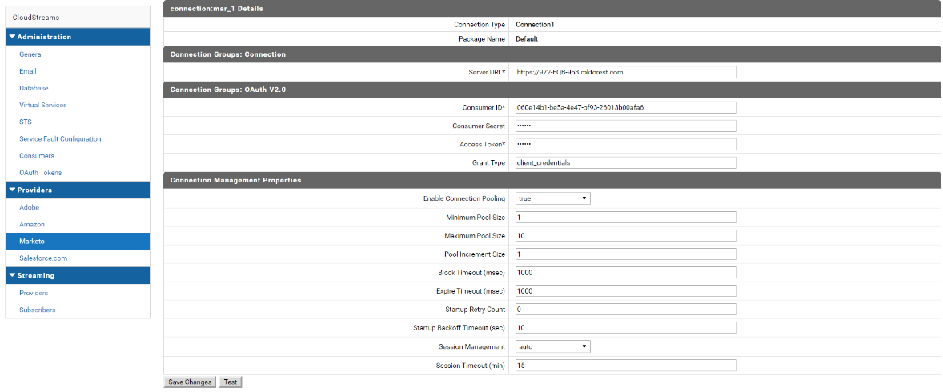

- To test an Enabled or Disabled connection
You can also test the connections from the Connections screen in which all the connections are listed as shown below:
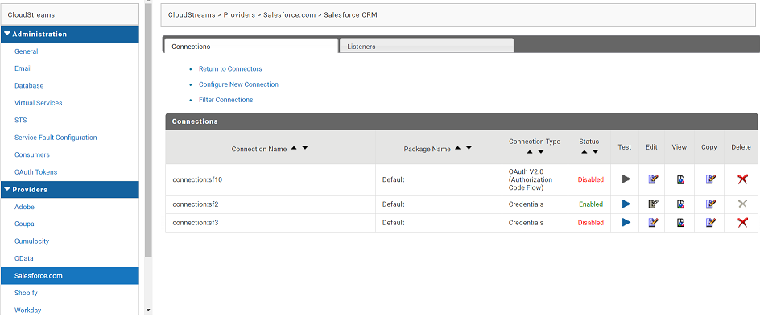
Note: By default, the Test button is disabled for all the connectors. However, you can use the Test connection functionality when the connector is updated with this feature.
To get updates about new connector releases, you can subscribe to the Software AG TECHcommunity page at https://techcommunity.softwareag.com.

Viewing Cloud Connections
You can view cloud connections and each connection’s parameters from the Integration Server Administrator.
Note: You can also view this information from the cloud connection editor in the Service Development perspective in Designer.
To view a connection
- In the Integration Server Administrator, go to Solutions > CloudStreams > Providers.
- Click the name of the cloud application provider you require.
- On the Connectors screen, click the Connector Name for the CloudStreams connector whose connection you want to view.
- On the Connections screen, click the icon in the View column for the connection you want to view.
- On the View Connection screen, select in which view you want to view the connection parameters:
- Basic view: This is the default. Use it to view the standard parameters for a cloud connection.
- Advanced view: To view additional parameters for a cloud connection, click the Advanced view link.
The View Connection screen displays the parameters for the connection. For descriptions of the connection parameters, see the table of parameters in Creating Cloud Connections.

Sorting and Filtering Connections
You can sort and filter the list of connections that appears on the Connections screen.
To sort and filter connections
- To sort information on the Connections screen, click the Up and Down arrows in each column.
- To filter the list of connections:
- On the Connections screen, click Filter Connections.
- Type the criterion by which you want to filter, into the Filter criteria box. Filtering is based on the connection alias. To locate all connections containing specific alphanumeric characters, use asterisks (*) as wildcards. For example, if you want to display all connections containing the string “abc”, type *abc* in the Filter criteria box.
- Click Search. The Connections screen displays the connections that match the filter criteria.
- To redisplay all connections, click Show All Connections.
The Connections screen appears, listing all the current connections.

Disabling Cloud Connections
You can disable cloud connections when you want to edit or delete them using the Integration Server Administrator.
To disable a connection
- In the Integration Server Administrator, go to Solutions > CloudStreams > Providers.
- Click the name of the cloud application provider you require.
- On the Connectors screen, click the Connector Name for the CloudStreams connector whose connection you want to disable.
- On the Connections screen, click the Enabled option in the Status column to disable the particular connection.
- Integration Server Administrator disables the connection and displays a No in the Enabled column.

Note: A cloud connection can only be Suspended if an enabled connection is deferred from loading during startup, if you have Lazy Asset Loading configuration enabled.

Editing Cloud Connections
If a connection parameter changes, or if you want to redefine parameters that a connection uses when connecting to a cloud application provider, you can update a connection’s parameters using the Integration Server Administrator.
To edit a connection
- In Integration Server Administrator, go to Solutions > CloudStreams > Providers.
- Click the name of the cloud application provider you require.
- On the Connectors screen, click the Connector Name for the CloudStreams connector whose connection you want to edit.
- Ensure that the connection is disabled before editing. To disable the connection, click the Enabled option in the Status column.
The Status column now appears Disabled for that connection.
- On the Connections screen, click the Edit icon for the connection you want to edit. The Edit Connection screen displays the current parameters for the connection. Select the view in which you want to edit and update the connection’s parameters by typing or selecting the values you want to specify.
For descriptions of the connection parameters, see Creating Cloud Connections.
Note: Once you edit the connection details, you can test the status of the connection using the Test button. For details on testing the cloud connection, refer Testing Cloud Connections.
- Click Save Changes.

Dynamically Changing a Cloud Service's Connection at Run Time
You can dynamically select the cloud connection a cloud service uses, to interact with a cloud application. You can run a cloud service using a cloud connection other than the default connection that was associated with the cloud service when the service was created. This feature enables one cloud service to interact with multiple, similar cloud applications.
To override the default cloud connection, you must code your flow to pass a value through the pipeline into a service's $connectionAlias field.

Copying Cloud Connections
You can copy an existing cloud connection to configure a new connection with the same or similar connection properties without having to retype all of the properties for the connection. You copy cloud connections using the Integration Server Administrator.
To copy a connection
- In Integration Server Administrator, go to Solutions > CloudStreams > Providers.
- Click the name of the cloud application provider you require.
- On the Connectors screen, click the Connector Name for the CloudStreams connector whose connection you want to copy.
- On the Connections screen, click the Copy icon for the connection you want to copy. The Copy Connection screen displays the current parameters for the connection you want to copy.
- Name the new connection, specify a package name and folder name, and edit any connection parameters as needed by typing or selecting the values you want to specify.
Note: When you copy a connection, the new connection does not save the password of the original connection. You must enter the password before you can save the new connection.
For descriptions of the connection parameters, see Creating Cloud Connections.
- Click Create.

Deleting Cloud Connections
You can delete cloud connections using the Integration Server Administrator.
To delete a connection
- In the Integration Server Administrator, go to Solutions > CloudStreams > Providers.
- Click the name of the cloud application provider you require.
- On the Connectors screen, click the Connector Name for the CloudStreams connector whose connection you want to delete.
- Ensure that the connection is disabled before deleting. To disable the connection, click the Enabled option in the Status column.
The Status column now appears Disabled for that connection.
- Click the Delete icon for the connection you want to delete.
Integration Server deletes the cloud connection.

Managing Cloud Connector Services
You can create and manage cloud connector services using the Software AG Designer.
Keep the following points in mind when creating a cloud connector service:
- Before you create a cloud connector service, ensure that the CloudStreams connector associated with your desired cloud application provider is installed. Also ensure that a cloud connection pool is created for that connector.
- If you are working with a SOAP-based provider, you should create at least one cloud connector service for each operation defined in the cloud connector descriptor. The operations contain a reference to a SOAP operation, defined in the connector’s WSDL
- If you are working with a REST-based provider, you should create at least one cloud connector service for each REST resource.

Creating a Cloud Connector Service
You can create a cloud connector service using Software AG Designer.
To create a cloud connector service
- Open the Service Development perspective in Software AG Designer if it is not already open.
- Navigate to and expand the package in which you want the cloud connector service to reside. Right-click the folder in which you want to create the service and select New > Cloud Connector Service.
Software AG Designer displays the New Cloud Connector Service wizard.
- On the Cloud Connector Service page of the wizard, in the Element name field, type the name you want to assign to the cloud connector service and click Next.
- On the Connector page of the wizard, select the CloudStreams Connector associated with the cloud application provider you want to access and click Next.
Tip! If the list of available connectors is long and you know the name of the connector you want to use, you can locate the connector quickly by typing its name in the box below Available Connectors. You can also use this technique when selecting the connection pool and service in the next steps.
- On the Connection Pool page of the wizard, select the connection pool for connecting to the cloud application provider and click Next.
- On the Select Service page of the wizard, select the cloud virtual service that you want the cloud connector service to invoke.
Note: If only one cloud virtual service is available to select, this page will not appear.
- Click Finish.
Software AG Designer creates the cloud connector service and displays the service details in the cloud connector service editor.
- Edit the cloud connector service as follows:
For this type of provider... | Follow the steps described in...
SOAP-based | Editing a Cloud Connector Service for a SOAP-Based Provider
REST-based | Editing a Cloud Connector Service for a REST-Based Provider

Editing a Cloud Connector Service for a SOAP-Based Provider
Editing a cloud connector service for a SOAP-based provider consists of specifying the operation, the business object associated with the operation, the headers to include in the service, the input/output signature that determines how the user interacts with the service, optional parameters to include in the input/output signature, and descriptive comments or usage notes, if any. You edit a cloud connector service using the service editor in Designer.
Keep the following points in mind when editing a cloud connector service:
- Before you edit a cloud connector service, create the service as described in Managing Cloud Connector Services.
- webMethods CloudStreams provides a default connector virtual service for policy enforcements, called WmCloudStreams.SoapVS. If this service does not meet the needs of your CloudStreams project, ensure that an appropriate connector virtual service has been created for your project. For more information about CloudStreams connector virtual services, see the Administering webMethods CloudStreams document.
- In pipeline, document, and input/output validation, the data validation applies constraints to its variables. Constraints are the restrictions on the structure or content of variables. For more information about icons for constrained variables, see Viewing the Constraints Applied to Variables.
To edit a cloud connector service for a SOAP-based provider
- Open Designer if it is not already open.
- Navigate to and open the cloud connector service you created in Creating a Cloud Connector Service.
The service opens in the cloud connector service editor.
- On the Operation tab, from the Connector Virtual Service list, select the connector virtual service to be used for policy enforcement.
For more information about CloudStreams connector virtual services, see the Administering webMethods CloudStreams document.
- To configure the operation, business object, fields, and data types of fields, click  next to Operation. Designer displays the Operation and Business Object Configuration wizard.
- Select the operation you want the cloud connector service to execute, and then click Next. When you change an operation, Designer clears all the metadata that were associated with the previously selected operation, including the headers, parameters, and data types of fields. You can select the metadata that the updated operation requires in the next steps.

Note: Software AG Designer displays the appropriate pages of the Operation and Business Object Configuration wizard depending on whether the selected operation requires metadata, such as a business object, fields, and data types of fields.
- In the Select the Business Object page, select a business object and click Next.
- In the Select Fields page, specify the fields or parameters to use in the request/response body for the object.
The mandatory fields or parameters for the business object are selected by default and cannot be cleared.
- You can add new custom fields by clicking  and entering the custom field details in the Add a new custom field dialog box. You can add custom fields only for the operations that support custom fields. Custom field names should be unique within the available fields. While adding a custom field as the child of another custom field, the field name must be unique among all the children of the parent field. The following table lists the different toolbar buttons available in the Select Fields page:
Select... | To...
 | Collapses all of the expanded fields
 | Adds a new custom field
 | Edits a custom field
 | Deletes a custom field
 | Moves a custom field down in the list
 | Moves a custom field up in the list
 | Promotes a custom field in the hierarchy, that is, moves the field one level up in the hierarchy
 | Demotes a custom field in the hierarchy, that is, makes the selected custom field a child of the preceding parent custom field

- If you want to configure concrete types for the abstract types in the operation you selected, click Next. If the operation you selected does not have any abstract type field, click Finish.
- In the Configure Data Types of Fields page, select a value from the list of values next to the abstract type to configure concrete types for the abstract types in the operation.
- Click Finish. Designer displays a confirmation message. Click OK to update the operation. Designer replaces the existing operation and associated metadata with the updated or default information.
- On the Headers tab, do the following:
- To include a header as part of the service signature, select the Active check box next to the header.
- To specify a default value for the header variable, click the Default Value box next to the variable and type or paste a default value. If the variable is null in the input pipeline, this default value will be used at run time. The value given at run time always takes precedence over the default value. However, if the existing default value is of type fixed default, the overwrite will fail.
- Repeat the above steps in the Output section of the tab to select the SOAP headers whose contents you want to add to the service’s output pipeline.
Note: If the operation you selected on the Operation tab has mandatory headers, Designer displays those headers in Grey. You cannot edit or delete a mandatory header.
- If the operation you selected has predefined input parameters (for example, the Query and QueryAll operations have the where and limit parameters), you can configure them on the Parameters tab as follows:
- To specify a default value for a parameter, click the Default Value box next to the parameter. Then, type or paste a default value. If the variable is null in the input pipeline, this default value will be used at run time. The value given at run time always take precedence over the default value. However, if the existing default value is of type fixed default, the overwrite will fail.
- If a predefined parameter is not mandatory, you can activate/de-activate the parameter by clicking the Active check box.
If a predefined parameter is mandatory, Designer displays the parameter in gray and the Active check box is selected. You cannot de-activate or delete a mandatory parameter.
- To move a parameter up in the list, select the parameter and click . To move a parameter down in the list, select the parameter and click .
- If you want to add other parameters to the service signature, such as variables to be replaced at run time with a user’s input, do the following on the Parameters tab:
- Click .
- Assign a name to the new parameter. If you want to rename the parameter later, click its name and type a new name.
- To specify a default value for the parameter, click the Default Value box next to the parameter. Then, type or paste a default value. If the variable is null in the input pipeline, this default value will be used at run time. The value given at run time always takes precedence over the default value. However, if the existing default value is of type fixed default, the overwrite will fail.
- You can activate/de-activate the parameter by clicking the Active check box, or you can delete it by selecting the parameter and clicking .
- To move a parameter up in the list, select the parameter and click . To move a parameter down in the list, select the parameter and click .
- On the Input/Output tab, do the following:
- To have the server validate the input to the service against the service input signature, select the Validate input check box.
- To have the server validate the output to the service against the service output signature, select the Validate output check box.
- Review the service’s input and output signature and make any necessary changes as follows:
To change the... | Go to the...
Virtual service name, operation, business object, fields, and data types of fields | Operation tab
List of headers in the requestHeaders or responseHeaders sections, or their default values | Headers tab
List of parameters in the parameters section, or their default values | Parameters tab
The requestBody and responseBody sections are derived from the operation you selected on the Operation tab. The value of $connectionAlias is derived from the connection pool you specified when you first created the cloud connector service. The fault section is derived from the operation response. You cannot change these values in the editor.
- On the Logged Fields tab, do the following:
- Select the check boxes next to the fields you want to log at run time.
- If you want to create an alias for a logged field to make it easier to locate in Software AG Designer, click the Alias box next to a field and type the alias name.
For more information about logged fields, see the section on logging input and output fields in Software AG Designer.
- On the Summary tab, review the details about the cloud connector service.
- On the Comments tab, enter descriptive comments or usage notes, if any.
- Click File > Save to save your changes.

Editing a Cloud Connector Service for a REST-Based Provider
Editing a cloud connector service for a REST-based provider consists of specifying the resource, the type of processing for requests or responses, the headers to include in the service, the input/output signature that determines how the user interacts with the service, default values for parameters included in the input/output signature, and descriptive comments or usage notes, if any. You can edit a cloud connector service using the service editor in Software AG Designer.
Keep the following points in mind when editing a cloud connector service:
- Before you edit a cloud connector service, create the service as described in Creating a Cloud Connector Service.
- webMethods CloudStreams provides a default connector virtual service for policy enforcements, called WmCloudStreams.RestVS. If this service does not meet the needs of your CloudStreams project, ensure that an appropriate connector virtual service has been created for your project. For more information about CloudStreams connector virtual services, see Administering webMethods CloudStreams.
- In pipeline, document, and input/output validation, the data validation applies constraints to its variables. Constraints are the restrictions on the structure or content of variables. For more information about icons for constrained variables, see Viewing the Constraints Applied to Variables.
To edit a cloud connector service for a REST-based provider
- Open Software AG Designer if it is not already open.
- Navigate to and open the cloud connector service you created in Creating a Cloud Connector Service. The service opens in the cloud connector service editor.
- On the Resource tab, do the following:
- From the Connector Virtual Service list, select the connector virtual service to be used for policy enforcements. For more information about CloudStreams connector virtual services, see the Administering webMethods CloudStreams document.
- Click next to Resource Name. On the Resource Details dialog box, select the REST resource you want the cloud connector service to process, and then click OK.
On the Resource tab, Designer displays the resource name and description, the HTTP method used to process the REST resource, and the path showing the location in which the resource file resides.
In the Request Processing section, select an appropriate parsing type. The parsing type determines how the service accepts the input.
Option | Meaning
Document | Builds the request message as an IS document type. Select this option when the provider’s XML file includes a schema or specification describing the content of the request.
Binary Stream | Builds the request message as a binary stream. Select this option when you expect the pipeline to contain an input stream for which no document type exists or when it is not practical to provide a schema description of the content.
Note: If the resource you selected does not contain any requests, this list is not available.
- In the Response Processing section, select an appropriate serialization type. The serialization type constructs the cloud connector service’s output signature and determines how the cloud connector service should return data to the user.
Option | Meaning
Document | Formats the response message as an IS document type. Select this option when the provider’s XML file includes a schema or specification describing the content of the response.
Binary Stream | Formats the response message as a binary stream. Select this option when you expect the pipeline to contain an output stream for which no document type exists or when it is not practical to provide a schema description of the content.  Note: This option works in conjunction with the response’s parsing type property. If you select Stream as the response’s serialization type, Designer also selects Stream as the response’s parsing type.
Note: If the resource you selected does not contain any responses, this list is not available.
- On the Headers tab, Software AG Designer displays the default HTTP transport headers for the resource, along with their default values. At run time, while processing the headers, CloudStreams substitutes values as necessary. To customize the headers, do the following:
- To specify a default value for the header variable, click the Default Value box to the right of the variable and type or paste the new value. If the variable is null in the input pipeline, this value will be used at run time. If the variable has an existing default value defined in the Cloud Connector Descriptor, this value will overwrite the existing value at run time. However, if the existing default value is of type fixed default, overwrite will fail as mentioned earlier.
- To add a custom header to the service’s input pipeline, in the Input section of the tab, click . Type a name for the header and provide a default value if desired.
- To move a header up in the list, select the header and click . To move a header down in the list, select the header and click .
- To include a header as part of the service signature, select the Active check box next to the header.
- To delete a custom header that you added, select the header and click .
Note: You cannot delete the resource’s required headers.
- Repeat the above steps in the Output section of the tab to select the HTTP transport protocol headers whose contents you want to add to the service’s output pipeline.
Note: A provider’s response headers appear in the pipeline signature only if they are added as active output headers in the Output section. Any unspecified headers returned by the native provider will not be included in the pipeline.
- On the Parameters tab, Software AG Designer displays the configured resource parameters. To customize the parameters, do the following:
- Review the details about the resource parameters. Software AG Designer displays the parameter name and description, the data type used to represent the kind of information the parameter can hold, the parameterization style of the request, and the dynamic default value needed to access the resource.
Currently, four parameter styles are supported: URI_CONTEXT, QUERYSTRING_PARAM, CFG_PARAM, and FORM_ENCODED_PARAM.
For more information about the supported parameter styles, see the section Understanding REST Parameters in the Administering webMethods CloudStreams document.
- To specify a default value for the parameter, click the Default Value box to the right of the parameter. Then, type or paste the default value. The default value is used at run time, if the parameter value is not explicitly specified in the input pipeline. Also, this default value will overwrite any existing default value that is defined in the Cloud Connector Descriptor, at run time. However, if the existing default value is of type fixed default, overwrite will fail as mentioned earlier.
Note: You cannot specify a default value for a parameter with data type as Record.
- On the Input/Output tab, do the following:
- To have the server validate the input to the service against the service input signature, select the Validate input check box.
- To have the server validate the output to the service against the service output signature, select the Validate output check box.
- Review the service’s input and output signature and make any necessary changes as follows:
To change the... | Go to the...
List of headers in the requestHeaders or responseHeaders section, or their default values | Headers tab
Default value of a parameter in the parameters section, or their default values | Parameters tab
The requestBody and responseBody sections are derived from the REST resource you selected on the Resource tab. The value of $connectionAlias is derived from the connection pool you specified when you first created the cloud connector service. The status, statusMessage, and fault values are derived from the resource response. You cannot change these values in the editor.
- On the Logged Fields tab, do the following:
- Select the check boxes next to the fields you want to log at run time.
- If you want to create an alias for a logged field to make it easier to locate in Designer, click the Alias box next to a field and type the alias name.
For more information about logged fields, see the section on logging input and output fields in Software AG Designer.
- On the Summary tab, review the details about the cloud connector service.
- On the Comments tab, enter descriptive comments or usage notes, if any.
- Click File > Save to save your changes.

Viewing the Constraints Applied to Variables
Software AG Designer displays small symbols next to a variable icon to indicate the constraints applied to the variable.
Software AG Designer displays variables in the following ways:
Variable | Constraint Status | Variable Properties
 | Required field. | The Required property is set to True.
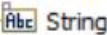 | Optional field. | The Required property is set to False.
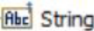 | Required field with content type constraint. | The Content type property specifies an IS schema or XML schema.
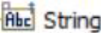 | Optional field with content type constraint. | The Required property is set to False, and the Content type property specifies an IS schema or XML schema.
 | Required field with default value. | The Fixed property is set to False, and the defaultValue property specifies a default value. The variable has a default value, but you can override this default value with any other valid values while executing the service or mapping the variables.
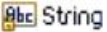 | Required field with fixed value. | The Fixed property is set to True, and the defaultValue property specifies a null value. The variable has a null value assigned to it by default and you cannot override this value. You cannot map this variable to another variable or assign any input values to this variable during service execution.
 | Required field with fixed default value. | The Fixed property is set to True, and the defaultValue property specifies a default value. The variable has a default value and you cannot override this value. You cannot map this variable to another variable or assign any input values to this variable during service execution.

Managing Connector listeners
Using a CloudStreams connector, a solution developer can integrate with streaming APIs that are exposed by a SAAS provider. The solution developer creates a connector listener, selects a subscription channel from a list of available channels for an endpoint, and configures the action to be applied on the incoming events. A connector listener, once it is enabled, receives, and processes the Streaming API events. In addition to creating, configuring, enabling, and disabling connections for SOAP and REST APIs, an Administrator can configure, enable, and disable connector listeners.
You use Integration Server Administrator to enable, disable, and configure the endpoint and transport related parameters for a connector listener.
You can create and additionally configure subscription and event processing for a connector listener using Software AG Designer.
Note: Before you create a connector listener, ensure that the CloudStreams connector associated with your desired cloud application provider is installed. Also ensure that a cloud connection pool is created for that connector.

Creating a Connector Listener
You can create a connector listener using Software AG Designer.
To create a connector listener
- Open the Service Development perspective in Software AG Designer if it is not already open.
- Navigate to and expand the package in which you want the connector listener to reside. Right-click the folder in which you want to create the connector listener and select New > Connector Listener.
- Software AG Designer displays the New Connector Listener wizard.
- On the Connector Listener page of the wizard, in the Element name field, type the name of the Connector Listener and click Next.
- On the Connector page of the wizard, select the CloudStreams connector associated with the cloud application provider you want to access, and click Next.
Note: If the list of available connectors is long and you know the name of the connector you want to use, you can locate the connector quickly by typing its name in the box below Available Connectors. You can also use this technique when selecting the connection pool and listeners.
- On the Connection Pool page of the wizard, select the connection pool for connecting to the cloud application provider, and click Next.
- On the Select Connector Listener page of the wizard, select the listener that you want to use.
- Click Finish.

Viewing Connector Listener Runtime Status
You can view the runtime status of a configured connector listener by using the Integration Server Administrator.
To view the runtime status of a connector listener,
- In Integration Server Administrator, go to Solutions > CloudStreams > Providers.
- Click the name of your cloud application provider.
- Go to the Listeners tab to see the status column displaying the connector listener status for the selected cloud application provider. The status of a connector listener can be one of the following:
- Enabled - Indicates that the configured cloud connector listener is successfully enabled by a user and the subscription is active. This means, connection with the streaming API is established, and incoming events will be processed whenever the streaming provider triggers the events. See “Understanding Connector Listener Status” for more information.
- Disabled - Indicates that the configured connector listener was disabled by a user. See “Understanding Connector Listener Status” for more information.
- Suspended - Indicates that the configured cloud connector listener was successfully enabled by a user but the subscription is currently inactive for one of the following reasons:
  - The configured connector listener is currently recovering from a subscription error. See “Understanding Connector Listener Status” for more information.
  - The configured connector listener has failed to recover due to a subscription error. See “Understanding Connector Listener Status” for more information.
To check the current state of a Suspended listener, hover over the Suspended option in the Status column.
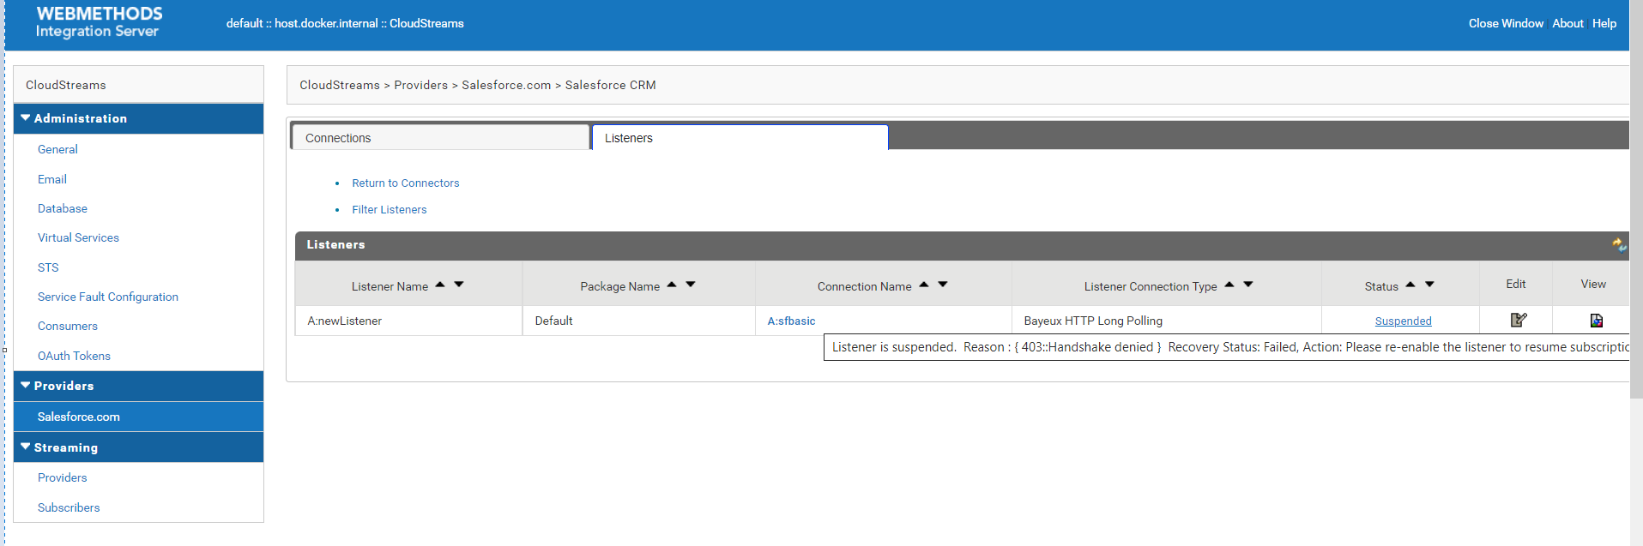
To get a detailed explanation of the error status, click on the Suspended option in the Status column.
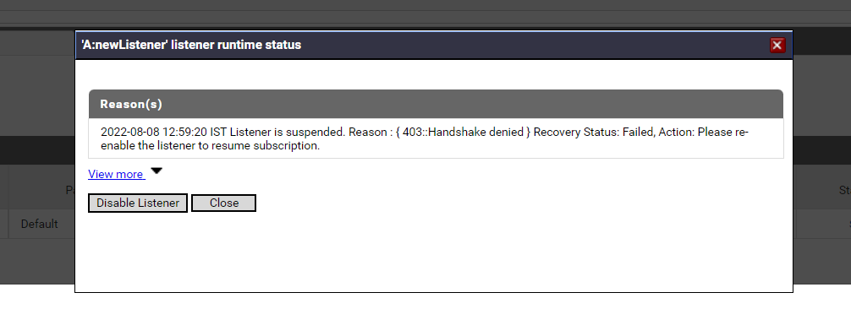
- To view the runtime status of configured connector listeners in the table, click the Refresh icon located on the right side of the screen.
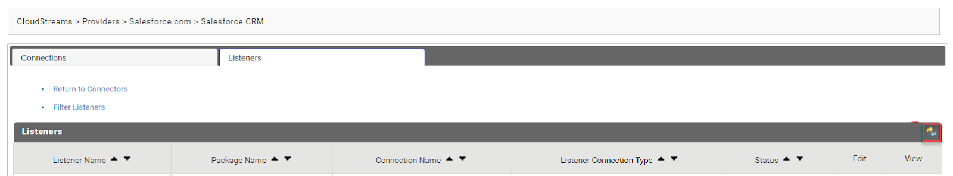
On clicking the Refresh icon, the runtime status of the listener will be reflected in the Status column.

Understanding Connector Listener Status
The following table describes the behavior of connector listener statuses in Integration Server Administrator.
Connector Listener Status | Behavior
Enabled | Whenever a connector listener is in the Enabled state, it indicates that the listener subscription is active. A connector listener in enabled state will automatically resume subscription after you restart Integration Server restart or reload the container package.  You can manually disable a connector listener using the Integration Server Administrator. See “Disabling a Connector Listener” for more information.
Disabled | Whenever a new connector listener is configured, the state of the listener is set as Disabled by default. A listener that is Disabled will remain in the same state even after you restart Integration Server or reload the custom package containing the listener.  You can manually enable the connector listener using Integration Server Administrator. See “Enabling a Connector Listener” for more information.
Suspended | A connector listener that is Enabled can transition to the Suspended state due to one of the following reasons:  - Recoverable errors: Recoverable errors are typically correctable errors for which cometD automatically attempts to establish a successful subscription. These errors might get recovered automatically without any user intervention. For example, errors such as connection throttling, busy server, or intermittent network failure will recover automatically after a certain time. See “Handling Errors” for more information.  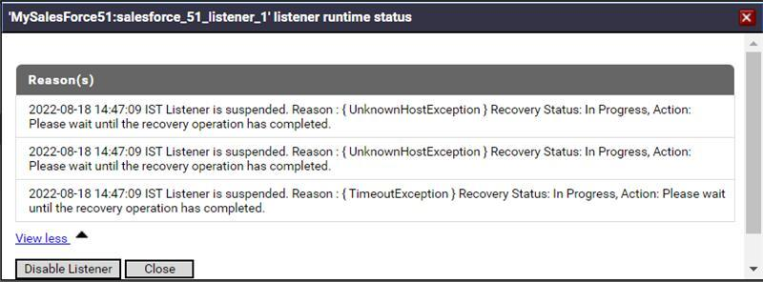  - Non-recoverable errors: Non-recoverable errors are fatal errors for which cometD stops establishing a successful subscription. User intervention is required to resolve these errors. For example, errors such as invalid authentication, invalid connection type, handshake denied, or time limit exceeded will be resolved only if users take the right actions. See “Handling Errors” for more information.

Understanding Connector Listener State Transition
The following diagram provides a high-level overview of how the status of a configured connector listener is determined and transitioned in Integration Server Administrator.
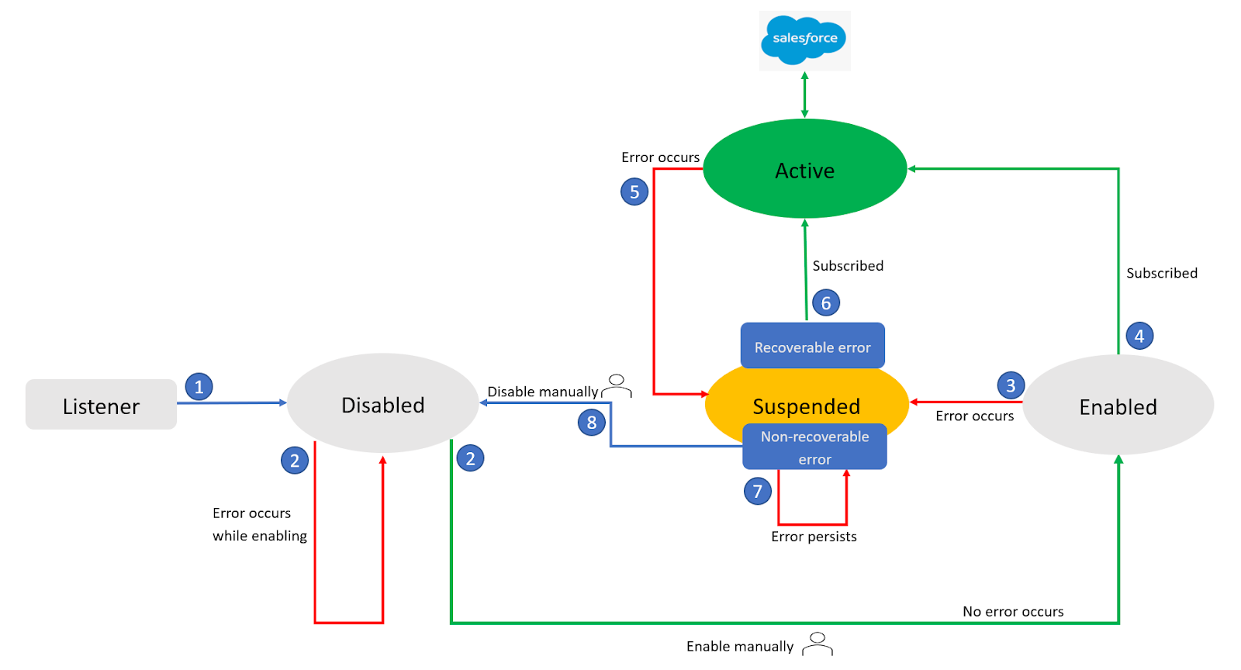
- Whenever a connector listener is created, the state of the listener is set as Disabled by default. A listener that is Disabled will remain in the same state even after you restart Integration Server or reload the custom package containing the listener.
- A disabled connector listener will not be in the usable state until it is manually enabled. Users can manually enable it using the Integration Server Administrator. See “Enabling a Connector Listener” for more information.
During enabling a disabled connector listener, if an error occurs, the listener will remain in the Disabled state only.
- While enabling a listener, if an error occurs, the listener will enter the Suspended state. Errors at this stage typically indicate a problem with either the listener configuration or the network.
- If no errors occur during enabling the listener, the listener enters the Enabled state and starts receiving and processing the Streaming API events.
- If an error is encountered after a listener is enabled, the listener will enter the Suspended state. Integration Server, in the backend, analyzes the cause of the error and categorizes it as either a recoverable error or a non-recoverable error.
- If an error is recoverable, the error handler will automatically correct the error and the listener will resume receiving and processing the Streaming API events.
- If an error is non-recoverable, for example, invalid authentication, the error handler cannot recover and hence, user involvement is required. See “Handling Errors'' for more information. If the error cannot be corrected, the listener will remain in the Suspended state.
- Users can manually disable the listener using the Integration Server Administrator. See “Disabling a Connector Listener” for more information.

Handling Errors
When a recoverable or non-recoverable error occurs, the Integration Server moves the listener to the Suspended state. However, since the user interface is not dynamically updated, users may not be aware that the listener is suspended. Hence, users will have to manually refresh the list of listeners by clicking the Refresh icon.
For example, if a configured listener encounters an error, you may not receive events from Salesforce, or the linked integration may not run as expected. During such scenarios, you must manually refresh the table by clicking the Refresh icon to ensure that the latest status of the listener is reflected in the user interface.
Users can check the error details of a listener by either hovering over or clicking the Suspended option in the Status column.
While recoverable errors are handled automatically by the error handler, non-recoverable errors will require user intervention to bring the listener back to action. On hovering over or clicking the Suspended option in the Status column, specific details about the error will be displayed on the screen. Users can identify the cause of the error and take the right action to resolve it.
The following table lists the most common error codes that users may encounter, explanation of the cause, and potential resolutions.
Error code | Error message | Explanation | Action
400 | API version in the URI is mandatory. URI format: '/cometd/55.0' | The API version is missing in the URI. | Specify the API version at the end of the URI. For example, '/cometd/55.0'  See “Configuring a Connection” for more information.
400 | Unsupported API version. Only API versions '23.0' and above are supported. URI format: '/cometd/55.0' | The specified API version is not supported. | Specify a valid API version. Supported API versions: ‘23.0’ and above.  See “Configuring a Connection” for more information.
400 | The channel you requested to subscribe to does not exist {channel_name} | The streaming channel requested to subscribe to does not exist. | Ensure that you have created a channel before subscribing.  See “Configuring a Connection” for more information.
400 | Channel name not specified | The channel name is not specified | Specify a valid channel name to subscribe to.  See “Configuring a Connection” for more information.
400 | Channel subscriptions must start with a leading '/' | The specified channel name format is invalid. | Specify a valid channel name. Channel names must start with a leading slash (/).  See “Configuring a Connection” for more information.
400 | Query fields {query_fields} do not exist on the topic entity | The supplied query fields do not exist on the Salesforce object specified in the PushTopic. | Specify valid query fields on the Salesforce object in the PushTopic.  See “Configuring a Connection” for more information.
400 | The replayId {replay_id} you provided was invalid. Please provide a valid ID, -2 to replay all events, or -1 to replay only new events. | The specified replay ID is invalid. | Specify a valid replay ID. -2 to replay all events or -1 to replay only new events.  See “Configuring a Connection” for more information.
401 | Authentication invalid | The specified authentication token or session ID is invalid. | Do the following to resolve this issue:  - Disable the suspended listener.  - Go to the Connections tab, disable the associated connection, and then re-enable it.  - Go back to the Listeners tab and enable the disabled listener.
401 | Request requires authentication | The authentication token or session ID was not provided in the request header. | Provide a valid authentication token or session ID in the request header.  See “Configuring a Connection” for more information.
403 | Cannot create channel {channel_name} | The subscription channel cannot be created, which can be due to insufficient permissions. | Ensure that the required access permissions are provided.  See “Configuring a Connection” for more information.
403 | Subscriber does not have access to the entity in this topic | The subscriber does not have access to the Salesforce object in the PushTopic. | Ensure that the subscriber has access to the Salesforce object in the PushTopic.  See “Configuring a Connection” for more information.
403 | Subscriber does not have access to all fields referenced in the where clause of the PushTopic | The subscriber does not have access to all fields referenced in the WHERE clause of the PushTopic. | Ensure that the subscriber has sufficient access to all fields referenced in the WHERE clause of the PushTopic.  See “Configuring a Connection” for more information.
403 | Handshake denied | The handshake request was denied. | Do the following to resolve this issue:  - Disable the suspended listener.  - Go to the Connections tab, disable the associated connection, and then re-enable it.  - Go back to the Listeners tab and enable the disabled listener.
403 | Client has not completed handshake | The client has not completed a handshake. | Do the following to resolve this issue:  - Disable the suspended listener.  - Go to the Connections tab, disable the associated connection, and then re-enable it.  - Go back to the Listeners tab and enable the disabled listener.
403 | Organization concurrent user limit exceeded | The maximum number of concurrent clients across all channels has been exceeded.
403 | Organization total events daily limit exceeded | The maximum number of delivered event notifications within a 24-hour period to all CometD clients has been exceeded. | Try again after 24 hours.
403 | Restricted channel | The user does not have the required permissions to subscribe to the streaming channel. | Ensure that you have the required permissions before subscribing to the streaming channel.  See “Configuring a Connection” for more information.
403 | User not enabled for streaming | The user does not have the read permission on the PushTopic. | Ensure that you have the read permission on the PushTopic.  See “Configuring a Connection” for more information.
403 | User not allowed to subscribe CDC without View All Data permissions | The user must have the View All Data permission to subscribe to Change Data Capture. | Ensure that you have the View All Data permission before subscribing to Change Data Capture.  See “Configuring a Connection” for more information.
403 | Subscription limit exceeded for this topic | The maximum number of concurrent clients per topic for PushTopic and generic events has been exceeded.
403 | Unknown client | The server deleted the client CometD session due to a timeout, which can be caused by a network failure. | This error is recoverable, and the error handler will automatically correct the error.  After some time, in Integration Server, on the Listeners screen, click the Refresh icon to see the updated status of the listener.
503 | Server is too busy. Please try your request again later. | The server cannot process the request because it is too busy. | This error is recoverable, and the error handler will automatically correct the error.  After some time, in Integration Server, on the Listeners screen, click the Refresh icon to see the updated status of the listener.

Editing a Connector Listener
Editing a connector listener for a provider consists of configuring the subscription and action(s) to apply on the incoming events. Additionally, you can configure comments in the Comments tab for a connector listener. You can edit a connector listener using the service editor in Software AG Designer.
To edit a connector listener for a provider
- Open Software AG Designer if it is not already open.
- Navigate to and open the connector listener you created in Creating a Connector Listener. The listener opens in the connector listener editor.

Configuring a Subscription
To configure a subscription for a connector listener
- On the Listener tab, select the Subscription you want to use. For more information about Subscriptions, see the Administering webMethods CloudStreams document.
- To configure the subscription, click next to Subscription. Software AG Designer displays the Subscription Configuration wizard.
- Select the subscriber you want the connector listener to subscribe, and then click Finish. When you change a subscription, Software AG Designer clears all the metadata that is associated with the previously selected subscriber, including the headers, parameters, and the configured action to be applied on the events.
- Software AG Designer displays a confirmation message. Click OK to update the subscriber. Software AG Designer replaces the existing subscriber and associated metadata with the updated or default information.
- On the Headers tab, do the following:
To include a header as a part of the subscription, select the Active check box next to the header.
To specify a default value for the header variable, click the Value check box next to the variable and type or paste a default value. If the variable is null in the input pipeline, this default value will be used at run time. If the existing default value is of type fixed default, overwrite will fail.
Note: If the subscription you selected on the Listener tab has mandatory headers, Software AG Designer displays those headers in Grey colour. You cannot edit or delete a mandatory header.
If you want to add other headers to the connector listener, do the following on the Headers tab:
- Click .
- Assign a name to the new header. If you want to rename the header later, click its name and type a new name.
- To specify a default value for the header, click the Value box next to the header. Then type or paste a value. If the variable is null in the input pipeline, this value will be used at run time. If the existing default value is of type fixed default, overwrite will fail.
You can activate or deactivate the header by clicking the Active check box, or you can delete it by selecting the parameter and clicking .
To move a header up in the list, select the header and click . To move a header down in the list, select the header and click .
On the Parameters tab, do the following:
- To include a parameter as part of subscription, select the Active check box next to the parameter.
- To specify a default value for the parameter variable, click the Default Value box next to the variable and type or paste a default value. If the variable is null in the input pipeline, this default value will be used at run time. If the existing default value is of type fixed default, overwrite will fail.
Note: If the subscription you selected on the Listener tab has mandatory parameters, Software AG Designer displays those headers in Grey colour. You cannot edit or delete a mandatory parameter. You must enter values for mandatory parameters. For example, the Push Topic Subscriber subscription has the pushTopicName parameter. You must enter pushTopicName to subscribe to the push topic events.
- You can also add custom parameters on the Parameters tab as follows:
- Click .
- Assign a name to the new parameter. If you want to rename the parameter later, click its name and type a new name.
- To specify a default value for the parameter, click the Value box next to the parameter. Then type or paste a value. If the variable is null in the input pipeline, this value will be used at run time. If the existing default value is of type fixed default, overwrite will fail.
- You can activate or deactivate the parameter by clicking the Active check box, or you can delete it by selecting the parameter and clicking .
- To move a parameter up in the list, select the parameter and click . To move a parameter down in the list, select the parameter and click .

Configuring an Action
To configure action(s) for a connector listener
You can configure the processing of the subscribed events by adding an Action to be applied on the incoming events. You can log or invoke a service based on your configurations.
On the Event tab, do the following:
- In Document, a reference document representing the event structure as IData will appear. In case you want to update the document reference, click Browse.
- In Action, you can add the action as Log Invocation or Service Invocation.
- For Log Invocation, select Log Level under Action Configuration.
- For Service Invocation, browse Service Name and select the user role in Run As User under Action Configuration.

Configuring a Connection
You can configure a connector listener and a listener’s connection parameters from the Integration Server Administrator.
To view a connection
- In the Integration Server Administrator, go to Solutions > CloudStreams > Providers.
- Click the name of the cloud application provider you require.
- On the Connectors screen, click the Connector Name for the CloudStreams connector whose connection you want to view.
- On the Listeners screen, click the icon in the View column for the listener you want to view.
- On the View Connection screen, select in which view you want to view the listener’s connection parameters:
- Basic view: This is the default view. Use it to view the standard connection parameters for a connector listener.
- Advanced view: To view additional connection parameters for a connector listener, click the Advanced view link.
The View Listeners screen displays the connection parameters for the connector listeners. You need to configure these parameters in order to enable a connector listener.
Section | Field | Description
Streaming | Listener Connection Type | Default: Bayeux HTTP Long Polling.  The listener connection type indicates the streaming protocol and transport being used for the listener instance. The supported values are Bayeux HTTP Long Polling and HTTP Streaming.
Streaming | Package Name | The package in which the connector listener resides. You must create the package using Software AG Designer before you can create a connector listener. For general information about creating and managing packages, see the Software AG Designer Service Development online help.  Note: It is recommended that you configure the connector listener in a user-defined package. The custom package that you create must have a dependency on the WmCloudStreams package.
Streaming | Connection Alias | The name of the existing connector which was used while creating the connector listener. The connector listener will use the existing connection you created to connect to the connector. You need not create a new connection to use the streaming capability.
Connection Groups:  Bayeux Configuration | Backoff Increment | Default: 1000  The number of milliseconds that the backoff time increments every time a connection with the Bayeux server fails. CometD attempts to reconnect after the backoff time elapses.
Connection Groups:  Bayeux Configuration | Max Backoff | Default: 30000  The maximum number of milliseconds of the backoff time after which the backoff time is not further incremented.
Connection Groups:  Bayeux Configuration | Max Message Size | Default: 1048576  The maximum size in bytes of an incoming event message.
Connection Groups: Bayeux Extension Configuration | Replay options | New – Connector listener will receive new events that are broadcast after enabling the connector listener.  All - Connector listener receives all events, that is, past events that are within the retention window and also new events.  You can choose the replay option as per your requirement.
Connection Groups:  HTTP Parameter Configuration | Streaming API Endpoint | The Streaming endpoint to initiate listening to the events.
Once you have configured the above connector listener fields, you can enable the connector listener.

Enabling a Connector Listener
You must enable a connector listener to receive the real time notifications or events from the SaaS provider. You enable a connector listener using the Integration Server Administrator.
To enable a connector listener
- In Integration Server Administrator, go to Solutions > CloudStreams > Providers.
- Click the name of your cloud application provider.
- Click the Connector Name for the CloudStreams connector whose listener you want to enable.
- Navigate to the Listeners tab to view the list of available listeners.
- Click No in the Enabled column for the listener you want to enable.
Integration Server Administrator enables the listener and displays Yes in the Enabled column.
Note: When you reload a package that contains enabled connector listeners, the listeners will automatically be enabled when the package reloads. If the package contains connector listeners that are disabled, they will remain disabled when the package reloads.

Disabling a Connector Listener
You can disable connector listeners when you want to edit, delete, or deactivate listening to the subscribed channel.
To disable a connector listener
- In the Integration Server Administrator, go to Solutions > CloudStreams > Providers.
- Click the name of the cloud application provider you require.
- Click the Connector Name for the CloudStreams connector whose listener you want to disable.
- On the Listeners screen, click Yes in the Enabled column for the connection you want to disable.
Integration Server Administrator disables the listener and displays No in the Enabled column.

FAQs
- What is the extent of JSON support in CloudStreams REST Connector resources?
CloudStreams supports most of the variations of the JSON data format, which includes Multi root node, Array root node element with key, Array root node without key for array, Multi array root node with key, and so on.
Currently, Multi array root node without key is not supported, which means that only one level of anonymity is supported in a Multi array root node without key. This is valid for request and response messages. This scenario can be handled as raw Streams instead of Document Type.
- After installation, the latest CloudStreams connectors are not visible.
The previously installed or generated connector artifacts may not have cleaned up properly. Ensure that you have applied the latest CloudStreams Server fix. Follow the “Connector Uninstallation” section steps and install the connector again. Always uninstall/delete older provider packages before installing any new version of provider packages.

- Why are CloudStreams connections not visible or disappear after reloading the CloudStreams package?
If the custom package has no dependency on the provider package, the artifacts of the package will not be notified to CloudStreams Server after the package reloads. The reason is that a different package classloader will load the package assets and with no dependency on the provider package, the assets will not be identified as meaningful CloudStreams nodes in Integration Server. Hence the connection nodes will not be visible to the user. To fix this, from Software AG Designer, set the custom packages dependency on the provider package and restart Integration Server.

- When I enable a connector listener in Integration Server Administrator, nothing seems to happen.
While enabling a CloudStreams connector listener, if there are connectivity issues like network and proxy issues while connecting to the streaming API endpoint, the connector listener automatically goes into retry mode and attempts to connect to the API endpoint until the configured connection timeout has been exhausted. The connector listener inherits the timeouts (Connection Timeout and Socket Read Timeout) from the referenced connector connection. In case the timeout is set to a large value, the update to the connector listener “enabled” status takes a long time to reflect in the Integration Server Administrator page. This may convey an impression that nothing is happening. To confirm the processing, check the server logs with the Streaming logging component configured to Debug or above. Alternatively, reduce the timeout values to speed up the “enabled” status update for the connector listener.
- After restarting Integration Server, listeners are not getting enabled. The listeners were all fine before the restart.
It can be due to the unavailability of the dependent connection at the time of the listener enablement. CloudStreams connector listeners are dependent on the connections they use to create and receive subscriptions. So before enabling the connector listeners, the connections must have been already registered and enabled. If both the connection and the listener artifacts reside in the same Integration Server package, then the order of loading the connection and then the listener is guaranteed. But this ordering cannot be assured if the connection and the listener are in different Integration Server packages, as the order of loading of the Integration Server packages is not guaranteed.
So in a scenario where the connection and the listener artifacts stay across different Integration Server packages, and where there is no dependency set between them, it might so happen that the package containing the listener gets loaded first, does not find the dependent connection, and thus fails to get enabled. You must ensure package loading ordering by explicitly creating and declaring a package dependency, such that the package that contains the connector listener must depend on the package that contains the connection.
- I come across network connectivity related issues, for example, IO and read timeout, while enabling a connection or executing a service.
These errors may be due to network connectivity issues, which can be handled by observing the following guidelines:
  - If your company has the proxy server configured, set up the proxy settings in the Integration Server Administrator. Go to Settings > Proxy Servers and specify the proxy alias in the respective Connector Connection page.
If you have already configured that alias as the default proxy for Integration Server, you do not need to specify the proxy alias in the Connector Connection page.
If you have not configured any proxy alias as the default proxy, then you must explicitly set the proxy alias name in the CloudStreams connection page in the Proxy Server Alias field.
  - In case the network is slow or the back end processing takes longer than usual, increase the Connection Timeout and the Socket Read Timeout values.
- I ran the OData service and I see the error code 500. There is no other information in the response error document.
After executing the OData service, if the response code is 500 and the error message null, then see the Integration Server logs to know the exact cause of this error. This could be because of timeout or some other internal error

