**PROJECT-1**

**Name-Anshul**

**Roll no –M22ME052**

1 matlab code:-

clear all;

close all;

clc;

%%

%naca 2412 nomenclature

u=input('first digit of naca = ');

v=input('second digit of naca = ');

w=input('last two digit of naca = ');

ymc_c=u*0.01;

xmc_c=v*0.1;

tm=w*0.01;

c=1;

z=input("alpha value = ");

alpha=z*pi/180;

U=10;

%%

%cosine clustring

%choose even number of points on circle

n=160;

theta=2*pi/(n-1);

i=1:n/2;

x_c=0.5*(1-cos((i-0.5)*theta));

[xl,yl,xu,yu]=surface_coordinate(tm,xmc_c,ymc_c,c,x_c);

x=[fliplr(xl),xu];

y=[fliplr(yl),yu];

for i=1:n-1

dx(i)=x(i+1)-x(i);

dy(i)=y(i+1)-y(i);

x_cp(i)=(x(i+1)+x(i))/2;

y_cp(i)=(y(i+1)+y(i))/2;

l(i)=sqrt((x(i+1)-x(i))^2+(y(i+1)-y(i))^2);

end

%%

A=zeros(n,n);

T=zeros(n,n);

B=zeros(n,1);

v_in_t=zeros(n,1);

for i=1:n-1

for j=1:n-1

[P]=influence_matrix_vortex(x(j),x(j+1),y(j),y(j+1),l(j),x_cp(i),y_cp(i));

A(i,j)=A(i,j)+(-P(1,1)*(y(i+1)-y(i))/l(i)+P(2,1)*(x(i+1)-x(i))/l(i));

A(i,j+1)=A(i,j+1)+(-P(1,2)*(y(i+1)-y(i))/l(i)+P(2,2)*(x(i+1)-x(i))/l(i));

end

end

for i=1:n-1

for j=1:n-1

[P]=influence_matrix_vortex(x(j),x(j+1),y(j),y(j+1),l(j),x_cp(i)+0.001*(-(y(i+1)-y(i))/l(i)),y_cp(i)+0.001*((x(i+1)-x(i))/l(i)));

T(i,j)=T(i,j)+(P(1,1)*(x(i+1)-x(i))/l(i)+P(2,1)*(y(i+1)-y(i))/l(i));

T(i,j+1)=T(i,j+1)+(P(1,2)*(x(i+1)-x(i))/l(i)+P(2,2)*(y(i+1)-y(i))/l(i));

end

end

A(n,[1,end])=1;

T(n,[1,end])=1;

for i=1:n-1

B(i,1)=U*((y(i+1)-y(i))*cos(alpha)-(x(i+1)-x(i))*sin(alpha))/l(i);

v_in_t(i,1)=U*((x(i+1)-x(i))*cos(alpha)+(y(i+1)-y(i))*sin(alpha))/l(i);

end

gamma=A\B;

T_vel=T*gamma+v_in_t;

%%

%cp variation

cp=1-(T_vel.^2./U^2);

figure(1)

plot(x_cp,cp(1:n-1));

xlabel('---- x/c ---->');

ylabel('---- cp ---->');

title("cp on upper and lower surface");

set(gca, 'YDir','reverse');

%%

% naca profile

figure(2)

plot(x,y);

xlabel('---- x/c ---->');

ylabel('---- y/c ---->');

title('naca 2412');

%%

cl=0;

cm_le=0;

for j=1:n-1

cl=cl+l(j)*(gamma(j)+gamma(j+1))/(U*c);

cm_le=cm_le-l(j)*((2*x(j)*gamma(j)+x(j)*gamma(j+1)+x(j+1)*gamma(j)+2*x(j+1)*gamma(j+1))*cos(alpha)+(2*y(j)*gamma(j)+y(j)*gamma(j+1)+y(j+1)*gamma(j)+2*y(j+1)*gamma(j+1))*sin(alpha))/(3*U*c^2);

end

cm_qc=cm_le+cl*(0.25);

%%

% streamline

%from trailing edge

% t_T(1)=1;

% s_T(1)=0;

% k=[1;0];

% for i=2:10

% v=zeros(2,1);

% [v]=global_vel(x,y,l,t_T(i-1),s_T(i-1),v,gamma,n,alpha,U);

% %euler method

% k=k+0.01*v;

% t_T(i)=k(1);

% s_T(i)=k(2);

% end

[t_T,s_T]=sl_by_point(x,y,l,gamma,n,alpha,U,1,0,0.01,30);

%%

a=[x(0.5*n-1),0,x(0.5*n+1)];

b=[y(0.5*n-1),0,y(0.5*n+1)];

vt=zeros(3,1);

for i=1:3

h=zeros(2,1);

[h]=global_vel(x,y,l,a(i)+10^(-4),b(i)+10^(-4),h,gamma,n,alpha,U);

vt(i)=[(x(0.5*n-1+i)-a(i))/sqrt((x(0.5*n-1+i)-a(i))^2+(y(0.5*n-1+i)-b(i))^2),(y(0.5*n-1+i)-b(i))/sqrt((x(0.5*n-1+i)-a(i))^2+(y(0.5*n-1+i)-b(i))^2)]*h;

end

d_u_vt=-(vt(3)-vt(2))/(a(3)-a(2));

d_l_vt=(vt(2)-vt(1))/(a(2)-a(1));

%%

vt_le=vt(2);

N_R=0;

u_vt_n=0;

l_vt_n=0;

while (u_vt_n<10^(-5)*U || l_vt_n<10^(-5)*U)

if (vt_le<0)%search upper

N_R=N_R-vt_le/d_u_vt;

else%search lower

N_R=N_R-vt_le/d_l_vt;

end

xl_g=0;yl_g=0;xu_g=0;yu_g=0;

[xl_n,yl_n,xu_n,yu_n]=surface_coordinate(tm,xmc_c,ymc_c,c,N_R);

h_u=zeros(2,1);

h_l=zeros(2,1);

[h_u]=global_vel(x,y,l,xu_n,yu_n,h_u,gamma,n,alpha,U);

[h_l]=global_vel(x,y,l,xl_n,yl_n,h_l,gamma,n,alpha,U);

xl_n=[xl_g,xl_n];yl_n=[yl_g,yl_n];xu_n=[xu_g,xu_n];yu_n=[yu_g,yu_n];

u_vt_n=[(xu_n(2)-xu_n(1))/sqrt((xu_n(2)-xu_n(1))^2+(yu_n(2)-yu_n(1))^2),(yu_n(2)-yu_n(1))/sqrt((xu_n(2)-xu_n(1))^2+(yu_n(2)-yu_n(1))^2)]*h_u;

l_vt_n=[(xl_n(2)-xl_n(1))/sqrt((xl_n(2)-xl_n(1))^2+(yl_n(2)-yl_n(1))^2),(yl_n(2)-yl_n(1))/sqrt((xl_n(2)-xl_n(1))^2+(yl_n(2)-yl_n(1))^2)]*h_l;

xl_g=xl_n(2);yl_g=yl_n(2);xu_g=xu_n(2);yu_g=yu_n(2);

end

if u_vt_n<l_vt_n

xs=xu_g;

ys=yu_g;

v_s=h_u;

else

xs=xl_g;

ys=yl_g;

v_s=h_l;

end

%%

%from leading edge

[t_L,s_L]=sl_by_point(x,y,l,gamma,n,alpha,U,xs,ys,-0.001,500);

figure(3)

plot(x,y);

xlabel('---- x/c ---->');

ylabel('---- y/c ---->');

title("streamline");

hold on;

plot(t_T,s_T);

hold on;

plot(t_L,s_L);

hold on;

%other streamlines

for i=-29:2:29

[m,o]=sl_by_point(x,y,l,gamma,n,alpha,U,t_L(end),s_L(end)+0.03*i,0.01,100);

plot(m,o);

hold on;

end

matlab function:-

1

function [xl,yl,xu,yu]=surface_coordinate(tm,xmc_c,ymc_c,c,x_c)

%%

%camber line formation

for j=1:length(x_c)

if(x_c(j)>=0) && (x_c(j)<=xmc_c)

ycx_c(j)=ymc_c*(2*(x_c(j)/xmc_c)-(x_c(j)/xmc_c)^2);

dyc_dx(j)=ymc_c*(2*(1/xmc_c)-(2*(x_c(j))/(xmc_c)^2));

else

ycx_c(j)=ymc_c*(2*((1-x_c(j))/(1-xmc_c))-((1-x_c(j))/(1-xmc_c))^2);

dyc_dx(j)=ymc_c*(2*(-1/(1-xmc_c))+(2*(1-x_c(j))/(1-xmc_c)^2));

end

end

%%

%thickness

for j=1:length(x_c)

% tx(j)=tm*(2.969*sqrt(x_c(j))-1.260*x_c(j)-3.516*x_c(j)*x_c(j)+2.843*x_c(j)*x_c(j)*x_c(j)-1.015*x_c(j)*x_c(j)*x_c(j)*x_c(j));

tx(j)=tm*(2.980*sqrt(x_c(j))-1.320*x_c(j)-3.280*x_c(j)*x_c(j)+2.441*x_c(j)*x_c(j)*x_c(j)-0.815*x_c(j)*x_c(j)*x_c(j)*x_c(j));

end

%%

%upper and lower surface

for j=1:length(x_c)

xu(j)=x_c(j)-0.5*tx(j)*dyc_dx(j)/sqrt(1+dyc_dx(j)*dyc_dx(j));

yu(j)=ycx_c(j)+0.5*tx(j)/sqrt(1+dyc_dx(j)*dyc_dx(j));

xl(j)=x_c(j)+0.5*tx(j)*dyc_dx(j)/sqrt(1+dyc_dx(j)*dyc_dx(j));

yl(j)=ycx_c(j)-0.5*tx(j)/sqrt(1+dyc_dx(j)*dyc_dx(j));

end

2

function [P]=influence_matrix_vortex(x1,x2,y1,y2,l,x_cp,y_cp)

dx=x2-x1;

dy=y2-y1;

geta=(1/l)*[dx,dy;-dy,dx]*[x_cp-x1;y_cp-y1];

g=geta(1,1);

n=geta(2,1);

A=atan2(n*l,g^2+n^2-l*g);

B=0.5*log((n^2+g^2)/((g-l)^2+n^2));

T=(1/l)*[dx,-dy;dy,dx];

p=[(l-g)*A+n*B,g*A-n*B;n*A-(l-g)*B-l,-n*A-g*B+l];

P=(1/(2*pi*l))*T*p;

3

function [v]=global_vel(a,b,e,f,g,v,gamma,n,alpha,U)

for j=1:n-1

[P]=influence_matrix_vortex(a(j),a(j+1),b(j),b(j+1),e(j),f,g);

v=v+P*[gamma(j),gamma(j+1)]';

end

v=[U*cos(alpha),U*sin(alpha)]'+v;

4

function [t_T,s_T]=sl_by_point(x,y,l,gamma,n,alpha,U,a,b,dx,N)

t_T(1)=a;

s_T(1)=b;

% v=zeros(2,1);

k=[a;b];

for i=2:N

v=zeros(2,1);

[v]=global_vel(x,y,l,t_T(i-1),s_T(i-1),v,gamma,n,alpha,U);

%euler method

k=k+dx*v;

t_T(i)=k(1);

s_T(i)=k(2);

end

**Result:-**

**For naca 2412 with alpha(AOA)=0**

lift_coefficient = 0.2599

Cm_qc = -0.1205

Cm_le = -0.0555

Xfoil

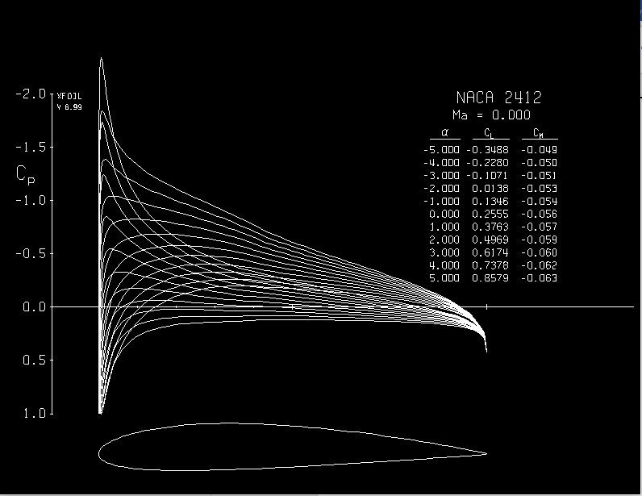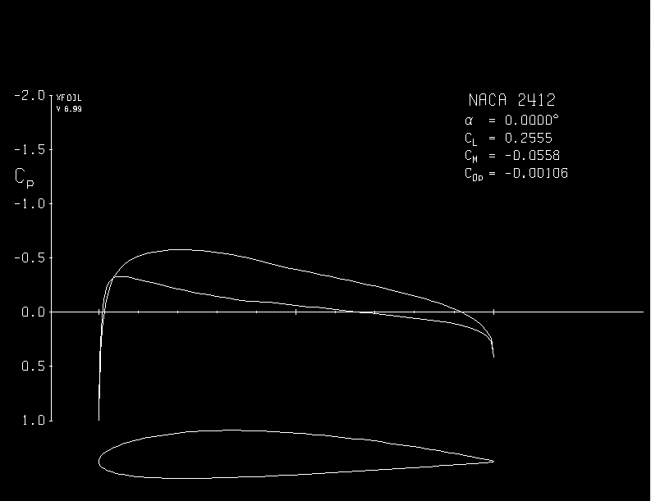







Alpha=4



Alpha = -4

