实验报告8

学号：117060400224 姓名：淦苏莉 班级：应用统计二班

实验名称：重复性实验

实验要求：利用循环和重复完成实验

程序习题：

1. 随机密码生成

实例代码：

import random

ch=['a','b','c','d','e','f','g','h','i','j','k','l','m','n','o','p','q','r','s','t','u','v','w','x','y','z','A','B','C','D','E','F','G','H','I','J','K','L','M','N','O','P','Q','R','S','T','U','V','W','M','X','Y','Z','1','2','3','4','5','6','7','8','9']

def generatePSW(chList,n=8):

psw=[]

size=len(chList)

for i in range(n):

k=random.randint(0,size-1)

psw.append(chList[k])

return"".join(psw)

for i in range(10):

print("第{0:2}个随机密码:{1}".format(i+1,generatePSW(ch)))

运行结果：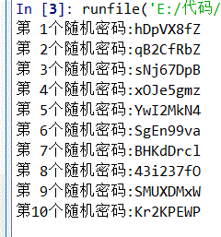

1. 重复元素判定

实例代码：

def isRepetitive(ls):

for x in ls:

n =ls.count(x)

if n>1:

return True

return False

list1=[1,2,3,4,1,2,3,4]

if isRepetitive(list1):

print("有重复")

else:

print("没有重复")