**Lab 2 – Linux Account Management and ACLs [10 Marks total]**

**Due Date – 26/3/2023**

* Follow the instructions in this document,
* Answer the questions in the order they appear in this document and in the labs included in this document (See each lab’s document for more instructions)
* Submit the file (.doc, .docx, .pdf) using the ecs submission system (i.e. Lab2). <https://apps.ecs.vuw.ac.nz/submit/CYBR371>

**Instructions:**

Sign in into the NETLAB (https://netlab.ecs.vuw.ac.nz/) with the provided credentials and complete the following labs:

• **Lab 1: Linux Account Management**

• **Lab 2: Linux Access Control List**

**Part 1 - Linux Account Management**

Complete the lab 1 “**Linux Account Management**” and answer the following questions:

* *Question 1.1 [2 Marks] - What is the numerical or octal representation of the following permissions?*

rwxrw-r-t = 1765

r-S-wx--x = 4431

rwxr-xr-- = 754

r-Sr-sr-x = 6455

432 = r--wx-w-

3532 = r-x-ws-wT

6713 = rws--s-wx

1530 = r-x-wx--T

* *Question 1.2 [1 Mark] - If the umask value for a user is 035, what are the default file and directory permissions set for the user? Write the permissions and how they were calculated.*

Default file permissions are 666 = rw-rw-rw

Default directory permissions are 777 = rwxrwxrwx

With a umask = 035, directory permissions are 742.

111 111 111 (777) &

111 100 010 (!035)

=

111 100 010 = 742

Permissions = rwx r-- -w-

While file permissions would be 642.

110 110 110 (666) &

111 100 010 (!035)

=

110 100 010 = 642

Permissions = rw-r--w-

* *Question 1.3 [1 Mark] - If the default permissions given to files the user xyz creates are rw-r--r--, what are the default permissions set for the directories created by the user? Write the permissions and how they were calculated.*

Default file permissions = 666. rw-r--r-- = 644 --> 666-644 = 022 🡪 umask=022

Default directory permissions = 777. (777-022 = 755) 🡪 rwx r-x r-x

**Part 2 - Linux Access Control List (ACL)**

Complete the lab “**Linux Access Control List**” and answer the questions highlighted in this document in the order they appear in the lab document. Please note that the questions below are dependent on the sequence of the lab instructions and must be followed and answered step by step as they appear in the **Linux Access Control List** lab document.

* *Question 2.1 [1 Mark]: Write the command(s) you used to add the users above with their associated provided information*

*sudo adduser cybr371*

*usermod -g sudo cybr371*

*sudo adduser ben*

*usermod -g sudo ben*

*sudo adduser david*

*sudo adduser mary*

*sudo adduser masood*

* *Question 2.2 [1 Mark]: after completion of step 6, Write the command you used to append the line and explain the output (i.e. did you manage to append the line? Explain why the command was successful and/or why it failed).*

*cd /home/cybr371*

*echo “This line is from the user ben” >> myfile.txt*

*cat myfile.txt*

*The command was successful as the permissions for the myfile.txt enabled both read and write for groups (you can see the permissions when running getfacl on myfile.txt- it shows that group is set to read and write). As Ben is part of the same group as cybr371 (sudo), it successfully wrote to the file, appending the new line.*

* *Question 2.3 [1 Mark]: after completion of step 7, what was the command you used to write to the file? Explain whether the operation is successful or not).*

*cd /home/cybr371*

*echo “This line is from the user david” >> myfile.txt*

*Upon execution, I received the error message = bash: myfile.txt : permission denied*

*This command was unsuccessful as the permissions set for the file does not allow those segregated within the “others” to be able to write to the file. You can see that the permission for the myfile.txt only says that the ‘others’ permission is set to only read.*

* *Question 2.4 [1 Mark]: after completion of step 12, Write a command to set an ACL to* ***deny*** *all access (read, write and execute) to myfile.txt for user david.*

*setfacl -m u:david:- myfile.txt*

*Running getfacl myfile.txt after executing the above command shows that davids permission as:*

*user:david:---*

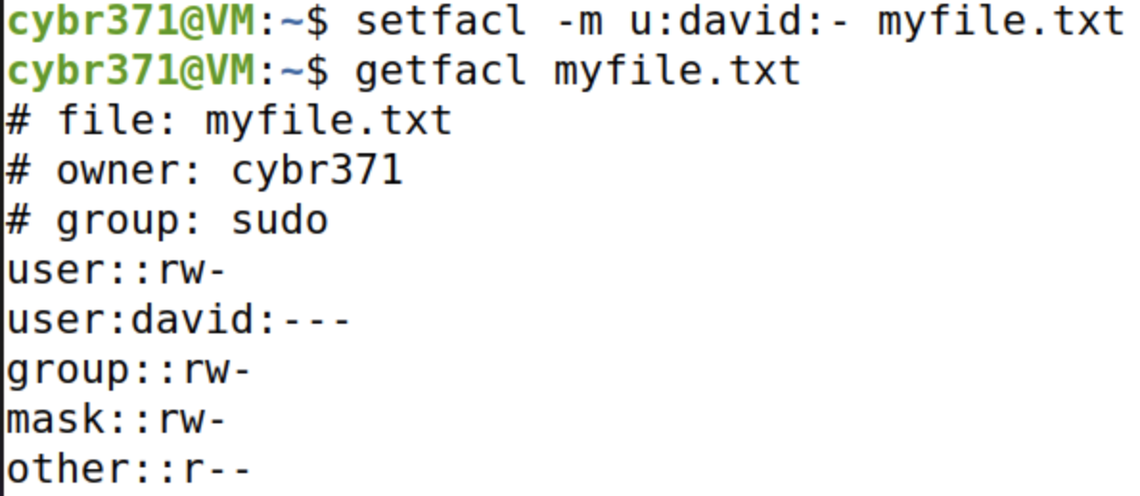

* *Question 2.5 [1 Mark] – after completion of step 12, Login as user masood and issue a command to read the content of the file mytext.txt in the cybr371’s home directory. Can the user masood read the file? Write the command and explain the output of the command.*

*cd /home/cybr371*

*cat myfile.txt*

*Yes, user masood can read the file. By executing the above command, it successfully printed the contents of the file. This is because the permissions for that file have set the “others” permission to only read. As user masood is neither part of the sudo group, he can not write and execute to the file- only being able granted read access.*

*We can test this by attempting to write to the myfile.txt 🡪 echo “this is masood” >> myfile.txt 🡪 returns with bash: myfile.txt: permission denied.*

* *Question 2.6 [1 Mark]: Write a command to create an ACL entry for user mary with write and execute permissions only on the file myfile.txt.*

setfacl -m u:mary:-wx myfile.txt

getfacl myfile.txt 🡪

user:mary:-wx

We can test that these permissions are correct by switching over to marys account and attempting to execute 🡪 cat myfile.txt

As suspected, upon executing the read command, it returned with cat: myfile.txt: Permission denied.

Now if we executed the command 🡪 echo “this is mary” >> myfile.txt, we can see that the command is successful.

