**K-NN Results**

PS12_1_8

Number of neighbors = 3

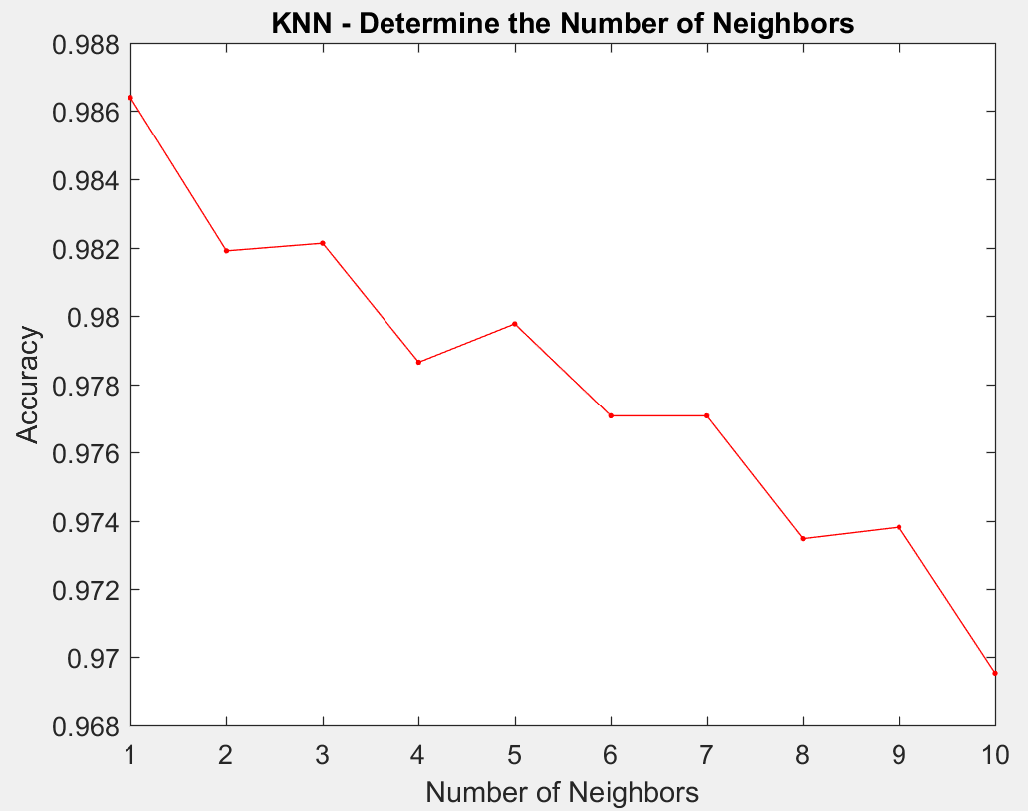

Validation Confusion Matrix:

3064 29 0 0 0

29 2825 24 0 0

1 40 2078 11 2

0 3 19 609 1

0 0 0 0 161

Validation Accuracy = 98.212680%

Testing Confusion Matrix:

3089 26 0 0 0

30 2930 23 1 0

2 39 1963 10 0

0 2 12 607 2

0 0 1 1 158

Testing Accuracy = 98.325090%

PS12_1_7

Number of neighbors = 3

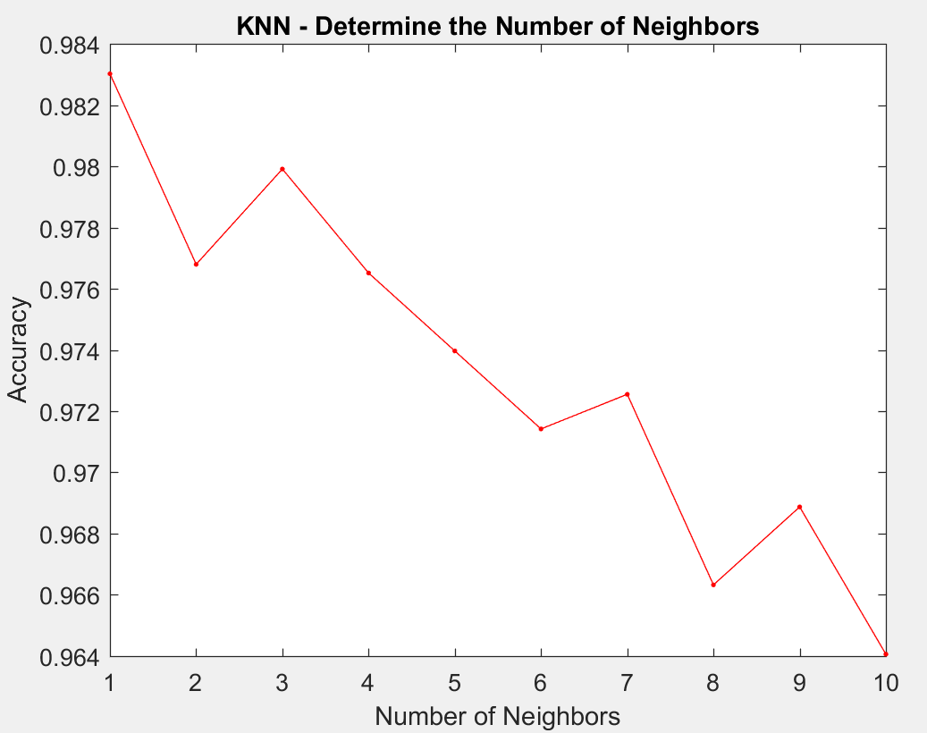

Validation Confusion Matrix:

2106 15 0 0

35 1192 7 0

0 11 126 0

0 0 3 39

Validation Accuracy = 97.990945%

Testing Confusion Matrix:

2117 15 0 0

26 1177 7 0

0 7 127 0

0 0 2 55

Testing Accuracy = 98.386640%

PS12_3_3

Number of neighbors = 3

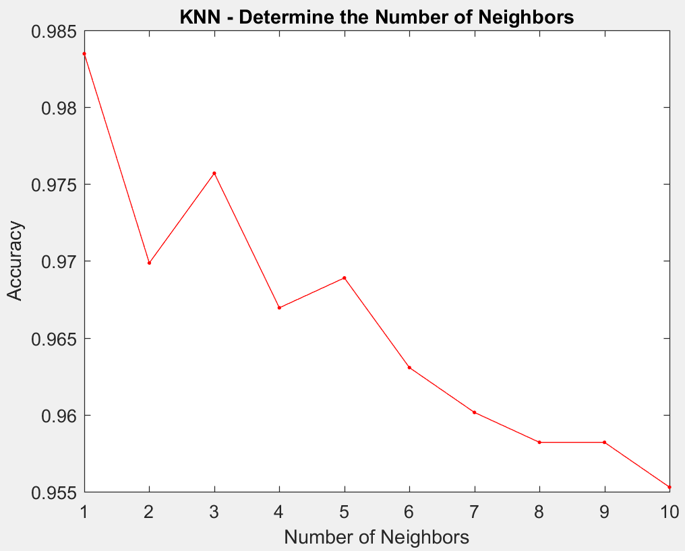

Validation Confusion Matrix:

523 3 0 0

18 298 2 0

1 0 136 0

0 0 1 47

Validation Accuracy = 97.570457%

Testing Confusion Matrix:

524 4 1 0

23 328 2 0

1 2 108 0

0 0 1 36

Testing Accuracy = 96.699029%