**04 NOVEMBER 2020**

**Grade 7 MathEMATICS Exam**

**Paper 2**

**SECTION A (25 MARKS)**

**Answer all questions from this section**

1. Find the product of 0.07 and 9 [2]

2. How many minutes are of a day? [2]

3. Compare the following statements using >, < or = to make them true.

a) $\frac{3}{5}$ $\frac{3}{4}$ [1]

b) 3² 2³ [1]

c) 0,45 [1]

4. Find the value of

a) $\frac{0,04}{0,5}$ in decimal form, [2]

b) 6 + 4 x 10 = [2]

5a) What is the name of a triangle with two equal sides? [2]

b) The perimeter of an equilateral triangle is found by saying -____________ [2]

6.a) Chenai bought a dress for $14.32. She later sold it and made a profit of $5.25. What was her selling price? [2]

b) What is the value of 3 five dollar notes, 2 ten dollar notes, 4 twenty cent coins and 3 five cent coins? [2]

7. In a factory each worker packs 288 packets of biscuits in a day. There are 36 workers. How many packets of biscuits are packed altogether? [2]

8.

The graph above shows marks obtained by Thabani in four csubjects.

a) In which subject did Thabani perform worst? [1]

b) Calculate Thabani’s average mark. [3]

**SECTION B (15 MARKS)**

**Answer any three questions in this section**

9 a) How many years has a century? [2]

b) My uncle was ¾ of a century old when he died. How old was he? [3]

10a) Write 0.49m as centimeters. [2]

b) MrCherai buys four 500ml packets of milk a day. How much milk, in litres does he use in one week? [3]

11a) What do we do to change tonnes to kilograms? [2]

b) The gross mass of a truck is 8,995 tonnes. The mass of the empty truck is 2,367 tonnes. Find the net mass. [3]

12.a) From 13 take away 10 $\frac{7}{10}$. [2]

b) Paida got 85 marks out of a hundred. Express this mark as a decimal. [2]

c) Write 0.09 as a percentage. [1]

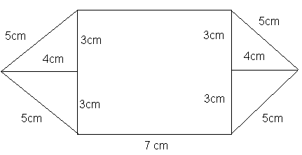13.

a) What is the perimeter of this shape? [2]

b) Calculate the area of the shape above. [3]