**Candidate Name Centre Number Candidate Number**



**ZIMBABWE REPUBLIC POLICE EDUCATION SECTION**

**GRADE SEVEN 2022 MOCK EXAMINATION**

**SOCIAL SCIENCES 705/2**

**PAPER 2**

SEPTEMBER 2022 Time: 1 hour 30 minutes

**Section A**

Answer **all** questions.

|  |  |
| --- | --- |
| **FOR EXAMINER’S USE** | |
| **Section A** |  |
| 1 |  |
| 2 |  |
| 3 |  |
| 4 |  |
| 5 |  |
| **Section B** |  |
|  |  |
|  |  |
| **Section C** |  |
|  |  |
|  |  |
| **TOTAL** |  |

Write your answers in the spaces provided on the question paper.

**Section B**

Answer any **three** questions.

Write your answers in the spaces provided on the question paper.

**Section C**

Answer any **two** questions.

Write your answers in the spaces provided on the question paper.

**This question paper consists of 8 printed pages**

ZRP Schools Examination Board, 2022 Mock Examinations

**[Turn over]**

**Section A**

Answer **all** questions in this section.

Write your answers in the spaces provided on the question paper.

1. Mr Hosho has twenty one wives. His family consists of parents and children.
2. Name the type of family Mr Hosho has.

_________________________________________________­­­­­­­­ [1]

1. Give **one** cause of family dynamics.

_________________________________________________ [1]

1. Define a lineage.

___________________________________________________ [1]

1. Identify what is used to trace one’s lineage.

___________________________________________________ [1]

1. State the importance of a totem.

____________________________________________________ [1]

1. The diagram shows friends influencing each other to take drugs and alcohol.



(a) Give any **one** reason why peer pressure is bad.

___________________________________________________ [1]

(b) Identify **one** way in which you can withstand peer pressure.

____________________________________________________ [1]

(c) State **one** reason why it is important to be part of a religion.

____________________________________________________ [1]

(d) List any **one** place where religious art is displayed.

__________________________________________________ __ [1]

(e) Give any **one** way in which children can be sexually abused.

________________________________________________ [1]

3. Zimbabwe has both natural and cultural heritage.

(a) Give **one** example of a cultural heritage.

­­­­­­­_____________________________________________________ [1]

(b) The diagram shows a natural heritage.

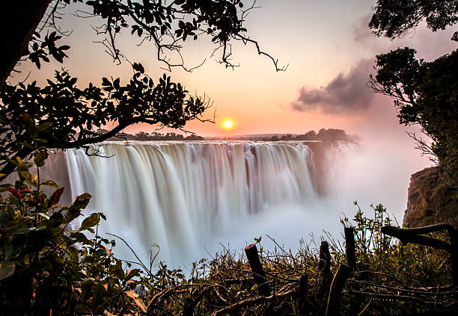

(i) Name the natural heritage site.

_______________________________________________________ [1]

(ii) State **one** importance of heritage sites

________________________________________________________ [1]

(c) State **one** cause of marital disputes.

________________________________________________________ [1]

1. Give **one** example of a National event in Zimbabwe.

­­­­­­­­­­­­­­­­­­­­­­­ ____________________________________________________ [1]

4. Natural and man-made disasters can be avoided.

(a) (i) Name **one** natural disaster.

___________________________________________________ [1]

(ii) State **one** way man-made disasters can be avoided.

____________________________________________________ [1]

(b) Suggest **one** way of acquiring accommodation.

_______________________________________________________ [1]

(c) The process of raising awareness of goods being sold to consumers is called

__________________________________________________ [1]

(d) Identify **one** effect of water pollution.

____________________________________________________ [1]

5. (a) (i) Define personal hygiene.

______________________________________________________ [1]

(ii) Give **one** example of a non-chronic disease.

________________________________________________________ [1]

1. Name the religion which believes that cleanliness is half of faith.

________________________________________________________ [1]

1. (i) State **one** good career in one’s life time.

____________________________________________________ [1]

(ii) Explain why the career named in (c) (i) is good.

_________________________________________________________ [1]

**Section B**

Answer any **three** questions in this section.

Write your answers in the spaces provided on the question paper.

6. Jesus Christ’s ministry started when he was baptised.

1. (i) State the name of the person who baptized Jesus.

_______________________________________________________ [1]

(ii) State the place where Jesus was baptised.

_________________________________________________________ [1]

(b) After the Pentecost, the apostles worshipped God by performing miracles.

Describe what happened at the Pentecost.

________________________________________________________ [1]

(c) The parable of the stewardship teaches

_______________________________________________________ [1]

1. Briefly explain what the Lord’s supper is known for.

____________________________________________________________ [1]

7. (a) The diagram shows an artifact of a religion.

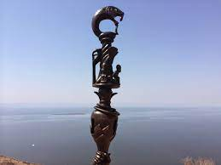

(i) Name the artifact.

_____________________________________________________ [1]

(ii) Give **one** ceremony of the indigenous religion.

____________________________________________________ [1]

(b) State any **one** national ancestor in Zimbabwe who was prominent in the 18th

century.

___________________________________________________________ [1]

(c) Name the famous shrine in Matabeleland used for rituals.

__________________________________________________________ [1]

(d) State **one** taboo in indigenous religion.

___________________________________________________________ [1]

8. (a) Give the name of the founder of the Jewish religion.

________________________________________________________ [1]

(b) Name the holy day in Judaism.

_______________________________________________________ [1]

(c) Give any **one** role of the Scribes in Judaism.

__________________________________________________________ [1]

(d) State the religion where circumcision is a rite.

________________________________________________________ [1]

(e) Name **one** of the three divisions of books that make up the Tanakh.

__________________________________________________________ [1]

9. (a) Name any **one** prophet mentioned in the Quran.

_______________________________________________________ [1]

(b) Give **one** way by which Muslims preserve the natural environment.

________________________________________________________ [1]

(c) Give **one** quality for someone to be chosen to be a Muezzin.

_______________________________________________________ [1]

(d) Identify the holy shrine in Islam.

________________________________________________________ [1]

(e) State the holy city faced by Muslims when they are praying.

_______________________________________________________ [1]

10. (a) Religions are at times positive towards those living with HIV and AIDS.

1. State any **one** religion which helps people with HIV and AIDS.

_________________________________________________ [1]

1. Identify **one** effect of HIV and AIDS.

_____________________________________________ [1]

(b) Name **one** international convention on people living with disability.

_____________________________________________________ [1]

(c) Give **one** circle of sexuality.

_____________________________________________________ [1]

(d) Define the term sexuality.

_______________________________________________________ [1]

**Section C**

Answer any **two** questions in this section.

Write your answers in the spaces provided on the question paper.

11. The San people were the first to live in Zimbabwe.

1. (i) Give any **one** way the San people lived.

_________________________________________________ [1]

(ii) Identify **one** material used by the San people to fetch water.

___________________________________________________ [1]

1. The Judiciary is made up of judges and law courts.
2. State the person who heads the judiciary.

___________________________________________________ [1]

1. Identify **one** role played by (b) (i).

_____________________________________________________ [1]

(c) Name **one** voluntary organisation that operates in Zimbabwe.

______________________________________________________ [1]

12. The diagram shows a desert in the environment.

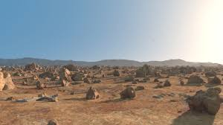

(a) (i) Name the type of a desert shown.

_______________________________________________________ [1]

(ii) Suggest **one** way of preventing desertification.

_______________________________________________________ [1]

(b) State the cause of transport disaster

______________________________________________________ [1]

(c) Identify **one** effect of transport disaster.

_____________________________________________________ [1]

(d) State **one** aim of the Red Cross.

____________________________________________________ [1]

13. (a) The picture shows people resolving conflicts at regional level.

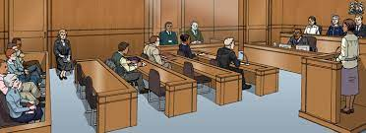

(i) Give **one** purpose of the practice.

_________________________________________________ [1]

(ii) Define the term conflict.

__________________________________________________ [1]

(b) State **one** example of mass media.

___________________________________________________ [1]

(c) Identify **one** negative effect of ICT development.

__________________________________________________ [1]

(d) State **one** acceptable way of earning money.

___________________________________________________ [1]

14. (a) The picture shows a person building.

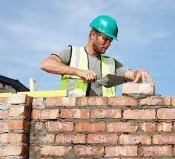

Name **one** protective clothing the man is wearing.

_______________________________________________________ [1]

(b) State **one** safety precaution that should be taken note of when at work.

_______________________________________________________ [1]

1. Name **one** indigenous method of preserving tourism destinations.

__________________________________________________ [1]

1. List **one** attribute of responsible behaviour.

________________________________________________ [1]

(e) Give **one** reason for the renunciation of citizenship.

____________________________________________________ [1]