ENSG00000117507
ID version: ENSG00000117507.4
Containing 1 protein coding transcript: ENST00000236166 (FMO6P-003), which lacks of transcript supporting evidence.

- RNA-seq Model in Ensembl did not support this transcript:
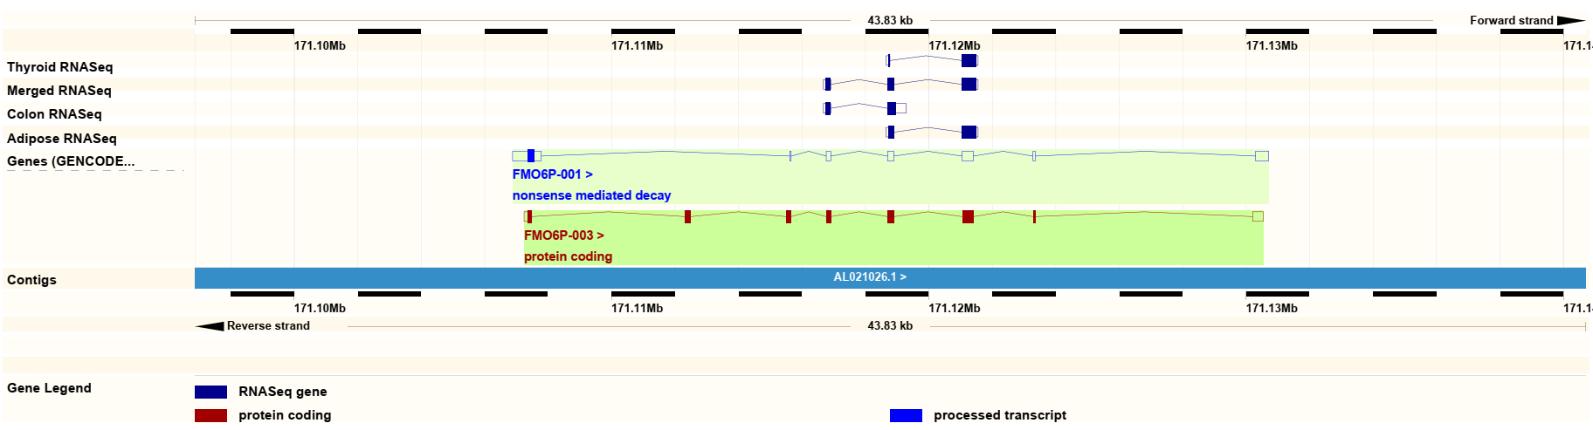
- No transcript supporting evidence for ENST00000236166:
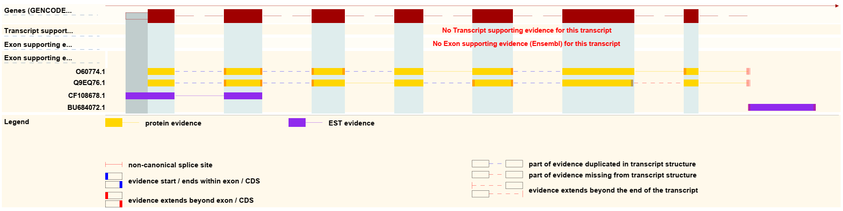

ENSG00000173209
ID version: ENSG00000173209.18
Containing 3 protein coding transcript: ENST00000394457 (AHSA2-001), ENST00000357022 (AHSA2-002) and ENST00000410073 (AHSA2-009).

- RNA-seq Model in Ensembl did not support these 3 transcripts:
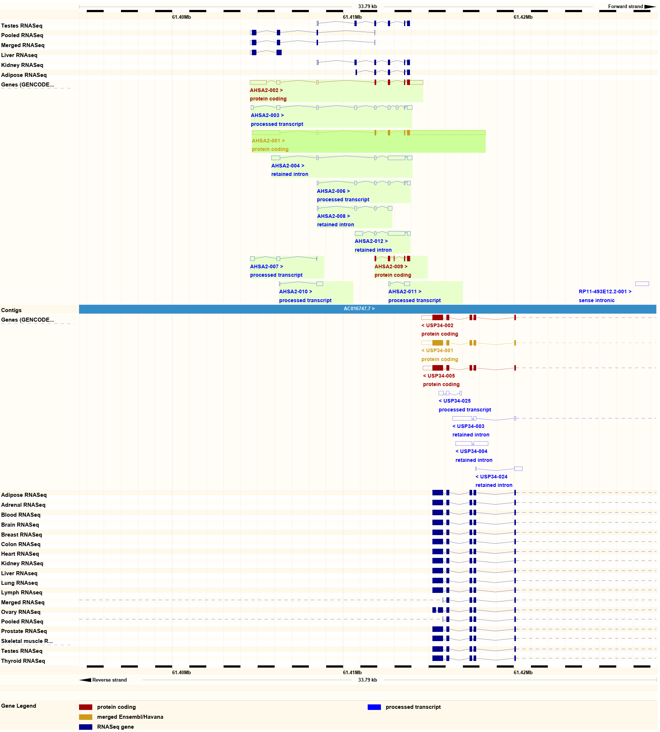
- There were 2 transcript evidence supporting for ENST00000394457: NM_152392.3 and CCDS1868.1. However, they are now being updated.
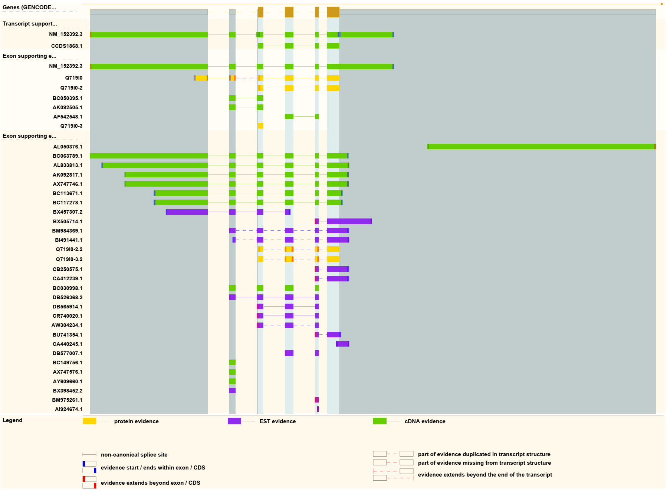
NM_152392.3 is now updated as NM_152392.4 and considered as a pseudogene:
As for CCDS1868.1, it is now removed:
- There was 1 transcript evidence supporting ENST00000357022: CCDS1868.1, which is now removed.
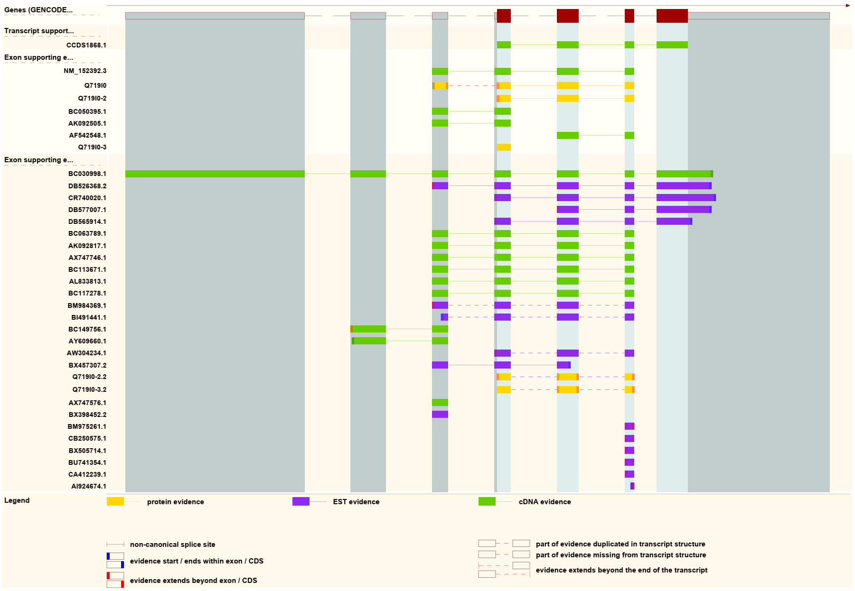
CCDS1868.1 is now removed:
- No transcript supporting evidence for ENST00000410073:
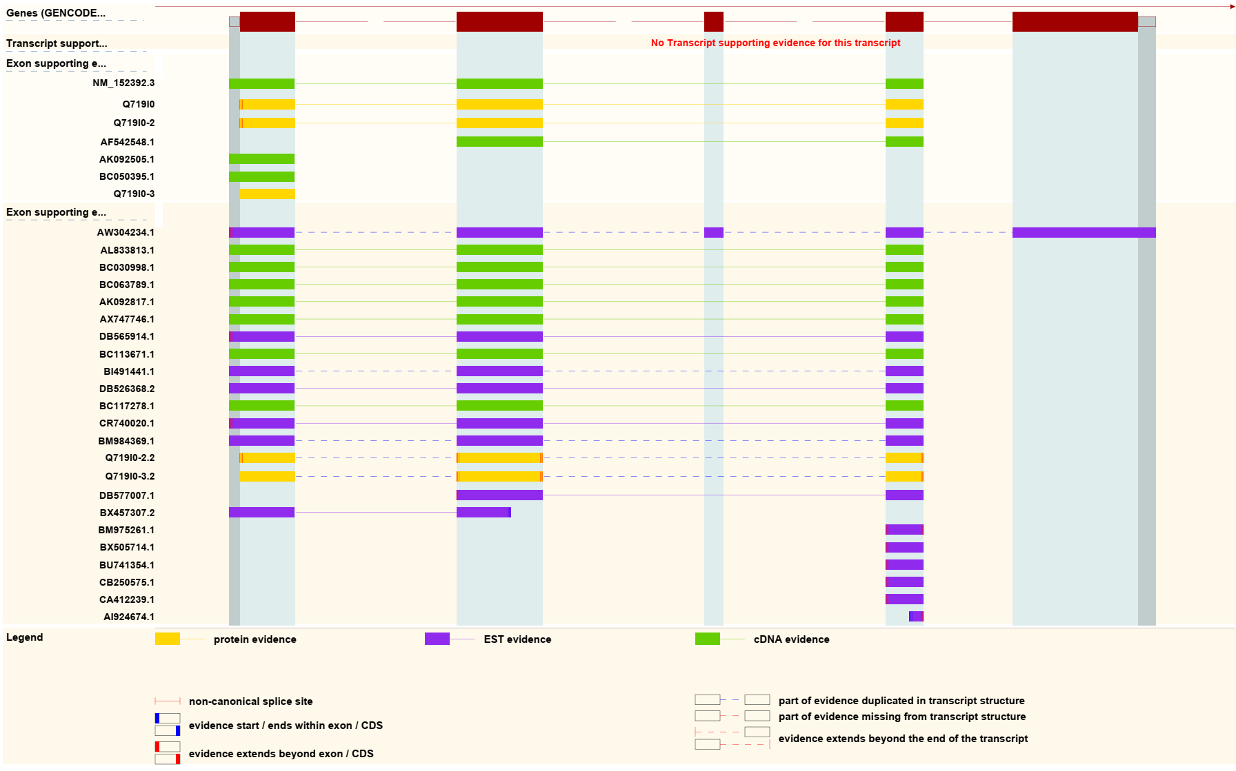

ENSG00000197376
ID version: ENSG00000197376.2
Containing 1 protein coding transcript: ENST00000310194 (OR8S1-001).

- RNA-seq Model in Ensembl did not support for ENST00000310194 (all the RNA-seq gene model were selected):
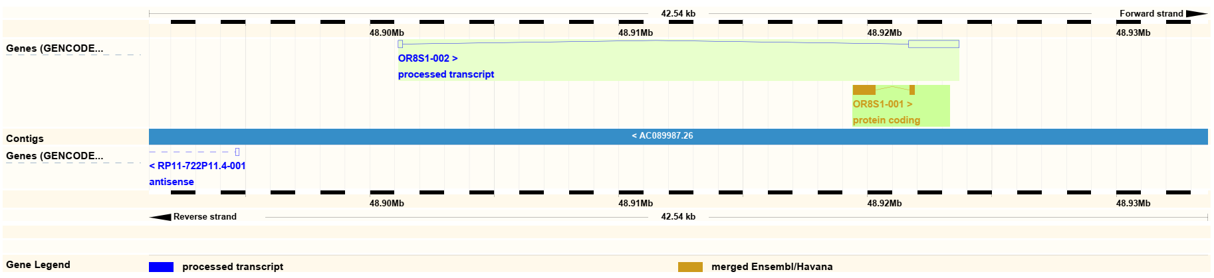
- There were 2 transcript evidence supporting for ENST00000310194: CCDS31789.1 and NM_001005203.2. However, both of them are now removed.
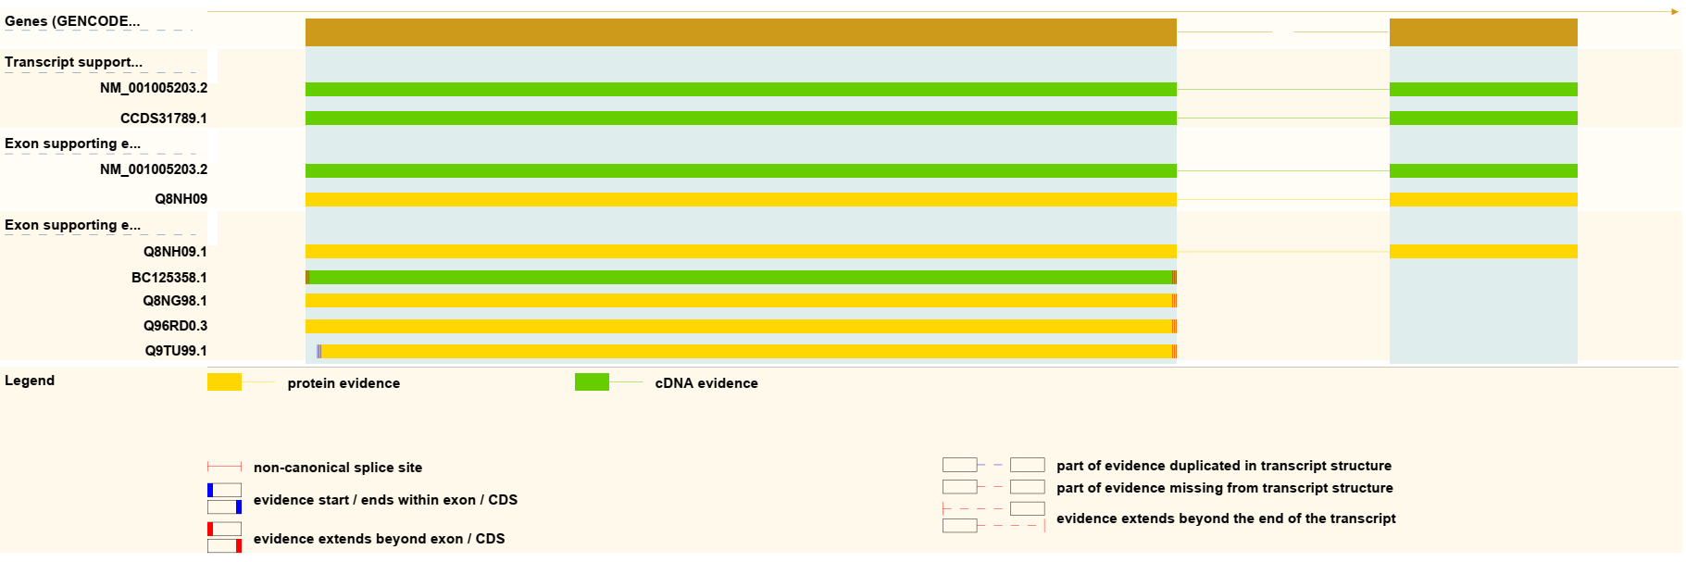
CCDS31789.1 is now removed:
As for NM_001005203.2, it is now removed since it lacking of sufficient support:

ENSG00000235156
ID version: ENSG00000235156.3
Containing 2 protein coding transcripts: ENST00000476804 (TMEM30C-002) and ENST00000429523 (TMEM30C-201).
- RNA-seq Model in Ensembl did not support these 2 transcripts:
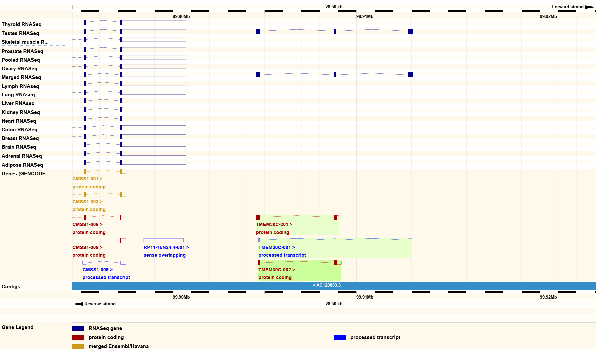
- No transcript supporting evidence for ENST00000476804:
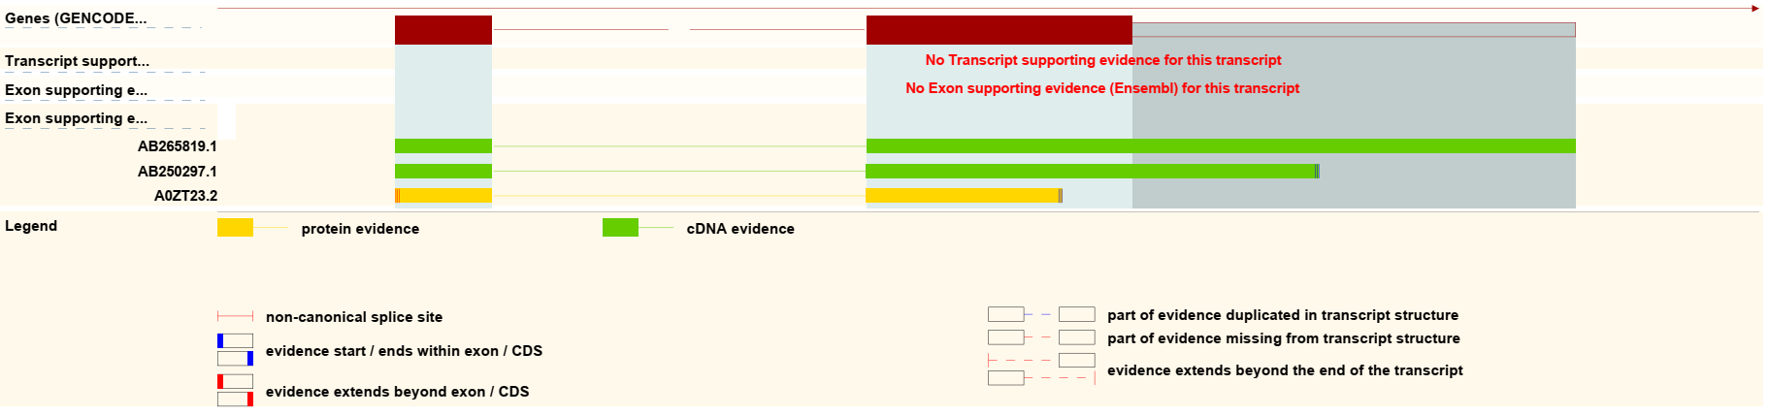
- There were 2 transcript evidence supporting for ENST00000429523: NR_028358.1 and A0ZSE6. But both of them indicated that this transcript is non-coding.
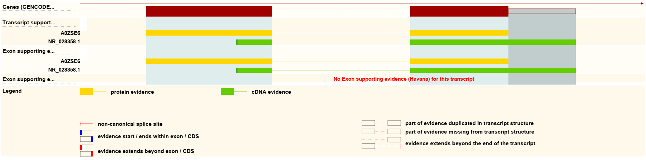
NR_028358.1 suggested that this transcript is non-coding:
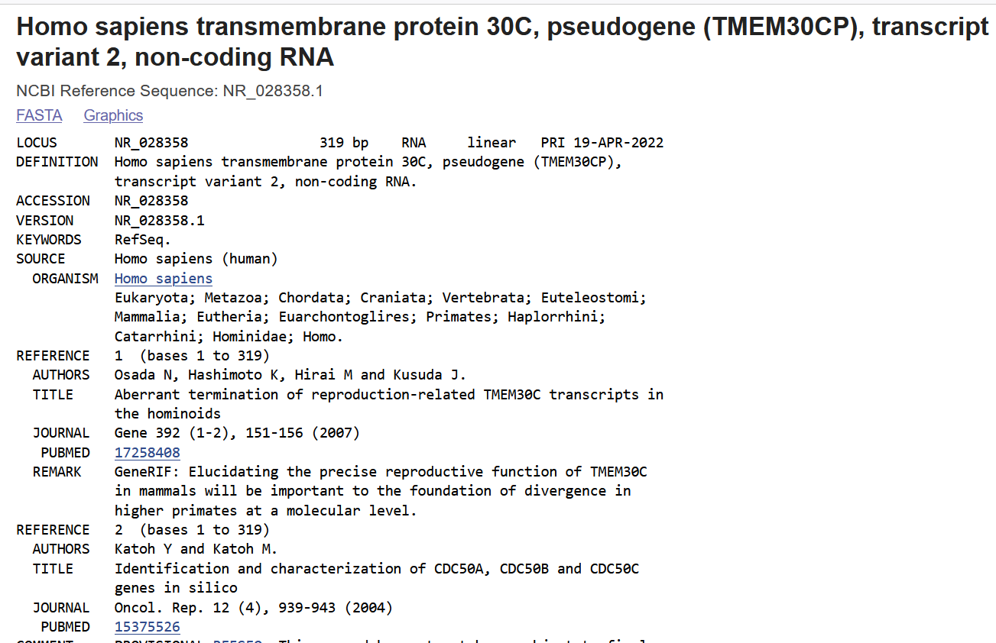
A0ZSE6 indicated that this transcript could also be non-coding:
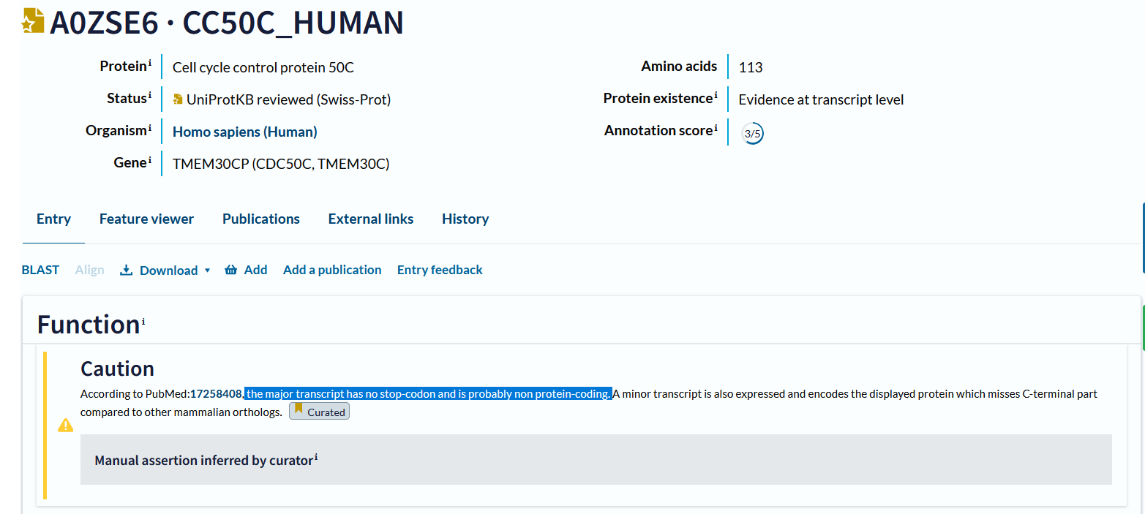

ENSG00000261603
ID version: ENSG00000261603.1
Containing 1 protein coding transcript: ENST00000463091 (PRSS46-003).

- RNA-seq Model in Ensembl did not support this transcript:
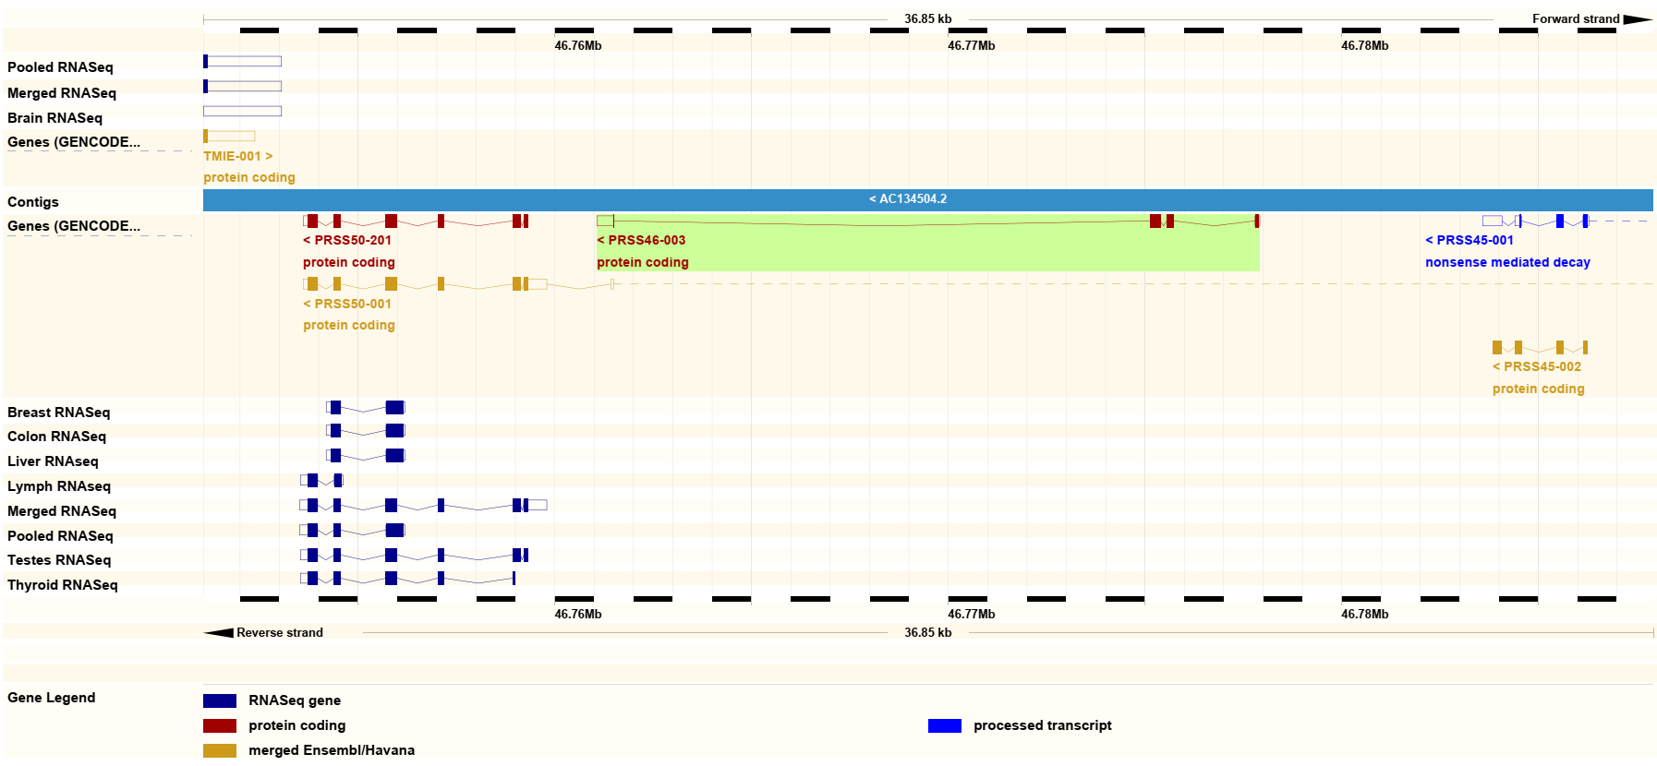
- There were 1 transcript evidence supporting for ENST00000463091: CCDS54576.1. But it is now being removed.
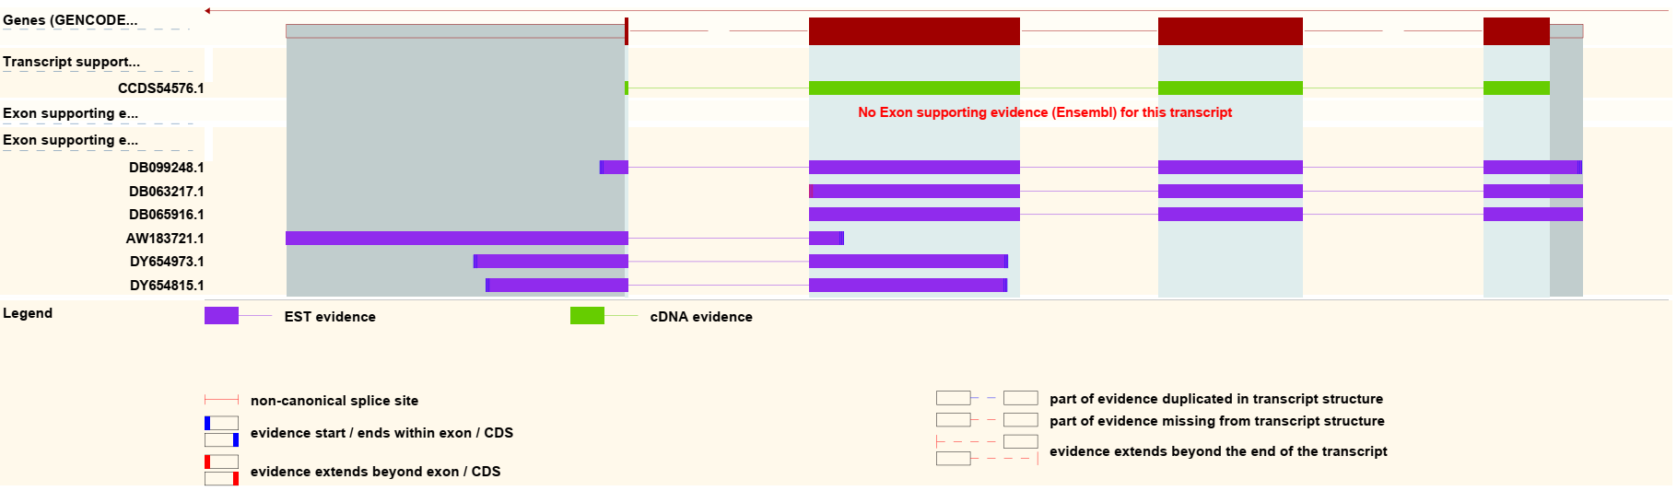
CCDS54576.1 is now removed:

