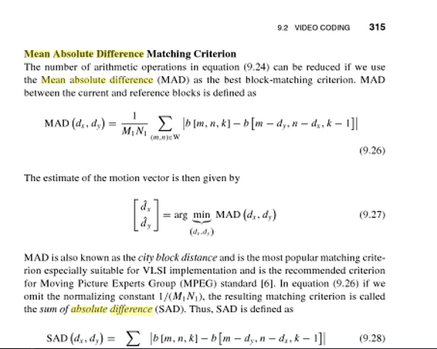

<http://books.google.com/books?id=adv71MkRIWYC&pg=PT329&lpg=PT329&dq=mean+absolute+difference+matlab&source=bl&ots=g9cuvPSBUX&sig=ZuFS-okBg15Xcm_KjsXmxVtMA68&hl=en&sa=X&ei=qwKcUbGbKqH6iwKm4YDAAw&ved=0CH0Q6AEwCQ>