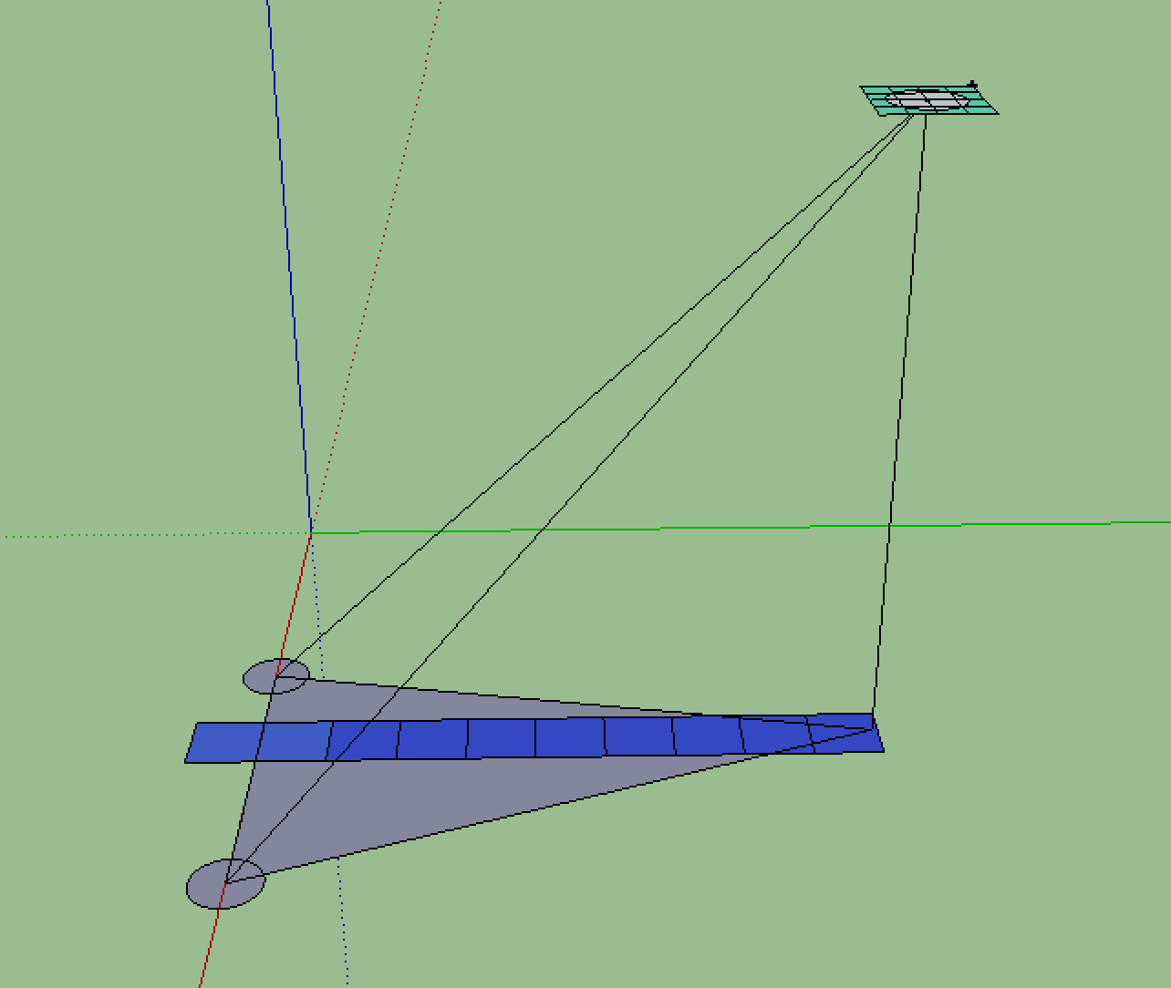

Given two cameras, as the position vector of $\vec{OC1}＝（x1,y1,0）,\vec{OC2}=(x2,y2,0)$ , now we can have two consecutive frames taken by camera 1, And we can analyze the frames to calculate the motion vector of each block.

Decide each cloud block to map with which solar cells.

1. deal with block(1,1)
2. adjust camera 1 to the position that block(1,1) is at the center of the frame. Record the 3D direction vector of camera 1 – norm $\vec{C1D}$
3. Adjust camera 2 to the position that block(1,1) is at the center of the frame as well. Record the 3D direction vector of camera 2 - norm $\vec{C2D}$
4. since $\vec{C2C1}=\left|\vec{C2D}\right|*norm\vec{C2D}+\left|\vec{C1D}\right|*norm\vec{C1D}$, there will be three equation. Suppose $\vec{OD}=$ (X,Y,Z), so
5. so the height of the cloud block is |Z|.