In model 2, we need two completely same sun-tracking cameras and they have been set up to be synced.

1. Preparation phase: calculate conversion relationship between actual distance and pixel in the photo.

Put two sun-tracking cameras along the side of the solar farm. Record the position of them as We can assume the all sunlight is parallel. Therefore the direction vector of both cameras can be recorded as .

Take consecutive frames using the two cameras at the same time. In a couple of photos which are taken at the same time, sun is at the center of the photos but the cloud blocks are at different position. Choose a cloud block in one photo which is in the same row as the sun; use it as a test block. Find out the test block in the other photo; calculate the difference in pixel in the couple of photos between the center of the test block and sun, record the pixel difference as p.

Besides, the dihedral angle γ between the plane of the photo and the ground is

Therefore, the ratio ρ of the true distance in the sky to the pixels in the photo is that ρ=, the unit is meter per pixel.

1. Calculate the motion vectors in two consecutive photos
2. Mapping motion vectors in the solar farms

Record each solar cells’ position coordinate. Set up a spatial coordinates as the picture below.

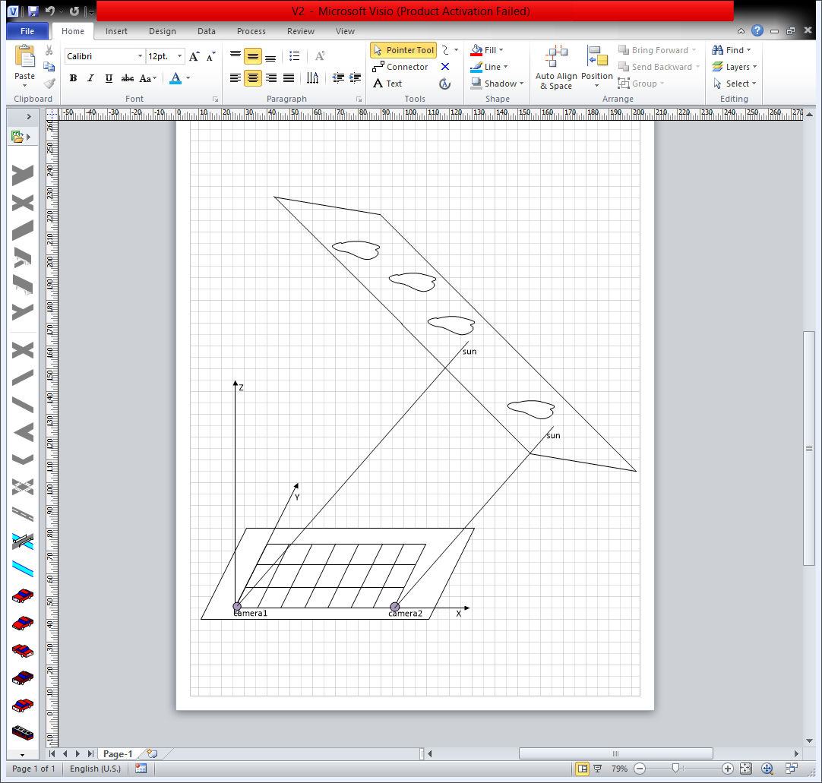

Since, the projection coordinate of sun on the ground is (0, 0, 0). Other projection coordinate of motion vector on the ground is .