In the third model, we need two normal cameras.

1. Solve ρ

Set two cameras around the solar farms, set the camera shot perpendicular to the ground. Record the camera position vectors as $\vec{OC1}$ and $\vec{OC2}$.

Since the cameras are perpendicular to the ground, the center of the photos they took should be the equivalent C1’ and C2’. Mix the two photos into one picture, $|\vec{C1’C2’}|$ is the distance between the centers in pixel. We can calculate the ratio ρ of the true distance in the sky to the pixels in the photo is that ρ= $\frac{|\vec{C1C2}|}{|\vec{C1^{'}C2^{'}}|}$, the unit is meter per pixel.

1. Map solar cells in the mixed photo

Establish a coordinate system in photo and use the sun in the photo as the origin, record it as Cs1, x-axis||Cs1Cs2, and y-axis⊥Cs1Cs2, use ρ to set up other coordinate of solar cells.

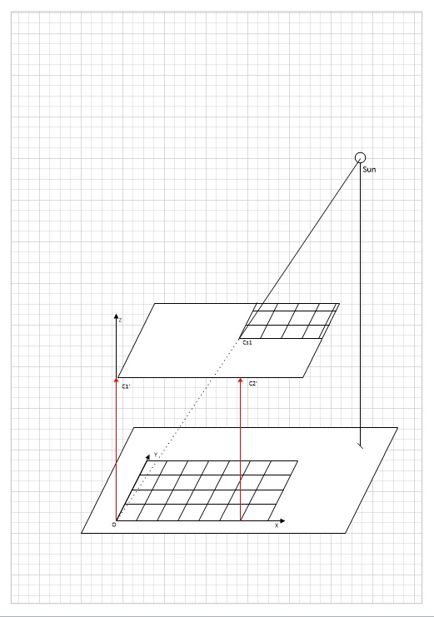

％Camera direction：只有与Z轴夹角？没有与x轴夹角or夹角为图片中SC1与C1C2夹角？

1. Use motion vectors to detect cloud and shut down solar cells.