**ALGORITHM FOR ABNORMAL DRIVING BEHAVIOR DETECTION.**

**A Project Report**

*Submitted in partial fulfilment for the award of the degree*

*Of*

**Master of Technology**

***In***

**POWER ELECTRONICS AND EMBEDDED SYSTEMS**

*By*

**VINU XAVIER**

**(16MPD0024)**

*Under the guidance of*

**A.Rammohan**

**Assistant Professor (Sr.), TIFAC-CORE,**

**Vellore Institute of Technology**



**Institute for Industry and International Program**

November, 2018



**Institute for Industry and International Program**

**DECLARATION BY THE CANDIDATE**

I hereby declare that the thesis entitled “**ALGORITHM FOR ABNORMAL DRIVING BEHAVIOR DETECTION.”** submitted by me to Vellore Institute of Technology, Vellore in partial fulfillment of the requirement for the award of the degree of **Master of Technology** in **Power Electronics and Embedded Systems** is a record of bonafide project work carried out by me under the supervision of Mr. A.Rammohan. I further declare that the work reported in this project has not been submitted and will not be submitted, either in part or in full, for the award of any other degree or diploma in this institute or any other Institute or University.

**Place**: Bangalore

**Date**: 07 October 2, 2018 **Signature of the Candidate**



**Institute for Industry and International Program**

**BONAFIDE CERTIFICATE**

This is to certify that the project work entitled “**ALGORITHM FOR ABNORMAL DRIVING BEHAVIOR DETECTION”** by **VINU XAVIER ( 16MPD0024 )**, to Vellore Institute of Technology, Vellore, in partial fulfillment of the requirement for the award of the degree of **Master of Technology** in **POWER ELECTRONICS AND EMBEDDED SYSTEMS** is a project bonafide work carried out by him under my supervision. The project fulfills the requirement as per the regulations of this Institute and in my opinion meets the necessary standards for submission. The contents of this report have not been submitted and will not be submitted either in part or in full, for the award of any other degree or diploma in this Institute or any other Institute or University.

**A.Rammohan**

**Internal Supervisor External Supervisor**

**Asst.Prof (Sr.)**

**TIFAC-CORE**

**VIT**

**Internal Examiner(s) External Examiner(s)**

**Acknowledgement**

We wish to express our heartfelt gratitude to **Dr.G.Viswanathan**, Chancellor, Vellore Institute of Technology, Vellore for providing facilities for the project.

We are highly grateful to our Vice Presidents. **Shri. Shankar Viswanathan** ,**Shri. Sekar Viswanthan and Shri.G.V.Selvam**, **Dr. Anand A.Samuel** Vice Chancellor, and **Dr. S.Narayanan** Pro-Vice Chancellor for providing necessary resources.

Our sincere gratitude to **Dr.M. Subaji**, Director, **Institute for Industry and International Program**  and **Jaidev Venkataraman,** Head of Vehicle Dynamics, Continental Automotive Components (India) Pvt. Ltd. for giving us the opportunity to undertake the project.

We would like to express my special gratitude and thanks to my internal guide **A.Rammohan,** Asst.Prof.(Sr.), TIFAC-CORE for encouraging me to complete the project successfully.

We thank the Management of Vellore Institute of Technology for permitting me to use the library resources. I also thank all the faculty members of VIT for giving me the courage and strength I needed to complete my goals. This acknowledgement would be incomplete without expressing my whole hearted thanks to my family and friends who motivated me during the course of the work.

Place:

Date: **VINU XAVIER**

**TABLE OF CONTENTS**

Contents

1 ABSTRACT 7

2 INTRODUCTION 11

2.1 MOTIVATION 11

3 Literature Survey 13

3.1 ELECTROMAGNETISM 13

3.2 Back EMF 15

3.3 Eddy Currents 15

3.4 Permanent Magnets and Electromagnets 16

3.5 Motors 19

3.5.1 Construction of DC Motor: 20

3.5.2 Yoke 20

3.5.3 Poles, and pole core: 21

3.5.4 pole shoe: 21

3.5.5 Field winding: 22

3.5.6 Armature core: 22

3.5.7 Armature winding: 22

3.6 Classification of DC Motor. 23

3.6.1 Separately Excited 23

3.6.2 Shunt 23

3.6.3 Series 24

3.6.4 Compound 25

3.7 Control of DC Motors 26

3.7.1 OPEN LOOP SPEED CONTROL 26

3.7.2 CLOSED LOOP SPEED CONTROL 31

4 DESIGN OF THE PROJECT 35

4.1 BLOCK DIAGRAM: DC MOTOR CONTROL UNIT 35

4.2 HW design 36

4.2.1 CIRCUIT DIAGRAM 36

4.2.2 Hardware Components 36

4.2.3 HW Functional Description 53

4.3 SW DESIGN: 55

5 RESULTS AND DISCUSSIONS 56

6 CONCLUSION AND FUTURE WORK 58

6.1 CONCLUSION 58

6.2 FUTURE WORK 59

7 REFERENCE 60

# ABSTRACT

The most modern Trends of the automotive industry is heading towards highly or fully automated driving. When we consider how far it can solve the existing troubles which cause the road accidents it's a very important fact that the human error is the most probable root cause for the majority of all accidents. The studies say that the driver negligence plays a vital role in the in the various reasons which cause an accident. Each and every abnormality in the driving behaviour is visible as a pattern and this thesis would like to consider various algorithms to detect the abnormalities in the driving behaviour and thereby either taking failed reactions in an appropriate manner so that prevention of accidents are possible. A drowsy or a drunken driver will always follow a pattern it is also called the degree of abnormality when considering the very regular way of driving to the same road in the same conditions. These abnormalities are visible mainly in the brake pedals the steering wheel and the suspension sensors. By carefully studying the factors which are observed in these sensors it is possible up to an extent to detect the abnormality which is not expected in that driving situation. The driving style can be continuously monitored into a database which may be efficient inside the cloud and make available continuously to run this comparison in the entire duration of driving. This thesis is mainly concentrated on the steering wheel and a sensor and various patterns which are carefully studied when taking the actual vehicle data and the software algorithm is developed as a prototype simulation in Matlab.

**LIST OF TABLES**

|  |  |  |
| --- | --- | --- |
| **Table No** | **Title** | **Page No** |
| 4.1 | Electrical Characteristics of MOSFET | 38 |
| 4.2 | Truth table of Optocoupler output voltage. | 47 |
| 5.1 | Motor terminal voltage measurement. | 57 |

**List of Figures**

|  |  |  |
| --- | --- | --- |
| **Figure No** | **Title** | **Page No** |
| 3.1 | Magnetic Hysteresis Loop | 18 |
| 3.2 | Different motor types | 20 |
| 3.3 | Construction of DC motor | 21 |
| 3.4 | Diagrammatic sketch of a D.C. motor | 22 |
| 3.5 | Schematic of a Separately Excited DC motor | 24 |
| 3.6 | Schematic of a Shunt-Wound DC Machine | 25 |
| 3.7 | Schematic of a Series-Wound DC motor | 25 |
| 3.8 | Compound-Wound DC motor | 26 |
| 3.9 | Model of Separately excited DC motor | 29 |
| 3.10 | closed loop speed control of a separately excited D.C motor | 32 |
| 3.11 | DC chopper circuit | 33 |
| 3.12 | Switching pulses | 34 |
| 4.1 | Block diagram DC Motor control | 35 |
| 4.2 | Circuit Diagram | 36 |
| 4.3 | Electrical connection of MOSFET | 37 |
| 4.4 | MY1016 250W 24V DC Motor | 39 |
| 4.5 | DPDT Relay | 40 |
| 4.6 | DPDT Relay Wiring Diagram | 41 |
| 4.7 | Current sensing technique at high current | 42 |
| 4.8 | Current sensing technique at low current | 43 |
| 4.9 | Opto coupler | 44 |
| 4.10 | Working of opto coupler | 45 |
| 4.11 | Testing circuit for opto coupler. | 47 |
| 4.12 | Arduino Due Pin Diagram | 48 |
| 4.13 | Arduino Due Schematic Diagram | 49 |
| 4.14 | PWM resolutions | 52 |
| 4.15 | DPDT relay connection | 54 |
| 4.16 | SW flowchart | 55 |
| 5.1 | Actual picture of HW | 57 |
| 6.1 | Expanded Block diagram DC Motor control | 59 |

**LIST OF Abbreviations**

|  |  |
| --- | --- |
| **ACRONYM** | **EXPANSION** |
| **MOSFET** | Metal Oxide Semiconductor Field Effect Transistor |
| **PWM** | Pulse Width Modulation |
| **DPDT** | Double Pole Double Throw |
| **LED** | Light Emitting Diode |
| **USB** | Universal Serial Bus |
| **ADC** | Analog To Digital Converter |
| **IDE** | Integrated Development Environment |
| **EMF** | Electromotive force |
|  |  |
|  |  |
|  |  |

# INTRODUCTION

## MOTIVATION

The road accident cause death of millions and facilities of more than that every year in the world. Even though the most modern technology heading towards autonomous driving the limitation of the technology is always the human driver who is sitting inside the car. Irrespective of house office ticketed is the technology the errors caused by the situations of negligence situations of lack of skills situations of ignorance situations of absence of mind situations of carelessness etc be in the leading position of the root causes of accidents. Irrespective of how best is the system which is fitted into a car or any automotive, it can only react to the situation but cannot prevent it. The root cause of the situation is the world itself is not having as many trained and skilled drivers of many automotive vehicles available in the world. a highly over a fully automatic driving can be the final solution for this, but the time it would take to come into an action can be decades or more than that. Under developing countries like India needs more time to have that infrastructure which will help the introduction of fully automated driving. In the next 3 years, India will be the third largest vehicle production countries in the world. When considering the death rate of road accidents caused every year in India we stand in the top of the world.

In parallel, the computational Technologies at the cost of implementing that is going down drastically into a very cheap opportunity so that implementing a Complex algorithm and deploying that it to bigger Industries like automotive would not make a huge amount of time to come into the market as compared to the fully automated driving. More than that, people following the road rules and having the right skill set to be eligible to drive in an in a complex driving situation like in India is very less. The authority is even given out the driving licenses for the price without even checking whether the driver has the right skills physically and mentally to handle Complex situations. People do not even think about following the line, wearing a seatbelt, following the speed rules and giving way to the most deserved.

Policing all the situation is hard. The only way in which it can be solved is self-monitoring of the driving behavior buy a system which is fitted into the vehicle itself. This system should be able to take care by itself when an abnormality is continuously visible and the human driver who is driving that vehicle is not taking care of or not improving the driving situations. Accumulating all these decisions the system should be able to judge that the person who is driving the car is not in the physical and mental situation to safely execute the driving manoeuvre.

In these days, the software is helpful to detect such kind of situations the installed software can react reducing after speed limit or glowing the hazard warning lamps or even take over the control of the vehicle and park to the nearest safest possible area and thereby allowing removing this vehicle from the traffic. The software could be complex to detect pattern based on machine learning and lead to Complex hardware to be installed into each and every vehicle which can increase the cost of the vehicle from affordable range. This situation can be solved by the technology of cloud computing where the input data is transferred into the cloud and the complex data processing happens in a remote area in the cloud. And, the decisions are given back to each and individual vehicles so that there are actuators which are mechanical and software facilitated and thereby reacting to the situation by considering the intensity of abnormality in the driving behaviour.

# **Literature** Survey

Literature review was conducted to better understand the principles and applications of this research. Below are the findings of this review.

## ELECTROMAGNETISM

When current carrying conductor is placed in a magnetic field it experience a force.

*F = BIL*.

Where L is a vector pointing in the direction of current flow with a magnitude equal to the length of the conductor, I is the current, B is a vector in the direction of the magnetic field and FB is the resultant force vector of the interaction. Thus increasing the strength of the magnetic field by increasing the current in a wire will increase the force exerted on the wire. In motors, the magnetic field is provided by permanent magnets or by multiple turns of a wire with a current flowing through it, surrounding an iron core. In the latter, the magnetic field strength is calculated using below equation

F = NI

Where F is the magnetic field flux, N is the number of turns of a wire and I is the current passing through the wire. It can be inferred from this equation that the magnetic moment produced in a motor can be increased by increasing the number of turns or increasing the current in the wire.

Typically it is more desirable to increase the number of turns as opposed to increasing the current in the wire. This is because of the Power Loss Equation, which represents the amount of power lost typically to heat generation.

Ploss = I2R

In this equation I is the current in the wire and R is the resistance of the wire as calculated. As can be seen in this equation, the power lost to heat is a square of the current! So, increasing the number of turns in a motor (as opposed to increasing current flow) is normally done to increase magnetic strength and hence torque. However this must be done in moderation. Equation 2.4 shows that the resistance of a wire depends on the length and diameter of the wire.

R = (4. ρ. L)/ πd2

Where l is the length of the wire, d is the diameter of the wire and r is the resistivity per unit length of the wire, measured in ohms. As conductor diameter decreases, the resistance increases, again contributing to power lost through heat dissipation. On the other hand if the conductor diameter is too large it becomes difficult to bend and manipulate, thereby preventing multiple turns of the wire in the motor. Additionally, and more notable, is the fact that an increase in wire diameter also directly increases the weight and cost of the motor. In practice, copper is by far the most common conductor material used in motors, with aluminum being a very distant 2nd place.

In summary there are several fundamental parameters in these equations that should be carefully considered when designing and selecting a motor. For example, the resistance, length and gauge of the wire that is used, is very important in determining magnetic flux, motor capabilities, cost and weight. In general, electromagnets can be much more powerful than permanent magnets because they are only restricted by the amount of current and the number of turns.

## Back EMF

According to Faraday’s law of induction, shown in Equation 2.5, the Electro Motive Force (EMF) induced in a circuit is directly proportional to the time rate of change of the magnetic flux through the circuit.

E = dB/dt (2.5)

The rotation of the armature in the magnetic field causes the change in magnetic flux mentioned above. Therefore, all motors generate a back EMF. Additionally, Lenz’s Law states that the induced current in a loop is always in the direction that creates a magnetic field that opposes the change in magnetic flux through the area enclosed by the loop.

Therefore, the back EMF is always in opposition to the flow of current in the armature. It is also interesting to note that the change in magnetic flux can be accomplished by varying the voltage and current in the windings of the field, and not just the position of the coil in the field. This is of particular interest in electric motors as a means of varying the speed of the motor.

## Eddy Currents

Faraday’s and Lenz’s law also explain the formation of eddy currents. Similar to those in fluid dynamics, eddy currents are circular currents that produce losses. In a motor, these eddy currents form within the motor armature. The eddy currents produce heat loss in the armature and thus have a negative impact on the efficiency of the motor. To attempt to reduce the prevalence of eddy currents, motor armatures are built with laminations. These layers of metal reduce the formation of Eddy Currents, while still allowing the armature to perform its function.

## Permanent Magnets and Electromagnets

Some crystalline materials exhibit a strong magnetic effect called ferromagnetism. As the name suggests, iron is one of these materials. Substances like iron contain regions called domains that have net magnetic moments. When these types of materials are subjected to an external magnetic field, the random magnetic moments in the material begin to become aligned, eventually to the point where all the moments in that material are aligned. This point is called saturation.

As the magnetic field is released from these materials, some of the magnetic moments return to randomness, but some stay aligned. This retention in magnetism is called hysteresis and is illustrated in Figure 3.1.

Figure 3.1 represents what happens when an object, with notable permeability, is wrapped with multiple turns of wire and then a current is sent through the wire. As the current increases in the wire, the magnetic field increases until saturation is reached at point b. At this point, any additional increase in current will have no effect on the magnetic field that is produced by the object. When the current is decreased the graph approaches point c where there is now zero current in the wire but a magnetic field remains. In this case a permanent magnet has been created. If current is now sent through the wire in the opposite direction, the magnetic field decreases to point d when the magnetic field strength is null. If the current continues to increase, point e is obtained where the object is again in saturation, but with the opposite pole.

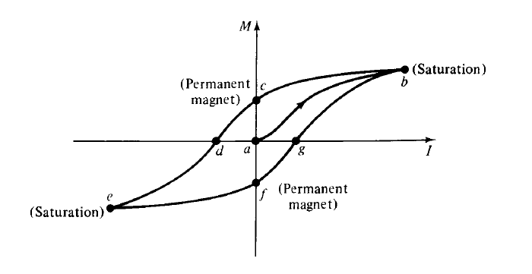

Figure 3.1: Magnetic Hysteresis Loop

In motors this has a special application during installation. For most motors to start rotating there must be a net magnetic moment in the field for the armature to react with. If a field is wired backwards during installation, current will flow in the wrong direction, thereby reducing the magnetic moment in the field and causing the motor to have problems starting. Each material has a different hysteresis curve. Some materials like iron alloyed with neodymium and boron retain their magnetic moments very well. Other material like met glass have very low magnetic hysteresis. Materials that retain a magnetic moment or have a very wide hysteresis graph are often referred to as hard magnetic materials. Substances which have a narrow hysteresis curve and do not retain a magnetic moment are referred to as soft magnetic materials.

An inference gained from this information is that materials with wide hysteresis graphs would probably be more suited to applications like the field of a DC motor, where high magnetic moment is desired. Soft magnetic materials would be better suited in applications where the magnetic field is changing often, like the armature of a DC motor for example.

Random thermal motions do compete during the aligning process, but at lower temperatures this competition is limited. However, above certain temperatures, the material properties change and it is possible for the domains to realign and remove any net magnetic moments. In such a case, the material can lose its ferromagnetic properties. This point was discovered by Pierre Curie (1859-1906) and is referred to as the Curie temperature. The Curie temperature is the point where materials change from being ferromagnetic to paramagnetic. This change is not gradual, but rather like a freezing or melting point of a metal. Motors that carry large amounts of current are most susceptible to heating and therefore are also susceptible to approaching Curie temperatures.

When this is the case, motors must incorporate some sort of cooling as protection. Most motors use air cooling, but some use liquid coolant flowing through the stator to avoid approaching Curie temperatures. Curie also discovered that the magnetic field in paramagnetic substances is proportional to the applied magnetic field and inversely proportional to the absolute temperature.

Magnetic geometry is also important in motor construction. Often permanent magnets are shaped in arcuate segments, which create points at the ends of the magnet which direct flux into the armature. This happens because the ability to conduct magnetic flux lines is different for different materials. For example, magnetic flux lines would much rather flow through iron than through air. This is because iron has a higher permeability than air. So, by carefully constructing a motor it is possible to concentrate flux lines and maximize the magnetic moment that is produced.

## Motors

Electric propulsion systems are at the heart of electric vehicles (EVs) and hybrid electric vehicles (HEVs). They consist of electric motors, power converters, and electronic controllers. The electric motor converts the electric energy into mechanical energy to propel the vehicle, or, vice versa.

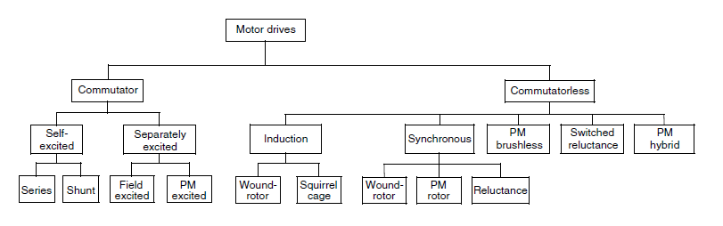

Figure 3.2: Different motor types.

Differing from the industrial applications of motors, the motors used in EVs and HEVs usually require frequent starts and stops, high rates of acceleration/deceleration, high torque and low-speed hill climbing, low torque and high-speed cruising, and a very wide speed range of operation. The motor drives for EVs and HEVs can be classified into two main groups, namely the commutator motors and commutatorless motors as illustrated in Figure 6.2. Commutator motors mainly are the traditional DC motors, which include series excited, shunt excited, compound excited, separately excited, and permanent magnet (PM) excited motors. DC motors need commutators and brushes to feed current into the armature, thus making them less reliable and unsuitable for maintenance-free operation and high speed. In addition, winding excited DC motors have low specific power density. Nevertheless, because of their mature technology and simple control, DC motor drives have been prominent in electric propulsion systems.

### Construction of DC Motor:

In order to understand the parameters affecting a motor, it is necessary to understand the basic construction and function of its components. Figure shows some of these components.

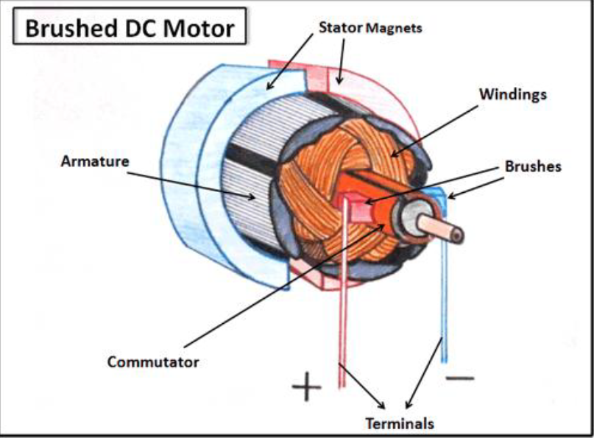

Figure 3.3: Construction of DC motor

The diagrammatic sketch of DC motors and function of each part of DC Motor is given below.

### Yoke

It is outer cover of dc motor also called as frame. It provides protection to the rotating and other part of the machine from moisture, dust etc.Yoke is an iron body which provides the path for the flux to complete the magnetic circuit and provides the mechanical support for the poles. Material Used is low reluctance material such as cast iron, silicon steel, rolled steel, cast steel etc.

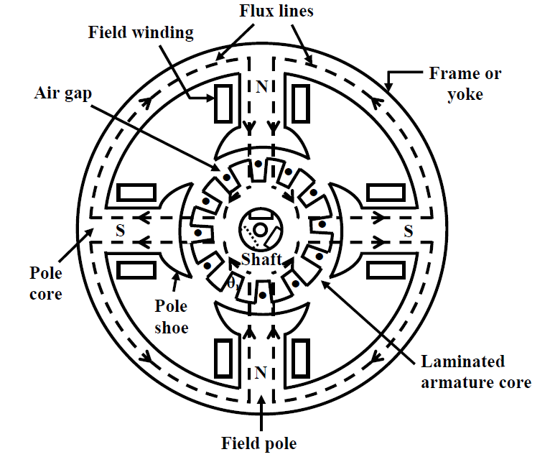

Figure 3.4: Diagrammatic sketch of a D.C. motor

### Poles, and pole core:

Poles are electromagnet, the field winding is wound over it. it produces the magnetic flux when the field winding is excited. The construction of pole is done using the lamination of particular shape to reduce the power loss due to eddy current.

### pole shoe:

Pole shoe is an extended part of a pole. Due to its typical shape, it enlarges the area of the pole, so that more flux can pass through the air gap to armature. Material use is low reluctance magnetic material such as cast steel or cast iron is used for construction of pole and pole shoe.

### Field winding:

The coil wound on the pole core are called field coils. Field coils are connected in series to form field winding. Current is passed through the field winding in a specific direction, to magnetize the poles and pole shoes. Thus magnetic flux is produce in the air gap between the pole shoe and armature. Field winding is also called as Exciting winding. Material Used for copper conductor is copper. Due to the current flowing through the field winding alternate N and S poles are produced.

### Armature core:

Armature core is a cylindrical drum mounted on the shaft. It is provided with large number of slots all over its periphery and it is parallel to the shaft axis. Armature conductors are placed in these slots. Armature core provides low reluctance path to the flux produced by the field winding. Material used is high permeability, low reluctance cast steel or cast iron material is used. Laminated construction of iron core is used to minimize the eddy current losses.

### Armature winding:

Armature conductor is placed in a armature slots present on the periphery of armature core. Armature conductor are interconnected to form the armature winding. When the armature winding is rotated using a prime mover, it cuts the magnetic flux lines and voltage gets induced in it. Armature winding is connected to the external circuit (load) through the commutator and brushes. Material Used is Armature winding is supposed to carry the entire load current hence it should be made up of conducting material such as copper.

## Classification of DC Motor.

Although the control methods for DC motors are the same regardless of construction, the performance characteristics of wound DC motors depends very much on their construction. The field/armature arrangements can exist in four varieties as noted below. These varieties have similar cost and weight characteristics because they only are different in the wiring of their terminals.

### Separately Excited

In separately excited motors the field and armature are connected to separate power supplies as shown in Figure

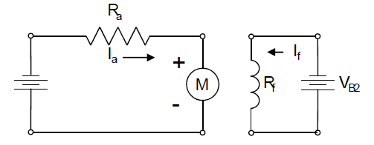

Figure 3.5: Schematic of a Separately Excited DC motor

### Shunt

Shunt-wound DC motors have the field connected in parallel with the armature as shown in Figure 2.6. This motor has natural speed governing characteristics. The speed of the motor is essentially controlled by the production of back EMF. When a load is applied to the motor, the motor begins to slow down; as this happens less back EMF is generated according to Equation (2.5). With less back EMF being generated, this allows the motor to pull more current to the armature which produces more torque, which again speeds up the motor to its original speed. In summary the DC shunt motor’s characteristics make it a constant speed motor, even under no load. The field in a shunt motor is typically many turns of fine wire because the current flowing in the field is much smaller than that in the armature.

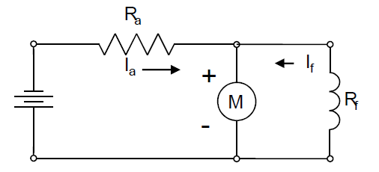 Figure 3.6: Schematic of a Shunt-Wound DC Machine

### Series

Series-wound DC motors have the field connected in series with the armature as shown in Figure 3.7

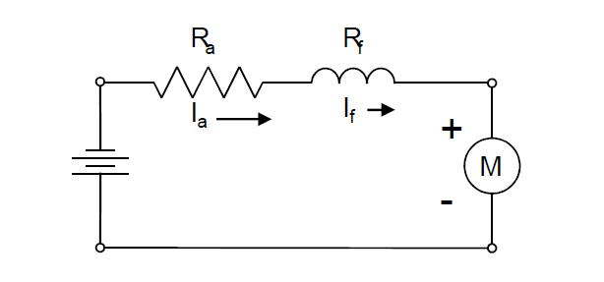

Figure 3.7: Schematic of a Series-Wound DC motor

The series motor has a higher starting torque than the shunt motor. This is because during startup, the current flowing to the armature also flows through the field. As current flows through the field it increases the magnetic flux thereby giving the motor more starting torque. The disadvantage to this is that the field windings must be capable of handling the same current as the armature. This makes construction awkward because the wire has to be a larger diameter to handle the current without a lot of heat loss (see Equation (2.3)). Additionally the larger wire can be heavier and less malleable, which makes it difficult to bend into loops or turns. This means that the field winding in a series motor will be few turns of large wire as opposed to the shunt machine which is many turns of fine wire.

### Compound

Compound-wound DC motors have two sets of field windings, one set is connected in series and the other set is connected in parallel with the armature as shown in Figure 3.8

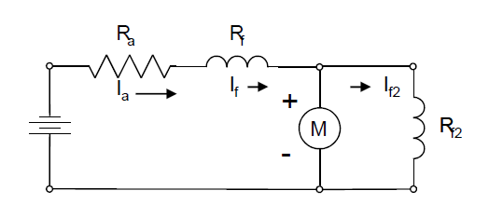

Figure 3.8: Compound-Wound DC motor

Compound motors can be wired in a cumulative or differential manner. In a cumulative setup, current flows into the shunt and series windings to produce a greater positive magnomotive force. In a differential setup the shunt and series magnomotive forces subtract from each other. The cumulative compound motor’s design allows it to have a hybrid effect of the series and shunt wound motors. It has better starting torque than the shunt motor, but less starting torque than a series motor. Additionally because of the shunt characteristics, this motor will not over speed while running with no load. The differential compound motor is theoretically possible but is practically un-useful. The circuit setup makes it almost impossible to start such a motor. Additionally it draws more current in the armature while under load and the flux in the motor also decreases under load. This causes the motor to be very unstable and not suited for any application. A differential motor is never intentionally used, but a compound motor may turn differential if conditions allow it to happen. This implies that for vehicle applications, if a compound motor is used, precautions should be taken to ensure that compound motor will not turn differential. This precaution could be in the form of a reverse-power trip circuit that would kill power to the motor if flow in the field reverses.

## Control of DC Motors

Choppers are used for the control of DC motors because of a number of advantages such as high efficiency, flexibility in control, light weight, small size, quick response, and regeneration down to very low speeds. Presently, the separately excited DC motors are usually used in traction, due to the control flexibility of armature voltage and field.

For a DC motor control in open-loop and closed-loop configurations, the

chopper offers a number of advantages due to its high operation frequency.

### OPEN LOOP SPEED CONTROL

Speed control means intentional change of the drive speed to a value required for performing the specific work process. Speed control is a different concept from speed regulation where there is natural change in speed due change in load on the shaft. Speed control is either done manually by the operator or by means of some automatic control device maintaining the integrity of the specifications. One of the important features of dc motor is that its speed can be controlled with relative ease.

The speed (N) of 3 types of dc motor – Series, Shunt and Compound can be varied by changing

• Terminal voltage of the armature (V)

• External resistance in armature circuit and

• Flux per pole (φ).

The first two cases involve change that affects armature circuit and the third one involves change in magnetic field. Therefore speed control of dc motor is classified as

• Armature control methods and

• Field control methods.



Figure 3.9: Model of Separately excited DC motor



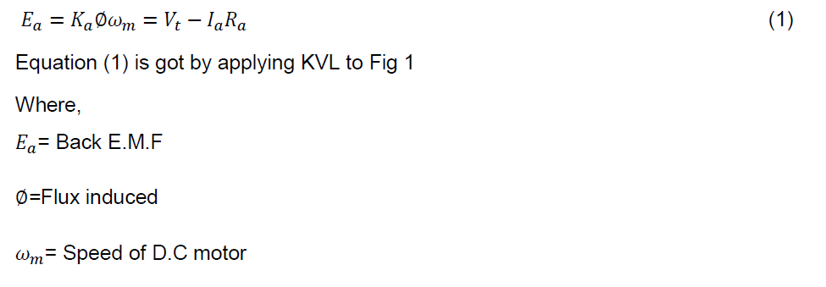

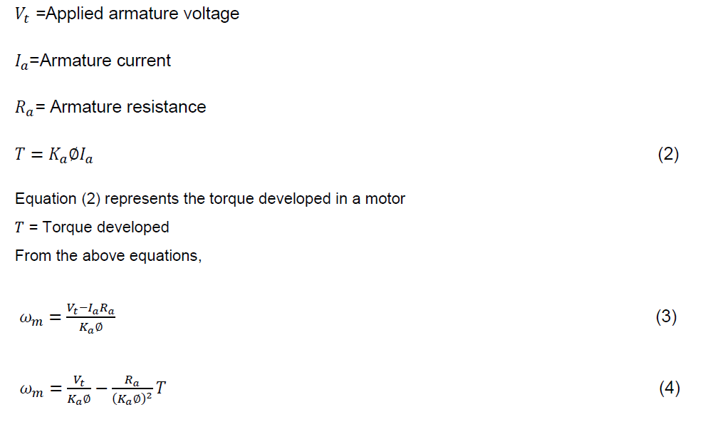

**Armature Control of DC Motor**

Speed adjustment of separately excited D.C motor by armature control may be done by any one of the methods that follows,

• ***Armature resistance control method***: This is the most common method employed. Here the controlling resistance is connected directly in series with the supply to the motor. The power loss in the control resistance of dc series motor can be neglected because this control method is utilized for a large portion of time for reducing the speed under light load condition. This method of speed control is most economical for constant torque. This method of speed control is employed for dc series motor driving cranes, hoists, trains etc.

• ***Shunted armature control***: The combination of a rheostat shunting the armature and a rheostat in series with the armature is involved in this method of speed control. The voltage applied to the armature is varies by varying series rheostat. The exciting current can be varied by varying the armature shunting resistance .This method of speed control is not economical due to considerable power losses in speed controlling resistances. Here speed control is obtained over wide range but below normal speed.

***Armature terminal voltage control***: The speed control of dc series motor can be accomplished by supplying the power to the motor from a separate variable voltage supply. This method involves high cost so it rarely used.

**Field control of a DC motor**

The speed of DC motor can be controlled by this method by any one of the following ways

• ***Field diverter method***: This method uses a diverter. Here the field flux can be reduced by shunting a portion of motor current around the series field. Lesser the diverter resistance less is the field current, less flux therefore more speed. This method gives speed above normal and the method is used in electric drives in which speed should rise sharply as soon as load is decreased.

• ***Tapped Field control***: This is another method of increasing the speed by reducing the flux and it is done by lowering number of turns of field winding through which current flows. In this method a number of tapping from field winding are brought outside. This method is employed in electric traction.

**Armature Resistance control**

In this method, the terminal voltage V and the field current (hence flux) are kept constant at rated values. The speed is controlled by changing resistance in armature circuit and hence armature circuit resistance is used for this purpose

### CLOSED LOOP SPEED CONTROL

The basic principle of a DC variable speed drive is that the speed of a separately excited DC motor is directly proportional to the voltage applied to the armature of DC motor. Armature voltage control method is used to vary the speed of separately excited DC motor below and up to the base speed. Rated speed is compared with the desired set point speed through a comparator and an error signal is generated. This error signal is fed to a two quadrant chopper which uses a switching device like MOSFET. Fixed frequency operation i.e. Pulse width modulation technique PWM technique is used as the power loss in the switching devices is very low.

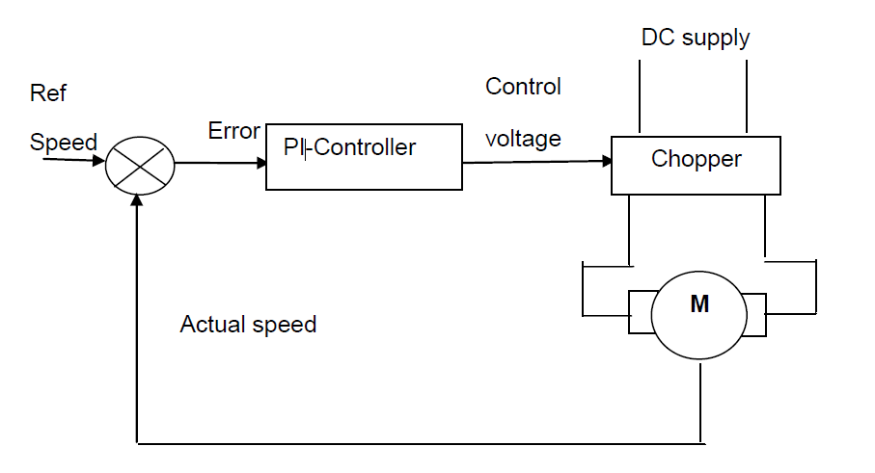

Figure 3.10 : closed loop speed control of a separately excited D.C motor



Figure 3.11 : DC chopper circuit

When switch is off there is practically no current and when it is on, there is almost no voltage drop across the switch, power loss being the product of voltage and current, in thus both cases close to zero. It also works well with digital control. Now Chopper provides variable voltage across the armature of separately excited DC motor due to which speed of the motor changes.

A transistor chopper controlled separately excited motor drive has transistor Tr which is operated periodically with period ‘T’ and remains on for a duration ton. Present day choppers operate at a frequency which is high enough to ensure continuous conduction. During on-period of the transistor, 0 ≤ t ≤ ton the motor terminal voltage is V. The operation is described by,

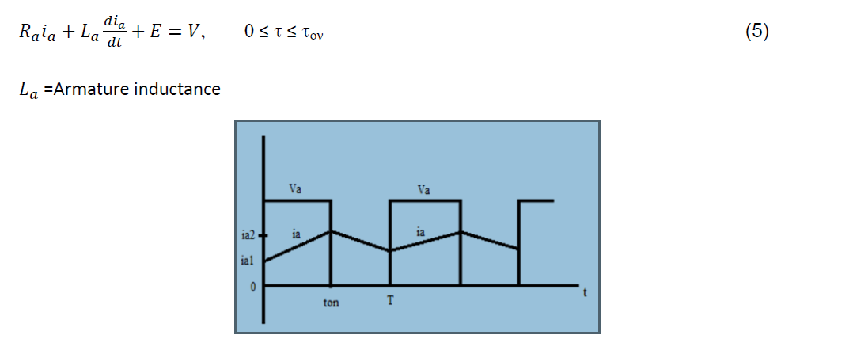

Figure 3.12: Switching pulses

In this interval, armature current increases from ia1 to ia2.Since motor is connected to the source during this interval, it is called duty interval.

At t =ton transistor Tr is turned off. Motor current freewheels through diode D and motor terminals voltage is zero during interval ton ≤ t ≤ T. Motor operation during this interval, known as freewheeling interval, is described by,

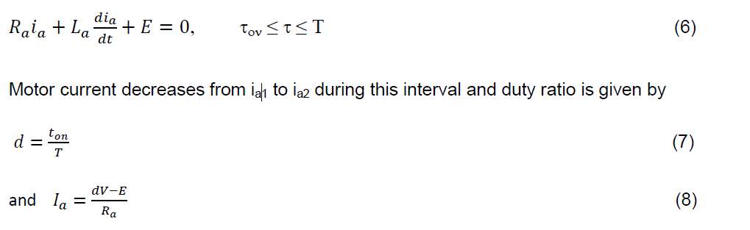

# DESIGN OF THE PROJECT

## BLOCK DIAGRAM: DC MOTOR CONTROL UNIT

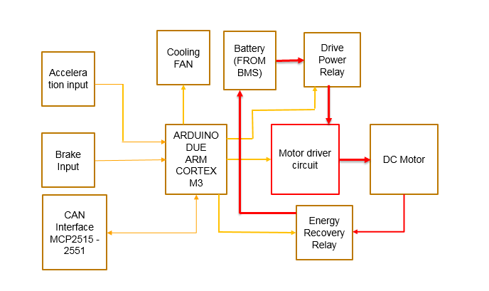

Figure 4.1: Block diagram DC Motor control

## HW design

### CIRCUIT DIAGRAM

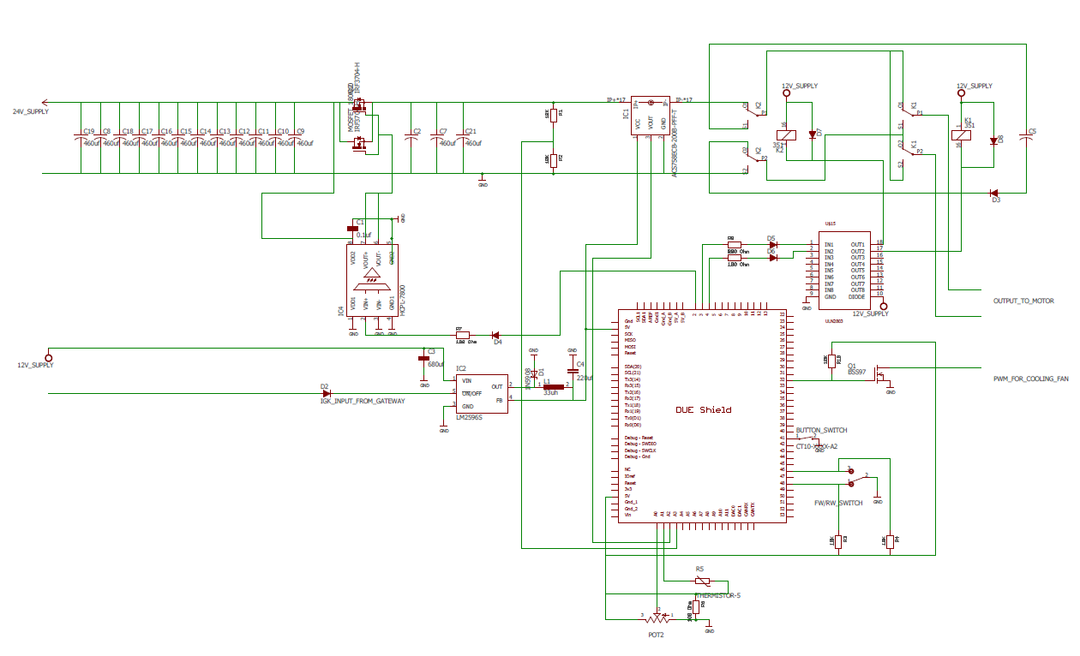

Figure 4.2:Circuit Diagram

### Hardware Components

#### MOSFET:

To control the motor speed using PWM. We are using N-Channel MOSFET at higher power side of the circuit. Mosfet is a 3 terminal device with “Gate” “Drain” and “Source” which is used for amplifying and switching the electrical signals in electronic devices. By generating the electrical field to control the flow of current through the channel between the source and drain. The electrical connection of MOSFET is as shown below.

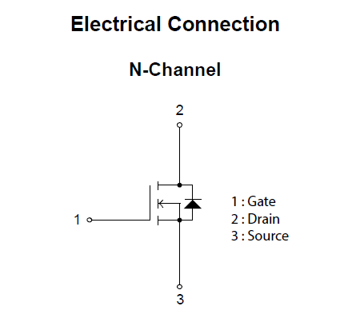

Figure 4.3: Electrical connection of MOSFET

The Gate terminal is electrically insulated from the main semiconductor by the thin layer of insulation materials (Glass, Fibre). This insulated metal gate terminal is like a plate of a capacitor which is having a very good high input resistance to almost infinity. Because of this isolation of the Gate terminal, there will be no current flows into the MOSFET from Gate terminal.

When some voltage is applied to the gate terminal, it changes the width of the Drain to Source channel along with which electron or hole flows. The wider is the channel, the better is the MOSFET conduction.

The electrical characteristics of MOSFET 180N10 at room temperature is as below.

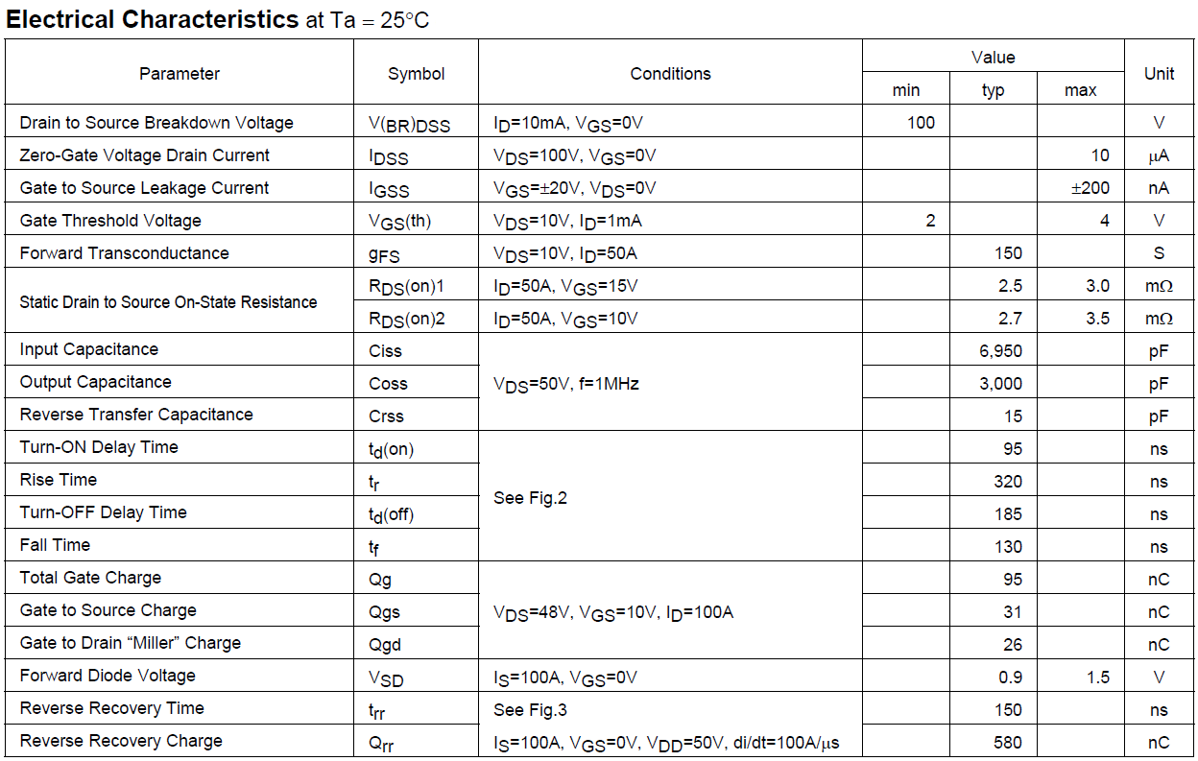

Table 4.1: Electrical Characteristics of MOSFET

#### DC MOTOR:

The Motor used for the demo purpose is MY1016 250W 24V DC Motor with 11 tooth chain sprocket. This dc motor is capable of rotation in both clockwise and anti clockwise direction by reversing the motor's power wires or terminals. Specifications of a demo motor is given below.

Model: MY1016

Power: 250 watt

Voltage: 24 volts DC

Speed: 3000 RPM

Weight: 2.90 Kg.

Torque: 11 N.m (110 kg.cm)

Stall Torque: 55 N.m (550 kg.cm)

Current: 13.5 amp

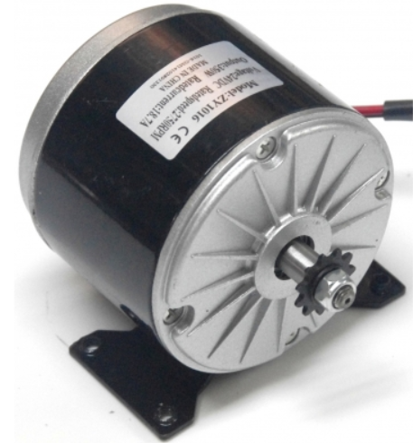

Figure 4.4: MY1016 250W 24V DC Motor

**RELAY:**

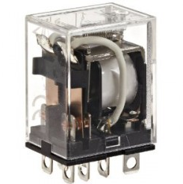

Figure 4.5: DPDT Relay

DPDT(Double Pole Double Throw) relay is the electromagnetic device. Which we are using to separate two circuits electrically and also to connect them magnetically. DPDT relays are often used to interface an electronic circuit also, which works at a very low voltage level in the electrical circuit which works at a very high voltage levels. DPDT relay we have used for demo is with the configuration of operating voltage of 24V and has a capacity to withstand upto 22A current flow.

In this DPDT relay we have two sections input and the output. The input section of the relay consists of the copper coil with two pins which are connected one to the ground and the other at the input supply. The output section of relay consists of a contactors which to connect or to disconnect the circuit mechanically. The output section relay consists of six connectors with two sets. Each sets has three changeover contnections, named as, NO (normally open), NC ( normally closed) and COM (common terminal). When there is no supply is given the COM terminal which will be connected to NC terminal. When some operating voltage from power supply is applied to the relay copper coil gets energized and the COM terminal changes its contact to NO (Normally Open).

This relay we can be used to power with one device to another. Where SPDT relay can be used only to switch the output circuits to on and off states.

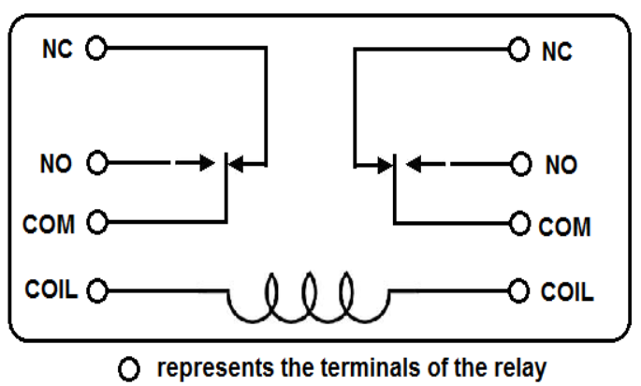

Figure 4.6: DPDT Relay Wiring Diagram

To drive the DC motor in both clockwise and anticlockwise directions. We have used this DPDT relay to change the polarity at the terminals of a device. When we provide the input signal, the contactors in the relay changes their positions, by resulting in the change in direction of the rotation of motor. So clockwise or anti clockwise rotation of motor is depending on the connection of relays terminals.

**Current Sensors**

Two current sensor IC’s are used in this project. One to measure the current in the circuit and the other to measure the voltage level in the circuit dynamically.

The current sensor ICs which we have used are integrate with a low-resistive copper primary conduction path for current. Where by enhancing the performance of the current sense in many ways, still in this current sensor there are some limitations imposed in current level which we will discuss later.

This current sensors uses a inovative methods by increasing the sensing range of current measurement. The simple methods that is involved in current sensing is by splitting the path where the current needs to be sensed. And the technology used in this sensor to sense the current is based on high precision linear Hall effect and magnetic field sensing method. Which allows the current to flow in both directions.

Current sensing technique at high level current sensor is as shown below.

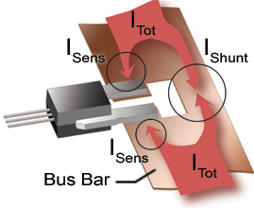

Figure 4.7 : Current sensing technique at high current.

Current sensing technique at low level current sensor is as shown below.

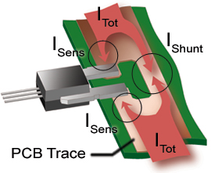

Figure 4.8 : Current sensing technique at low current

To increase the accuracy of the sensor which is optimized through a closed proximity of the current to a Hall effect transducer. In two sensors one current sensor is connected directly to the higher current side in the circuit which is of about 100A current to measure the current directly the other is connected parallely to the circuit with 1M resistor in series to measure the voltage. Where this circuit works as a voltage divider circuit.

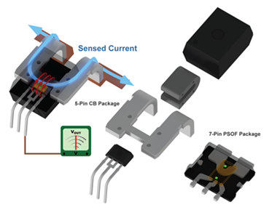

The magnetic field generated by the current is sensed by the integrated Hall IC in the current sensor and converts it into a proportional voltage level. Even though there are lot of advantages in this sensors, but still there some disadvantages in them. Sensor reduces the resolution of the system current by the some small proportion as the sensed current is divided.

#### Opto coupler:

As we all know about the Transformers that they can be used to step up and step down the voltage levels, along with providing the electric isolation between the higher voltage level in primary side with lower voltage level on the secondary side of the transformer.

We can also define it as, transformers are used to isolate the primary input voltage from the secondary output voltage by using electromagnetic coupling. Which is achieved by using the magnetic flux circulating within the laminated iron core of the transformer.

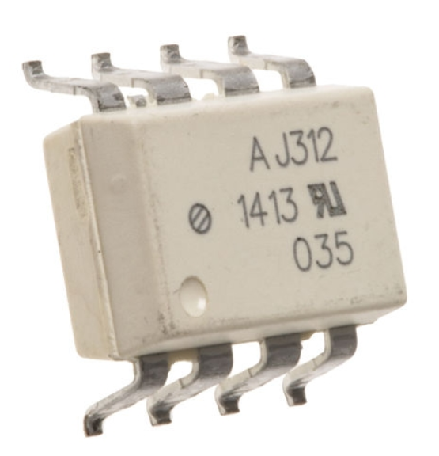

Figure 4.9: Opto coupler

The electrical isolation between the input side and the output side is provided by using just light or by using a electronic integrated component which is called as **Optocoupler**.

The design of the optocoupler is consists of an LED bulb that produces a light and a semiconductor on the other side is a photo-sensitive component which is used to detect the emitted light from LED bulb. Both the LED and photo-sensitive component are enclosed in a closed package with metal legs for the electrical connections as shown in above optocoupler image.

Optocoupler which is also called as opto-isolator is consists of a light emitter, the LED and the light sensitive receiver which is a single photo transister, photo resistor, photo diode, with this basic explaination of operation of an optocoupler is very easy to understand.

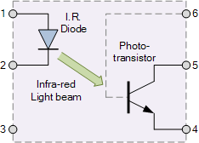

Figure 4.10: Working of opto coupler.

Assume a photo transistor device as shown in the above figure. Assume current from the supply passes through the input of LED bulb connected to terminal 1 and 2 as shown, which emits the light where intensity of the light is directly proportional to the input of an applied electrical signal.

The emitted light from the LED bulb falls on the photo sensitive plate of the photo transistor, making photo transister to switch it ON and conduct in a same way as a bipolar transistor.

The photo sensitive plate connection of the photo transistor device can be left unconnected for a more sensitivity to the LEDs light energy or can also be connected to ground using pulldown resistor to control the sensitivity of switching and making switching more stable and resistive for the false activaition from an a external electrical disturbances.

If the flow of current via LED bulb is disturbed/interrupted, which will cut’s off the emitted light. Leading the photo transister to stop conducting. To switch the ouput current in the circuit we are using a photo transister. The combination of bulb and the photo sensitive plate are isolated by a glass material or by a plastic material. As there are not direct electrical connection between the input and the output of the opto isolator, maximum up to 16kv isolation can be achieved by the optocoupler.

As explained previously we have four different types of **Optocouplers**. Every optocoupler will be having an LED at input side but will have different photo-sensitive materials in it.

The four optocouplers are:

1) *Photo-transistor*

2) *Photo-darlington*

3) *Photo-SCR*

4) *Photo-triac*.

In this project AJ312 optocoupler is used where functional diagram of this optocoupler and its truth table is as shown in below

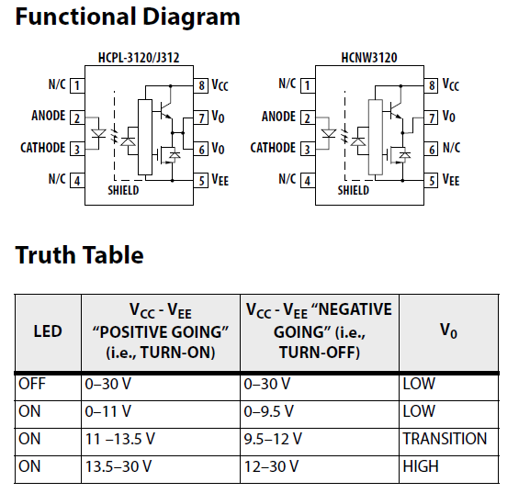

Table 4.2: Truth table of Optocoupler output voltage.

The testing circuit of the A J312 optocoupler specified by the component manufacturer or supplier.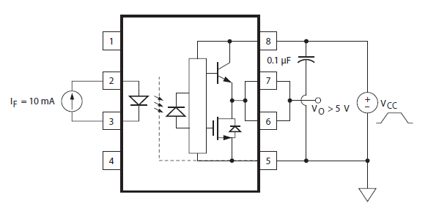

Figure 4.11: Testing circuit for opto coupler.

### Arduino Board:

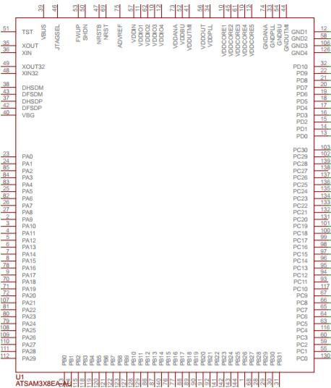

Figure 4.12: Arduino Due Pin Diagram

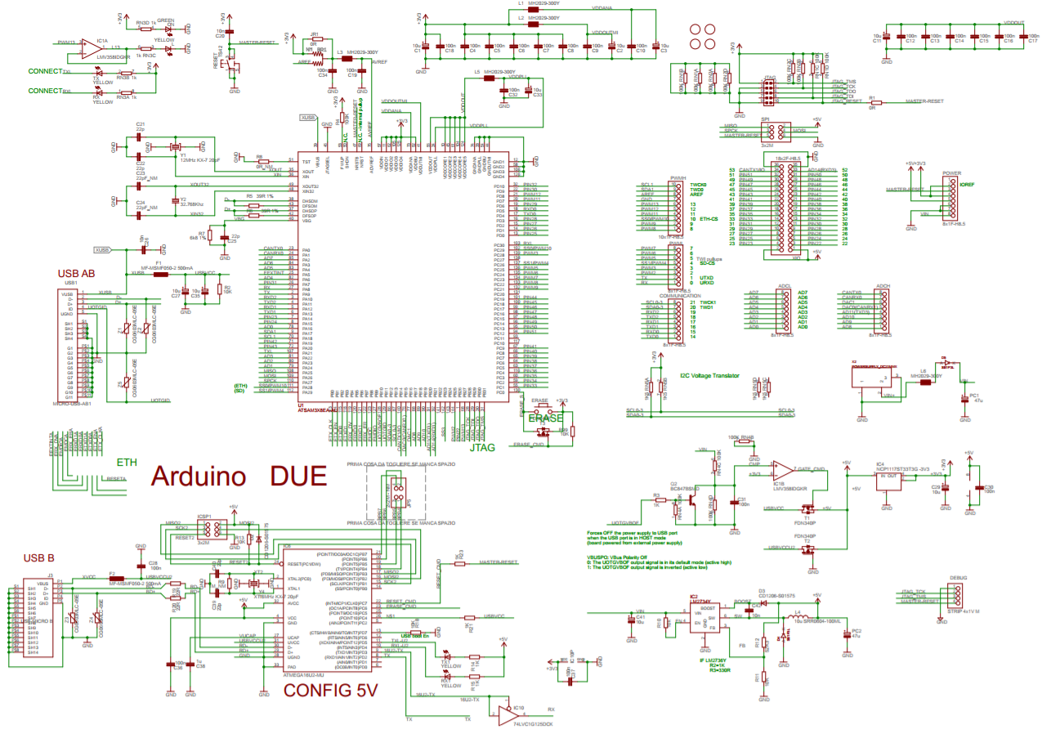

Figure 4.13: Arduino Due Schematic Diagram

Arduino due board is similar to other normal arduino boards we use for smaller operations. But we have a major difference in its operation and the expanded functionalities. The arduino Due is having the same footprint as the arduino Mega 2560.

In the arduino due the microcontroller mounted at the center of the board and it runs at 3.3Volts, which means in only 3.3 volts we have power the sensors and drivers to an a actuartors. As a other arduino boards if we try to connect more than 3.3volts may damage the controller or even burn the controller in arduino due.

The board is capable of taking the power from DC Adptors or also from USB connectors. If we are using the DC adaptors with the supply voltage upto 12V is OK. As Arduino Due is having built in voltage regulator to regulate the voltage level to 3.3volts from 12v which is required for microcontroller and also compatible with the micro USB. In the board power to the controller can also provided by USB cable. But when we use the board as a usb host, external power from the DC Adaptor is must required.

The Arduino Due board consists of two USB ports in it. USB is connected directly to the SAM3X micro controller unit. And the other USB is for programming. Which is connected to ATMEL 16U2 USB-to-Serial converter. The programming USB port is the default programming port for uploading and communicating to controller.

This USB to serial converter of the programming port is connected first to the UART. By using the Serial object in the arduino programming language, we can be able to communicate on this port.

The USB connector port is directly connected to the USB host pins of the controller. We can use arduino due as a client USB pheriperals to connect the keyboard, mouse and phones by using the native port or by using a USB host device. Serial USB object in arduino programming language can be used to use this USB port as a virtual serial port.

**Automatic Software Reset**

Because of the flash memory, flash memory needed to be erased everytime before the controller re-programing. so this Arduino due microcontroller is differing from other AVR microcontrollers. By holding the button provided to erase for a second, we can erase controller by manually, later need to press the reset button. Due to this manual erase of the flash is repetitive, arduino has managed automatically in two different ways:

**Native USB port** : Opening and closing of the Native port at the baud rate of 1200bps triggers the soft erase procedure, the flash memory is erased and the board is restarted with the bootloader. Due to some reason, if the microcontroller is crashed during this process, it is likely that the soft erase procedure not worked.

Opening and closing of the Native port at a baudrate other than 1200bps will not reset the controller. To see what your sketch does from the beginning and to use the serial monitor, we need to add some lines of code in the setup.

By pressing the Reset button on the Arduino Due will causes the controller to reset as well as resets the USB communication. This interruption means that if the serial monitor is open, it's necessary to close and reopen it to restart the communication.

**Programming port :** The Programming port in the arduino due uses a USB to serial chip connected to the first UART of the Microcontroller. The USB-to-serial chip has two pins connected to the Reset and Erase pins of the SAM3X. When we open this serial port, the USB to Serial will activates the Erase and Reset sequence before it begins to communicate with the UART of the SAM3X. This procedure is much more reliable and should work even if the main microcontroller unit has crashed.

**USB Host**

The Arduino Due has the ability to act as a USB host for peripherals connected to the SerialUSB port. When we are using the Arduino Due as a host, Due will be providing power to the attached device. It is strongly recommended to use the 12v DC power connector when acting as a host.

**ADC and PWM resolutions**

The Arduino Due has the ability to change its default analog read and analog write resolutions from 10-bits and 8-bits respectively. Due can support up to 12-bit ADC and PWM resolutions.

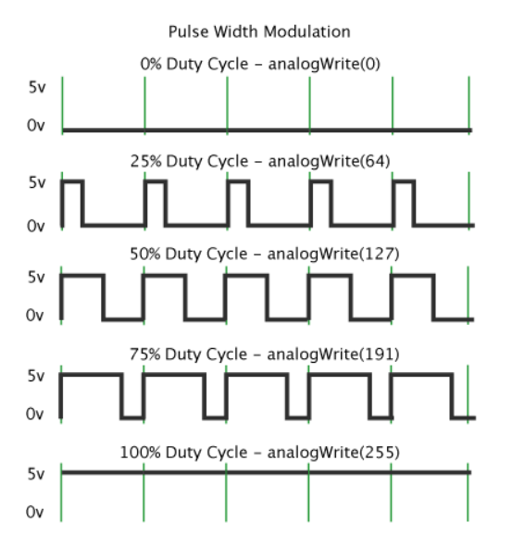

Figure 4.14: PWM resolutions.

**Expanded SPI functionality:**

The Arduino Due has a expanded functionality on its SPI bus, which is useful for communicating with multiple devices that can speak at different speeds.

### HW Functional Description

As shown in circuit diagram the circuit is powered with two different sources which is from BCM(Battery Control Module) module in vehicle, For demo purpose we have used two DC adapters to power the circuit. One is 12v 1A DC supply to control low power components. And the other with 24v 10A DC supply which is the main supply to the MOTOR. Potentiometer, Brake switch, Current sensor, Voltage sensor, Gear Switch and Temperature Sensor, are connected as input to the microcontroller. And at output side we have Cooling fans, Relays, Buzzer, PWM output to DC motor and PWM output to Cooling fans. The components with high power rating requirement are connected with drivers to controller to drive them.

Based on the potentiometer input to the microcontroller, The PWM output is generated, The PWM pin is connected to MOSFET with Optocoupler driver IC, By which changing the input from potentiometer the speed of the DC motor is controlled.

To change the direction of the motor, We are using a DPDT relay. Based on the input from the gear switch and based on the motor speed, we are controlling the relay to switch the direction of motor, the switching of the relay will takes place only when the speed of the motor is equal to zero and the gear switch is at reverse position. As the relay switches the polarity of the supply to the motor reverses and based on PWM output the motor starts to rotate in reverse direction.

For regenerative braking we are using the DPDT relay, the controlling of DPDT relay is based on the braking switch and the accelerator pedal. When the brake is pressed. The complete circuit is disconnected from motor and motor gets connected to the super capacitor bank, where capacitor bank charges and this charge can be used for charging the battery.

DPDT relay connection in circuit is as shown below.

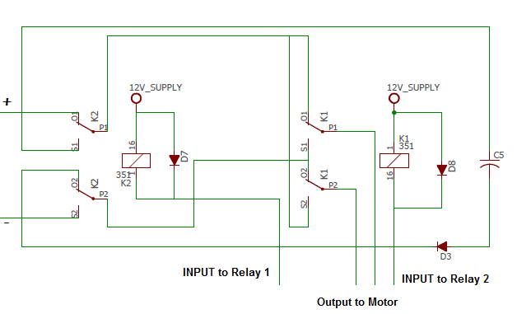

Figure 4.15: DPDT relay connection

For safety purpose, if the vehicle is moving with certain speed and by accidentally someone changes the gear switch position. As explained previously the change in direction of motor is also based on motor speed, the vehicle will continues to move in the same direction as its moving. In such accidental situation to inform the driver regarding the wrong attempt/wrong position of the switch a audible sound will be produced by the buzzer connected for ten seconds.

Cooling system is used to cool the MOSFET connected. Due to fast switching of the MOSFET, the MOSFETs heats up quickly. If the heat is above predefined threshold level the cooling fans starts. To sense the temperature the heat sensors are connected very closer to the mosfets. Based on the input from the temperature sensors the speed of the cooling fans are controlled by microcontroller.

## SW DESIGN:

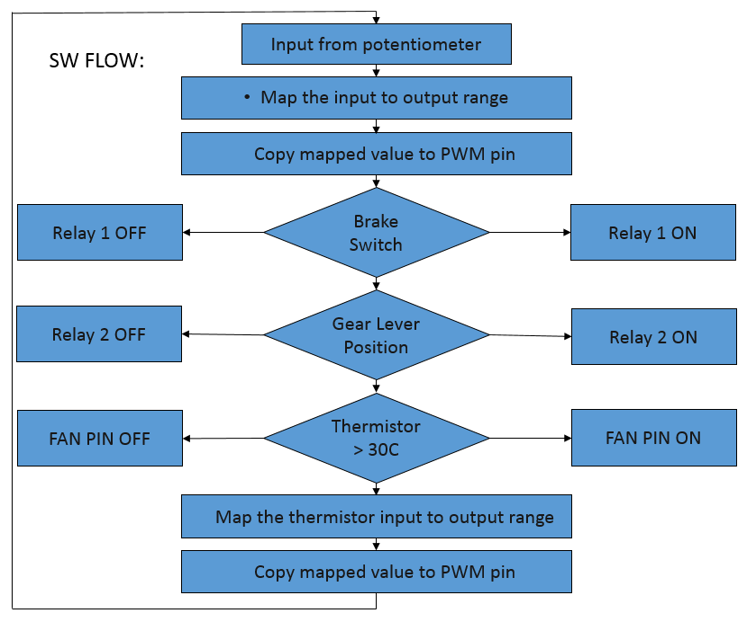

Figure 4.16: SW flowchart

The open-source Arduino Software (IDE) makes it easy to write code and upload it to the board. User-written code only requires two basic functions, for starting the sketch and the main program loop, that are compiled and linked with a program stub main() into an executable cyclic executive the GNU tool chain also included with the IDE distribution. The Arduino IDE employs the program avrdude to convert the executable code into a text file in hexadecimal encoding that is loaded into the Arduino board by a loader program in the board's firmware.

# RESULTS AND DISCUSSIONS

Pulse with fixed frequency is generated by the microcontroller, which is fed to the base of transistor. Transistor acts here as a switch. The output voltage of the motor is dependent on the amount of the on time of the transistor. The more time transistor remain on more the voltage will produce. A Freewheeling diode is used for back e.m.f. protection given to other portion.

|  |  |  |
| --- | --- | --- |
| D (Duty cycle) | Voltage Using  Equation(V) | Voltage Measured by  Multimeter(V) |
| 0.1 | 2 | 4.6 |
| 0.3 | 7.2 | 7 |
| 0.5 | 12 | 15.6 |
| 0.7 | 16.8 | 19 |
| 0.9 | 21.6 | 23.2 |

Table 5.1: Motor terminal voltage measurement.

The goal of this paper is to design a DC motor speed control system by using Arduino board. It is a closed-loop real time control system. The controller will maintain the speed at desired speed when there is a variation of potentiometer. By varying the PWM signal from microcontroller to the motor driver, motor speed can be controlled back to desired value easily.

The ADC senses voltage drop across the potentiometer and converts it to digital value, based on this value the pulse width of the PWM signal is generated which controls the MOSFET output voltage. The output voltage determines the speed of the motor.

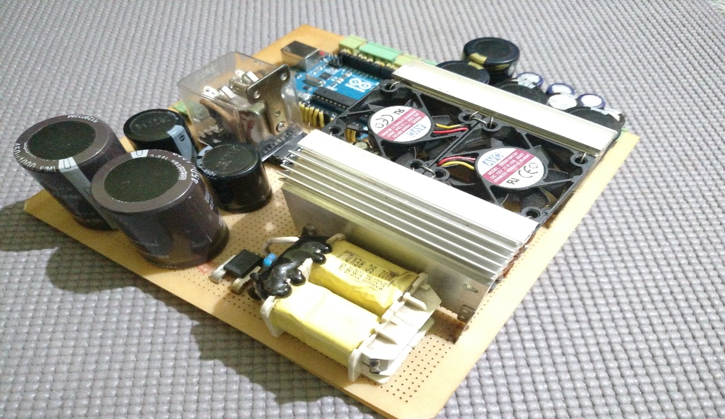

Figure 5.1: Actual picture of HW

The speed of DC motor is directly proportional to the supply voltage. Pulse duration is directly proportional to the value of input voltage. When the value of voltage is slow, pulse will generate narrow and the value of voltage is high, pulse will generate wide. PWM controls adjusts the duty ratio of the DC motor. DC voltage is converted to a square-wave signal. When the voltage of motor decrease, the speed must decrease. When the voltage of motor increase, the speed must increase. The average DC value of the signal can be varied by varying the duty cycle.

# CONCLUSION AND FUTURE WORK

## CONCLUSION

PWM duty cycle control techniques enable greater efficiency of the DC motor. PWM switching control methods improve speed control and reduce the power losses in the system and the pulses reach the full supply voltage and will produce more torque in a motor by being able to overcome the internal motor resistances more easily. By using PWM technique power loss in the switching devices is very low.

There are several benefits and conclusions that can be drawn from this research. To begin with, the literature review provides good background material for persons interested in learning about motor construction and the different types of motors that exist. The material covers basic and some advanced principles of motor operation. The literature review presents information that has been collected from many sources into one helpful overview. By having this information altogether, it becomes easier for engineers and designers to understand how motor principles are interrelated and helps them decide which motors to choose for an electric vehicle powertrain.

Recent developments in science and technology provide a wide range scope of applications of high performance DC motor drives in area such as rolling mills, chemical process, electric trains, robotic manipulators and the home electric appliances require speed controllers to perform tasks. DC motors have speed control capabilities, which means that speed, torque and even direction of rotation can be changed at any time to meet new condition.

The goal of this project is to design a DC motor speed control system by using Arduino board. It is a closed-loop real time control system. The controller will maintain the speed at desired speed when there is a variation of load. By varying the PWM signal from microcontroller to the motor driver, motor speed can be controlled back to desired value easily.

## FUTURE WORK

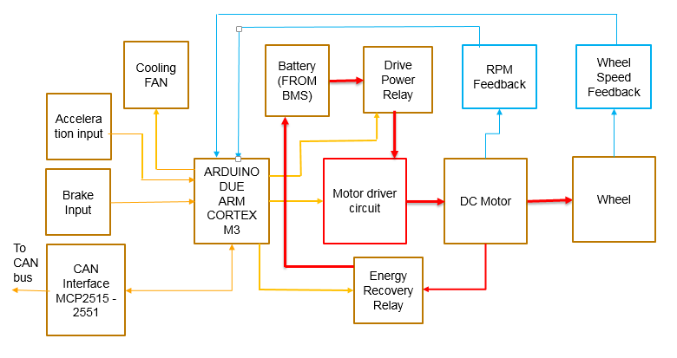

Figure 6.1: Expanded Block diagram DC Motor control

The speed of a D.C motor can be controlled using two types of loop configurations such as open loop speed control and closed loop speed control techniques. The open loop speed control characteristics has been verified using current implementation as discussed above.

For precise speed control of servo system, closed-loop control is used. Basically, the block diagram in figure 6.0 is expanded version. The speed, which is sensed by analog sensing devices (e.g., tachometer), is compared with the reference speed to generate the error signal and to vary the armature voltage of the motor by varying the duty cycle of PWM.

# REFERENCE

1. Ehsani, M., **Modern electric, hybrid electric, and fuel cell vehicles: fundamentals, theory, and design**. CRC Press, Boca Raton, 2005.
2. Bimbhra, P.S., **Power Electronics**. New Delhi, Khanna Publishers, 2006.
3. Pierre Guillemin “**Fuzzy Logic Applied to Motor Control**” IEEE TRANSACTIONS ON INDUSTRY APPLICATIONS, VOL. 32, NO. 1,JANUARYIFEBRUARY 1996.
4. P. C. Sen and M. L. MacDonald. “Thyristorized DC Drives with Regenerative Braking and Speed Reversal”. IEEE Transactions on Energy Conversion, 1978, Vol IECI-25, No. 4: 347-354.
5. Gopal K. Dubey, “**Fundamentals of ElectricDrives**”, .Narosa Publishing House New Delhi,1989.
6. Muhammad H. Rashid, ‘‘**Power ElectronicsCircuits,Devices,and Applications**,” Prentice Hall, 3rdedition, 2003.
7. Nicolai and T Castagnet , “A Flexible Micro controller Based Chopper Driving a Permanent Magnet DC Motor”, The European Power Electronics Application. 1993.