类图：
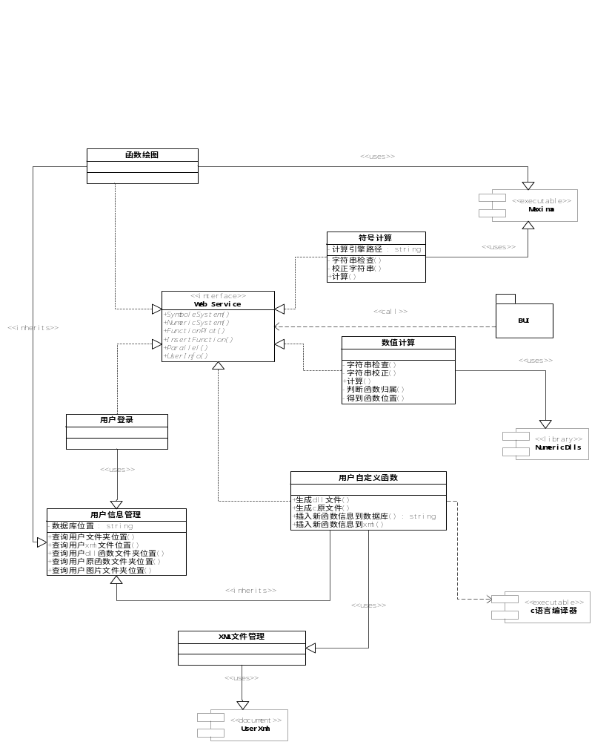

数据库设计：
用户数据库(uerinformation.xml)
<?xml version="1.0" encoding="gb2312" ?>
- <users>
- <user>
<username>gcy</username>
<password>123</password>
<userxmlpath>users\gcy\user.asp</userxmlpath>
</user>
- <user>
<username />
<password />
<userxmlpath />
</user>
</users>
共享数据信息(shared.asp):
<?xml version="1.0"?>
<user username="shared">
<!--display in tree-->
<funclibrary dllpath="shared\funclibrary\" sourcepat="shared\source\">
<toolbox name="matrixtoolbox">
<function name="rinv" input="inputarguments" output="outputarguments">
describtion of the funcname1
</function>
<function name="funcname2" input="inputarguments" output="outputarguments">
describtion of the funcname2
</function>
<function name="funcname3" input="inputarguments" output="outputarguments">
describtion of the funcname3
</function>
</toolbox>
<toolbox name="statistictoolbox">
<function name="funcname1" input="inputarguments" output="outputarguments">
describtion of the funcname1
</function>
</toolbox>
<toolbox name="sharedtoolbox">
<function name="funcname1" input="inputarguments" output="outputarguments">
describtion of the funcname1
</function>
</toolbox>
</funclibrary>
</user>

用户配置文件（Userxml.asp）
<?xml version="1.0"?>
<user username="username">
<userinformation>
<totalfunc>
</totalfunc>
<totalimage>
</totalimage>
<totalvariable>
</totalvariable>
<totaloperation>
</totaloperation>
</userinformation>
<!--display in tree-->
<funclibrary dllpath="users\gcy\library\" sourcepath="users\gcy\source\">
<toolbox name="privatetoolbox">
<function name="funcname1" input="inputarguments" output="outputarguments">
describtion of the funcname1
</function>
<function name="max" input="double a,double b,out double* z" output="z 1*1">求最大值</function>
<function name="maxnum" input="double a,double b,out double* z" output="z 1*1">sdad</function>
</toolbox>
</funclibrary>
<!--display in grid-->
<imagelibrary ipath="users\gcy\image\">
<image name="abcd">
<name>abcd</name>
<expression>x^2+y^2</expression>
<type>3D</type>
</image>
<image name="gcya2">
<name>gcya2</name>
<expression>sin(x^2+y^2)</expression>
<type>3D</type>
</image>
<image name="test2d">
<name>test2d</name>
<expression>(x+sin(x))/x</expression>
<type>2d</type>
</image>
<image name="test2d2">
<name>test2d2</name>
<expression>x^2</expression>
<type>2d</type>
</image>
<image name="test2d3">
<name>test2d3</name>
<expression>(x+sin(x))/x</expression>
<type>2d</type>
</image>
<image name="kankan">
<name>kankan</name>
<expression>x^3+y^2</expression>
<type>3D</type>
</image>
<image name="kan">
<name>kan</name>
<expression>1/x</expression>
<type>2d</type>
</image>
<image name="2d">
<name>2d</name>
<expression>x^5+x^3+4</expression>
<type>2d</type>
</image>
<image name="testuser">
<name>testuser</name>
<expression>sqrt(x)+sqrt(y)</expression>
<type>3D</type>
</image>
</imagelibrary>
<!--display in grid-->
<variable>
<var>
<name> name1</name>
<type>type1</type>
<value>value1</value>
</var>
<var>
<name>name2</name>
<type>type2</type>
<value>value2</value>
</var>
</variable>
<!--display in grid-->
<history>
<operation>
<name> //name1</name>
<date>date1</date>
<time>time1</time>
</operation>
<operation>
<name>name2</name>
<date>date2</date>
<time>time2</time>
</operation>
</history>
</user>

