# Instruction

**Prerequirements:**

Maven and java should be installed on Linux first.

**Procedures:**

1. Create mysql database table with ‘result.sql’ from program.

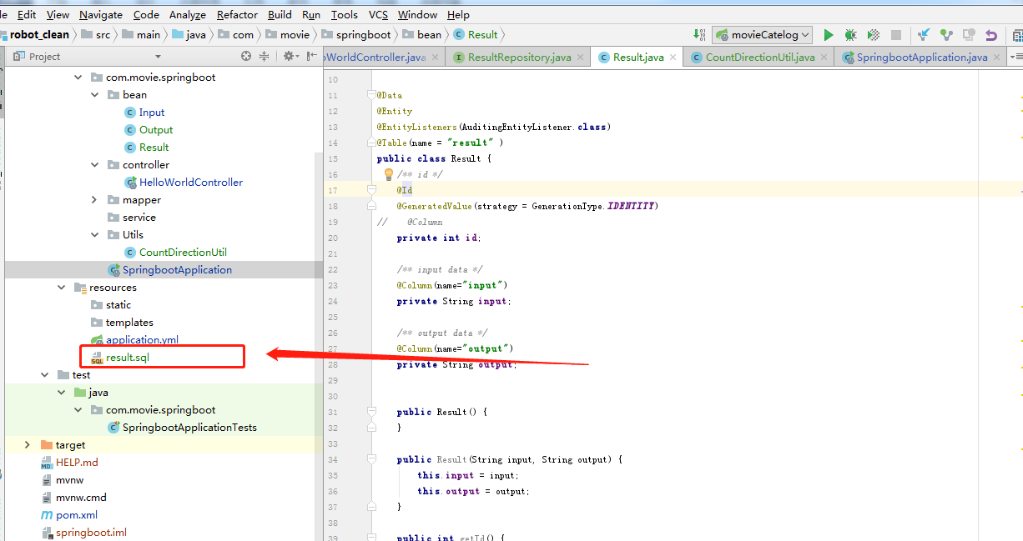

1. Put ‘springboot-0.0.1-SNAPSHOT.jar’ into linux or mac, and run it successfully.

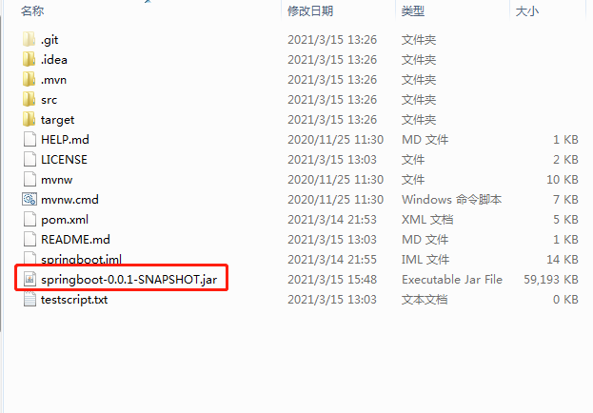

3.Open the postman website, set headers and input the json payload.

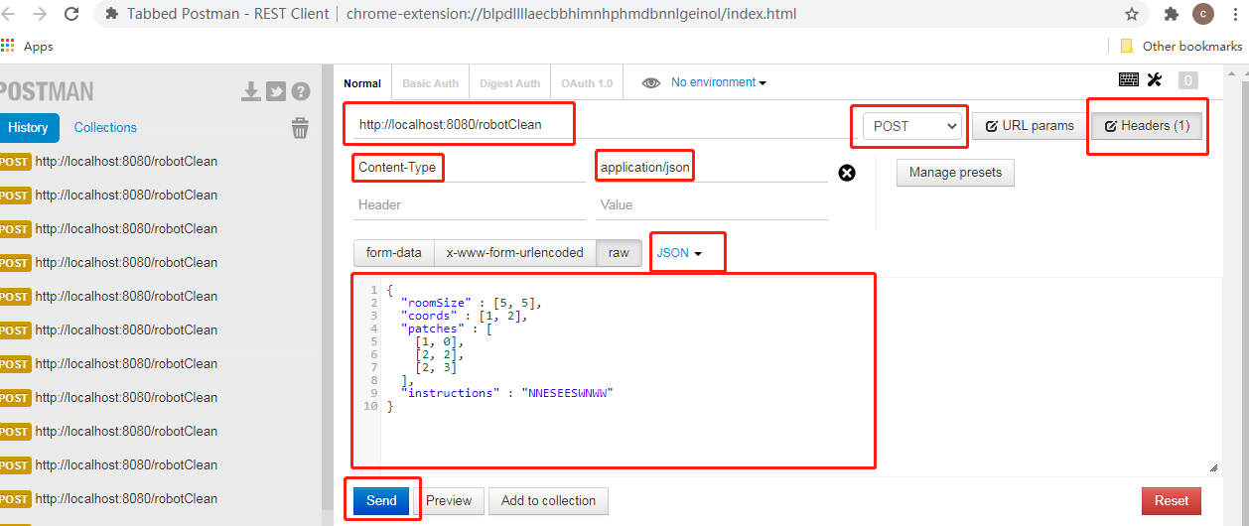

4. there is result into the body of postman.

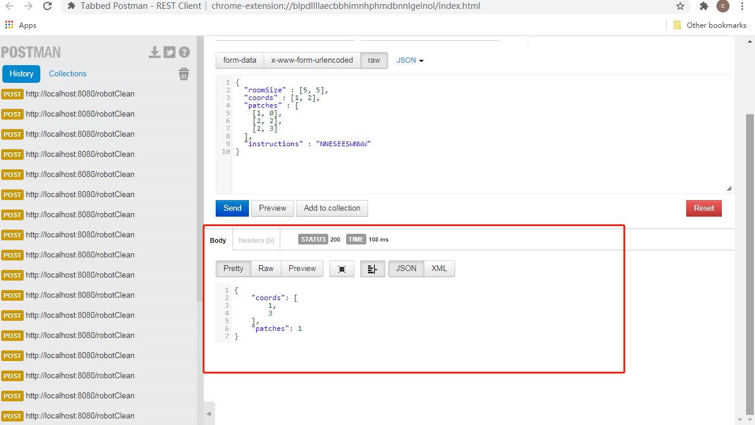

5. check the mysql database, all input and output information will be recorded.

