**Tips of Setting up Google Test and Google Mock**

1. Get google test source code from <https://github.com/google/googletest>. An easy way is to use git (or we can use zip ball). Google mock is now a part of google test.

git clone <https://github.com/google/googletest.git>

2. Download and install CMake from: <http://www.cmake.org/>

3. Build google test & mock lib following the tips here: <https://github.com/google/googletest/blob/master/googletest/README.md>. I build the lib together with google test & mock examples:

cd $(googletestfolder)

mkdir build

cmake -Dgtest_build_samples=ON $(googletestfolder)

4. Create a Visual Studio 2013 C++ project. Do the following change:

4.1 C/C++ 🡪 Include header files search path, add both include folder for google test and mock

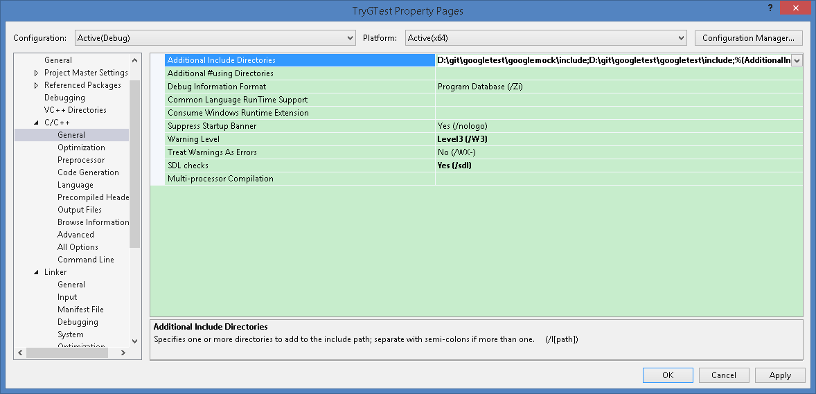

4.2 C/C++ 🡪 Code Generation changed to /MTd for debug

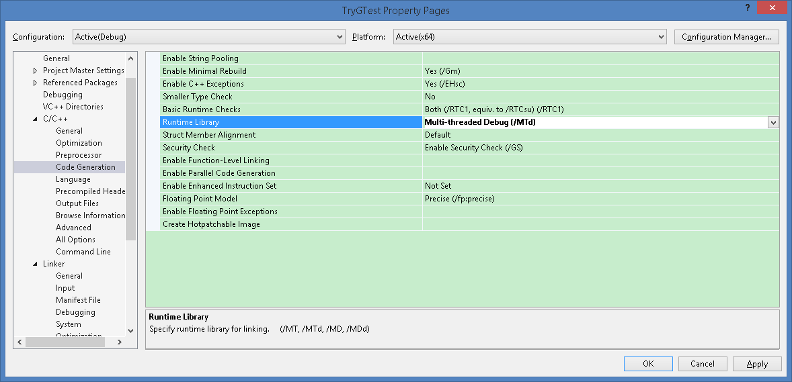

4.3 Linker 🡪 Additional libraries: gmock.lib, gmock_main.lib, gtest.lib, gtest_main.lib

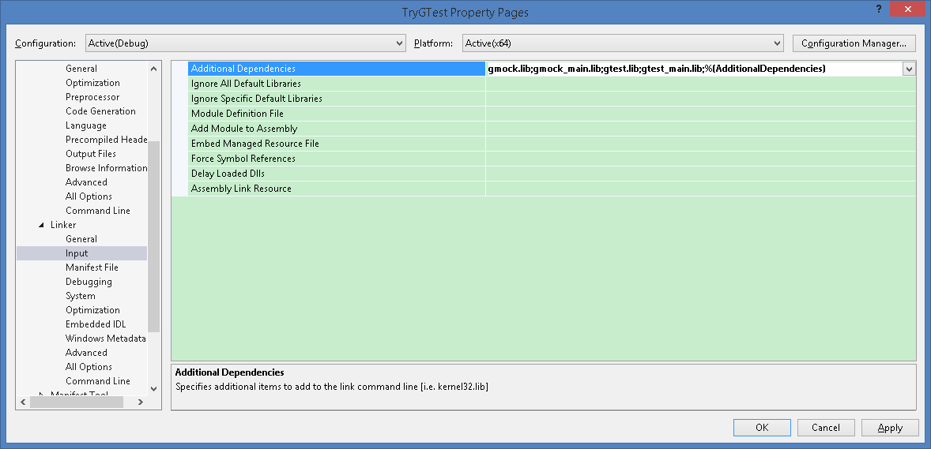

4.4 Linker 🡪 Additional libraries search path: add the path of gmock.lib/gmock_main.lib under the previous build directory, gtest.lib/gtest_main.lib is also under that directory but differs from gmock.lib

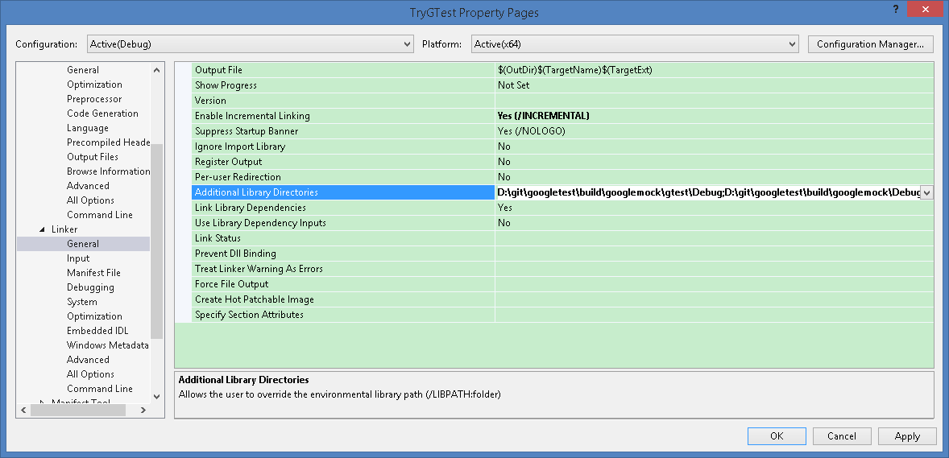

5. Now the setup for google mock/test is done. Follow the docs to start google unit test: <https://github.com/google/googletest/blob/master/googlemock/README.md> <https://github.com/google/googletest/blob/master/googletest/README.md>