User Guide
This document is a description about how to use Weather Search application. The application is deployed on the AWS Cloud, so that you can access it at any where of the world with quick response.

- You could type the following address to access our application.
http://ec2-52-70-253-159.compute-1.amazonaws.com:8080/#/
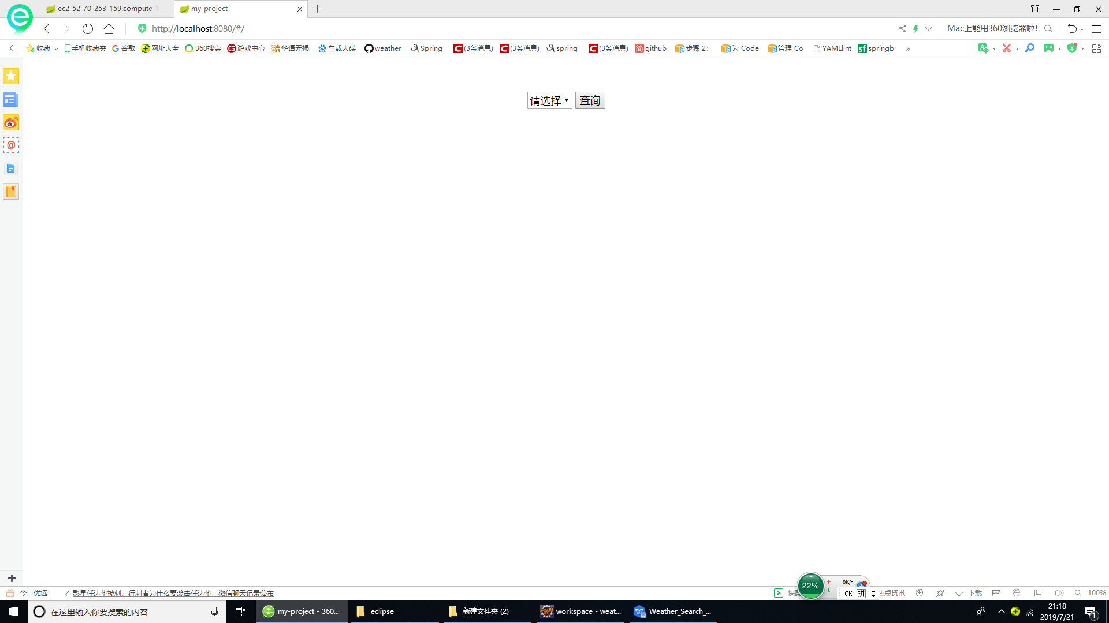

- We only provide three cities’ search functionality for now. They are Sydney, Melbourne and Wollongong.More cities are coming soon.
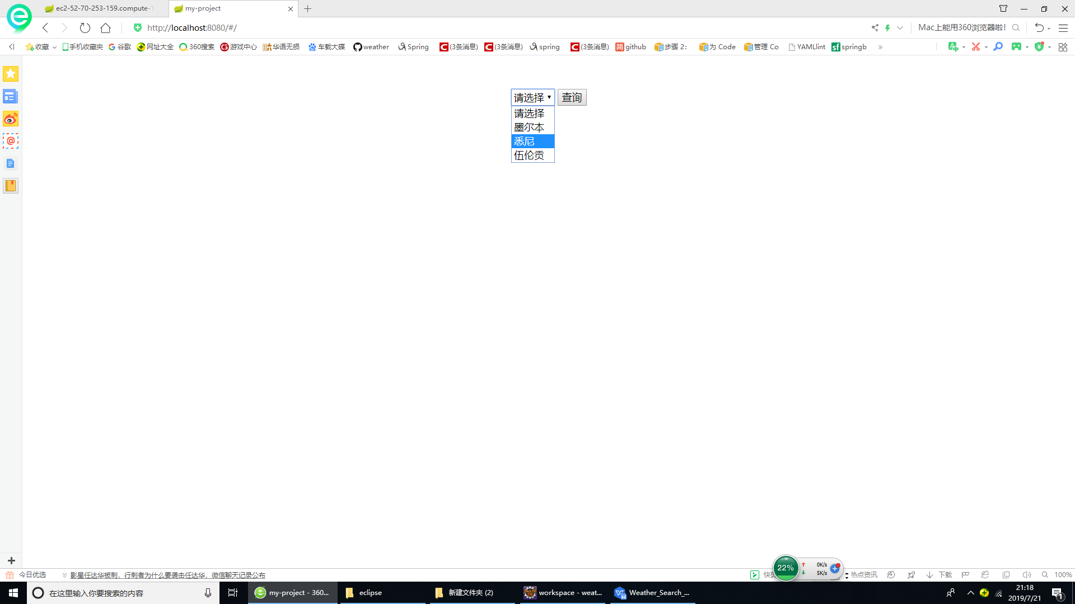
- You should select a city in the dropdown list, then click search button on the right. Then you can quickly get the response. The weather data is real-time.
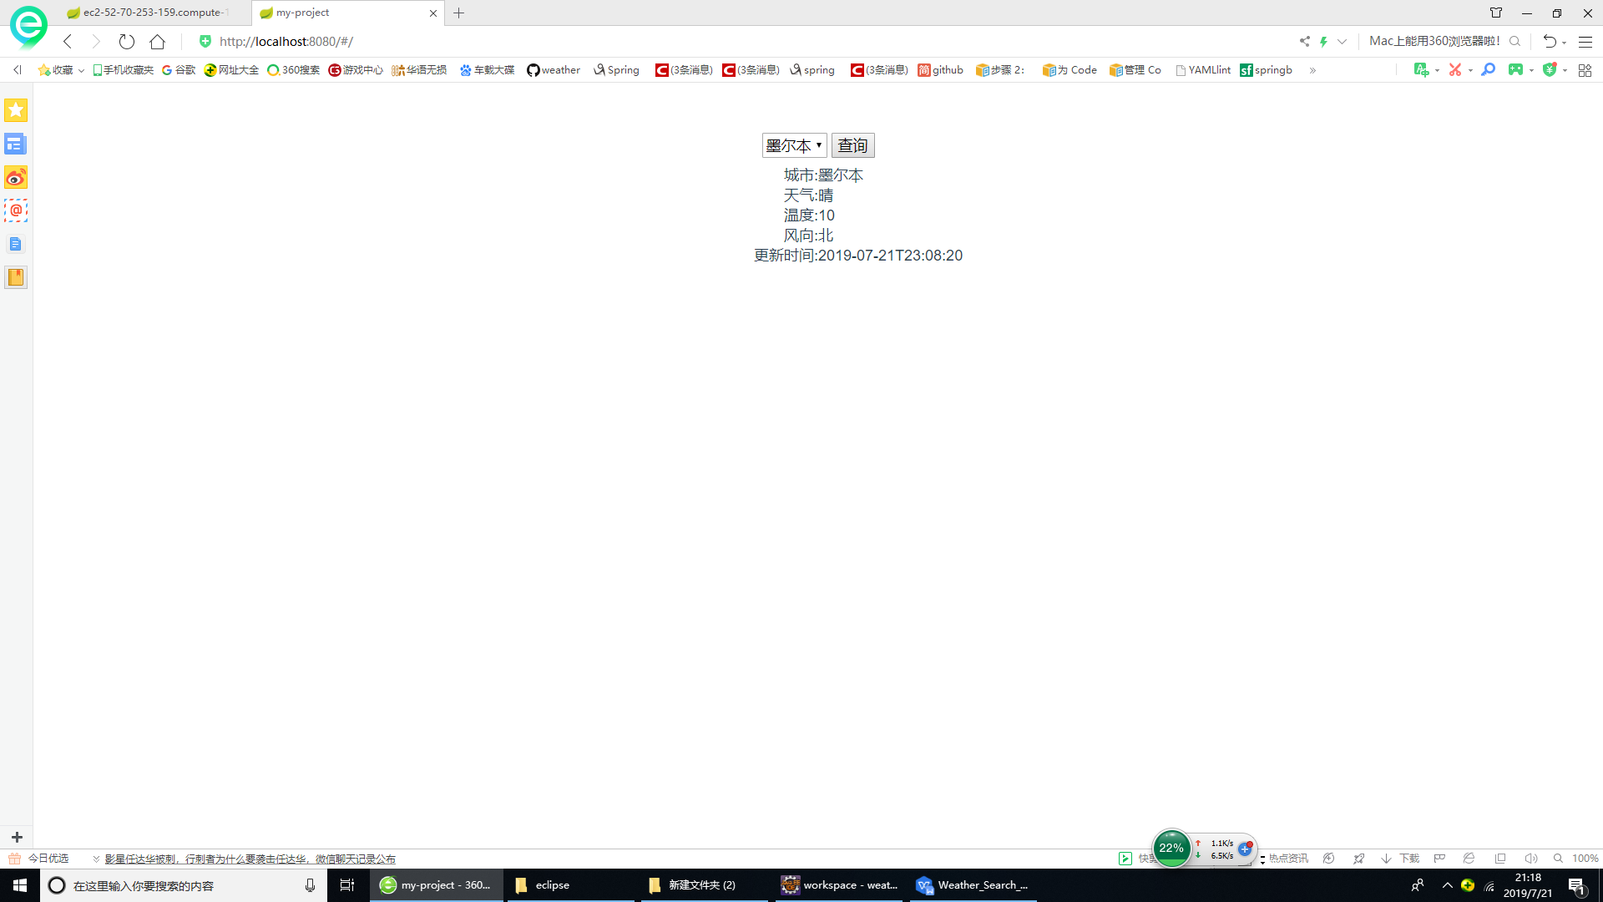

Sometimes depends on your location, the service may be unavailable. If you see the following errors, please contact our desk service for help.

- Cities list timeout
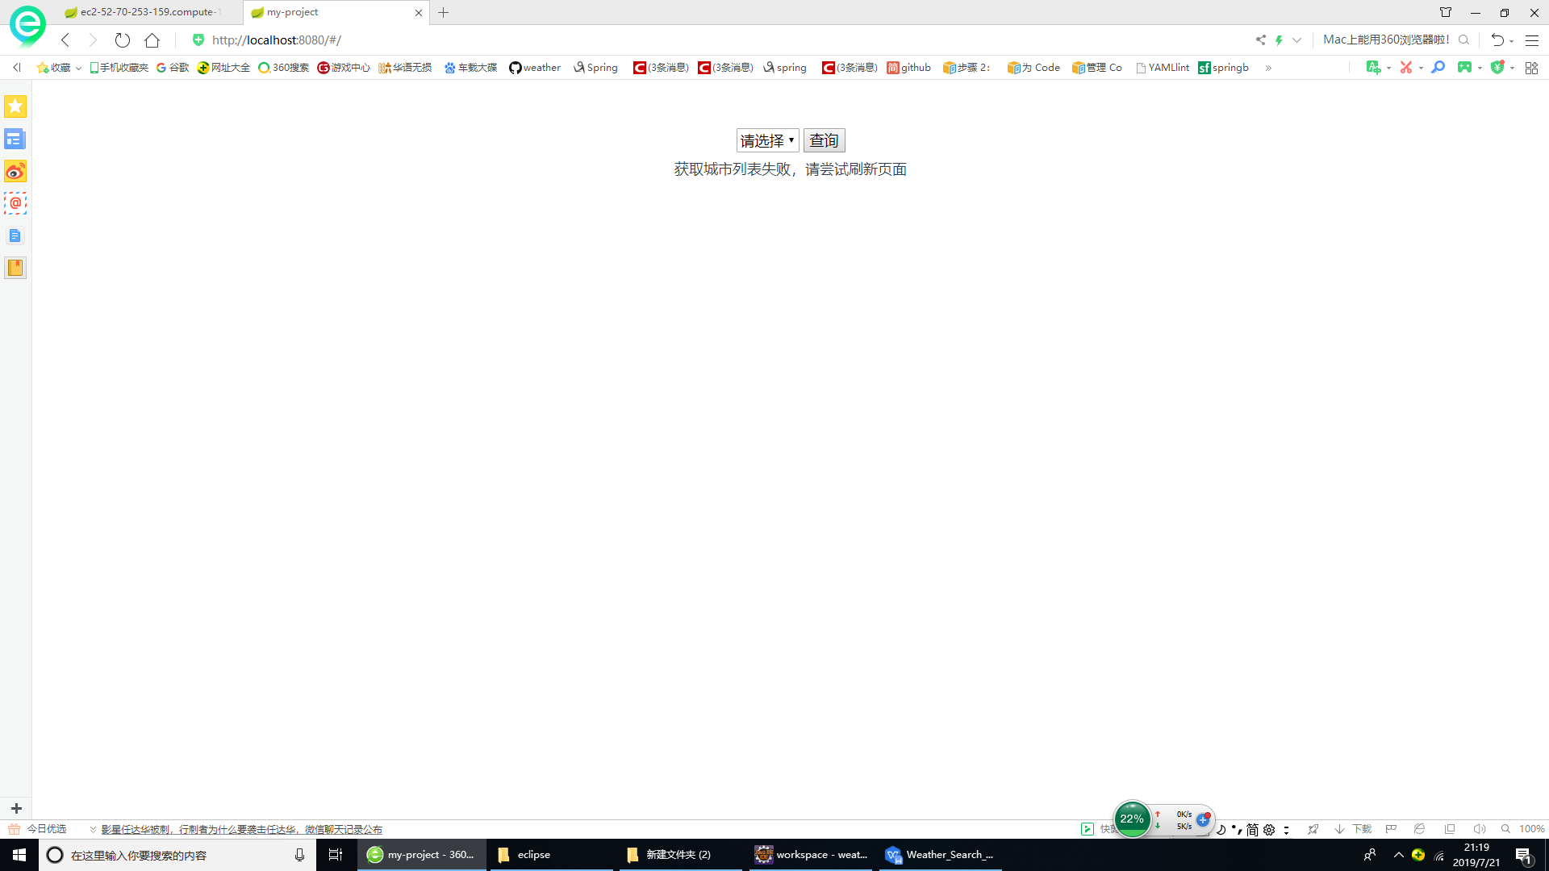

- Backend service is not available. We may work on some upgrade at that time.
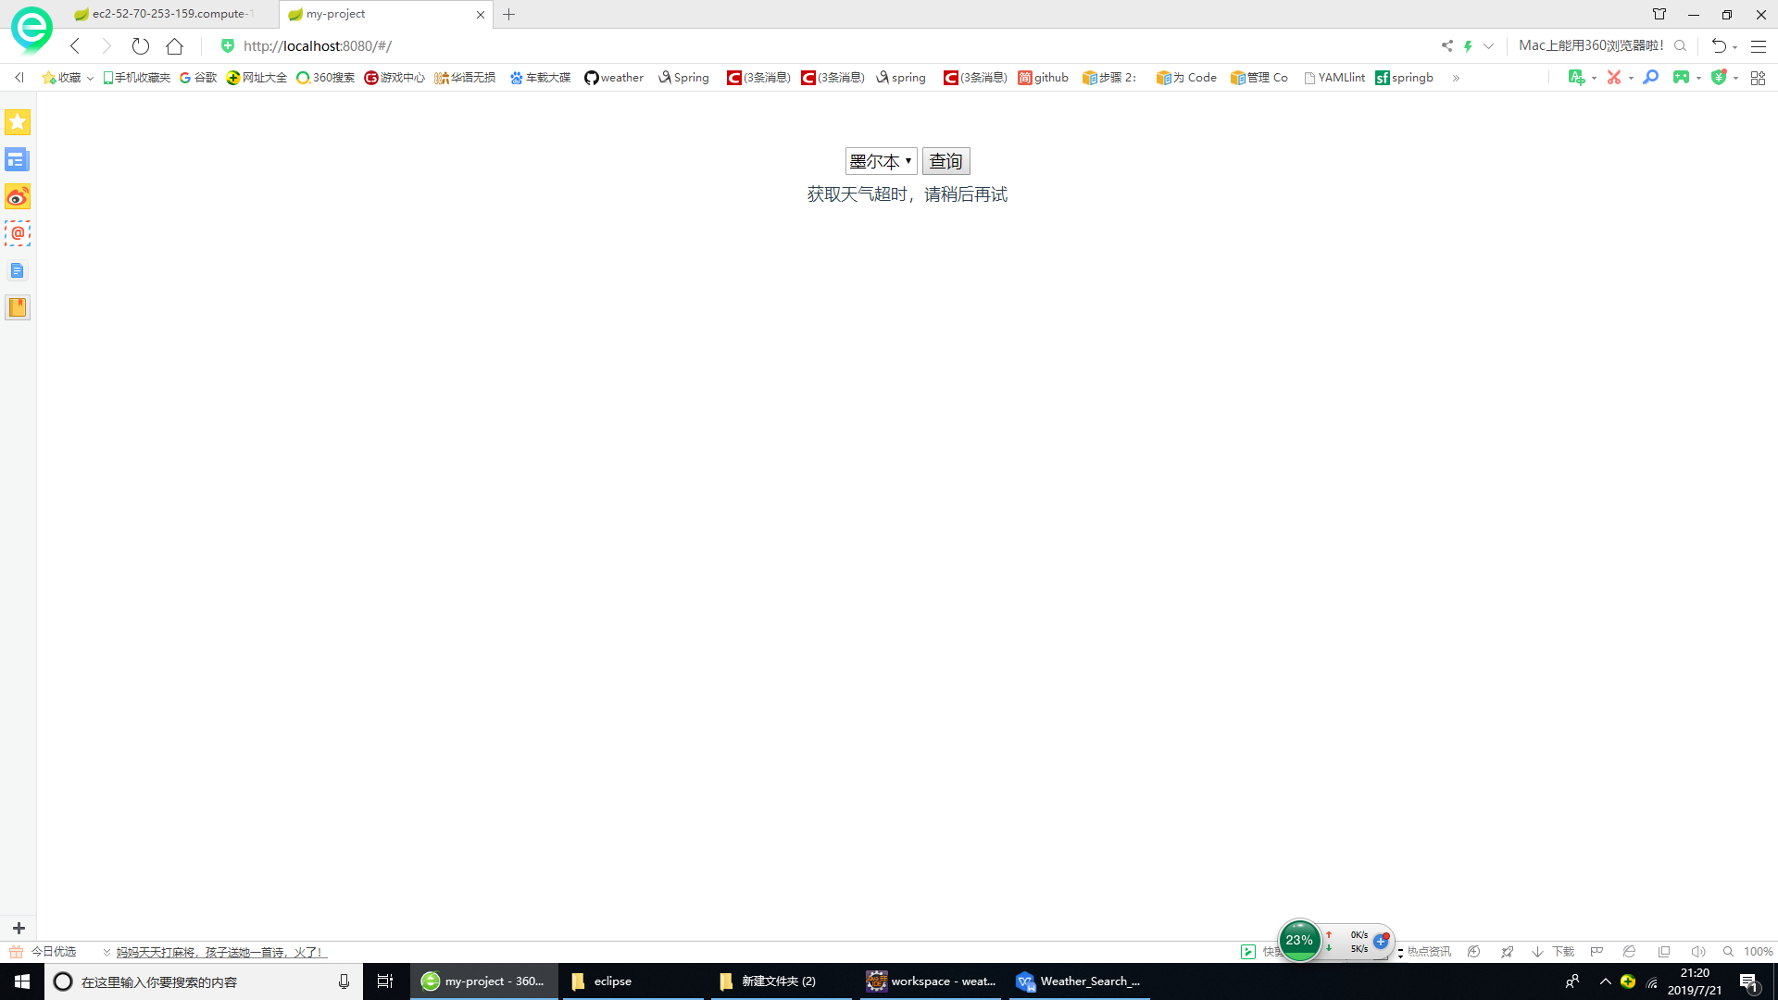

- No known system error. It hardly ever happens.
