2019-03-25-工作记录2-前端界面

上一篇用react框架实现了最简单的页面交互测试，能在页面上显示出来合约管理者地址，现在我们来做更复杂的事情，让页面具备输入框和按钮，这些动作还能与合约互动起来。

1 改造mytest/contracts/lottery.sol, 增加getPlayers方法。原因是使用缺省的get方法只得到单个的player对象，不能获得players数组对象，因此我们自己写个public函数返回数组。

function getPlayers() public returns(address[]){

return players;

}

2 由于mytest/contracts/lottery.sol合约更改了，需要重新部署重新运行：node deploy.js, 获得地址和abi接口。

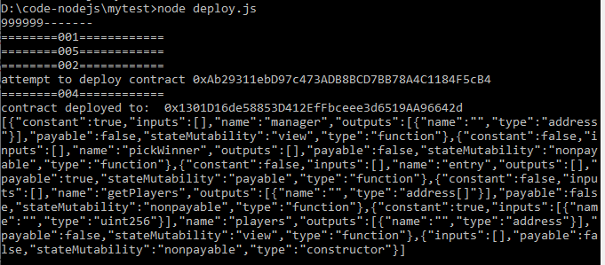

3 改造reactDemo/src/lottery.js,更新地址和abi接口信息，

import web3 from './web3';

const address = '0xAb29311ebD97c473ADB8BCD7BB78A4C1184F5cB4';

const abi = [{"constant":true,"inputs":[],"name":"manager","outputs":[{"name":"","type":"address"}],"payable":false,"stateMutability":"view","type":"function"},{"constant":false,"inputs":[],"name":"pickWinner","outputs":[],"payable":false,"stateMutability":"nonpayable","type":"function"},{"constant":false,"inputs":[],"name":"entry","outputs":[],"payable":true,"stateMutability":"payable","type":"function"},{"constant":false,"inputs":[],"name":"getPlayers","outputs":[{"name":"","type":"address[]"}],"payable":false,"stateMutability":"nonpayable","type":"function"},{"constant":true,"inputs":[{"name":"","type":"uint256"}],"name":"players","outputs":[{"name":"","type":"address"}],"payable":false,"stateMutability":"view","type":"function"},{"inputs":[],"payable":false,"stateMutability":"nonpayable","type":"constructor"}];

export default new web3.eth.Contract(abi,address);

4改造reactDemo/src/App.js,添加html元素。文件内容如下：

import React, { Component } from 'react';

import logo from './logo.svg';

import './App.css';

import web3 from './web3';

import lottery from './lottery'; //导入合约对象实例

class App extends Component {

//定义状态变量

state = {

manager:'',

players:[],

balance:''

}

//生命周期函数，将在render()执行完后自动执行。注意名字千万不要拼写错了，错了就不会被调用执行

async componentDidMount(){

//lottery对象有一个public的状态变量manager，现在通过调用同名getter方法得到该变量

const manager = await lottery.methods.manager().call();

const players = await lottery.methods.getPlayers().call(); //数组变量比较特殊，必须要单独编写get函数

const balance = await web3.eth.getBalance(lottery.options.address);

this.setState({manager,players,balance}); //为获得manager变量后保存在状态变量中。

}

render() {

console.log(web3.version);

return (

<div>

<h1>lottery管理者地址:</h1>

<p>this is manager by {this.state.manager}</p>

<p>当前参与者数量:{this.state.players.length}</p>

<p>当前资金池: {this.state.balance}</p>

<hr/>

<form>

<h4>参与到博彩项目？</h4>

<div>

<label>您的投注金额：</label>

<input />

</div>

<button>提交</button>

</form>

</div>

);

}

}

export default App;

5 运行reactDemo项目，看看网页效果：

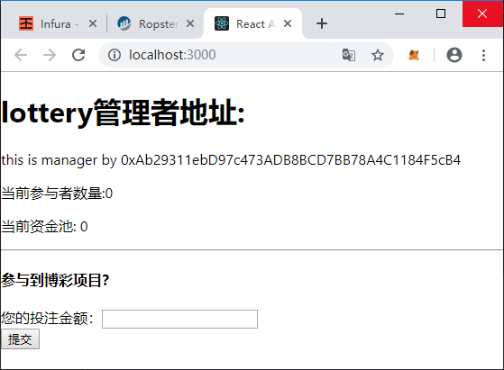

大功告成~~~