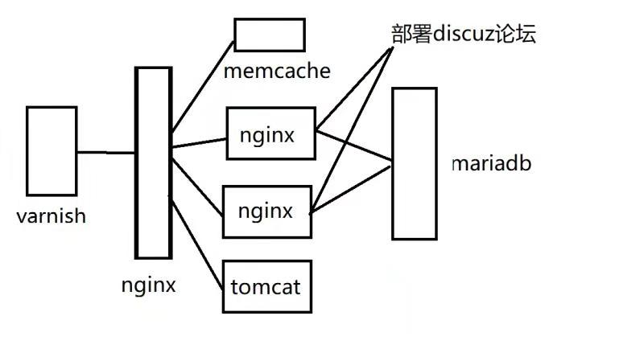

**步骤1：按照下表给服务器配置IP**

|  |  |
| --- | --- |
| Varnish | eth1：192.168.2.1 |
| NginxAgent | eth0：192.168.4.2  eth1：192.168.2.2 |
| Nginx1 | eth0：192.168.4.3 |
| Nginx2 | eth0：192.168.4.4 |
| Tomcat | eth0：192.168.4.5 |
| Mariadb | eth0：192.168.4.6 |

**步骤2：一键配置yum源，分发lnmp.tar.gz**

[root@real lnmp_soft]# yum -y install pssh-2.3.1-5.el7.noarch.rpm

#真机安装pssh

[root@real ~]# for i in `cat host.txt`; do ssh-copy-id $i; done

#分发keygen私钥

[root@real ~]# pscp.pssh -h host.txt /var/ftp/rhel7.repo /etc/yum.repos.d/

#批量拷贝rhel7.repo，单独修改Varnish主机的Yum源

[root@real ~]# pscp.pssh -h host.txt /root/lnmp_soft.tar.gz /root/

#批量拷贝lnmp_soft包

[root@real ~]# pssh -h host.txt tar -xf /root/lnmp_soft.tar.gz

#批量解压lnmp_soft包

**步骤3：一键搭建LNMP环境**

[root@nginx1 ~]# cat /root/lnmp.sh

#编写一键LNMP脚本

#/bin/bash

cd /root/lnmp_soft/

tar -xf nginx-1.12.2.tar.gz

cd nginx-1.12.2/

yum -y install gcc pcre-devel openssl-devel

useradd -s /sbin/nologin nginx

./configure --user=nginx --group=nginx --with-http_ssl_module --with-stream --with-http_stub_status_module

make && make install

ln -s /usr/local/nginx/sbin/nginx /sbin/nginx

ln -s /usr/local/nginx/conf/nginx.conf /nginx.conf.link

echo nginx >> /etc/rc.local

chmod +x /etc/rc.local

yum -y install mariadb-server mariadb mariadb-devel

yum -y install php php-mysql

cd /root/lnmp_soft/

yum -y install php-fpm-5.4.16-42.el7.x86_64.rpm

nginx

systemctl restart mariadb php-fpm

systemctl enable mariadb php-fpm

clear

netstat -antpl | grep 80

netstat -antpl | grep 9000

netstat -antpl | grep 3306

[root@real ~]# pscp.pssh -h host.txt /root/lnmp.sh /root/

#分发LNMP脚本，NginxAgent、Nginx1、Nginx2执行脚本

**步骤4：创建远程数据库、用户名及密码**

[root@mariadb ~]# yum -y install mariadb mariadb-server

[root@mariadb ~]# systemctl restart mariadb

[root@mariadb ~]# systemctl enable mariadb

[root@mariadb ~]# mysql

MariaDB [(none)]> create database bbsdb;

MariaDB [(none)]> grant all on bbsdb.* to gjq identified by '123456';

**步骤5：Nginx1部署论坛主程序并捆绑远程数据库**

[root@nginx1 ~]# unzip lnmp_soft/php_scripts/Discuz_X3.4_SC_UTF8.zip -d /usr/local/nginx/html/

[root@nginx1 html]# mv upload/* .

[root@nginx1 html]# chmod -R 777 .

#部署论坛主程序到网页根目录

[root@nginx1 ~]# cat /nginx.conf.link

#配置网页动静分离，添加index.php默认网页文件

location / {

root html;

index index.html index.htm index.php;

}

location ~ \.php$ {

root html;

fastcgi_pass 127.0.0.1:9000;

fastcgi_index index.php;

include fastcgi.conf;

}

[root@nginx1 html]# firefox 127.0.0.1

#捆绑远程数据库，指定IP、数据库、用户名、密码

**步骤6：远程同步论坛主程序到Nginx2**

[root@nginx1 html]# rsync -avz --delete /usr/local/nginx/html/ root@192.168.4.4:/usr/local/nginx/html/

#远程同步论坛主程序

[root@nginx1 html]# rsync -avz --delete /usr/local/nginx/conf/nginx.conf root@192.168.4.4:/usr/local/nginx/conf/nginx.conf

#远程同步nginx.conf主配置文件

[root@nginx2 ~]# nginx -s reload

#Nginx2主机重启配置

**步骤7：搭建Tomcat网页**

[root@tomcat ~]# yum -y install java-1.8.0-openjdk java-1.8.0-openjdk-headless

#默认已安装jdk

[root@tomcat lnmp_soft]# tar -xf apache-tomcat-8.0.30.tar.gz

[root@tomcat lnmp_soft]# cp -r apache-tomcat-8.0.30 /usr/local/tomcat

#解压tomcat源码包，无需编译直接拷贝到指定目录

[root@tomcat tomcat]# /usr/local/tomcat/bin/startup.sh

#启动tomcat，不作任何配置

[root@tomcat tomcat]# firefox 127.0.0.1:8080

#测试默认页面

**步骤8：配置反向代理服务器NginxAgent**

[root@nginxagent ~]# cat /nginx.conf.link

http {

...

upstream nginx { #nginx地址池

ip_hash;

server 192.168.4.3:80;

server 192.168.4.4:80;

}

upstream tomcat { #tomcat地址池

server 192.168.4.5:8080;

}

server {

listen 80;

server_name www.ng123.com;

location / {

proxy_pass http://nginx;

proxy_set_header Host $host;

proxy_set_header X-Real-IP $remote_addr;

#解决网页样式错位

}

server {

listen 80;

server_name www.tc123.com;

location / {

proxy_pass http://tomcat;

}

}

}

**步骤9：配置memcache共享session**

[root@nginxagent ~]# yum -y install memcached.x86_64

#代理服务器NginxAgent安装memcached

[root@nginxagent ~]# systemctl start memcached

[root@nginxagent ~]# systemctl enable memcached

[root@nginxagent ~]# netstat -antpl | grep 11211

#NginxAgent配置memcache数据库

[root@nginx1 html]# yum -y install php-pecl-memcache

[root@nginx1 html]# cat /etc/php-fpm.d/www.conf

php_value[session.save_handler] = memcache

php_value[session.save_path] = "tcp://192.168.4.2:11211"

[root@nginx1 html]# systemctl restart php-fpm

#Nginx1、Nginx2部署session共享

**步骤10：搭建Varnish后端服务器**

（参考OPERATION-->Day05的笔记）

1）安装软件依赖包，源码安装Varnish包

2）复制启动脚本及配置文件

3）修改代理配置文件

[root@varnish ~]# cat /usr/local/etc/default.vcl

backend default {

.host = "192.168.2.2";

.port = "80";

}

4）启动Varnish服务

[root@varnish ~]# varnishd -f /usr/local/etc/default.vcl

5）真机配置/etc/hosts

[root@room9pc01 ~]# cat /etc/hosts

192.168.2.1 www.tc123.com www.ng123.com

#域名指向Varnish服务器IP