1. Boostrap

Boostrap教学视频：www.bilibili.com搜索李炎恢

1. **栅格系统**

栅格系统中，浏览器会随着屏幕的大小的增减自动分配最多 12 列。

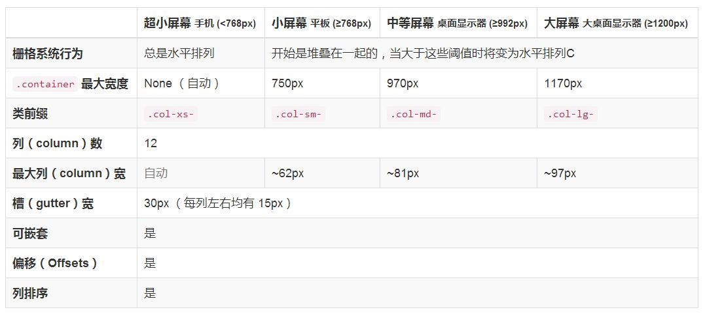

**2、下拉菜单**

<div class="dropdown">

<!--data-toggle需要js-->

<button class="btn btn-default" data-toggle="dropdown">

下拉菜单<span class="caret"></span>

</button>

<ul class="dropdown-menu">

<li><a href="#">Linux</a></li>

<li><a href="#">Network</a></li>

<li><a href="#">Python</a></li>

<li><a href="#">html+css</a></li>

</ul>

</div>

<script src="static/js/jquery.min.js"></script>

<script src="static/js/bootstrap.min.js"></script>

1. **案例演示**

参考资料：NSD1808_项目资料/阶段5课程/nsd_2018/ebooks/web/boot_css

1. ：栅格系统
2. ：菜单与按钮组件
3. ：导航组件

第15章：选项卡功能

第18章：轮播插件

网页文件：/root/文档/NSD1808_阶段5/4.DEVWEB/bootcss2.html

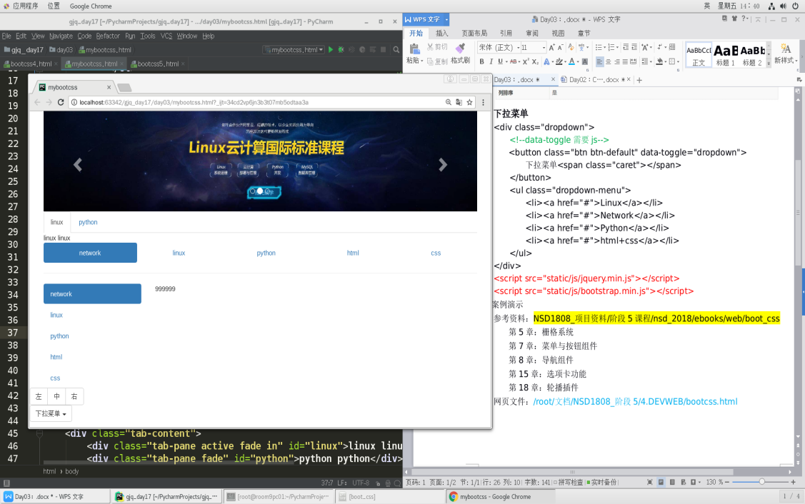

二、Python词云

**1、安装模块**

[root@room9pc01 ~]# pip3 install wordcloud

[root@room9pc01 ~]# pip3 install matplotlib

[root@room9pc01 ~]# pip3 install scipy #做心形图片

**2、制作词云**

**1）使用字符串生成图片**

>>> import wordcloud

>>> w = wordcloud.WordCloud(width=100, height=50) # 图像大小

>>> w.generate('7sc72f') #使用字符串

>>> w.to_file('/tmp/ww.png')

[root@room9pc01 ~]# eog /tmp/ww.png

ww

1. **使用文件生成图片**

>>> import wordcloud

>>> w = wordcloud.WordCloud(width=800, height=100)

>>> with open('/etc/hosts') as fobj:

... w.generate(fobj.read())

>>> w.to_file('/tmp/hosts.png')

[root@room9pc01 ~]# eog /tmp/hosts.png

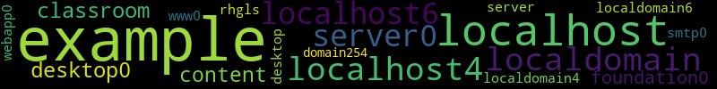

1. **使用个性字体**

>>> import wordcloud

>>> w = wordcloud.WordCloud(width=800, height=300, font_path='/root/下载/nsd1808/devweb/day03/static/fonts/CabinSketch-Bold.ttf')

>>> with open('/etc/hosts') as fobj:

... w.generate(fobj.read())

>>> w.to_file('/tmp/sss.png')

[root@room8pc16 day04]# eog /tmp/sss.png

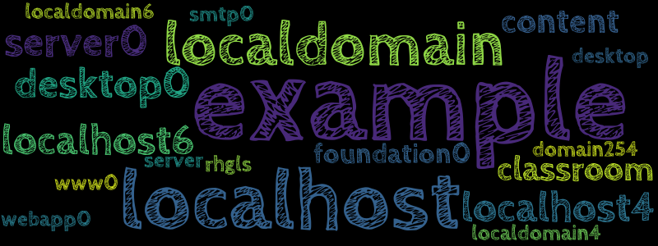

1. **生成心形图片**

>>> import wordcloud

>>> from scipy.misc import imread

>>> bg_img = imread('/root/下载/nsd1808/devweb/day03/static/imgs/heart.jpeg')

>>> w = wordcloud.WordCloud(font_path='/root/下载/nsd1808/devweb/day03/static/fonts/CabinSketch-Bold.ttf', mask=bg_img)

>>> with open('/etc/hosts') as fobj:

... w.generate(fobj.read())

>>> w.to_file('/tmp/heart.png')

[root@room8pc16 day04]# eog /tmp/heart.png

