**CPS420 – Framework Project: Phase 2 & 3**

**Assigned: Week 5 Due: Week 10 60 Points**

**Phase 2 (Analysis and Design): 30 Points - Design the application based upon the problem statement in your Phase 1 proposal**

Resources: Sample Design Templates/Documents (get ideas from these but you don’t need all parts from these):

* <http://ccftp.scu.edu.cn:8090/Download/uploadfile/20130902152342720.pdf>
* <https://web.cs.dal.ca/~arc/teaching/CS3130/Templates/Design%20Templates/Software%20Design%20Specification.doc>
* <http://www.facultyintranet.unic.ac.cy/onlinecourse/CourseFiles/COMP-401_976/Project/IEEE%20STANDARD%201016.doc>
* <https://projects.cecs.pdx.edu/attachments/download/1165/SAD_DTCPII_ver1.4.doc>

Create a design document with the following 7 Sections **About Your Application:**

**Section**

1. **Explain the Purpose of the Site.**
2. Provide information (diagrams/images) about the architecture of your Framework and specifically the design of your application in that framework.
3. Create a prototype/wireframe of the interface showing user interaction for each page on the website.
4. Provide the project/folder structure
5. Provide a list of modules to be developed, including

* The code that lives on the server and responds to HTTP requests.
* The HTML markup code and any client-side scripts

1. Provide on additional section from the resources above.
2. Answer the following questions:

* How does the site store persistent data?
* What Client-Side Code and languages used for the front-end?
* What Server-Side Code and languages used for the back-end?
* What database server will be used?
* What platform it will be hosted in (Windows, Linux, Mac)?
* What types of security will be implemented?
* What web server software would be used?

**Examples of the ASP.NET Architecture:**

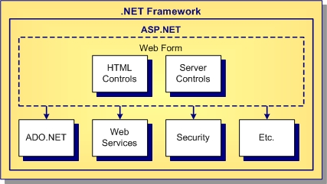

Security Architecture:

<https://blogs.msdn.microsoft.com/alikl/2009/03/19/asp-net-security-architecture-cheat-sheet-for-very-busy-architects/>

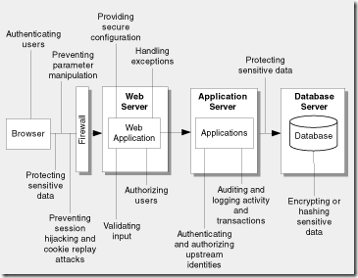

**Phase 3 (Implementation): 30 Points - Develop a web application with the following aspects:**

**Code Requirements:**

1. Develop a multi-page (at least 2) web application
2. Create a User Interface (UI)
3. Provide the necessary front end (HTML, CSS, JS, etc.) and back end components
4. Demonstrate the use of validation controls
5. Demonstrate the use of server controls
6. Demonstrate how to work with state, cookies, and URL encoding
7. Include Database components (at least a 2-table database) and presentation of data using a grid
8. Implement Server and Code Security (See: <http://www.beyondsecurity.com/web-security-and-web-scanning.html>)

**Include the Phase 2 and Phase 3 documents/code zipped up in a folder on Blackboard**