**CPS420 - Lab #6: Using ADO.NET in ASP.NET**

**Assigned: Week 9 Due: Week 10 40 Points**

Read the following chapters:

* **Chapter 15 How to use the DetailsView and FormView controls**
* **Chapter 16 How to use the ListView and DataPager controls**
* **Chapter 17 How to use object data sources with ADO.NET**

ADO.NET is an essential technology in .NET to interact with databases, create connections to data sources with Connection, Command and DataReader, and access containers of data such as DataSet, DataTable, DataRow. Review the following YouTube videos:

* Create Database and make simple interface: <https://www.youtube.com/watch?v=_L3VOfJ6D28>
* Update the Database: <https://www.youtube.com/watch?v=PJeCg6wtc-s#t=4.151156>

Each of these are about 20 minutes in length. Please follow along with the projects that the narrator is walking through. From the video, here are the steps to Direct Data Access

* Create a ConnectionString. Create a SqlConnection, Create a Command (SqlCommand), Create SqlDataReader
* Use the Reader, Close the Connection
* Send Pages to Users

1. You are to create a new website project
2. Create a database and populate one table with a different data set

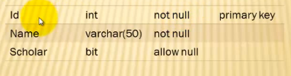

1. Add at least 10 records to your file.
2. Code the connection as directed in the video. A ConnectionString is a connection to a data source, implemented in a try-catch-finally block
3. Develop the interface as is directed in the video.
4. First Simple Interface – textbox and dropdown list to search and display data in a listbox.

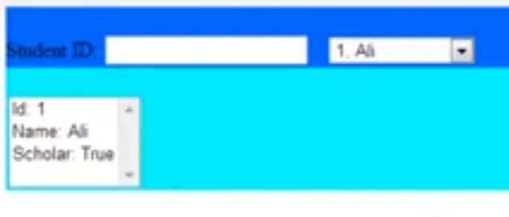

1. Second interface for updating the Database:

