# Overview of the Assignment:

This first exercise is a review of database design and normalization. Recall that normalization applies to single relations (tables). Your task is to review the following spreadsheet example and create a normalized design with extensions to handle missing data such as payment status.

# Topic: Bike Rental and Repair Shop Database

You have received a spreadsheet containing data for a bike (bicycle) rental and repair shop. The shop has been having trouble making business decisions and tracking all the relevant information. You have been asked to prepare a database for the bike shop.

The bike shop has the following issues within their spreadsheet design, among others:

* There are data anomalies within customer name and address because of redundancy.
* It is difficult to know when members rented which bikes and their riding preferences.
* It’s hard to predict which parts should be in stock and which should be on special order; parts required most often for repairs should be stocked, and right now the shop is having a hard time figuring this out.
* It’s difficult to track payment status or what specifically was fixed. This is an example of missing data, which is common in spreadsheets.

The names and data types of the columns of the spreadsheet are below. The names, data types and meanings of the columns are:

|  |  |  |
| --- | --- | --- |
| **Column name** | **Data type** | **What it represents** |
| First name | a string such as “Brian” | the member’s first name |
| Last name | a string such as “Anderson” | the member’s last name |
| Bike rented | a string such as “Mongoose Impasse mountain bike #3” | Each bike, there are various brands and types of bikes, and there are multiple copies of each bike, it’s hard to know when the shop acquired the bike |
| Bike rental info | A string such as “rented for ½ a day, returned dirty with flat tire” | Rental information |
| Member Contact Info | A string with primary phone and email info. | the member’s preferred phone number and email address for the shop to use for communications |
| Member address1 | a string such as “123 Main Street” | first line of member’s street address |
| Member address2 | A string such as “Apartment 4” | second line of member’s street address |
| City | a string such as “Boston” | the member’s resident city |
| State | a string such as “MA” | the member’s resident state |
| Postal code | a string such as “02215” | the member’s home postal code |
| Repair Info | A string such as “Replaced rear tire and tube, noticed that brakes were worn, will need to be replaced in a week or two. Look to replace chain soon!” | Specific information regarding what needs to be repaired and/or what was repaired |

Consider normalization rules through BCNF and fourth normal form if you feel this is needed.

1. Within a few paragraphs briefly answer the following questions:
   1. What specific issues do you see in the original spreadsheet design? Provide a sample data set showing possible anomalies or inconsistencies to demonstrate your points.

Anomalies can be created anywhere.

For example, if deleting the bike a customer has rented can create anomalies because everything is in one single cell. Also, status and time period of rental has been stored in same attribute; this will cause the problem when editing the rental info.



* 1. Briefly explain your choices of the entities in your normalized design and how these would reduce or eliminate the issues that you previously identified.

Separating user information into Customers, contact information, address, zip code, city and state multiple entities can eliminate the anomaly of the customer's address when editing the same information in all records; it can also better record preferences. In addition, creating separate consumption records, Orders, Bikes, and Parts entities can eliminate anomalies that may occur when updating information. The payment entity will solve the trouble that the payment status is difficult to confirm. At the same time, distinguish Rental and Repair; this will enable them to better grasp their respective Status. For independent Parts entities, it is now possible to determine whether they are hot-selling parts through monthly sales and set special labels.

|  |  |
| --- | --- |
| **Entities** | **Description** |
| Customers | Include basic information of customers |
| Contact_Info | Include primary phone and email info in different attributes |
| Riding_Preferences | Include any type of preferences |
| Address | Include address ID, address_line1, address_line2, and zipcode |
| Address_Bridge | Include each records of address and will not effect others |
| Postcode | Include zipcode, city ID and state ID |
| City | Include city ID and city name |
| State | Include state ID and state name |
| Order_History | Include customer ID, Order ID, Date, and Payment info |
| Payment | Include payment ID, the type of how they paid, the status of payment processing, and cost of the order |
| Rental_Order | Include order ID, Bike ID, how long they rent, and the status of rental processing |
| Repair_Order | Include order ID, Bike ID, how long they rent, and the status of repair processing so people can know how the repair be done or not |
| Bikes | Include bike ID, brand ID, nickname, when it acquired, and the cost for rental |
| Parts | Include Part ID, brand ID, name, how many it has been expended per month, how many left in stock, and the cost |
| Bike_Brands | Include the brand ID, brand name, and type ID |
| Part_Types | Include the brand ID, brand name, and type ID |
| Bike_Brands | Include the type ID, and type name |
| Part_ Types | Include the type ID, type name, and whether it is special or not |

* 1. Select one or two of the more complex tables (i.e. a bridge table) in your design and explain and if it is in BCNF and or not, explain specifically by demonstrating through a sample data set that the table is in BCNF or not.

Parts and Bikes have similar design and they are not BCNF because there is no pretty much needed to normalize to be BCNF and educe efficiency of searching data from other entities. For example, in Parts table, the time_repair and stocks are not been set in unique tables for avoiding anomalies. However, we also need the cost of time for repairing and things such as stock and the costs, otherwise, we will need to process through more tables for each specific attributes.

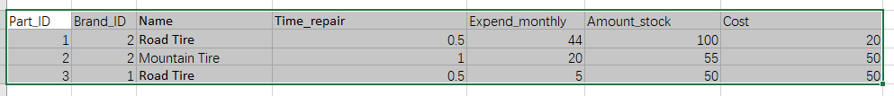

1. Create a reasonable normalized design for Bike Rental and Repair Shop. You may use Lucidchart, Microsoft Visio or another similarly capable drawing application to produce your ERD. Relationship connectivities using Crow’s foot or UML are required as well as distinction between strong and weak relationships.

Insert a logical entity relationship diagram below. You can alternatively add the file as a separate attachment. If you choose to attach a file, please note here for your facilitator the name of that file.

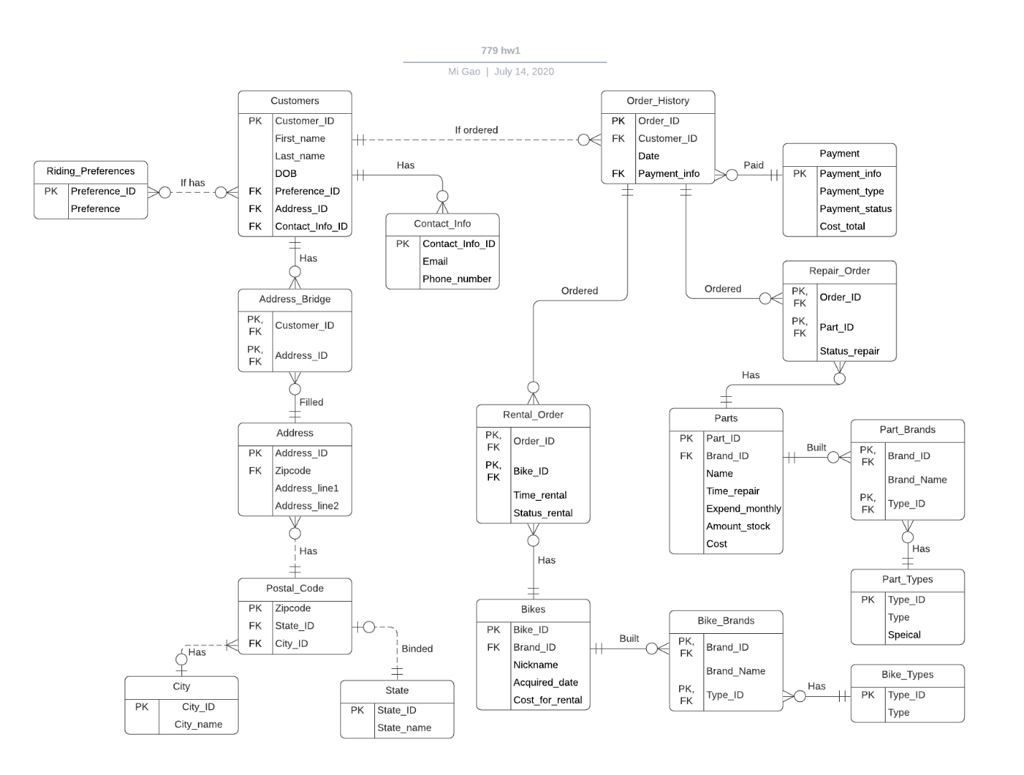

1. The Bike Rental and Repair would like you to identify a business need to track additional data and create additional tables to support this within the design. Please select a single area to focus on. You may want to do some research. Examples include:
   * Ridership habits and preferences
   * Employee management (i.e. sales, repair, relationship to bikes)
   * Bike Sales
   1. Within a few paragraphs briefly explain the enhanced area that you added to your design including entities and relationships that you have selected. You can organize your response in a tabular form.

Add three tables called Employees, Jobs, Repair_Department, and Sales_Department. There has specific job for employees, and each job work belongs to either Sales or Repair department. Also, each department’s table will record what job title takes charge of selling what kind of bike or repairing what kind of parts. Therefore, based on how Rental_Order and Repair_Order tables work, this will show the same functionality to differentiate the duties in different jobs.

* 1. Insert the updated logical entity relationship diagram below. You can alternatively add the file as a separate attachment. If you choose to submit a separate file please note here for your facilitator the name of that file.

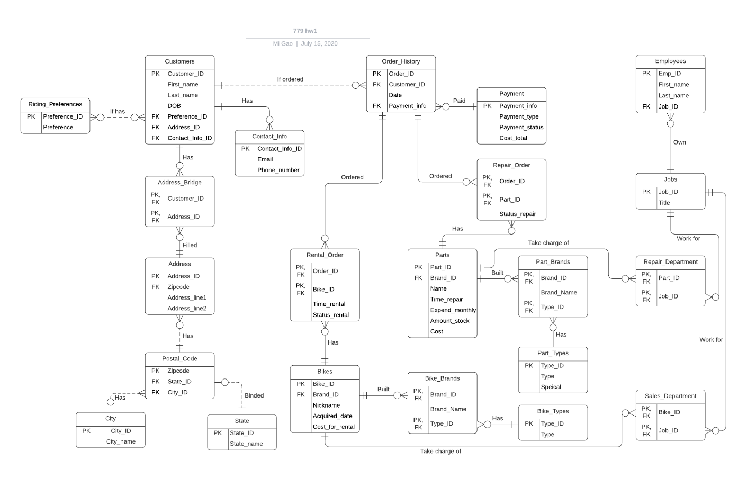

Use the **Ask the Teaching Team Discussion Forum** if you have any questions regarding the how to approach this assignment.

Save your assignment as ***lastnameFirstname_assign1_0.docx*** and submit it in the *Assignments* section of the course.

For help uploading files please refer to the *Technical Support* page in the syllabus.