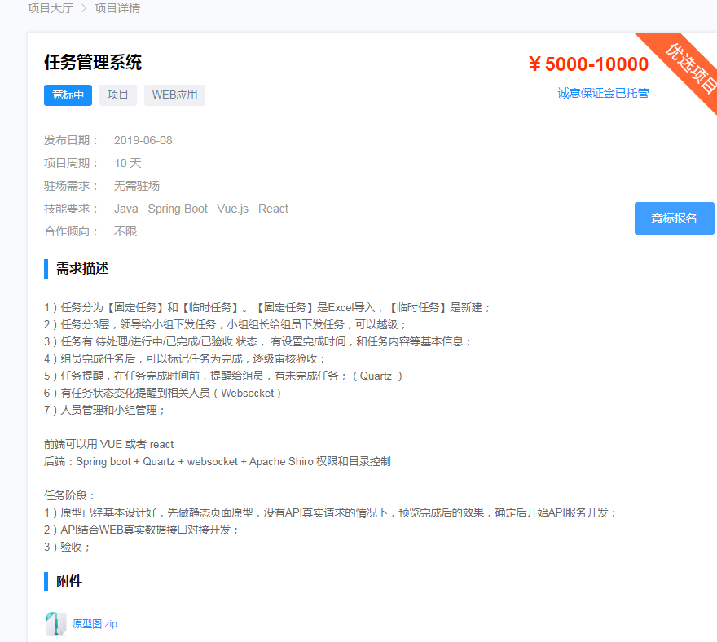

<https://zb.oschina.net/project/detail.html?id=14569125>