**Supplemental Methods**

*Simulation studies*

We performed empirical power calculations of two-point linkage analysis on several known non-syndromic hearing loss genes, including two autosomal recessive genes *GJB2* and *SLC26A4*, and two autosomal dominant genes *MYO7A* and *MYH9*. We simulated 2-generational pedigrees for recessive genes and 3-generational pedigrees for dominant genes, allowing for 3 ~ 10 offspring in the last generation with proportions determined by the distribution of number of children per family in the United States in 2012 (3 children: xx%, 4 children: xx%, 5 children: xx%, 6 children: xx%, …). Genotypes are simulated for the four genes based on the variant sites and the corresponding minor allele frequencies in European Americans recorded in Exome Variant Server. We annotate these variants using Deafness Variation Database (DVD) and NCBI ClinVar, labelling variants as “pathogenic” if they present in both databases as pathogenic. Disease status for individuals are determined by genotypes on those pathogenic sites under dominant mode of inheritance for *MYO7A* and *MYH9*, and recessive & compound recessive for *GJB2* and *SLC26A4*, assuming complete penetrance. Such settings create linkage heterogeneity among family members. We ascertain simulated families having two or more affected offspring for linkage analysis. To introduce pedigree heterogeneity we mix families having pathogenic mutations in one gene but not others, so that each simulated gene contributes to the etiology of only a proportion of families in the entire dataset. We simulate multiple replicates under different settings of sample sizes, mode of inheritance, proportion of pedigree heterogeneity, etc. For each replicate we compute LOD and HLOD scores using regional markers generated by collapsed haplotype pattern method (CHP) as well as the maximum LOD and HLOD scores using single variant markers. Power is estimated by  and where “#” stands for “number of times” and *N* is the total number of replicates.

**Supplemental Figures**

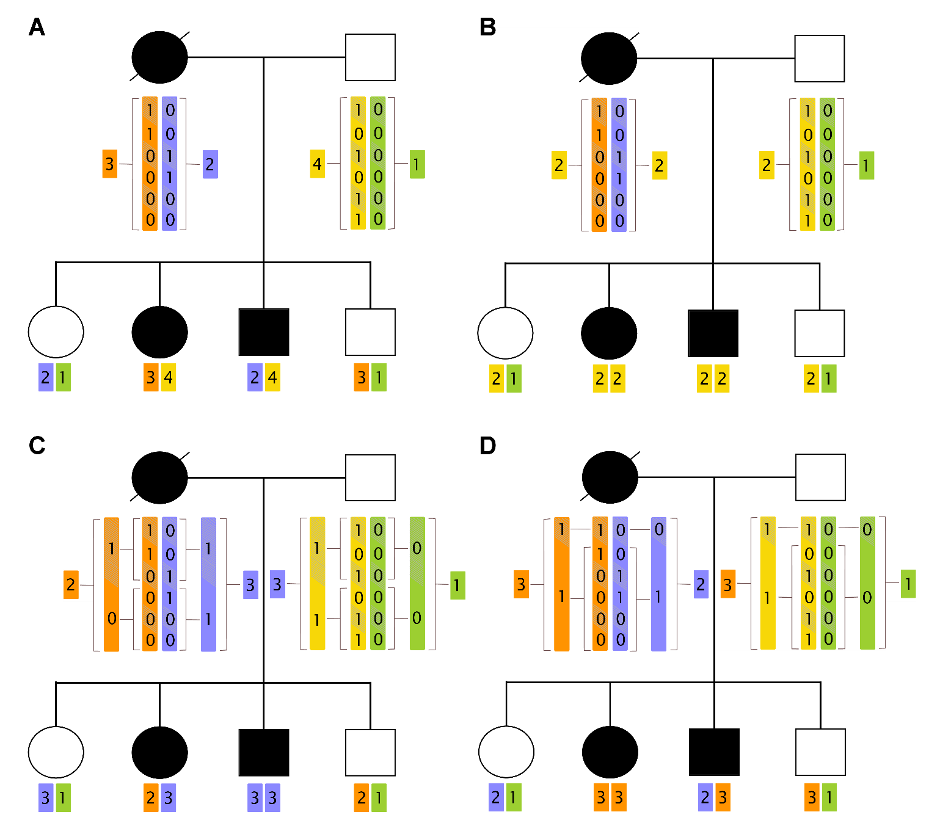

**Fig. S1:** . This represents an autosomal compound recessive disorder. Panel A displays the use of original haplotype patterns as regional markers, a special case of the CHP method using windows of size 1; panel B displays the *complete collapsing* theme with window size equaling the length of the region; panel C displays a collapsing theme with windows of size 3 and panel D displays the *LD based collapsing* theme assuming the 2nd to 6th variant loci are in LD with each other. (write about LOD score for A~D should be the same and should be greater than the max of LOD for single variant analysis)

**Supplemental Tables**

**Table S1:**

**Table S2:**

**Web Resources**

America’s Families and Living Arrangements, <https://www.census.gov/prod/2013pubs/p20-570.pdf>

Exome Variant Server (EVS), <http://evs.gs.washington.edu/EVS/>

Deafness Variation Database (DVD), http://deafnessvariationdatabase.com/

NCBI ClinVar, https://www.ncbi.nlm.nih.gov/clinvar/