**Supplemental Methods**

*Simulation studies*

We performed empirical power calculations of two-point linkage analysis using data on four non-syndromic hearing impairment (NSHI) genes: two autosomal recessive genes *GJB2* and *SLC26A4*, and two autosomal dominant genes *MYO7A* and *MYH9* (Table S1). We simulated 2-generational pedigrees, allowing for 3 up to 8 offspring in the last generation with the proportions determined by the distribution of number of children per family in the United States in 2012, rescaled such that these proportions add up to 100% (3 children: 69.34%, 4 children: 20.52%, 5 children: 6.84%, 6 children: 2.28%, 7 children 0.76%, 8 children 0.26%). Genotypes are simulated for the four genes based on the variant sites and the corresponding minor allele frequencies in European Americans recorded in Exome Variant Server. We annotate these variants using Deafness Variation Database (DVD) and NCBI ClinVar, labelling variants as “pathogenic” if they present in both databases as pathogenic. Disease status for individuals are determined by genotypes on those pathogenic sites under dominant mode of inheritance for *MYO7A* and *MYH9*, and recessive (compound heterozygotes and homozygotes) for *GJB2* and *SLC26A4*, assuming complete penetrance. Additionally for each mode of inheritance we allow for allelic heterogeneity among families, i.e., the causal variant site in a gene may not be the same for different families. We ascertain simulated families having two or more affected offspring for linkage analysis. To introduce locus heterogeneity we mix families having pathogenic mutations in one gene but not others, so that each simulated gene contributes to etiology of only a proportion of families in the entire dataset. We simulate 500 replicates under each different setting of sample size, modes of inheritance, presence of allelic heterogeneity and locus heterogeneity. For each replicate we compute LOD and HLOD (heterogeneity LOD) scores using regional markers generated by collapsed haplotype pattern markers (CHP) as well as the maximum LOD and HLOD scores analyzing individual SNV markers for comparison purposes. Power is estimated by  where the denominator is the total number of replicates and the numerator is the number of tests that successfully detected the simulated linkage signal, i.e. LOD score greater than 3.3 or HLOD score greater than 3.6. Power comparisons between CHP and individual SNV are summarized by contour plots as displayed in Figures S3 – S8.

**Supplemental Figures**

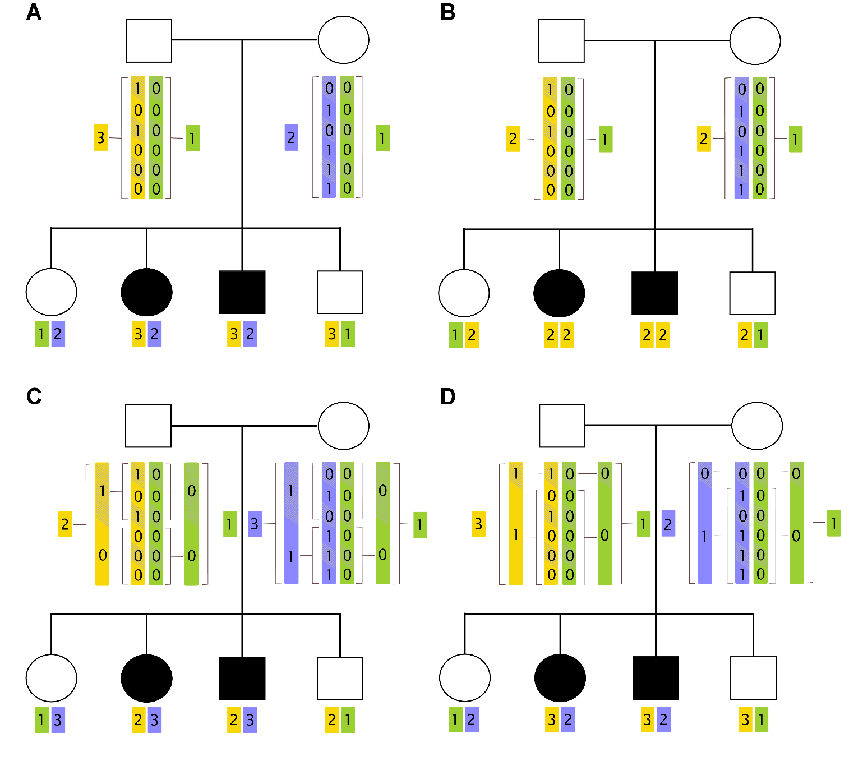

**Figure S1: The Collapsed Haplotype Pattern (CHP) method**. This figure illustrates the creation of regional markers for a group of 6 variants in pedigree with autosomal compound recessive disorder. Panel A displays the use of original haplotype patterns as regional markers, a special case of the CHP method using bins of size 1; panel B displays the *complete collapsing* theme with bin size equaling the length of the region; panel C displays a collapsing theme with bins of size 3 and panel D displays the *LD based collapsing* theme assuming the 2nd to 6th variant loci are in LD with each other.

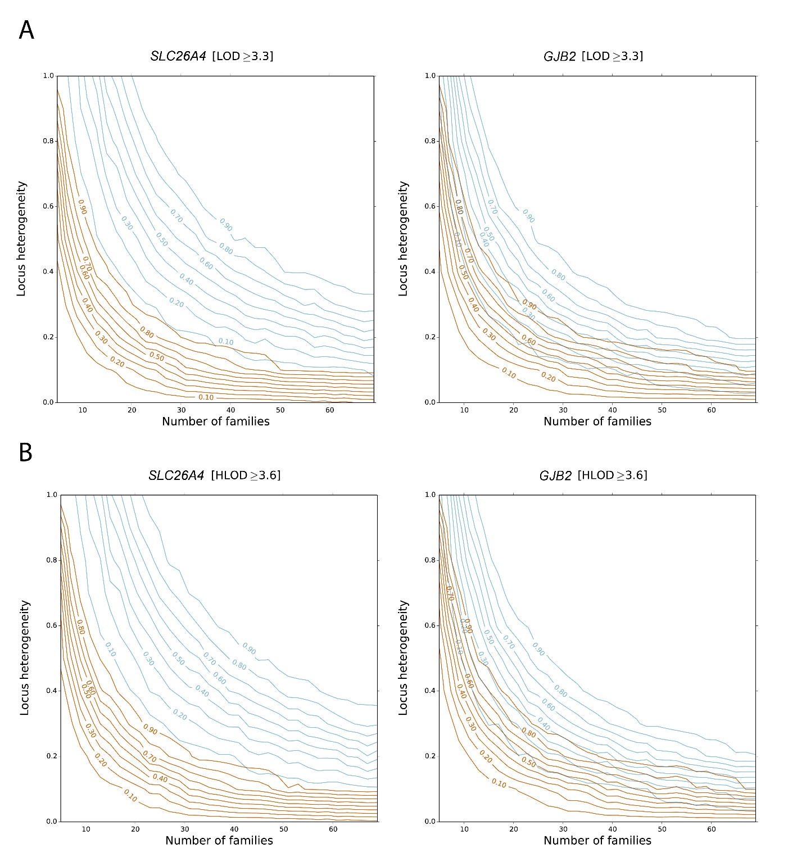

**Figure S2: Power comparisons for LOD and HLOD statistics under recessive model.** This figure shows the power for collapsed haplotype pattern markers (CHP) vs. single variant (SNV) analysis under recessive model in the presence of inter-family allelic heterogeneity. X-axis is number of families, Y-axis is proportion of locus heterogeneity, i.e. the proportion of families with non-syndromic hearing impairment (NSHI) caused by detrimental mutations in the gene under investigation, i.e. either *GJB2* or *SLC26A4*. Contour curves on the graphs are power estimates, dark orange lines for CHP and light blue lines for SNV. Panel A displays the power for the LOD statistic; panel B displays the power for the HLOD statistic. CHP method is more powerful for both statistics at a significance level of α=0.05, but the absolute power of HLOD is not greater than LOD. This is because for most families the non-causal gene often has no variants at all and therefore are uninformative for HLOD calculation, due to the very low frequencies of the genes under investigation (Table S1).

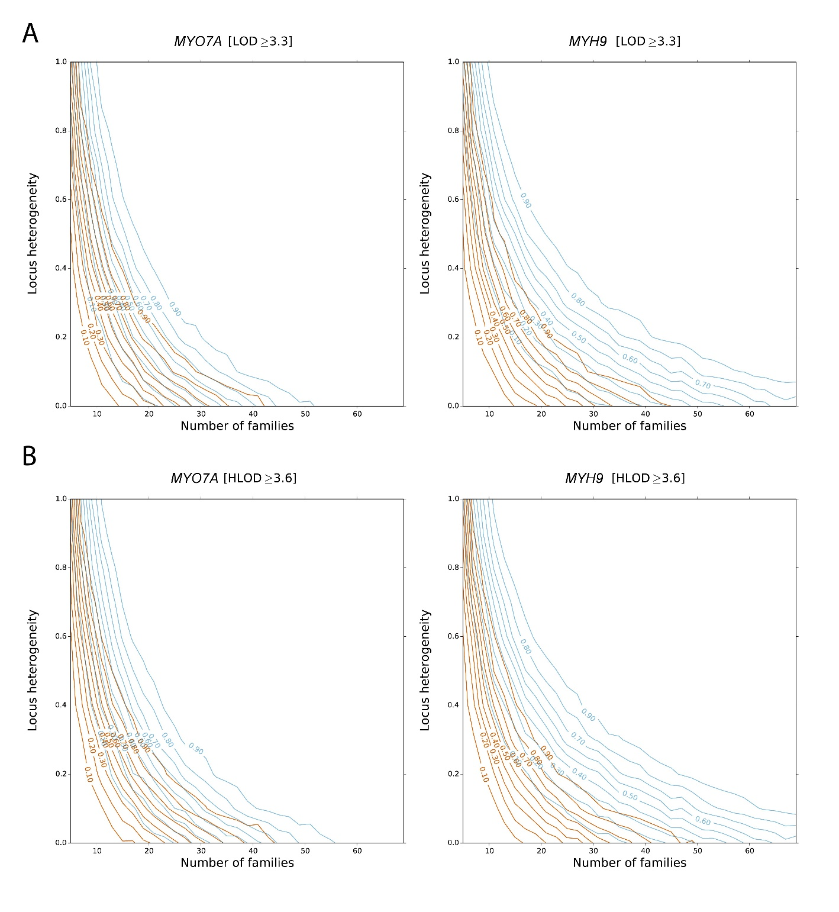

**Figure S3: Power comparisons for LOD and HLOD statistics under dominant model.** This figure shows the power for collapsed haplotype pattern markers (CHP) vs. single variant (SNV) analysis under recessive model in the presence of inter-family allelic heterogeneity. X-axis is number of families, Y-axis is proportion of locus heterogeneity, i.e. the proportion of families with non-syndromic hearing impairment (NSHI) caused by detrimental mutations on the gene under investigation, i.e. either *MYO7A* or *MYH9*. Contour curves on the graphs are power estimates, dark orange lines for CHP and light blue lines for SNV. Panel A displays the power for the LOD statistic; panel B displays the power for the HLOD statistic. CHP method is more powerful for both statistics at a significance level of α=0.05, but the absolute power of HLOD is not greater than LOD. This is because for most families the non-causal gene often has no variants at all and therefore are uninformative for HLOD calculation, due to the very low frequencies of the genes under investigation (Table S1).

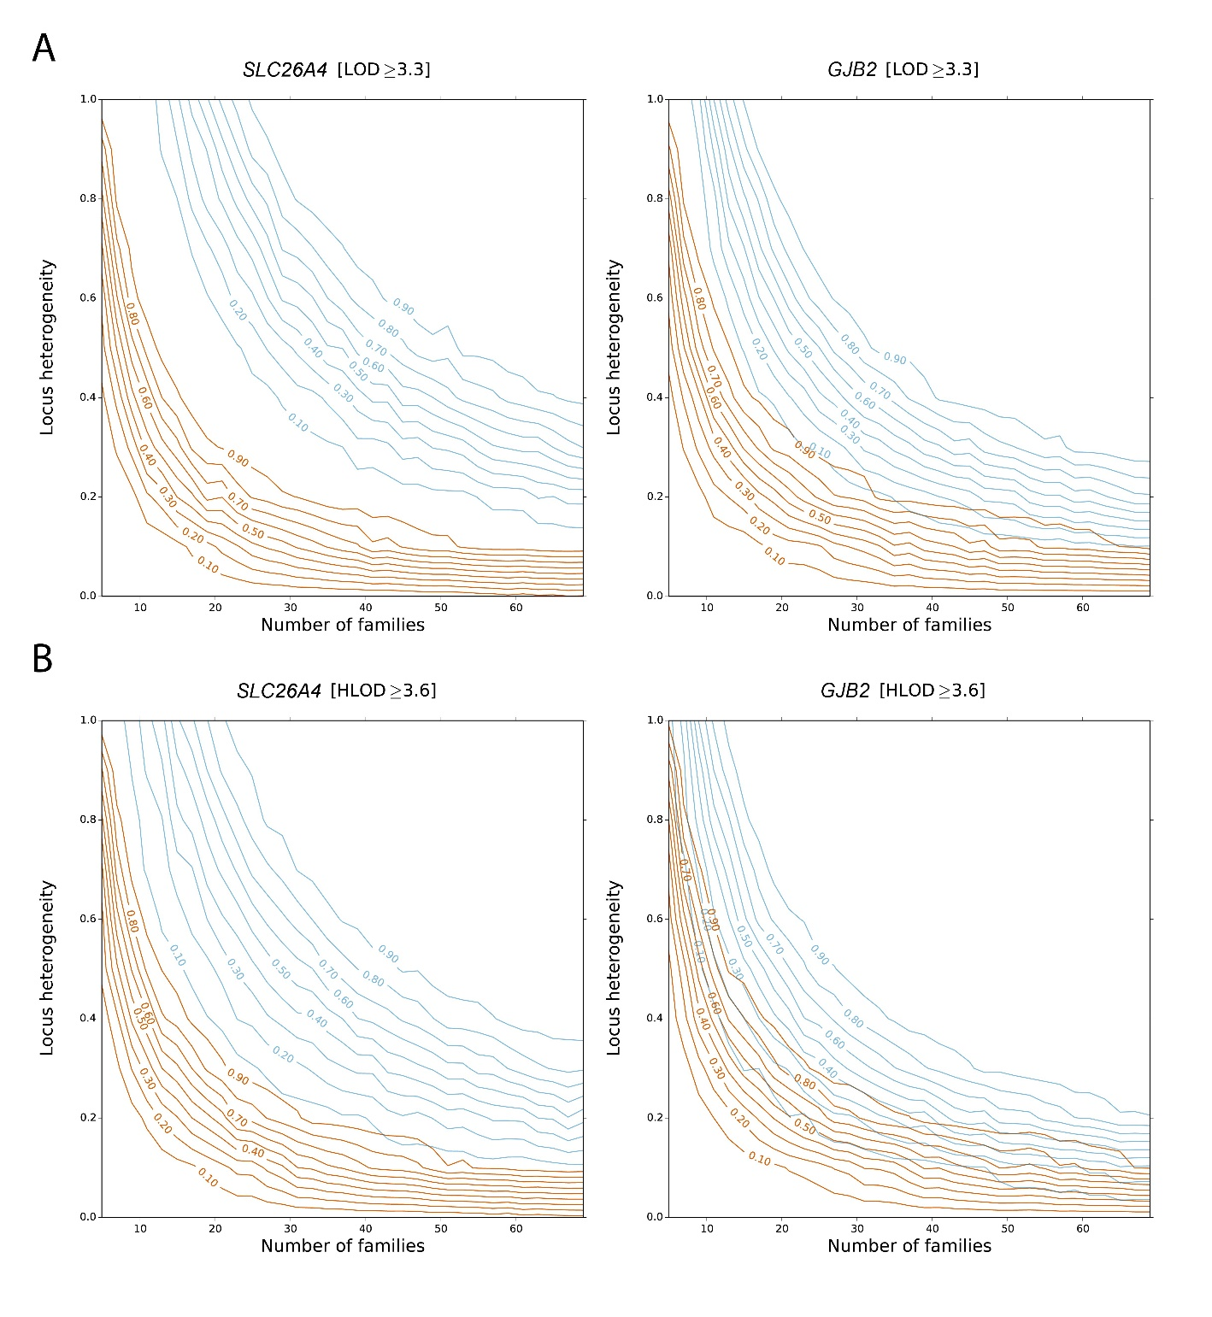

**Figure S4: Power comparisons for LOD and HLOD statistics under the compound heterozygous model.** This figure shows the power for collapsed haplotype pattern markers (CHP) vs. single variant (SNV) analysis under recessive model in the presence of both intra- and inter-family allelic heterogeneity, i.e. tfor inter heterogeneity affected individuals are compound heterozygous. X-axis is number of families, Y-axis is proportion of locus heterogeneity, i.e. the proportion of families with non-syndromic hearing impairment (NSHI) caused by detrimental mutations on the gene under investigation, i.e. either *GJB2* or *SLC26A4*. Contour curves on the graphs are power estimates, dark orange lines for CHP and light blue lines for SNV. Panel A displays the power for the LOD statistic; panel B displays the power for the HLOD statistic. CHP method is more powerful for both statistics at a significance level of α=0.05, but the absolute power of HLOD is not greater than LOD. This is because for most families the non-causal gene often has no variants at all and therefore are uninformative for HLOD calculation, due to the very low frequencies of the genes under investigation (Table S1).

**Supplemental Table**

**Table S1: List of variants from Exome Variant Server for simulation of pedigrees for linkage study of non-syndromic hearing impairment.**

|  |  |  |  |  |
| --- | --- | --- | --- | --- |
| Gene | Chromosome | Position | MAF in European American | Pathogenicity in DVD and ClinVar |
| *SLC26A4* | 7 | 107302101 | 0.000128 | non-pathogenic |
| *SLC26A4* | 7 | 107302103 | 0.000127 | non-pathogenic |
| *SLC26A4* | 7 | 107302214 | 0.000364 | non-pathogenic |
| *SLC26A4* | 7 | 107303757 | 0.000116 | non-pathogenic |
| *SLC26A4* | 7 | 107303787 | 0.000116 | non-pathogenic |
| *SLC26A4* | 7 | 107303801 | 0.000349 | non-pathogenic |
| *SLC26A4* | 7 | 107312540 | 0.000465 | non-pathogenic |
| *SLC26A4* | 7 | 107312600 | 0.000116 | non-pathogenic |
| *SLC26A4* | 7 | 107312618 | 0.000116 | non-pathogenic |
| *SLC26A4* | 7 | 107312627 | 0.000233 | pathogenic |
| *SLC26A4* | 7 | 107314579 | 0.000116 | non-pathogenic |
| *SLC26A4* | 7 | 107314593 | 0.000116 | non-pathogenic |
| *SLC26A4* | 7 | 107314596 | 0.000116 | non-pathogenic |
| *SLC26A4* | 7 | 107314596 | 0.000363 | non-pathogenic |
| *SLC26A4* | 7 | 107314665 | 0.000116 | non-pathogenic |
| *SLC26A4* | 7 | 107314679 | 0.000116 | non-pathogenic |
| *SLC26A4* | 7 | 107314716 | 0.000116 | non-pathogenic |
| *SLC26A4* | 7 | 107314725 | 0.000116 | non-pathogenic |
| *SLC26A4* | 7 | 107314758 | 0.000116 | non-pathogenic |
| *SLC26A4* | 7 | 107314765 | 0.000116 | non-pathogenic |
| *SLC26A4* | 7 | 107314815 | 0.000121 | non-pathogenic |
| *SLC26A4* | 7 | 107314817 | 0.000349 | non-pathogenic |
| *SLC26A4* | 7 | 107315373 | 0.003023 | non-pathogenic |
| *SLC26A4* | 7 | 107315415 | 0.000698 | pathogenic |
| *SLC26A4* | 7 | 107315496 | 0.001047 | pathogenic |
| *SLC26A4* | 7 | 107315599 | 0.000116 | non-pathogenic |
| *SLC26A4* | 7 | 107323599 | 0.000582 | non-pathogenic |
| *SLC26A4* | 7 | 107323677 | 0.000116 | pathogenic |
| *SLC26A4* | 7 | 107323719 | 0.000116 | non-pathogenic |
| *SLC26A4* | 7 | 107323726 | 0.000116 | pathogenic |
| *SLC26A4* | 7 | 107323730 | 0.000233 | pathogenic |
| *SLC26A4* | 7 | 107323753 | 0.000116 | non-pathogenic |
| *SLC26A4* | 7 | 107323873 | 0.000116 | non-pathogenic |
| *SLC26A4* | 7 | 107323879 | 0.000116 | non-pathogenic |
| *SLC26A4* | 7 | 107323951 | 0.000465 | non-pathogenic |
| *SLC26A4* | 7 | 107323982 | 0.000116 | non-pathogenic |
| *SLC26A4* | 7 | 107323983 | 0.000581 | pathogenic |
| *SLC26A4* | 7 | 107324011 | 0.000116 | non-pathogenic |
| *SLC26A4* | 7 | 107329489 | 0.000465 | non-pathogenic |
| *SLC26A4* | 7 | 107329499 | 0.00186 | pathogenic |
| *SLC26A4* | 7 | 107329536 | 0.000233 | non-pathogenic |
| *SLC26A4* | 7 | 107329537 | 0.000116 | non-pathogenic |
| *SLC26A4* | 7 | 107329557 | 0.000349 | non-pathogenic |
| *SLC26A4* | 7 | 107329639 | 0.000116 | non-pathogenic |
| *SLC26A4* | 7 | 107330570 | 0.000349 | pathogenic |
| *SLC26A4* | 7 | 107330648 | 0.000349 | pathogenic |
| *SLC26A4* | 7 | 107330649 | 0.000116 | non-pathogenic |
| *SLC26A4* | 7 | 107330653 | 0.000116 | non-pathogenic |
| *SLC26A4* | 7 | 107330665 | 0.000116 | pathogenic |
| *SLC26A4* | 7 | 107330681 | 0.000116 | pathogenic |
| *SLC26A4* | 7 | 107334815 | 0.000116 | non-pathogenic |
| *SLC26A4* | 7 | 107334864 | 0.000121 | non-pathogenic |
| *SLC26A4* | 7 | 107334918 | 0.000233 | pathogenic |
| *SLC26A4* | 7 | 107334926 | 0.000116 | non-pathogenic |
| *SLC26A4* | 7 | 107334972 | 0.000116 | non-pathogenic |
| *SLC26A4* | 7 | 107335132 | 0.000116 | non-pathogenic |
| *SLC26A4* | 7 | 107335210 | 0.000349 | non-pathogenic |
| *SLC26A4* | 7 | 107336364 | 0.000116 | non-pathogenic |
| *SLC26A4* | 7 | 107336365 | 0.000969 | non-pathogenic |
| *SLC26A4* | 7 | 107336394 | 0.000116 | pathogenic |
| *SLC26A4* | 7 | 107336428 | 0.000233 | non-pathogenic |
| *SLC26A4* | 7 | 107336431 | 0.000465 | non-pathogenic |
| *SLC26A4* | 7 | 107336481 | 0.000116 | pathogenic |
| *SLC26A4* | 7 | 107336484 | 0.000116 | non-pathogenic |
| *SLC26A4* | 7 | 107336493 | 0.000698 | non-pathogenic |
| *SLC26A4* | 7 | 107336528 | 0.000116 | non-pathogenic |
| *SLC26A4* | 7 | 107338475 | 0.000116 | non-pathogenic |
| *SLC26A4* | 7 | 107338482 | 0.000116 | non-pathogenic |
| *SLC26A4* | 7 | 107338556 | 0.000116 | non-pathogenic |
| *SLC26A4* | 7 | 107338557 | 0.000116 | pathogenic |
| *SLC26A4* | 7 | 107338563 | 0.000233 | non-pathogenic |
| *SLC26A4* | 7 | 107340625 | 0.000116 | non-pathogenic |
| *SLC26A4* | 7 | 107341528 | 0.030123 | non-pathogenic |
| *SLC26A4* | 7 | 107341581 | 0.000116 | non-pathogenic |
| *SLC26A4* | 7 | 107341628 | 0.00907 | non-pathogenic |
| *SLC26A4* | 7 | 107341669 | 0.000116 | non-pathogenic |
| *SLC26A4* | 7 | 107342235 | 0.000116 | non-pathogenic |
| *SLC26A4* | 7 | 107342249 | 0.000116 | non-pathogenic |
| *SLC26A4* | 7 | 107342294 | 0.000814 | non-pathogenic |
| *SLC26A4* | 7 | 107342333 | 0.000116 | non-pathogenic |
| *SLC26A4* | 7 | 107342369 | 0.000116 | non-pathogenic |
| *SLC26A4* | 7 | 107342377 | 0.000233 | non-pathogenic |
| *SLC26A4* | 7 | 107342388 | 0.000116 | non-pathogenic |
| *SLC26A4* | 7 | 107342433 | 0.000116 | non-pathogenic |
| *SLC26A4* | 7 | 107342461 | 0.000116 | non-pathogenic |
| *SLC26A4* | 7 | 107342483 | 0.000349 | pathogenic |
| *SLC26A4* | 7 | 107342485 | 0.000116 | non-pathogenic |
| *SLC26A4* | 7 | 107344811 | 0.000117 | non-pathogenic |
| *SLC26A4* | 7 | 107350481 | 0.000116 | non-pathogenic |
| *SLC26A4* | 7 | 107350519 | 0.000116 | non-pathogenic |
| *SLC26A4* | 7 | 107350527 | 0.000116 | non-pathogenic |
| *SLC26A4* | 7 | 107350528 | 0.000116 | non-pathogenic |
| *SLC26A4* | 7 | 107350539 | 0.000233 | non-pathogenic |
| *SLC26A4* | 7 | 107350560 | 0.000233 | non-pathogenic |
| *SLC26A4* | 7 | 107350572 | 0.000116 | non-pathogenic |
| *SLC26A4* | 7 | 107350599 | 0.000116 | non-pathogenic |
| *SLC26A4* | 7 | 107350621 | 0.000116 | non-pathogenic |
| *SLC26A4* | 7 | 107350627 | 0.000116 | non-pathogenic |
| *SLC26A4* | 7 | 107350628 | 0.000233 | pathogenic |
| *SLC26A4* | 7 | 107352969 | 0.000233 | non-pathogenic |
| *SLC26A4* | 7 | 107353020 | 0.000121 | non-pathogenic |
| *SLC26A4* | 7 | 107353039 | 0.000116 | non-pathogenic |
| *SLC26A4* | 7 | 107353040 | 0.000116 | non-pathogenic |
| *SLC26A4* | 7 | 107355846 | 0.007326 | non-pathogenic |
| *SLC26A4* | 7 | 107355874 | 0.002209 | non-pathogenic |
| *SLC26A4* | 7 | 107355887 | 0.000116 | non-pathogenic |
| *SLC26A4* | 7 | 107355926 | 0.000116 | non-pathogenic |
| *SLC26A4* | 7 | 107355942 | 0.000349 | non-pathogenic |
| *MYO7A* | 11 | 76841633 | 0.00012 | non-pathogenic |
| *MYO7A* | 11 | 76853738 | 0.00024 | non-pathogenic |
| *MYO7A* | 11 | 76853742 | 0.00012 | non-pathogenic |
| *MYO7A* | 11 | 76853746 | 0.00012 | non-pathogenic |
| *MYO7A* | 11 | 76853783 | 0.342275 | non-pathogenic |
| *MYO7A* | 11 | 76853790 | 0.000119 | non-pathogenic |
| *MYO7A* | 11 | 76853814 | 0.000118 | non-pathogenic |
| *MYO7A* | 11 | 76853829 | 0.000118 | pathogenic |
| *MYO7A* | 11 | 76853832 | 0.000118 | non-pathogenic |
| *MYO7A* | 11 | 76853833 | 0.000118 | non-pathogenic |
| *MYO7A* | 11 | 76858797 | 0.000119 | non-pathogenic |
| *MYO7A* | 11 | 76858830 | 0.000118 | non-pathogenic |
| *MYO7A* | 11 | 76858837 | 0.005548 | non-pathogenic |
| *MYO7A* | 11 | 76858860 | 0.000118 | non-pathogenic |
| *MYO7A* | 11 | 76858863 | 0.000118 | non-pathogenic |
| *MYO7A* | 11 | 76858897 | 0.000119 | non-pathogenic |
| *MYO7A* | 11 | 76858950 | 0.000241 | non-pathogenic |
| *MYO7A* | 11 | 76866915 | 0.000117 | non-pathogenic |
| *MYO7A* | 11 | 76866926 | 0.00105 | non-pathogenic |
| *MYO7A* | 11 | 76866929 | 0.000117 | non-pathogenic |
| *MYO7A* | 11 | 76866948 | 0.001051 | non-pathogenic |
| *MYO7A* | 11 | 76866955 | 0.017402 | non-pathogenic |
| *MYO7A* | 11 | 76867026 | 0.000236 | non-pathogenic |
| *MYO7A* | 11 | 76867047 | 0.000237 | non-pathogenic |
| *MYO7A* | 11 | 76867058 | 0.00149 | non-pathogenic |
| *MYO7A* | 11 | 76867062 | 0.000119 | non-pathogenic |
| *MYO7A* | 11 | 76867064 | 0.000356 | pathogenic |
| *MYO7A* | 11 | 76867076 | 0.000119 | non-pathogenic |
| *MYO7A* | 11 | 76867115 | 0.000836 | pathogenic |
| *MYO7A* | 11 | 76867116 | 0.000358 | non-pathogenic |
| *MYO7A* | 11 | 76867135 | 0.018913 | non-pathogenic |
| *MYO7A* | 11 | 76867167 | 0.000121 | non-pathogenic |
| *MYO7A* | 11 | 76867180 | 0.001808 | non-pathogenic |
| *MYO7A* | 11 | 76867183 | 0.000121 | non-pathogenic |
| *MYO7A* | 11 | 76867721 | 0.000715 | non-pathogenic |
| *MYO7A* | 11 | 76867745 | 0.002724 | non-pathogenic |
| *MYO7A* | 11 | 76867784 | 0.000118 | non-pathogenic |
| *MYO7A* | 11 | 76867870 | 0.00012 | non-pathogenic |
| *MYO7A* | 11 | 76867903 | 0.000833 | non-pathogenic |
| *MYO7A* | 11 | 76867967 | 0.000119 | pathogenic |
| *MYO7A* | 11 | 76867991 | 0.000119 | non-pathogenic |
| *MYO7A* | 11 | 76868002 | 0.000478 | non-pathogenic |
| *MYO7A* | 11 | 76868003 | 0.00012 | non-pathogenic |
| *MYO7A* | 11 | 76868045 | 0.00012 | non-pathogenic |
| *MYO7A* | 11 | 76868046 | 0.000961 | pathogenic |
| *MYO7A* | 11 | 76868069 | 0.000121 | non-pathogenic |
| *MYO7A* | 11 | 76868076 | 0.000121 | non-pathogenic |
| *MYO7A* | 11 | 76868090 | 0.000121 | non-pathogenic |
| *MYO7A* | 11 | 76868096 | 0.002421 | non-pathogenic |
| *MYO7A* | 11 | 76868278 | 0.054964 | non-pathogenic |
| *MYO7A* | 11 | 76868310 | 0.001646 | non-pathogenic |
| *MYO7A* | 11 | 76868372 | 0.353282 | non-pathogenic |
| *MYO7A* | 11 | 76868392 | 0.001569 | pathogenic |
| *MYO7A* | 11 | 76868478 | 0.000848 | non-pathogenic |
| *MYO7A* | 11 | 76869285 | 0.00012 | non-pathogenic |
| *MYO7A* | 11 | 76869368 | 0.000354 | non-pathogenic |
| *MYO7A* | 11 | 76869378 | 0.002707 | pathogenic |
| *MYO7A* | 11 | 76869399 | 0.000118 | non-pathogenic |
| *MYO7A* | 11 | 76869443 | 0.000118 | non-pathogenic |
| *MYO7A* | 11 | 76869454 | 0.000118 | non-pathogenic |
| *MYO7A* | 11 | 76869457 | 0.000235 | non-pathogenic |
| *MYO7A* | 11 | 76869495 | 0.000709 | non-pathogenic |
| *MYO7A* | 11 | 76869514 | 0.000119 | non-pathogenic |
| *MYO7A* | 11 | 76870458 | 0.055745 | non-pathogenic |
| *MYO7A* | 11 | 76870495 | 0.000121 | non-pathogenic |
| *MYO7A* | 11 | 76870496 | 0.001927 | non-pathogenic |
| *MYO7A* | 11 | 76870567 | 0.000119 | non-pathogenic |
| *MYO7A* | 11 | 76870609 | 0.00012 | non-pathogenic |
| *MYO7A* | 11 | 76871246 | 0.000119 | non-pathogenic |
| *MYO7A* | 11 | 76871254 | 0.000119 | non-pathogenic |
| *MYO7A* | 11 | 76871260 | 0.000359 | non-pathogenic |
| *MYO7A* | 11 | 76871314 | 0.000119 | non-pathogenic |
| *MYO7A* | 11 | 76871350 | 0.000121 | non-pathogenic |
| *MYO7A* | 11 | 76871358 | 0.000121 | non-pathogenic |
| *MYO7A* | 11 | 76871997 | 0.000242 | non-pathogenic |
| *MYO7A* | 11 | 76872031 | 0.00012 | non-pathogenic |
| *MYO7A* | 11 | 76872050 | 0.000239 | non-pathogenic |
| *MYO7A* | 11 | 76872106 | 0.000239 | non-pathogenic |
| *MYO7A* | 11 | 76872167 | 0.00024 | non-pathogenic |
| *MYO7A* | 11 | 76872169 | 0.05654 | non-pathogenic |
| *MYO7A* | 11 | 76872193 | 0.017233 | non-pathogenic |
| *MYO7A* | 11 | 76872211 | 0.000915 | non-pathogenic |
| *MYO7A* | 11 | 76873138 | 0.001517 | non-pathogenic |
| *MYO7A* | 11 | 76873180 | 0.000117 | non-pathogenic |
| *MYO7A* | 11 | 76873222 | 0.000117 | non-pathogenic |
| *MYO7A* | 11 | 76873225 | 0.000117 | non-pathogenic |
| *MYO7A* | 11 | 76873244 | 0.000466 | non-pathogenic |
| *MYO7A* | 11 | 76873277 | 0.000117 | non-pathogenic |
| *MYO7A* | 11 | 76873384 | 0.002277 | non-pathogenic |
| *MYO7A* | 11 | 76873857 | 0.009204 | non-pathogenic |
| *MYO7A* | 11 | 76873949 | 0.003303 | non-pathogenic |
| *MYO7A* | 11 | 76873950 | 0.000118 | non-pathogenic |
| *MYO7A* | 11 | 76873954 | 0.000118 | non-pathogenic |
| *MYO7A* | 11 | 76873967 | 0.000119 | non-pathogenic |
| *MYO7A* | 11 | 76874015 | 0.00012 | non-pathogenic |
| *MYO7A* | 11 | 76874038 | 0.000241 | non-pathogenic |
| *MYO7A* | 11 | 76874043 | 0.000241 | non-pathogenic |
| *MYO7A* | 11 | 76874072 | 0.000605 | non-pathogenic |
| *MYO7A* | 11 | 76877068 | 0.000239 | non-pathogenic |
| *MYO7A* | 11 | 76877139 | 0.00012 | non-pathogenic |
| *MYO7A* | 11 | 76877250 | 0.000365 | non-pathogenic |
| *MYO7A* | 11 | 76883774 | 0.000127 | non-pathogenic |
| *MYO7A* | 11 | 76883779 | 0.000252 | non-pathogenic |
| *MYO7A* | 11 | 76883780 | 0.000252 | non-pathogenic |
| *MYO7A* | 11 | 76883828 | 0.000122 | non-pathogenic |
| *MYO7A* | 11 | 76883850 | 0.004141 | non-pathogenic |
| *MYO7A* | 11 | 76883863 | 0.000122 | non-pathogenic |
| *MYO7A* | 11 | 76883868 | 0.000123 | non-pathogenic |
| *MYO7A* | 11 | 76883902 | 0.000122 | non-pathogenic |
| *MYO7A* | 11 | 76883912 | 0.000123 | non-pathogenic |
| *MYO7A* | 11 | 76883952 | 0.000124 | non-pathogenic |
| *MYO7A* | 11 | 76883965 | 0.000251 | non-pathogenic |
| *MYO7A* | 11 | 76885779 | 0.456975 | non-pathogenic |
| *MYO7A* | 11 | 76885826 | 0.00012 | non-pathogenic |
| *MYO7A* | 11 | 76885871 | 0.00012 | pathogenic |
| *MYO7A* | 11 | 76885901 | 0.000359 | non-pathogenic |
| *MYO7A* | 11 | 76885947 | 0.00012 | non-pathogenic |
| *MYO7A* | 11 | 76886381 | 0.00024 | non-pathogenic |
| *MYO7A* | 11 | 76886429 | 0.000715 | non-pathogenic |
| *MYO7A* | 11 | 76886504 | 0.000239 | non-pathogenic |
| *MYO7A* | 11 | 76886529 | 0.00012 | non-pathogenic |
| *MYO7A* | 11 | 76886542 | 0.001521 | non-pathogenic |
| *MYO7A* | 11 | 76886543 | 0.000253 | non-pathogenic |
| *MYO7A* | 11 | 76886547 | 0.00121 | non-pathogenic |
| *MYO7A* | 11 | 76886555 | 0.000121 | non-pathogenic |
| *MYO7A* | 11 | 76888569 | 0.00024 | non-pathogenic |
| *MYO7A* | 11 | 76888570 | 0.00012 | non-pathogenic |
| *MYO7A* | 11 | 76888625 | 0.000119 | non-pathogenic |
| *MYO7A* | 11 | 76888657 | 0.000119 | non-pathogenic |
| *MYO7A* | 11 | 76888739 | 0.000224 | non-pathogenic |
| *MYO7A* | 11 | 76890051 | 0.000118 | non-pathogenic |
| *MYO7A* | 11 | 76890069 | 0.008023 | non-pathogenic |
| *MYO7A* | 11 | 76890071 | 0.000118 | non-pathogenic |
| *MYO7A* | 11 | 76890072 | 0.000118 | non-pathogenic |
| *MYO7A* | 11 | 76890091 | 0.001415 | non-pathogenic |
| *MYO7A* | 11 | 76890101 | 0.00059 | non-pathogenic |
| *MYO7A* | 11 | 76890116 | 0.000355 | non-pathogenic |
| *MYO7A* | 11 | 76890131 | 0.000119 | pathogenic |
| *MYO7A* | 11 | 76890156 | 0.000119 | non-pathogenic |
| *MYO7A* | 11 | 76890860 | 0.000625 | non-pathogenic |
| *MYO7A* | 11 | 76890865 | 0.000124 | non-pathogenic |
| *MYO7A* | 11 | 76890889 | 0.000129 | pathogenic |
| *MYO7A* | 11 | 76890902 | 0.000133 | non-pathogenic |
| *MYO7A* | 11 | 76890919 | 0.000546 | non-pathogenic |
| *MYO7A* | 11 | 76890940 | 0.000282 | non-pathogenic |
| *MYO7A* | 11 | 76891450 | 0.000719 | non-pathogenic |
| *MYO7A* | 11 | 76891451 | 0.00012 | non-pathogenic |
| *MYO7A* | 11 | 76891458 | 0.00012 | non-pathogenic |
| *MYO7A* | 11 | 76891557 | 0.000119 | non-pathogenic |
| *MYO7A* | 11 | 76892429 | 0.000121 | non-pathogenic |
| *MYO7A* | 11 | 76892462 | 0.000121 | non-pathogenic |
| *MYO7A* | 11 | 76892485 | 0.002173 | non-pathogenic |
| *MYO7A* | 11 | 76892524 | 0.000121 | non-pathogenic |
| *MYO7A* | 11 | 76892529 | 0.000725 | non-pathogenic |
| *MYO7A* | 11 | 76892561 | 0.00012 | non-pathogenic |
| *MYO7A* | 11 | 76892617 | 0.00072 | non-pathogenic |
| *MYO7A* | 11 | 76892666 | 0.00012 | non-pathogenic |
| *MYO7A* | 11 | 76892677 | 0.00012 | non-pathogenic |
| *MYO7A* | 11 | 76892962 | 0.00012 | non-pathogenic |
| *MYO7A* | 11 | 76893080 | 0.000119 | non-pathogenic |
| *MYO7A* | 11 | 76893435 | 0.000125 | non-pathogenic |
| *MYO7A* | 11 | 76893442 | 0.000119 | non-pathogenic |
| *MYO7A* | 11 | 76893454 | 0.000119 | non-pathogenic |
| *MYO7A* | 11 | 76893494 | 0.000119 | pathogenic |
| *MYO7A* | 11 | 76893517 | 0.00024 | non-pathogenic |
| *MYO7A* | 11 | 76893573 | 0.000119 | non-pathogenic |
| *MYO7A* | 11 | 76893605 | 0.000119 | non-pathogenic |
| *MYO7A* | 11 | 76893606 | 0.000119 | non-pathogenic |
| *MYO7A* | 11 | 76893620 | 0.000119 | non-pathogenic |
| *MYO7A* | 11 | 76893622 | 0.000119 | non-pathogenic |
| *MYO7A* | 11 | 76893630 | 0.00012 | non-pathogenic |
| *MYO7A* | 11 | 76893643 | 0.001077 | non-pathogenic |
| *MYO7A* | 11 | 76894124 | 0.000383 | non-pathogenic |
| *MYO7A* | 11 | 76894235 | 0.425852 | non-pathogenic |
| *MYO7A* | 11 | 76895638 | 0.00012 | non-pathogenic |
| *MYO7A* | 11 | 76895661 | 0.000238 | non-pathogenic |
| *MYO7A* | 11 | 76895684 | 0.000119 | non-pathogenic |
| *MYO7A* | 11 | 76895771 | 0.397308 | non-pathogenic |
| *MYO7A* | 11 | 76895772 | 0.264362 | non-pathogenic |
| *MYO7A* | 11 | 76895777 | 0.000456 | non-pathogenic |
| *MYO7A* | 11 | 76900421 | 0.000239 | non-pathogenic |
| *MYO7A* | 11 | 76900549 | 0.001205 | non-pathogenic |
| *MYO7A* | 11 | 76900558 | 0.000121 | non-pathogenic |
| *MYO7A* | 11 | 76901123 | 0.00012 | non-pathogenic |
| *MYO7A* | 11 | 76901153 | 0.000238 | pathogenic |
| *MYO7A* | 11 | 76901189 | 0.001192 | non-pathogenic |
| *MYO7A* | 11 | 76901193 | 0.003697 | non-pathogenic |
| *MYO7A* | 11 | 76901708 | 0.000121 | non-pathogenic |
| *MYO7A* | 11 | 76901754 | 0.001247 | pathogenic |
| *MYO7A* | 11 | 76901771 | 0.000119 | non-pathogenic |
| *MYO7A* | 11 | 76901775 | 0.000119 | non-pathogenic |
| *MYO7A* | 11 | 76901780 | 0.000119 | non-pathogenic |
| *MYO7A* | 11 | 76901819 | 0.000595 | non-pathogenic |
| *MYO7A* | 11 | 76901828 | 0.000119 | non-pathogenic |
| *MYO7A* | 11 | 76901849 | 0.000238 | non-pathogenic |
| *MYO7A* | 11 | 76901856 | 0.000119 | non-pathogenic |
| *MYO7A* | 11 | 76901927 | 0.486205 | non-pathogenic |
| *MYO7A* | 11 | 76901944 | 0.000245 | non-pathogenic |
| *MYO7A* | 11 | 76901954 | 0.00037 | non-pathogenic |
| *MYO7A* | 11 | 76903086 | 0.000119 | non-pathogenic |
| *MYO7A* | 11 | 76903088 | 0.000238 | non-pathogenic |
| *MYO7A* | 11 | 76903134 | 0.000119 | non-pathogenic |
| *MYO7A* | 11 | 76903149 | 0.000238 | non-pathogenic |
| *MYO7A* | 11 | 76903150 | 0.000119 | pathogenic |
| *MYO7A* | 11 | 76903174 | 0.000119 | non-pathogenic |
| *MYO7A* | 11 | 76903189 | 0.000237 | pathogenic |
| *MYO7A* | 11 | 76903190 | 0.000119 | non-pathogenic |
| *MYO7A* | 11 | 76903195 | 0.000119 | non-pathogenic |
| *MYO7A* | 11 | 76903245 | 0.006004 | non-pathogenic |
| *MYO7A* | 11 | 76903299 | 0.000117 | non-pathogenic |
| *MYO7A* | 11 | 76903341 | 0.000117 | non-pathogenic |
| *MYO7A* | 11 | 76903344 | 0.000117 | non-pathogenic |
| *MYO7A* | 11 | 76903345 | 0.000117 | non-pathogenic |
| *MYO7A* | 11 | 76903362 | 0.000118 | non-pathogenic |
| *MYO7A* | 11 | 76905380 | 0.00012 | non-pathogenic |
| *MYO7A* | 11 | 76905391 | 0.001198 | non-pathogenic |
| *MYO7A* | 11 | 76905392 | 0.00024 | non-pathogenic |
| *MYO7A* | 11 | 76905404 | 0.00012 | non-pathogenic |
| *MYO7A* | 11 | 76905438 | 0.00012 | non-pathogenic |
| *MYO7A* | 11 | 76905441 | 0.00012 | non-pathogenic |
| *MYO7A* | 11 | 76905468 | 0.000239 | non-pathogenic |
| *MYO7A* | 11 | 76905469 | 0.00012 | non-pathogenic |
| *MYO7A* | 11 | 76905482 | 0.00012 | non-pathogenic |
| *MYO7A* | 11 | 76905507 | 0.00024 | non-pathogenic |
| *MYO7A* | 11 | 76905531 | 0.000121 | non-pathogenic |
| *MYO7A* | 11 | 76905604 | 0.463157 | non-pathogenic |
| *MYO7A* | 11 | 76908528 | 0.000121 | non-pathogenic |
| *MYO7A* | 11 | 76908564 | 0.000241 | non-pathogenic |
| *MYO7A* | 11 | 76908589 | 0.000121 | non-pathogenic |
| *MYO7A* | 11 | 76909506 | 0.000121 | non-pathogenic |
| *MYO7A* | 11 | 76909533 | 0.00012 | non-pathogenic |
| *MYO7A* | 11 | 76909548 | 0.00036 | pathogenic |
| *MYO7A* | 11 | 76909559 | 0.006099 | non-pathogenic |
| *MYO7A* | 11 | 76909564 | 0.000119 | non-pathogenic |
| *MYO7A* | 11 | 76909569 | 0.000119 | non-pathogenic |
| *MYO7A* | 11 | 76909585 | 0.000119 | non-pathogenic |
| *MYO7A* | 11 | 76909586 | 0.000119 | non-pathogenic |
| *MYO7A* | 11 | 76909591 | 0.000119 | non-pathogenic |
| *MYO7A* | 11 | 76909678 | 0.003071 | non-pathogenic |
| *MYO7A* | 11 | 76909708 | 0.000237 | non-pathogenic |
| *MYO7A* | 11 | 76909711 | 0.000119 | non-pathogenic |
| *MYO7A* | 11 | 76910532 | 0.001014 | non-pathogenic |
| *MYO7A* | 11 | 76910600 | 0.000314 | non-pathogenic |
| *MYO7A* | 11 | 76910678 | 0.000118 | non-pathogenic |
| *MYO7A* | 11 | 76910679 | 0.000118 | non-pathogenic |
| *MYO7A* | 11 | 76910708 | 0.007009 | non-pathogenic |
| *MYO7A* | 11 | 76910746 | 0.000119 | non-pathogenic |
| *MYO7A* | 11 | 76910750 | 0.000356 | non-pathogenic |
| *MYO7A* | 11 | 76910759 | 0.000119 | non-pathogenic |
| *MYO7A* | 11 | 76910766 | 0.478452 | non-pathogenic |
| *MYO7A* | 11 | 76910815 | 0.000121 | non-pathogenic |
| *MYO7A* | 11 | 76910816 | 0.000121 | non-pathogenic |
| *MYO7A* | 11 | 76910856 | 0.002062 | non-pathogenic |
| *MYO7A* | 11 | 76910862 | 0.000121 | non-pathogenic |
| *MYO7A* | 11 | 76912463 | 0.000707 | non-pathogenic |
| *MYO7A* | 11 | 76912479 | 0.000118 | non-pathogenic |
| *MYO7A* | 11 | 76912524 | 0.000118 | non-pathogenic |
| *MYO7A* | 11 | 76912550 | 0.000118 | non-pathogenic |
| *MYO7A* | 11 | 76912557 | 0.000118 | non-pathogenic |
| *MYO7A* | 11 | 76912560 | 0.000235 | non-pathogenic |
| *MYO7A* | 11 | 76912564 | 0.000118 | non-pathogenic |
| *MYO7A* | 11 | 76912577 | 0.000118 | non-pathogenic |
| *MYO7A* | 11 | 76912590 | 0.000236 | non-pathogenic |
| *MYO7A* | 11 | 76912615 | 0.000118 | non-pathogenic |
| *MYO7A* | 11 | 76912636 | 0.457457 | non-pathogenic |
| *MYO7A* | 11 | 76912646 | 0.000118 | non-pathogenic |
| *MYO7A* | 11 | 76912663 | 0.000119 | non-pathogenic |
| *MYO7A* | 11 | 76912703 | 0.000835 | non-pathogenic |
| *MYO7A* | 11 | 76912724 | 0.00012 | non-pathogenic |
| *MYO7A* | 11 | 76912730 | 0.00012 | non-pathogenic |
| *MYO7A* | 11 | 76913297 | 0.000121 | non-pathogenic |
| *MYO7A* | 11 | 76913409 | 0.000119 | non-pathogenic |
| *MYO7A* | 11 | 76913410 | 0.000119 | non-pathogenic |
| *MYO7A* | 11 | 76913421 | 0.00012 | non-pathogenic |
| *MYO7A* | 11 | 76913440 | 0.00012 | non-pathogenic |
| *MYO7A* | 11 | 76913457 | 0.008959 | non-pathogenic |
| *MYO7A* | 11 | 76914077 | 0.001509 | non-pathogenic |
| *MYO7A* | 11 | 76914104 | 0.087803 | non-pathogenic |
| *MYO7A* | 11 | 76914151 | 0.000125 | non-pathogenic |
| *MYO7A* | 11 | 76914163 | 0.003842 | non-pathogenic |
| *MYO7A* | 11 | 76914189 | 0.00037 | non-pathogenic |
| *MYO7A* | 11 | 76914275 | 0.000492 | non-pathogenic |
| *MYO7A* | 11 | 76915091 | 0.000119 | non-pathogenic |
| *MYO7A* | 11 | 76915140 | 0.000119 | non-pathogenic |
| *MYO7A* | 11 | 76915143 | 0.000358 | non-pathogenic |
| *MYO7A* | 11 | 76915149 | 0.000239 | non-pathogenic |
| *MYO7A* | 11 | 76915150 | 0.000119 | non-pathogenic |
| *MYO7A* | 11 | 76915163 | 0.000119 | non-pathogenic |
| *MYO7A* | 11 | 76915167 | 0.000119 | non-pathogenic |
| *MYO7A* | 11 | 76915168 | 0.000119 | non-pathogenic |
| *MYO7A* | 11 | 76915183 | 0.000119 | non-pathogenic |
| *MYO7A* | 11 | 76915212 | 0.000119 | non-pathogenic |
| *MYO7A* | 11 | 76915294 | 0.000238 | non-pathogenic |
| *MYO7A* | 11 | 76916464 | 0.000372 | non-pathogenic |
| *MYO7A* | 11 | 76916493 | 0.000241 | non-pathogenic |
| *MYO7A* | 11 | 76916549 | 0.000118 | non-pathogenic |
| *MYO7A* | 11 | 76916585 | 0.000472 | non-pathogenic |
| *MYO7A* | 11 | 76916599 | 0.000237 | pathogenic |
| *MYO7A* | 11 | 76916608 | 0.000119 | non-pathogenic |
| *MYO7A* | 11 | 76916645 | 0.023861 | non-pathogenic |
| *MYO7A* | 11 | 76916704 | 0.000362 | non-pathogenic |
| *MYO7A* | 11 | 76916714 | 0.007394 | non-pathogenic |
| *MYO7A* | 11 | 76917106 | 0.00048 | non-pathogenic |
| *MYO7A* | 11 | 76917113 | 0.00024 | non-pathogenic |
| *MYO7A* | 11 | 76917145 | 0.00012 | non-pathogenic |
| *MYO7A* | 11 | 76917146 | 0.00012 | non-pathogenic |
| *MYO7A* | 11 | 76917220 | 0.481731 | non-pathogenic |
| *MYO7A* | 11 | 76917244 | 0.000121 | non-pathogenic |
| *MYO7A* | 11 | 76917274 | 0.000121 | non-pathogenic |
| *MYO7A* | 11 | 76918317 | 0.00012 | non-pathogenic |
| *MYO7A* | 11 | 76918322 | 0.413471 | non-pathogenic |
| *MYO7A* | 11 | 76918366 | 0.000119 | non-pathogenic |
| *MYO7A* | 11 | 76918468 | 0.000121 | non-pathogenic |
| *MYO7A* | 11 | 76918497 | 0.42755 | non-pathogenic |
| *MYO7A* | 11 | 76919457 | 0.000119 | non-pathogenic |
| *MYO7A* | 11 | 76919468 | 0.427672 | non-pathogenic |
| *MYO7A* | 11 | 76919478 | 0.480523 | non-pathogenic |
| *MYO7A* | 11 | 76919484 | 0.002974 | non-pathogenic |
| *MYO7A* | 11 | 76919514 | 0.00012 | non-pathogenic |
| *MYO7A* | 11 | 76919517 | 0.00012 | non-pathogenic |
| *MYO7A* | 11 | 76919522 | 0.000719 | non-pathogenic |
| *MYO7A* | 11 | 76919543 | 0.000121 | non-pathogenic |
| *MYO7A* | 11 | 76919546 | 0.000121 | non-pathogenic |
| *MYO7A* | 11 | 76919596 | 0.000121 | non-pathogenic |
| *MYO7A* | 11 | 76919619 | 0.412634 | non-pathogenic |
| *MYO7A* | 11 | 76919710 | 0.001123 | non-pathogenic |
| *MYO7A* | 11 | 76919727 | 0.000119 | non-pathogenic |
| *MYO7A* | 11 | 76919747 | 0.000119 | non-pathogenic |
| *MYO7A* | 11 | 76919816 | 0.00012 | non-pathogenic |
| *MYO7A* | 11 | 76919865 | 0.42441 | non-pathogenic |
| *MYO7A* | 11 | 76919869 | 0.000121 | non-pathogenic |
| *MYO7A* | 11 | 76919891 | 0.000123 | non-pathogenic |
| *MYO7A* | 11 | 76922186 | 0.000239 | non-pathogenic |
| *MYO7A* | 11 | 76922208 | 0.000714 | non-pathogenic |
| *MYO7A* | 11 | 76922236 | 0.000119 | non-pathogenic |
| *MYO7A* | 11 | 76922353 | 0.00012 | non-pathogenic |
| *MYO7A* | 11 | 76922403 | 0.000121 | non-pathogenic |
| *MYO7A* | 11 | 76922826 | 0.000117 | non-pathogenic |
| *MYO7A* | 11 | 76922856 | 0.000117 | non-pathogenic |
| *MYO7A* | 11 | 76922868 | 0.043291 | non-pathogenic |
| *MYO7A* | 11 | 76922874 | 0.000117 | non-pathogenic |
| *MYO7A* | 11 | 76922875 | 0.000233 | non-pathogenic |
| *MYO7A* | 11 | 76922946 | 0.199136 | non-pathogenic |
| *MYO7A* | 11 | 76922954 | 0.000117 | non-pathogenic |
| *MYO7A* | 11 | 76923001 | 0.000123 | non-pathogenic |
| *MYO7A* | 11 | 76923017 | 0.197294 | non-pathogenic |
| *MYO7A* | 11 | 76923024 | 0.000118 | non-pathogenic |
| *MYO7A* | 11 | 76924005 | 0.000364 | non-pathogenic |
| *MYO7A* | 11 | 76924054 | 0.000362 | non-pathogenic |
| *MYO7A* | 11 | 76924066 | 0.000241 | non-pathogenic |
| *MYO7A* | 11 | 76924068 | 0.00012 | non-pathogenic |
| *MYO7A* | 11 | 76924130 | 0.029022 | non-pathogenic |
| *MYO7A* | 11 | 76924873 | 0.000238 | non-pathogenic |
| *MYO7A* | 11 | 76924874 | 0.336985 | non-pathogenic |
| *MYO7A* | 11 | 76924933 | 0.000119 | non-pathogenic |
| *MYO7A* | 11 | 76924985 | 0.016049 | non-pathogenic |
| *MYO7A* | 11 | 76924986 | 0.000118 | non-pathogenic |
| *MYO7A* | 11 | 76925012 | 0.000472 | non-pathogenic |
| *MYO7A* | 11 | 76925013 | 0.000118 | non-pathogenic |
| *MYO7A* | 11 | 76925018 | 0.000118 | non-pathogenic |
| *MYO7A* | 11 | 76925040 | 0.259518 | non-pathogenic |
| *MYO7A* | 11 | 76925049 | 0.017029 | non-pathogenic |
| *MYO7A* | 11 | 76925075 | 0.028829 | non-pathogenic |
| *MYO7A* | 11 | 76925604 | 0.054302 | non-pathogenic |
| *MYO7A* | 11 | 76925609 | 0.013523 | non-pathogenic |
| *MYO7A* | 11 | 76925626 | 0.000477 | non-pathogenic |
| *MYO7A* | 11 | 76925641 | 0.019281 | non-pathogenic |
| *MYO7A* | 11 | 76925721 | 0.00012 | non-pathogenic |
| *MYO7A* | 11 | 76925733 | 0.0006 | non-pathogenic |
| *GJB2* | 13 | 20763037 | 0.001295 | non-pathogenic |
| *GJB2* | 13 | 20763039 | 0.000587 | non-pathogenic |
| *GJB2* | 13 | 20763045 | 0.000117 | non-pathogenic |
| *GJB2* | 13 | 20763051 | 0.000117 | pathogenic |
| *GJB2* | 13 | 20763058 | 0.000117 | non-pathogenic |
| *GJB2* | 13 | 20763104 | 0.000116 | pathogenic |
| *GJB2* | 13 | 20763210 | 0.000233 | non-pathogenic |
| *GJB2* | 13 | 20763243 | 0.000465 | non-pathogenic |
| *GJB2* | 13 | 20763246 | 0.000116 | pathogenic |
| *GJB2* | 13 | 20763247 | 0.000116 | non-pathogenic |
| *GJB2* | 13 | 20763264 | 0.003372 | non-pathogenic |
| *GJB2* | 13 | 20763269 | 0.000116 | non-pathogenic |
| *GJB2* | 13 | 20763305 | 0.000814 | pathogenic |
| *GJB2* | 13 | 20763341 | 0.003023 | non-pathogenic |
| *GJB2* | 13 | 20763353 | 0.000233 | non-pathogenic |
| *GJB2* | 13 | 20763361 | 0.000121 | pathogenic |
| *GJB2* | 13 | 20763366 | 0.000349 | pathogenic |
| *GJB2* | 13 | 20763380 | 0.00093 | pathogenic |
| *GJB2* | 13 | 20763395 | 0.000116 | non-pathogenic |
| *GJB2* | 13 | 20763395 | 0.000242 | pathogenic |
| *GJB2* | 13 | 20763452 | 0.000581 | pathogenic |
| *GJB2* | 13 | 20763472 | 0.003256 | non-pathogenic |
| *GJB2* | 13 | 20763480 | 0.000116 | pathogenic |
| *GJB2* | 13 | 20763490 | 0.000116 | pathogenic |
| *GJB2* | 13 | 20763534 | 0.000116 | pathogenic |
| *GJB2* | 13 | 20763544 | 0.000116 | non-pathogenic |
| *GJB2* | 13 | 20763552 | 0.000116 | pathogenic |
| *GJB2* | 13 | 20763554 | 0.001454 | pathogenic |
| *GJB2* | 13 | 20763602 | 0.000116 | pathogenic |
| *GJB2* | 13 | 20763612 | 0.00186 | pathogenic |
| *GJB2* | 13 | 20763620 | 0.012907 | pathogenic |
| *GJB2* | 13 | 20763633 | 0.000116 | pathogenic |
| *GJB2* | 13 | 20763642 | 0.002093 | non-pathogenic |
| *GJB2* | 13 | 20763686 | 0.010783 | pathogenic |
| *GJB2* | 13 | 20763744 | 0.000582 | non-pathogenic |
| *GJB2* | 13 | 20763748 | 0.000465 | non-pathogenic |
| *GJB2* | 13 | 20763754 | 0.000815 | non-pathogenic |
| *GJB2* | 13 | 20763759 | 0.000116 | non-pathogenic |
| *MYH9* | 22 | 36678706 | 0.001047 | non-pathogenic |
| *MYH9* | 22 | 36678719 | 0.000349 | non-pathogenic |
| *MYH9* | 22 | 36678779 | 0.002907 | non-pathogenic |
| *MYH9* | 22 | 36678782 | 0.000581 | non-pathogenic |
| *MYH9* | 22 | 36678809 | 0.000233 | non-pathogenic |
| *MYH9* | 22 | 36678816 | 0.000582 | non-pathogenic |
| *MYH9* | 22 | 36678827 | 0.000116 | non-pathogenic |
| *MYH9* | 22 | 36678828 | 0.000116 | non-pathogenic |
| *MYH9* | 22 | 36678834 | 0.000364 | non-pathogenic |
| *MYH9* | 22 | 36678844 | 0.000117 | non-pathogenic |
| *MYH9* | 22 | 36680105 | 0.000233 | non-pathogenic |
| *MYH9* | 22 | 36680183 | 0.000116 | non-pathogenic |
| *MYH9* | 22 | 36680187 | 0.000233 | non-pathogenic |
| *MYH9* | 22 | 36680191 | 0.000116 | non-pathogenic |
| *MYH9* | 22 | 36680195 | 0.000116 | non-pathogenic |
| *MYH9* | 22 | 36680275 | 0.000116 | non-pathogenic |
| *MYH9* | 22 | 36680308 | 0.000116 | non-pathogenic |
| *MYH9* | 22 | 36680315 | 0.000116 | non-pathogenic |
| *MYH9* | 22 | 36680335 | 0.000233 | non-pathogenic |
| *MYH9* | 22 | 36680360 | 0.000116 | non-pathogenic |
| *MYH9* | 22 | 36680420 | 0.000116 | non-pathogenic |
| *MYH9* | 22 | 36680496 | 0.000116 | non-pathogenic |
| *MYH9* | 22 | 36680587 | 0.000121 | non-pathogenic |
| *MYH9* | 22 | 36681148 | 0.000233 | non-pathogenic |
| *MYH9* | 22 | 36681156 | 0.000116 | non-pathogenic |
| *MYH9* | 22 | 36681163 | 0.021977 | non-pathogenic |
| *MYH9* | 22 | 36681180 | 0.000116 | non-pathogenic |
| *MYH9* | 22 | 36681194 | 0.000349 | non-pathogenic |
| *MYH9* | 22 | 36681226 | 0.000116 | non-pathogenic |
| *MYH9* | 22 | 36681272 | 0.000349 | non-pathogenic |
| *MYH9* | 22 | 36681327 | 0.001977 | non-pathogenic |
| *MYH9* | 22 | 36681358 | 0.000116 | non-pathogenic |
| *MYH9* | 22 | 36681380 | 0.000242 | non-pathogenic |
| *MYH9* | 22 | 36681385 | 0.000242 | non-pathogenic |
| *MYH9* | 22 | 36681660 | 0.000349 | non-pathogenic |
| *MYH9* | 22 | 36681666 | 0.000116 | non-pathogenic |
| *MYH9* | 22 | 36681731 | 0.000233 | non-pathogenic |
| *MYH9* | 22 | 36681797 | 0.000116 | non-pathogenic |
| *MYH9* | 22 | 36681802 | 0.000116 | non-pathogenic |
| *MYH9* | 22 | 36681841 | 0.000465 | non-pathogenic |
| *MYH9* | 22 | 36681852 | 0.000606 | non-pathogenic |
| *MYH9* | 22 | 36681918 | 0.002907 | non-pathogenic |
| *MYH9* | 22 | 36681919 | 0.000349 | non-pathogenic |
| *MYH9* | 22 | 36681931 | 0.000116 | non-pathogenic |
| *MYH9* | 22 | 36681937 | 0.000116 | non-pathogenic |
| *MYH9* | 22 | 36681972 | 0.000116 | non-pathogenic |
| *MYH9* | 22 | 36681981 | 0.000116 | non-pathogenic |
| *MYH9* | 22 | 36681995 | 0.000606 | non-pathogenic |
| *MYH9* | 22 | 36682724 | 0.000233 | non-pathogenic |
| *MYH9* | 22 | 36682734 | 0.000349 | non-pathogenic |
| *MYH9* | 22 | 36682754 | 0.000116 | non-pathogenic |
| *MYH9* | 22 | 36682799 | 0.00093 | non-pathogenic |
| *MYH9* | 22 | 36682852 | 0.000116 | non-pathogenic |
| *MYH9* | 22 | 36682853 | 0.000116 | non-pathogenic |
| *MYH9* | 22 | 36682868 | 0.000116 | non-pathogenic |
| *MYH9* | 22 | 36682869 | 0.000116 | non-pathogenic |
| *MYH9* | 22 | 36682873 | 0.001395 | pathogenic |
| *MYH9* | 22 | 36682919 | 0.000116 | non-pathogenic |
| *MYH9* | 22 | 36684247 | 0.000116 | non-pathogenic |
| *MYH9* | 22 | 36684256 | 0.000116 | non-pathogenic |
| *MYH9* | 22 | 36684258 | 0.000116 | non-pathogenic |
| *MYH9* | 22 | 36684280 | 0.000116 | non-pathogenic |
| *MYH9* | 22 | 36684285 | 0.000116 | non-pathogenic |
| *MYH9* | 22 | 36684328 | 0.000581 | non-pathogenic |
| *MYH9* | 22 | 36684331 | 0.035 | non-pathogenic |
| *MYH9* | 22 | 36684334 | 0.000116 | non-pathogenic |
| *MYH9* | 22 | 36684352 | 0.001047 | non-pathogenic |
| *MYH9* | 22 | 36684354 | 0.19814 | non-pathogenic |
| *MYH9* | 22 | 36684358 | 0.198023 | non-pathogenic |
| *MYH9* | 22 | 36684412 | 0.000465 | non-pathogenic |
| *MYH9* | 22 | 36684430 | 0.000116 | non-pathogenic |
| *MYH9* | 22 | 36684722 | 0.000233 | non-pathogenic |
| *MYH9* | 22 | 36684816 | 0.001744 | non-pathogenic |
| *MYH9* | 22 | 36684873 | 0.000116 | non-pathogenic |
| *MYH9* | 22 | 36684890 | 0.000116 | non-pathogenic |
| *MYH9* | 22 | 36684926 | 0.000116 | non-pathogenic |
| *MYH9* | 22 | 36684961 | 0.000116 | non-pathogenic |
| *MYH9* | 22 | 36684980 | 0.012674 | non-pathogenic |
| *MYH9* | 22 | 36684996 | 0.000116 | non-pathogenic |
| *MYH9* | 22 | 36685080 | 0.001628 | non-pathogenic |
| *MYH9* | 22 | 36685084 | 0.000116 | non-pathogenic |
| *MYH9* | 22 | 36685087 | 0.001047 | non-pathogenic |
| *MYH9* | 22 | 36685091 | 0.000116 | non-pathogenic |
| *MYH9* | 22 | 36685110 | 0.000233 | non-pathogenic |
| *MYH9* | 22 | 36685176 | 0.000116 | non-pathogenic |
| *MYH9* | 22 | 36685209 | 0.000116 | non-pathogenic |
| *MYH9* | 22 | 36685241 | 0.000233 | non-pathogenic |
| *MYH9* | 22 | 36685292 | 0.004651 | non-pathogenic |
| *MYH9* | 22 | 36685329 | 0.000581 | non-pathogenic |
| *MYH9* | 22 | 36685335 | 0.000116 | non-pathogenic |
| *MYH9* | 22 | 36685354 | 0.000233 | non-pathogenic |
| *MYH9* | 22 | 36688022 | 0.001047 | non-pathogenic |
| *MYH9* | 22 | 36688041 | 0.000121 | non-pathogenic |
| *MYH9* | 22 | 36688068 | 0.000233 | non-pathogenic |
| *MYH9* | 22 | 36688128 | 0.000116 | non-pathogenic |
| *MYH9* | 22 | 36688151 | 0.000698 | non-pathogenic |
| *MYH9* | 22 | 36688158 | 0.000116 | non-pathogenic |
| *MYH9* | 22 | 36688175 | 0.000116 | non-pathogenic |
| *MYH9* | 22 | 36688178 | 0.002209 | pathogenic |
| *MYH9* | 22 | 36688271 | 0.000116 | non-pathogenic |
| *MYH9* | 22 | 36688332 | 0.000218 | non-pathogenic |
| *MYH9* | 22 | 36689333 | 0.000116 | non-pathogenic |
| *MYH9* | 22 | 36689355 | 0.000581 | non-pathogenic |
| *MYH9* | 22 | 36689390 | 0.000116 | non-pathogenic |
| *MYH9* | 22 | 36689420 | 0.000116 | non-pathogenic |
| *MYH9* | 22 | 36689553 | 0.000116 | non-pathogenic |
| *MYH9* | 22 | 36689778 | 0.000233 | non-pathogenic |
| *MYH9* | 22 | 36689833 | 0.000116 | non-pathogenic |
| *MYH9* | 22 | 36689836 | 0.000116 | non-pathogenic |
| *MYH9* | 22 | 36689895 | 0.000116 | non-pathogenic |
| *MYH9* | 22 | 36689909 | 0.000116 | non-pathogenic |
| *MYH9* | 22 | 36689917 | 0.000233 | non-pathogenic |
| *MYH9* | 22 | 36689921 | 0.001396 | non-pathogenic |
| *MYH9* | 22 | 36690094 | 0.000233 | non-pathogenic |
| *MYH9* | 22 | 36690101 | 0.000349 | non-pathogenic |
| *MYH9* | 22 | 36690110 | 0.000116 | non-pathogenic |
| *MYH9* | 22 | 36690113 | 0.318911 | non-pathogenic |
| *MYH9* | 22 | 36690120 | 0.011863 | non-pathogenic |
| *MYH9* | 22 | 36690158 | 0.000233 | non-pathogenic |
| *MYH9* | 22 | 36690269 | 0.000116 | non-pathogenic |
| *MYH9* | 22 | 36690298 | 0.000116 | non-pathogenic |
| *MYH9* | 22 | 36690360 | 0.000116 | non-pathogenic |
| *MYH9* | 22 | 36690389 | 0.000116 | non-pathogenic |
| *MYH9* | 22 | 36690933 | 0.000116 | non-pathogenic |
| *MYH9* | 22 | 36690952 | 0.000116 | non-pathogenic |
| *MYH9* | 22 | 36690956 | 0.000116 | non-pathogenic |
| *MYH9* | 22 | 36690979 | 0.000116 | non-pathogenic |
| *MYH9* | 22 | 36691153 | 0.004767 | non-pathogenic |
| *MYH9* | 22 | 36691154 | 0.000116 | non-pathogenic |
| *MYH9* | 22 | 36691169 | 0.000116 | non-pathogenic |
| *MYH9* | 22 | 36691502 | 0.00093 | non-pathogenic |
| *MYH9* | 22 | 36691607 | 0.029767 | non-pathogenic |
| *MYH9* | 22 | 36691639 | 0.000116 | non-pathogenic |
| *MYH9* | 22 | 36691658 | 0.000116 | non-pathogenic |
| *MYH9* | 22 | 36691691 | 0.012326 | non-pathogenic |
| *MYH9* | 22 | 36691696 | 0.000116 | pathogenic |
| *MYH9* | 22 | 36691716 | 0.000116 | non-pathogenic |
| *MYH9* | 22 | 36691789 | 0.000116 | non-pathogenic |
| *MYH9* | 22 | 36692869 | 0.000233 | non-pathogenic |
| *MYH9* | 22 | 36692945 | 0.000581 | non-pathogenic |
| *MYH9* | 22 | 36692954 | 0.000116 | non-pathogenic |
| *MYH9* | 22 | 36692969 | 0.001047 | non-pathogenic |
| *MYH9* | 22 | 36692971 | 0.000116 | non-pathogenic |
| *MYH9* | 22 | 36692977 | 0.000116 | non-pathogenic |
| *MYH9* | 22 | 36692980 | 0.000233 | non-pathogenic |
| *MYH9* | 22 | 36692984 | 0.000116 | non-pathogenic |
| *MYH9* | 22 | 36693072 | 0.000116 | non-pathogenic |
| *MYH9* | 22 | 36694924 | 0.001512 | non-pathogenic |
| *MYH9* | 22 | 36694954 | 0.028256 | non-pathogenic |
| *MYH9* | 22 | 36695014 | 0.000116 | non-pathogenic |
| *MYH9* | 22 | 36695053 | 0.000116 | non-pathogenic |
| *MYH9* | 22 | 36695123 | 0.028256 | non-pathogenic |
| *MYH9* | 22 | 36696131 | 0.000116 | non-pathogenic |
| *MYH9* | 22 | 36696133 | 0.000233 | non-pathogenic |
| *MYH9* | 22 | 36696147 | 0.000233 | non-pathogenic |
| *MYH9* | 22 | 36696148 | 0.000116 | non-pathogenic |
| *MYH9* | 22 | 36696150 | 0.000116 | non-pathogenic |
| *MYH9* | 22 | 36696155 | 0.000349 | non-pathogenic |
| *MYH9* | 22 | 36696156 | 0.000116 | non-pathogenic |
| *MYH9* | 22 | 36696163 | 0.000233 | non-pathogenic |
| *MYH9* | 22 | 36696184 | 0.000116 | non-pathogenic |
| *MYH9* | 22 | 36696236 | 0.000116 | non-pathogenic |
| *MYH9* | 22 | 36696277 | 0.001395 | non-pathogenic |
| *MYH9* | 22 | 36696862 | 0.00035 | non-pathogenic |
| *MYH9* | 22 | 36696869 | 0.000116 | non-pathogenic |
| *MYH9* | 22 | 36696920 | 0.000116 | non-pathogenic |
| *MYH9* | 22 | 36696927 | 0.000116 | non-pathogenic |
| *MYH9* | 22 | 36697022 | 0.000116 | non-pathogenic |
| *MYH9* | 22 | 36697100 | 0.000116 | non-pathogenic |
| *MYH9* | 22 | 36697109 | 0.000121 | non-pathogenic |
| *MYH9* | 22 | 36697549 | 0.001163 | non-pathogenic |
| *MYH9* | 22 | 36697620 | 0.000116 | non-pathogenic |
| *MYH9* | 22 | 36697628 | 0.000233 | non-pathogenic |
| *MYH9* | 22 | 36697646 | 0.000116 | non-pathogenic |
| *MYH9* | 22 | 36697683 | 0.000116 | non-pathogenic |
| *MYH9* | 22 | 36697694 | 0.000581 | non-pathogenic |
| *MYH9* | 22 | 36697725 | 0.000121 | non-pathogenic |
| *MYH9* | 22 | 36697725 | 0.000698 | non-pathogenic |
| *MYH9* | 22 | 36697726 | 0.000116 | non-pathogenic |
| *MYH9* | 22 | 36697729 | 0.000116 | non-pathogenic |
| *MYH9* | 22 | 36697737 | 0.000116 | non-pathogenic |
| *MYH9* | 22 | 36698575 | 0.000116 | non-pathogenic |
| *MYH9* | 22 | 36698665 | 0.001279 | non-pathogenic |
| *MYH9* | 22 | 36698719 | 0.000116 | non-pathogenic |
| *MYH9* | 22 | 36698737 | 0.000116 | non-pathogenic |
| *MYH9* | 22 | 36698770 | 0.000116 | non-pathogenic |
| *MYH9* | 22 | 36698771 | 0.000116 | non-pathogenic |
| *MYH9* | 22 | 36700087 | 0.000116 | non-pathogenic |
| *MYH9* | 22 | 36700136 | 0.000116 | non-pathogenic |
| *MYH9* | 22 | 36700175 | 0.049884 | non-pathogenic |
| *MYH9* | 22 | 36700212 | 0.000116 | non-pathogenic |
| *MYH9* | 22 | 36700253 | 0.0013 | non-pathogenic |
| *MYH9* | 22 | 36701040 | 0.000116 | non-pathogenic |
| *MYH9* | 22 | 36701087 | 0.000233 | non-pathogenic |
| *MYH9* | 22 | 36701092 | 0.000116 | non-pathogenic |
| *MYH9* | 22 | 36701125 | 0.000116 | non-pathogenic |
| *MYH9* | 22 | 36701181 | 0.000116 | non-pathogenic |
| *MYH9* | 22 | 36701931 | 0.000116 | non-pathogenic |
| *MYH9* | 22 | 36701937 | 0.047952 | non-pathogenic |
| *MYH9* | 22 | 36702050 | 0.000116 | non-pathogenic |
| *MYH9* | 22 | 36702074 | 0.000116 | non-pathogenic |
| *MYH9* | 22 | 36702094 | 0.000116 | non-pathogenic |
| *MYH9* | 22 | 36702100 | 0.000116 | non-pathogenic |
| *MYH9* | 22 | 36702102 | 0.001395 | non-pathogenic |
| *MYH9* | 22 | 36702121 | 0.000116 | non-pathogenic |
| *MYH9* | 22 | 36702122 | 0.000116 | non-pathogenic |
| *MYH9* | 22 | 36702149 | 0.013432 | non-pathogenic |
| *MYH9* | 22 | 36702447 | 0.000121 | non-pathogenic |
| *MYH9* | 22 | 36702456 | 0.000116 | non-pathogenic |
| *MYH9* | 22 | 36702613 | 0.000116 | non-pathogenic |
| *MYH9* | 22 | 36702623 | 0.000116 | non-pathogenic |
| *MYH9* | 22 | 36702676 | 0.000116 | non-pathogenic |
| *MYH9* | 22 | 36702690 | 0.000349 | non-pathogenic |
| *MYH9* | 22 | 36705285 | 0.000116 | non-pathogenic |
| *MYH9* | 22 | 36705286 | 0.000116 | non-pathogenic |
| *MYH9* | 22 | 36705300 | 0.000233 | non-pathogenic |
| *MYH9* | 22 | 36705447 | 0.001163 | non-pathogenic |
| *MYH9* | 22 | 36708063 | 0.000116 | non-pathogenic |
| *MYH9* | 22 | 36708079 | 0.000116 | non-pathogenic |
| *MYH9* | 22 | 36708084 | 0.087791 | non-pathogenic |
| *MYH9* | 22 | 36708100 | 0.000116 | non-pathogenic |
| *MYH9* | 22 | 36708186 | 0.000116 | non-pathogenic |
| *MYH9* | 22 | 36708196 | 0.000233 | non-pathogenic |
| *MYH9* | 22 | 36708256 | 0.000116 | non-pathogenic |
| *MYH9* | 22 | 36708288 | 0.000116 | non-pathogenic |
| *MYH9* | 22 | 36708311 | 0.000116 | non-pathogenic |
| *MYH9* | 22 | 36710183 | 0.329419 | non-pathogenic |
| *MYH9* | 22 | 36710207 | 0.000116 | non-pathogenic |
| *MYH9* | 22 | 36710225 | 0.000116 | non-pathogenic |
| *MYH9* | 22 | 36710240 | 0.000116 | non-pathogenic |
| *MYH9* | 22 | 36710371 | 0.000116 | non-pathogenic |
| *MYH9* | 22 | 36712531 | 0.000116 | non-pathogenic |
| *MYH9* | 22 | 36712598 | 0.000116 | non-pathogenic |
| *MYH9* | 22 | 36712682 | 0.000116 | non-pathogenic |
| *MYH9* | 22 | 36712700 | 0.001047 | non-pathogenic |
| *MYH9* | 22 | 36712718 | 0.000116 | non-pathogenic |
| *MYH9* | 22 | 36712732 | 0.000116 | non-pathogenic |
| *MYH9* | 22 | 36714248 | 0.000116 | non-pathogenic |
| *MYH9* | 22 | 36714267 | 0.000116 | non-pathogenic |
| *MYH9* | 22 | 36714321 | 0.001163 | non-pathogenic |
| *MYH9* | 22 | 36714330 | 0.000116 | non-pathogenic |
| *MYH9* | 22 | 36715547 | 0.002209 | non-pathogenic |
| *MYH9* | 22 | 36715566 | 0.000233 | non-pathogenic |
| *MYH9* | 22 | 36715576 | 0.006744 | non-pathogenic |
| *MYH9* | 22 | 36715610 | 0.006279 | non-pathogenic |
| *MYH9* | 22 | 36715636 | 0.000116 | non-pathogenic |
| *MYH9* | 22 | 36716240 | 0.000116 | non-pathogenic |
| *MYH9* | 22 | 36716286 | 0.000116 | non-pathogenic |
| *MYH9* | 22 | 36716343 | 0.000116 | non-pathogenic |
| *MYH9* | 22 | 36716344 | 0.000116 | non-pathogenic |
| *MYH9* | 22 | 36716371 | 0.000116 | non-pathogenic |
| *MYH9* | 22 | 36716386 | 0.000233 | non-pathogenic |
| *MYH9* | 22 | 36716420 | 0.000349 | non-pathogenic |
| *MYH9* | 22 | 36716432 | 0.000233 | non-pathogenic |
| *MYH9* | 22 | 36716815 | 0.000233 | non-pathogenic |
| *MYH9* | 22 | 36717773 | 0.000814 | non-pathogenic |
| *MYH9* | 22 | 36717788 | 0.000465 | non-pathogenic |
| *MYH9* | 22 | 36717828 | 0.000116 | non-pathogenic |
| *MYH9* | 22 | 36717885 | 0.000116 | non-pathogenic |
| *MYH9* | 22 | 36717916 | 0.000116 | non-pathogenic |
| *MYH9* | 22 | 36718426 | 0.000233 | non-pathogenic |
| *MYH9* | 22 | 36718433 | 0.000116 | non-pathogenic |
| *MYH9* | 22 | 36718451 | 0.000233 | non-pathogenic |
| *MYH9* | 22 | 36718452 | 0.000116 | non-pathogenic |
| *MYH9* | 22 | 36718457 | 0.000349 | non-pathogenic |
| *MYH9* | 22 | 36718460 | 0.002209 | non-pathogenic |
| *MYH9* | 22 | 36718463 | 0.002558 | non-pathogenic |
| *MYH9* | 22 | 36718464 | 0.000233 | non-pathogenic |
| *MYH9* | 22 | 36718589 | 0.000116 | non-pathogenic |
| *MYH9* | 22 | 36718617 | 0.000116 | non-pathogenic |
| *MYH9* | 22 | 36722582 | 0.000116 | non-pathogenic |
| *MYH9* | 22 | 36722605 | 0.000116 | non-pathogenic |
| *MYH9* | 22 | 36722649 | 0.000116 | non-pathogenic |
| *MYH9* | 22 | 36722682 | 0.000233 | non-pathogenic |
| *MYH9* | 22 | 36722710 | 0.000116 | non-pathogenic |
| *MYH9* | 22 | 36722730 | 0.000116 | non-pathogenic |
| *MYH9* | 22 | 36722731 | 0.000116 | non-pathogenic |
| *MYH9* | 22 | 36723438 | 0.000629 | non-pathogenic |
| *MYH9* | 22 | 36723483 | 0.000116 | non-pathogenic |
| *MYH9* | 22 | 36723485 | 0.00521 | non-pathogenic |
| *MYH9* | 22 | 36723492 | 0.000116 | non-pathogenic |
| *MYH9* | 22 | 36723540 | 0.000116 | non-pathogenic |
| *MYH9* | 22 | 36723565 | 0.000233 | non-pathogenic |
| *MYH9* | 22 | 36723592 | 0.000314 | non-pathogenic |
| *MYH9* | 22 | 36737455 | 0.000116 | non-pathogenic |
| *MYH9* | 22 | 36737485 | 0.000116 | non-pathogenic |
| *MYH9* | 22 | 36737530 | 0.000116 | non-pathogenic |
| *MYH9* | 22 | 36737591 | 0.000116 | non-pathogenic |
| *MYH9* | 22 | 36745045 | 0.000116 | non-pathogenic |
| *MYH9* | 22 | 36745049 | 0.000116 | non-pathogenic |
| *MYH9* | 22 | 36745089 | 0.000116 | non-pathogenic |
| *MYH9* | 22 | 36745146 | 0.002907 | non-pathogenic |
| *MYH9* | 22 | 36745150 | 0.000233 | non-pathogenic |
| *MYH9* | 22 | 36745178 | 0.000116 | non-pathogenic |
| *MYH9* | 22 | 36745250 | 0.000233 | non-pathogenic |
| *MYH9* | 22 | 36745262 | 0.000116 | non-pathogenic |
| *MYH9* | 22 | 36745275 | 0.003023 | non-pathogenic |
| *MYH9* | 22 | 36745307 | 0.002442 | non-pathogenic |
| *MYH9* | 22 | 36745326 | 0.000116 | non-pathogenic |
| *MYH9* | 22 | 36745333 | 0.000217 | non-pathogenic |

**Web Resources**

America’s Families and Living Arrangements, https://www.census.gov/prod/2013pubs/p20-570.pdf

Exome Variant Server (EVS), http://evs.gs.washington.edu/EVS

Deafness Variation Database (DVD), http://deafnessvariationdatabase.com

NCBI ClinVar, https://www.ncbi.nlm.nih.gov/clinvar