**Supplemental Figures**

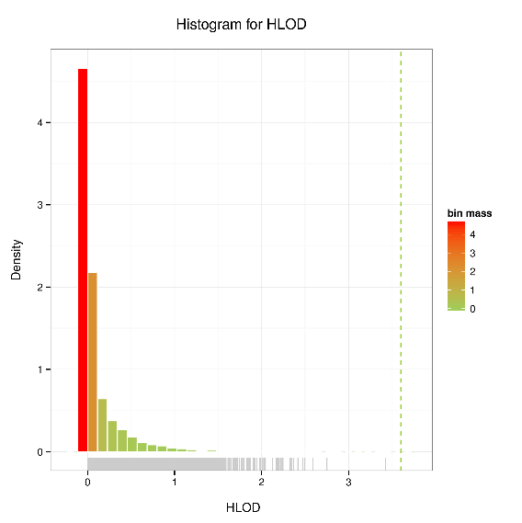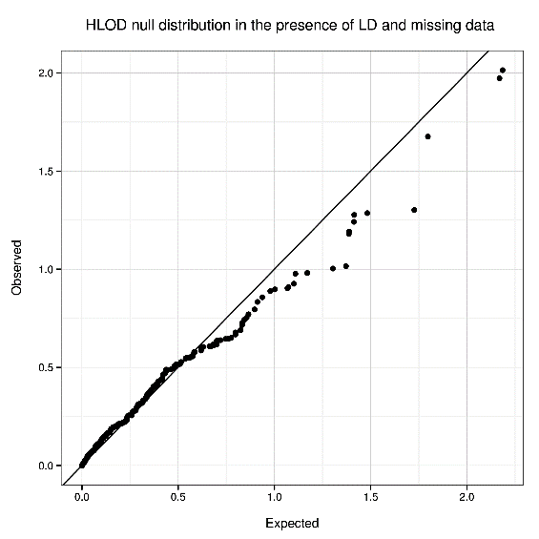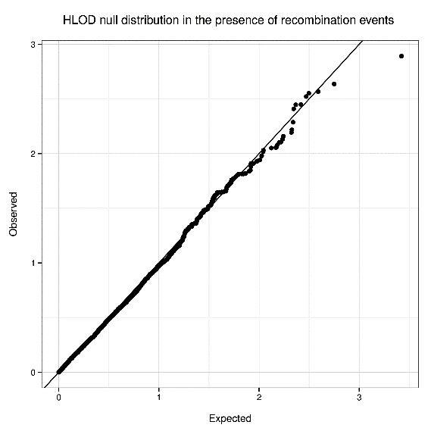 **A B C**

**Figure S1. Distribution of CHP HLOD statistic under the null.** CHP statistics are generated for gene *SLC26A4* for 20 families under compound recessive model, using 20,000 null replicates for each scenario. (A) Distribution of the HLOD statistic. The maximum value is 3.4. The vertical dashed line represents the genome-wide significance threshold for HLOD (3.6). (B) Quantile-Quantile (QQ) plot for HLOD null distribution in the presence of recombination events. (C) QQ plot for HLOD null distribution in the presence of linkage disequilibrium and missing genotype data for one parent in each family.

**Supplemental Tables**

**Table S1. Power comparisons between two-point (single marker) linkage (SNV), multipoint linkage (MP) and CHP method, under compound recessive model for gene *SLC26A4*, for 20 families with different locus heterogeneity rates (see Methods of the main text).**

|  |  |  |  |  |  |  |  |  |  |  |  |
| --- | --- | --- | --- | --- | --- | --- | --- | --- | --- | --- | --- |
|  | 0% | 10% | 20% | 30% | 40% | 50% | 60% | 70% | 80% | 90% | 100% |
| SNV | 0.0 | 0.0 | 0.0 | 0.002 | 0.02 | 0.05 | 0.14 | 0.25 | 0.42 | 0.56 | 0.73 |
| MP | 0.0 | 0.02 | 0.20 | 0.46 | 0.72 | 0.85 | 0.96 | 0.99 | 1.0 | 1.0 | 1.0 |
| CHP | 0.0 | 0.07 | 0.23 | 0.60 | 0.81 | 0.96 | 1.0 | 1.0 | 1.0 | 1.0 | 1.0 |

**Web Resources**

Exome Variant Server (EVS), http://evs.gs.washington.edu/EVS

Deafness Variation Database (DVD), http://deafnessvariationdatabase.com

NCBI ClinVar, https://www.ncbi.nlm.nih.gov/clinvar