# Asset Manager Application

## Requirements

Asset Manager is a parcel delivery management system consisting of several components. There is a web administration portal for managing the lockers.

You are required to develop a Single Page Web application to display the following locker map on screen.

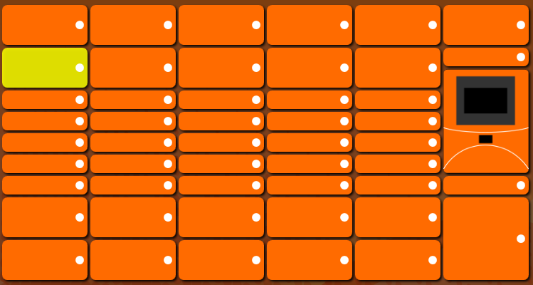

This layout is defined in an XML file attached separately. In this XML file, each individual locker is defined as a “LockerInfo” element which has Name, Size, and Terminal properties as shown below:

<LockerInfo>  
 <Name>SP1</Name>  
 <Size>Medium</Size>  
 <Terminal>false</Terminal>  
 </LockerInfo>

The possible values of the Size property are: Small, Medium, Large and ExtraLarge. If small size locker is 30 pixels in height, then the medium locker is 60 pixels, large is 90 pixels and extra-large is 120 pixels. There is one special LockerInfo element with the Terminal property set to true. The height of this terminal is 5 times height of a small locker. In the above case, the terminal is in 150 pixels.

After this layout is displayed on the screen, the user should be able to click on each locker except the terminal. Once the locker is in the selected state, the locker should be highlighted. In the highlighted mode, the locker should flash three times.

## Pass criteria

To successfully pass this test, you need to develop a simple solution that meets the following criteria:

1. A web service that reads the LockerBank.xml and provides the locker layout information to client apps.

The web service need to expose RESTful API to client app.

1. A Single Page Application which gets the locker layout from the web service created in the previous step.

The web application should be developed with VUE, React or Angular.

1. Image is not allowed to render this locker bank layout. The only exception is the terminal. This image is attached with this test.
2. After the user selected a locker on the screen, the locker should flash three times at 500ms intervals between normal and highlight states. Colour codes for these two states are provided below:

* The colour of orange (normal state) locker is: 255, 107, 0 (RGB)
* The colour of highlighted locker is: 222, 222, 0 (RGB)

1. The terminal is not clickable.

## Solution

* All the projects should be developed with any popular framework of Java .
* The solution and code should be production quality.
* When you are developing the application, please consider software development best practices such as SOLID principles, unit testing, and the readability and maintainability of the source code.

## Submission

Once completed, please send the solution in a .zip file.