# Reproducible Research: Peer Assessment 1

# Loading and processing the data

library(ggplot2)  
unzip("activity.zip")  
data <- read.csv("activity.csv", colClasses = c("integer", "Date", "factor"))  
data$month <- as.numeric(format(data$date, "%m"))

# Calculate the total/mean/median number of steps taken per day

StepsByday <- tapply(data$steps, data$date, sum, na.rm = TRUE)  
  
# Make a histogrem of the total number of steps taken each day  
ggplot(data, aes(date, steps)) + geom_bar(stat = "identity",  
 colour = "steelblue",  
 fill = "steelblue") +  
 facet_grid(.~month, scales = "free") +  
 labs(title = "Histogram of Total Number of Steps Taken Each Day", x = "Date", y = "Total Number of Steps")

## Warning: Removed 2304 rows containing missing values (position_stack).

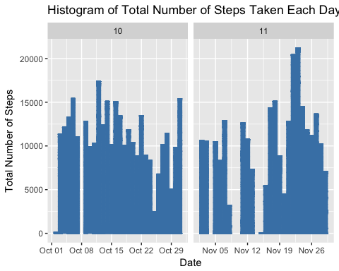

# What is mean and median of total number of steps taken per day  
mean(StepsByday)

## [1] 9354.23

median(StepsByday)

## [1] 10395

# What is the average daily activity pattern?

# Make a time series plot (i.e. type = "l") of the 5-minute interval (x-axis) and the average number of steps taken, averaged across all days (y-axis)  
AvgSteps <- aggregate(data$steps,   
 list(interval = as.numeric(as.character(data$interval))),  
 FUN = "mean",   
 na.rm = TRUE)  
names(AvgSteps)[2] <- "AvgSteps"  
ggplot(AvgSteps, aes(interval, AvgSteps)) +  
 geom_line(color = "steelblue", size = 1.0) +  
 labs(title = "Time Series Plot of 5mins Interval", x = "Interval", y = "Average Number of Steps")

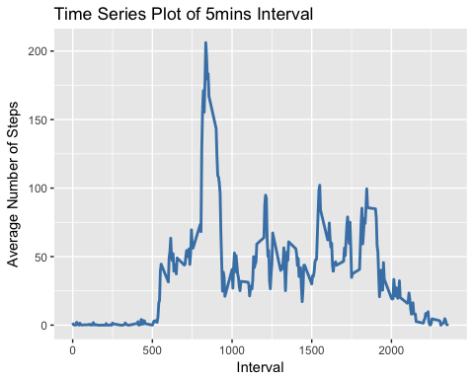

# Which 5-minute interval, on average across all the days in the dataset, contains the maximum number of steps?  
AvgSteps[AvgSteps$AvgSteps == max(AvgSteps$AvgSteps),]

## interval AvgSteps  
## 104 835 206.1698

# Imputing the missing values

# check total number of rows with NAs  
sum(is.na(data))

## [1] 2304

# Create a new dataset that is equal to the original dataset but with the missing data filled in.  
# fill in missing data by the mean for that 5 mins interval  
newdata <- data  
for (i in 1:nrow(newdata)) {  
 if (is.na(newdata$steps[i])) {  
 newdata$steps[i] <- AvgSteps[which(newdata$interval[i] == AvgSteps$interval), ]$AvgSteps  
 }  
}  
head(newdata)

## steps date interval month  
## 1 1.7169811 2012-10-01 0 10  
## 2 0.3396226 2012-10-01 5 10  
## 3 0.1320755 2012-10-01 10 10  
## 4 0.1509434 2012-10-01 15 10  
## 5 0.0754717 2012-10-01 20 10  
## 6 2.0943396 2012-10-01 25 10

sum(is.na(newdata))

## [1] 0

# Make a histogram of the total number of steps taken each day and Calculate and report the mean and median total number of steps taken per day.  
ggplot(newdata, aes(date, steps)) +   
 geom_bar(stat = "identity",  
 color = "steelblue",  
 fill = "steelblue",  
 width = 0.8) +  
 facet_grid(.~month, scales = "free") +  
 labs(title = "Histogram of Total Number of Steps by Date", x = "Date", y = "Total Number of Steps")

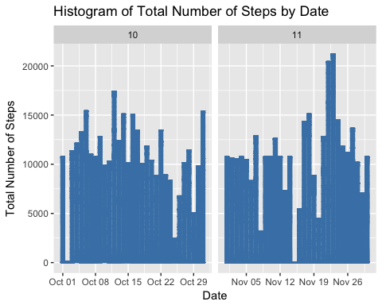

# mean and median of steps taken of new data with missing values filled  
NewTotalSteps <- tapply(newdata$steps, newdata$date, sum, na.rm = TRUE)  
mean(NewTotalSteps)

## [1] 10766.19

median(NewTotalSteps)

## [1] 10766.19

# compare with old mean and median  
mean(NewTotalSteps) - mean(StepsByday)

## [1] 1411.959

median(NewTotalSteps) - median(StepsByday)

## [1] 371.1887

# Are there differences in activity patterns between weekdays and weekends?

# Create a new factor variable in the dataset with two levels -- "weekday" and "weekend" indicating whether a given date is a weekday or weekend day.  
newdata$daytype <- factor(format(newdata$date, "%A"))  
levels(newdata$daytype) <- list(weekdays = c("Monday", "Tuesday", "Wednesday", "Thursday", "Friday"),  
 weekend = c("Saturday", "Sunday"))  
levels(newdata$daytype)

## [1] "weekdays" "weekend"

table(newdata$daytype)

##   
## weekdays weekend   
## 12960 4608

# Make a panel plot containing a time series plot (i.e. type = "l") of the 5-minute interval (x-axis) and the average number of steps taken, averaged across all weekday days or weekend days (y-axis).  
AvgStepsDaytype <- aggregate(newdata$steps,   
 list(interval = as.numeric(as.character(newdata$interval)),  
 daytype = newdata$daytype),  
 FUN = "mean")  
names(AvgStepsDaytype)[3] <- "MeanSteps"  
head(AvgStepsDaytype)

## interval daytype MeanSteps  
## 1 0 weekdays 2.25115304  
## 2 5 weekdays 0.44528302  
## 3 10 weekdays 0.17316562  
## 4 15 weekdays 0.19790356  
## 5 20 weekdays 0.09895178  
## 6 25 weekdays 1.59035639

library(lattice)  
xyplot(AvgStepsDaytype$MeanSteps ~ AvgStepsDaytype$interval | AvgStepsDaytype$daytype,  
 layout = c(1,2), type = "l",  
 xlab = "Interval", ylab = "Number of Steps")

