39th ICDCS 2019: Dallas, TX, USA

Research Track 1: Cloud Computing and Data Centers

Research Track 2: Distributed Big Data Systems and Analytics

Research Track 3: Distributed Operating Systems and Middleware

Research Track 4: Distributed Algorithms and Theory

Research Track 5: Distributed Fault Tolerance and Dependability

Research Track 6: Distributed Green Computing and Energy Management

Research Track 7: Internet of Things and Cyber-Physical Systems

Research Track 8: Mobile and Wireless Network Computing

Research Track 9: Edge Computing

Research Track 10: Security, Privacy, and Trust in Distributed Systems

Research Track 11: Social Networks and Crowdsourcing

Research Track 12: Blockchain

Research Track 13: Industry and Experimentation

Research Track 14: Distributed Machine Learning

Research Track 15: UNcertainty in distrIbuted compuTing Systems (UNITS)

Research Track 16: Vision/Blue Sky Thinking (Special Track)

Research Track 6: Distributed Green Computing and Energy Management

1. Near Optimal Charging Scheduling for 3-D Wireless Rechargeable Sensor Networks with Energy Constraints. 624-633
2. Toward Efficient Compute-Intensive Job Allocation for Green Data Centers: A Deep Reinforcement Learning Approach. 634-644
3. DeepEE: Joint Optimization of Job Scheduling and Cooling Control for Data Center Energy Efficiency Using Deep Reinforcement Learning. 645-655
4. Collision-resistant Communication Model for State-free Networked Tags. 656-665
5. Goldilocks: Adaptive Resource Provisioning in Containerized Data Centers. 666-677

Research Track 7: Internet of Things and Cyber-Physical Systems

1. HyperEar: Indoor Remote Object Finding with a Single Phone. 678-687
2. p^2Charging: Proactive Partial Charging for Electric Taxi Systems. 688-699
3. WiMi: Target Material Identification with Commodity Wi-Fi Devices. 700-710
4. Modeling and Forecasting of Timescale Network Traffic Dynamics in M2M Communications. 711-721
5. Multi-Sensor Calibration Planning in IoT-Enabled Smart Spaces. 722-731
6. Providing Reliability-Aware Virtualized Network Function Services for Mobile Edge Computing. 732-741
7. Understanding Energy Efficiency in IoT App Executions. 742-755
8. DÏoT: A Federated Self-learning Anomaly Detection System for IoT. 756-767
9. Road Gradient Estimation Using Smartphones: Towards Accurate Estimation on Fuel Consumption and Air Pollution Emission on Roads. 768-777
10. EchoWrite: An Acoustic-based Finger Input System Without Training. 778-787
11. Towards Energy-Fairness in LoRa Networks. 788-798
12. CBMA: Coded-Backscatter Multiple Access. 799-809

39th IEEE Conference on Computer Communications, INFOCOM 2020, Toronto, ON, Canada, July 6-9, 2020. IEEE 2020, ISBN 978-1-7281-6412-0



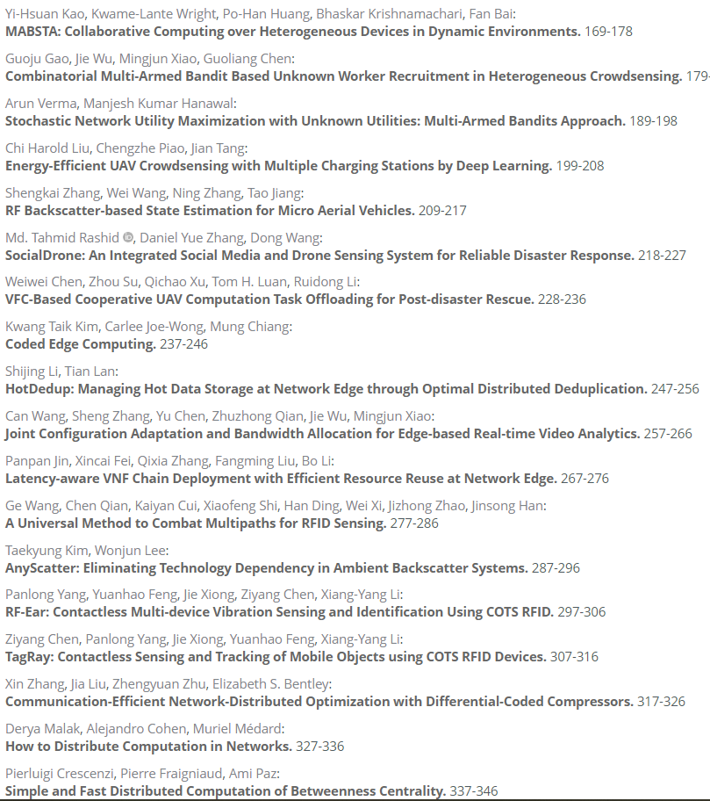

总结：

1. (A) method (using utils/ via utils)

for purpose

in scenario/with condition (constraints)/without conditions

(Exploring) Optimal Detection for Selfish Nodes in OppNet with Two-hop Constraints

Based on Pontryagin Maximal Principle

1. Name:

function (using utils/ via utils)

in scenario/with condition (constraints)/without conditions

ΩScan/Detection: Achieving Low Cost/High Performance via Optimal Detection in OppNets

1. Is/Does/How …?
2. ABCD: Axx Bxx Cxx Dxx
3. 

Analytical Optimal Solution of Perimeter Traffic Flow Control Based on MFD Dynamics: A Pontryagin’s Maximum Principle Approach

T-ITS

Analytical Optimal Solution of Selfish node detection with 2-hop Constraints in Opportunistic networks: A Pontryagin’s Maximum Principle Approach