PROJECT 02 / DIRECT-TO-CHIP LIQUID COOLING

Designing a 6 kW
AI accelerator cooling tray
A model-based workflow linking cold-plate CFD, reduced-order models, manifold hydraulics, and pump/fault decisions.
6.0 kW | 9.16 L/min | 12.3°C margin
8 × 750 W design load | Modeled pump/tray flow | Below the 85°C project limit

The engineering decision
Retain a 19.05 mm common header as the provisional baseline. At the nominal modeled operating point, the tray reaches 72.72°C estimated peak device temperature with 0.342% flow maldistribution. The result is a design-study prediction, not hardware qualification. [E01–E02]

From component physics to a system model
Screened cold-plate candidates in COMSOL; selected a 30-channel, 0.40 × 1.00 mm Candidate C design. Fitted pressure-drop and thermal-resistance ROMs, then integrated branch tubing, illustrative QD/fitting losses, and a scalable same-side manifold network. A representative pump curve determines actual modeled flow rather than prescribing the thermal target. [E10]

Independent component-level CFD check
The 1.15 L/min, 750 W, 30°C COMSOL case was withheld from fitting. The extended calibration flow range is 0.50–1.20 L/min. [E03–E04]
Output | COMSOL | ROM | Difference
Pressure drop | 11.258 kPa | 11.260 kPa | +0.0178%
Thermal resistance | 0.0255542 K/W | 0.0256179 K/W | +0.2493%
Maximum base temperature | 53.870°C | 53.908°C | +0.0382°C
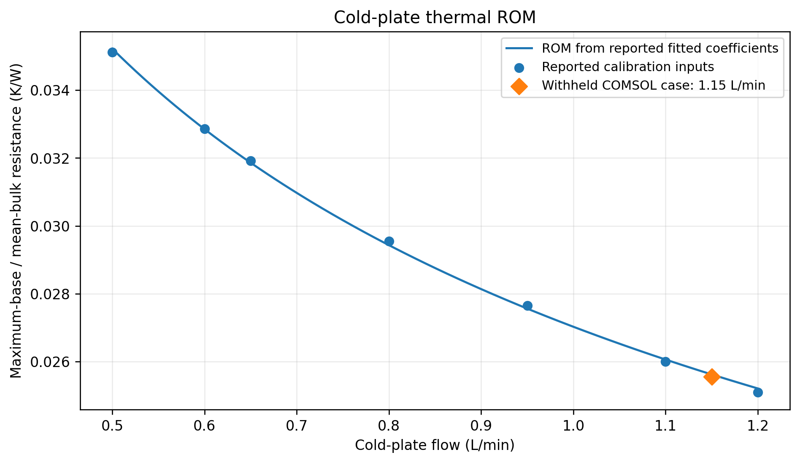
Reported fit and withheld CFD point; resistance is referenced to (Tin + Tout)/2. ROM agreement with CFD does not establish hardware accuracy.

Hydraulic limits can fail before temperature
Six reported scenarios separate temperature compliance from flow and uniformity requirements. Nominal tray differential pressure is 11.44 kPa; the illustrative pump provides 6.02% flow margin above the fixed 8.64 L/min target. [E01–E02]
Scenario | Flow  L/min | Mflow  % | Tmax est.  °C | Reported outcome
Nominal | 9.1604 | 0.342 | 72.72 | Pass
Hot coolant* | 9.1604 | 0.342 | 77.72 | Pass*
Uneven power | 9.1604 | 0.342 | 72.72 | Pass
Restricted branch | 9.0632 | 18.323 | 75.05 | Fail: uniformity
Weak pump | 8.2056 | 0.333 | 74.10 | Fail: flow target
Combined stress* | 8.1016 | 18.575 | 81.67 | Fail: flow + uniformity
* 35°C inlet: constant-property sensitivity only, not additional inlet-temperature CFD validation. Mflow = 100 × (qmax − qmin) / qmean. Status uses the adopted fixed-flow and 10% uniformity criteria.

What changed the design judgment?
A 30% increase in one branch hydraulic characteristic raised maldistribution to 18.32% while the estimated device peak remained 75.05°C. The weak-pump case also remained below the temperature limit but missed the flow target. Temperature alone therefore would not identify every operating-requirement violation. [E01]
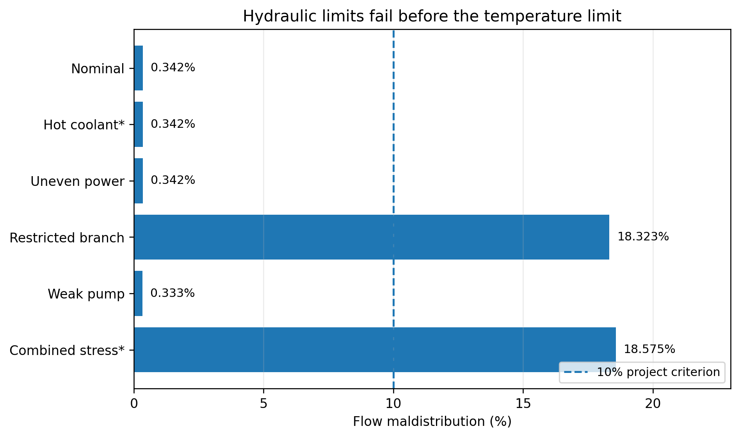
Fault results replotted from the supplied scenario table. No new CFD or full-system simulation was run to prepare this document.

Scope of the recommendation
The pump curve, QD/fitting coefficients, and 0.025 K/W package-plus-TIM resistance are modeling assumptions. Pressure covers the tray, not a full CDU/facility loop. The 35°C cases are sensitivities; the complete manifold lacks independent CFD/hardware qualification. The 19.05 mm choice is provisional, not a global optimum or released mechanical assembly. [E10]
Evidence: E01 scenario table; E02 pump/tray summary; E03–E04 withheld component comparison; E10 model settings. Full source index and limitations accompany this document in the portfolio package.

