**(b) Load the following data into your PostgreSQL server and answer the questions below showing your workings (i.e. SQL).**

(i) How long is *route1* in metres (1 decimal place will do) ? (remember to show your SQL too) (1 mark)

**Answer**: 1227.7 metres

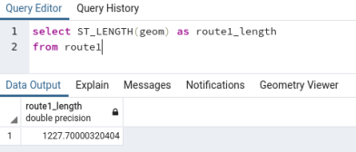

(ii) How long are all the roads in this dataset in metres (to 1 dp)? (1 mark)

**Answer**: 117467.3 metres

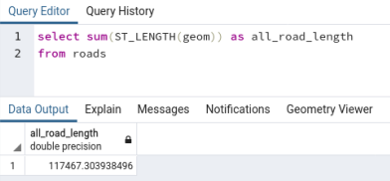

(iii) How many *letter boxes* (pointxclass: 06340457) are within 200 metres of route1? (1 mark)

**Answer**: 12

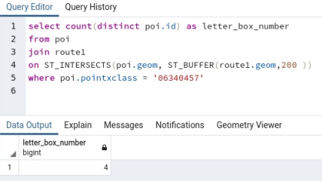

(iv) To the nearest metre what are the closest and furthest Euclidean distances (i.e. straight line) between a cash machine (pointxclass: 02090141) and a Bus Stop (pointxclass: 10590732) in the points of interest dataset. (2 marks)

**Answer**: closest distances: 8.1 metres

furthest distances: 4722.1 metres

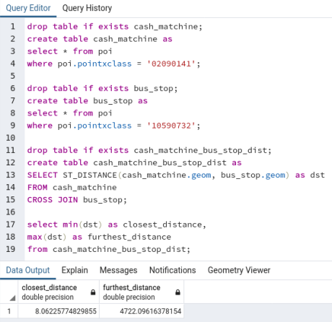

(v) Which zone has the greatest density of points? Include the point density value (2 marks)

**Answer**: Zone 1 has the greatest density of point. The point density value is 2752.

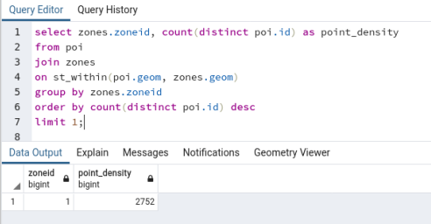

(vi) What are the total road lengths (in metres) per zone? (3 marks)

**Answer**: The total lengths of each zone are as follows:

Zone 1: 27494.4 metres,

Zone 2: 24819.5 metres,

Zone 3: 34284.0 metres,

Zone 4: 16921.5 metres.

