**Q1 (a)**

(i) With reference to the ANSI/SPARC three tier architecture, what are the different schemas, and explain the effect to the schemas of adding a new index? (3 marks)

(ii) With respect to the following data requirements, **identify and explain** the errors or problems in the ER diagram below. *(Marks will only be given when there is an explanation)*

• Customers are only stored in the system once they have ordered a book

• Customers should be able to order many books, the date of the order should be captured

• A book can be bought by many customers, but does not need to be bought by any

• A book must have one author but can have more

• An author can write many books

• Authors are only stored if they have written at least one book

(4 marks)

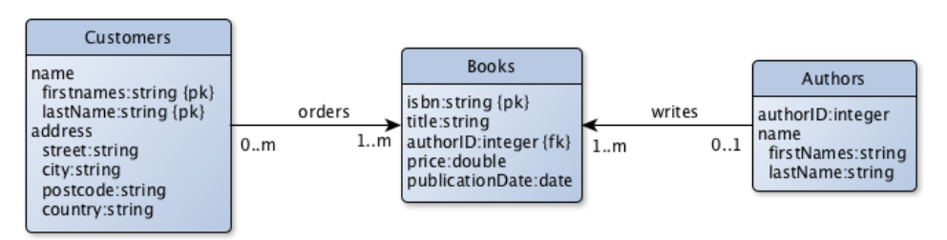

**Answer**:

**Error #1**: PKs fields of “Customers” table.

**Explanation #1**: In the table “Customers”, there are two PKs, and the PK is set to names, which is not unique for each customer, since in this world, many persons share the same names. The correct PK of the customers should be an unique, not null, customer number.

**Error #2**: The authorID field of “Books” table.

**Explanation #2**: A book must have one author but can have more. But in the table Books, there is only one author field, which limits the number author for each book to only one. The correct way is to leave this authorID field to an additional table “writes” as follows,

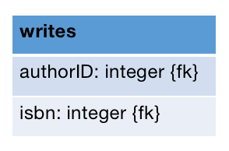

**Error #3**: The “Authors” table does not have a PK.

**Explanation #3**: The field authorID of “Authors” should be set to PK since each author is a unique existing.