**Q1. (b) Considering the following schemas and sample data.**

*(underlined attributes in the schema indicate the primary key)*

Customers(cid:int, name:string)

Boats(bid:int, bname:string, colour:enum[red,blue]

Reserves(cid:int, bid:int, day:date)

(i) State what happens with each of the SQL statements and **explain**

why the DBMS does this.

A: INSERT INTO Reserves

VALUES (4, 9001, 2020-12-12)

B: INSERT INTO Boats

VALUES (9003, 'Malaysia', 'yellow')

C: INSERT INTO Reserves

VALUES (NULL, 9001, 2020-12-07)

(3 marks)

(ii) Write an SQL query to find the names of customers who have hired a blue boat. (4 marks)

(iii) Write an SQL query to find the names of customers who have not reserved a boat. (3 marks)

**Answer**:

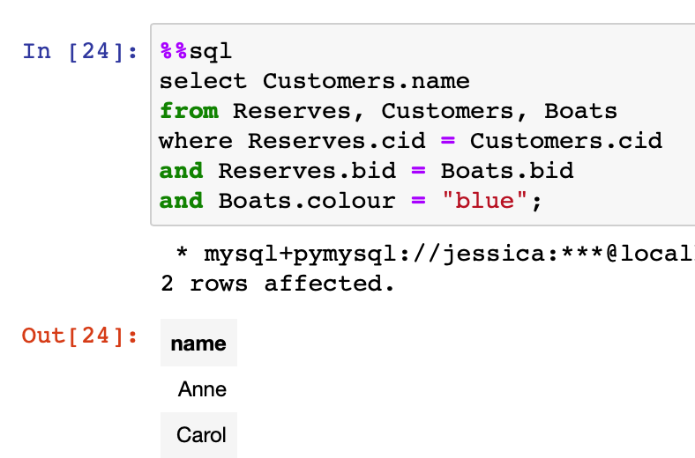

(iv) Write an SQL query to find the number of reservations per boat for each day.

**Answer**:

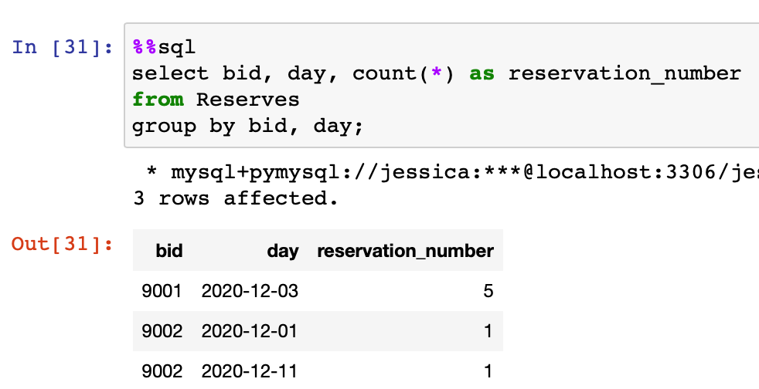

For more than 4 hires in a day, return the name of the boat, together the date in a EUROPEAN style, and the number of times the boat was hired. (5 marks)

**Answer**:

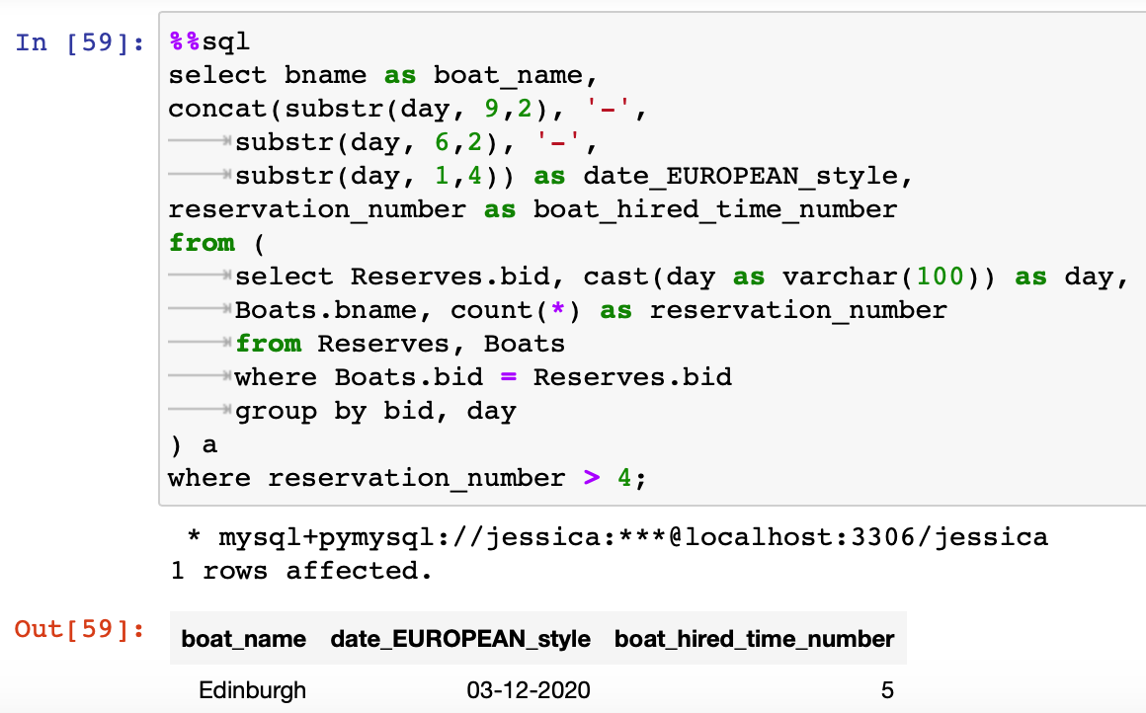

(v) Consider the following query plan for a query that returns the name of customers who have hired blue boats in December 2020. Restructure it into a more efficient plan for pipeline query processing. State the steps that you have taken and **explain** why they improve the performance. (4 marks)

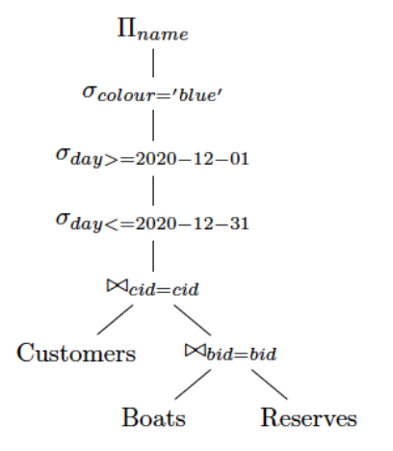

**Answer**: