**Q2 (c) Load the following data into MongoDB and answer the questions showing your workings.**

(i) How many tracks are listed? (1 mark)

**Answer**: 3503

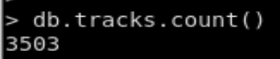

(ii) How many unique artist names begin with “The” or “the” ? (2 marks)

**Answer**: 12

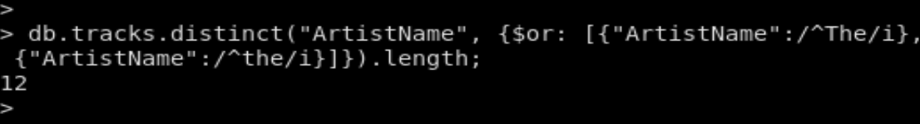

The 12 names begins with “The” or “the” are given by the following code:

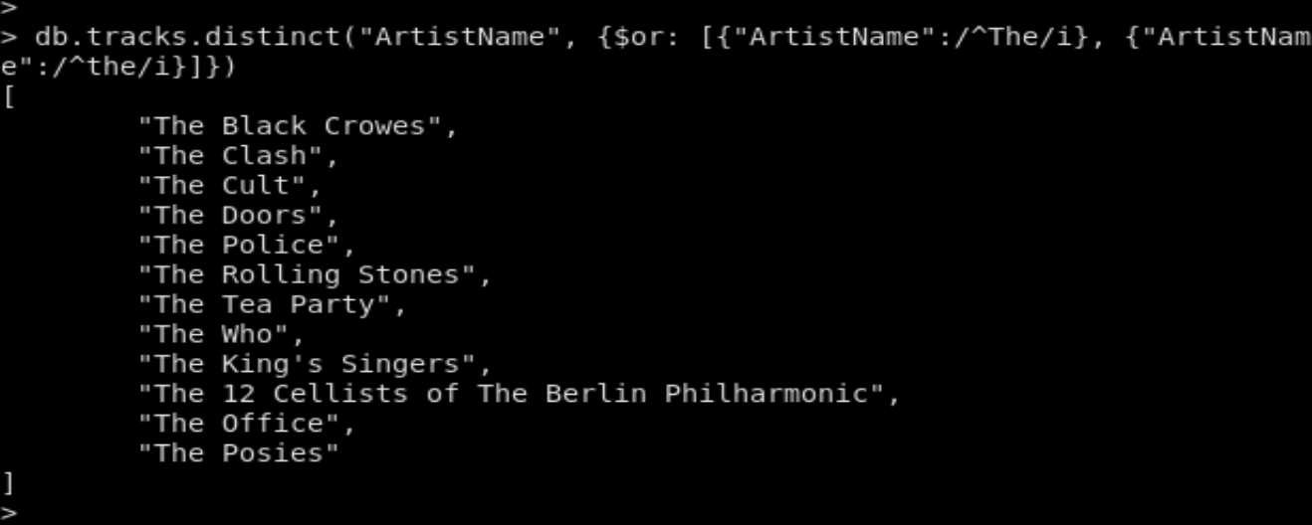

(iii) Which genre is the most popular based on track counts? (2 marks)

**Answer**: “Rock” is the most poplar genre based on track counts. Its track count is 1297.

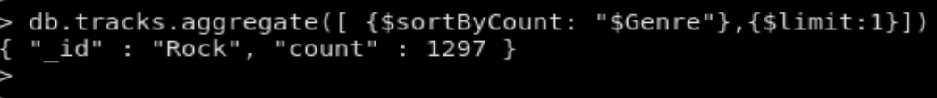

(iv) What is the average track length in milliseconds for each genre (done as 1 query)? (2 marks)

**Answer**: The average track length in milliseconds for each genre is given as follows by the following query:

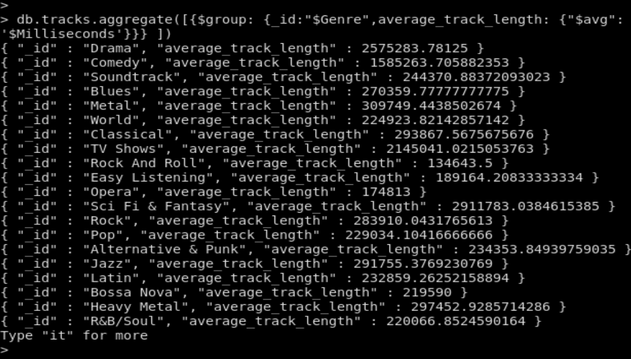

(v) What is the most number of times a track appears in the playlist collection?

(1 mark)

**Answer**: 5.



(vi) Which track(s) do not appear in the playlist collection at all? (2 marks)

**Answer**:The track with Track 3 and track name “Fast As a Shark” does not appear in the palylist collection at all. The code to query this track is give as follows:

