**Instruction for using the simulation models**

***1 Matlab version:*** Matlab 2019a

***2 Steps to run the simulation model***

* Step1 download following four files in the repository:

file1: Grid_connected_windfarm_multiple_PMSGs.slx

file2: int5.m

file3: Data_5PMSG_heterogeneous.XLSX

file4: windfarm_figure.JPG

Put the above four files into a folder (named folder A):

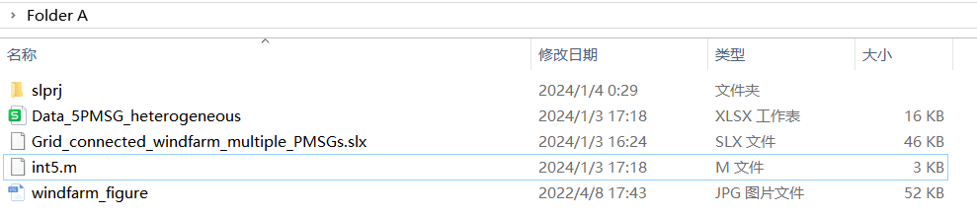

* Step2 Setup the Matlab 2019a and add the Folder A as the file path:

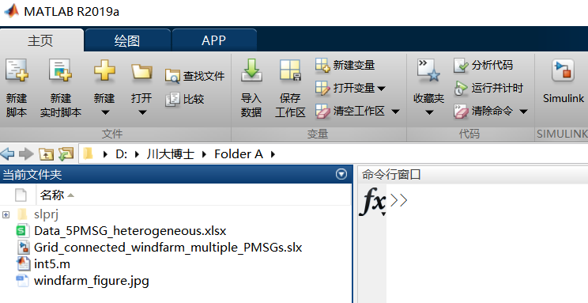

* Step 3 double click the icon of file1: Grid_connected_windfarm_multiple_PMSGs.slx. The simulation model built in the MATLAB/Simulink platform will be shown as follows:

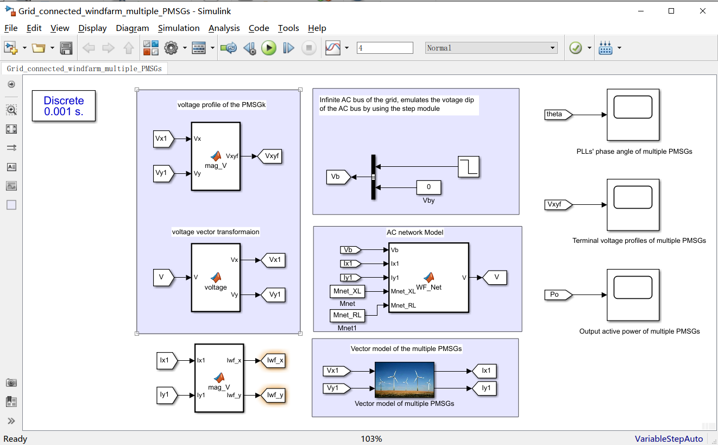

* Step 4: Click the Run Icon and following “Select the data” window can be shown:



* Step 5: double click the file3 named Data_5PMSG_heterogeneous, then the simulation model will be compiled and running.

Then the simulation results including PLLs’ phase angle of multiple PMSGs, Terminal voltage profiles of multiple PMSGs and Output active power of multiple PMSGs can be observed by click the scope in Simulink window:



Such as click the Scope named PLL’s phase angle of multiple PMSGs, then following simulation results can be shown:

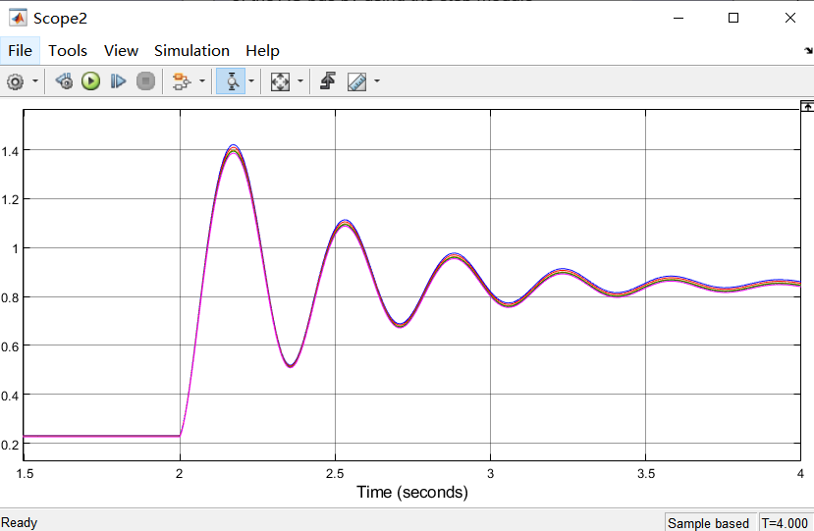

***3 Instruction of modifying the simulation parameters***

***3.1 Voltage dip of the AC grid bus.***

Suppose the voltage of the AC grid bus always align the x-axis, the voltage dip of the AC grid bus is emulated by the step change of the voltage vector’s x-axis as shown in the simulation model in the Matlab/simulink window:

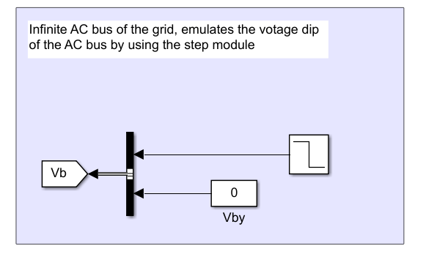

For example, we change the voltage dip to 0.3 in the “Step block”:

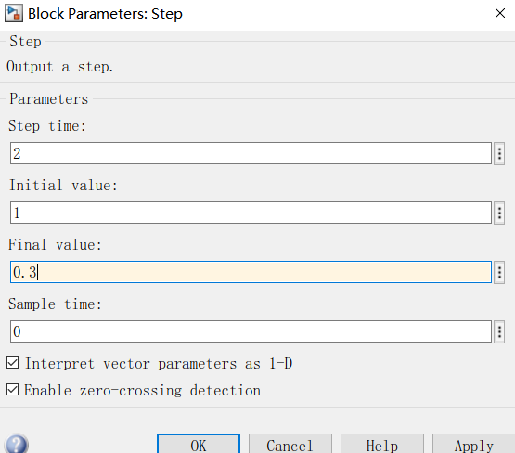

and run the simulation model again according to the guidelines provided in section 2 of this instruction. The simulation results show that the loss of synchronization risk occurs when voltage dip is set to 0.3 p.u.:

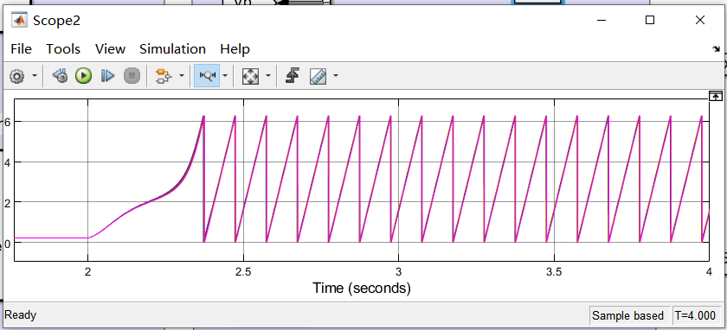

***3.2 Pre-fault loading and Current injections of the PMSGs during the fault.***

Open the Excel file, named Data_5PMSG_heterogeneous in the Folder A and select the Node Excel as followings:

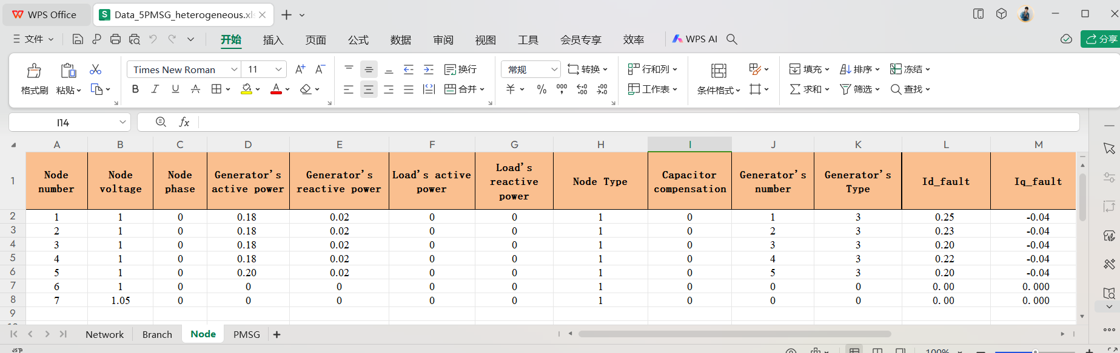

Then the five PMSGs’ active and reactive power before the fault (Corresponding to the Generator’s active tive power and Generator’s reactive power in the excel) and the current injections reference during the fault (Id_fault and Iq_fault in the excel) can be found. We can change the values of these variables in the excel according to the case studies in the paper.

***3.3 Control Parameters of the PMSGs***

The PI gains of the PLLs and PI gains of the outer and inner control loops of the GSCs can be found and changed in the PMSG excel of the Data_5PMSG_heterogeneous:

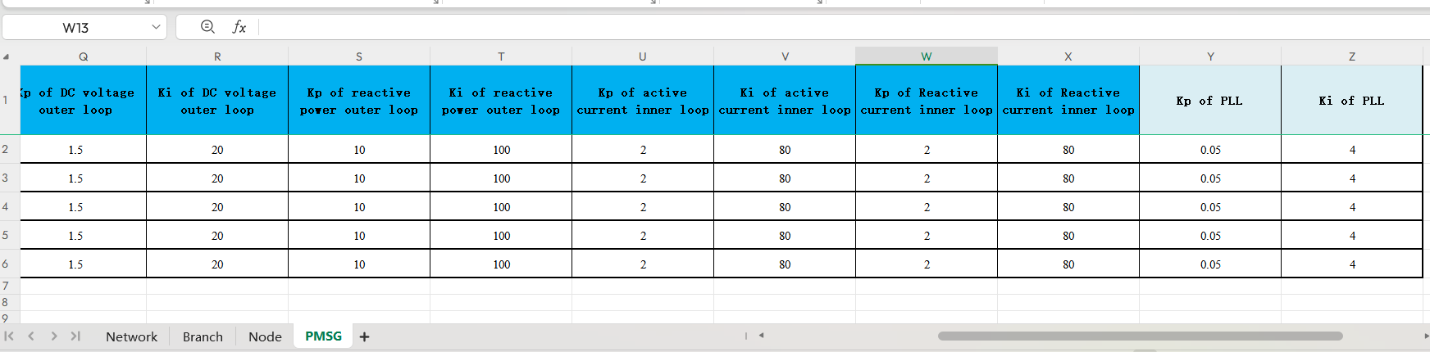

***3.4 Reactance of the five collecting lines and the impedance of the AC transmission line***

The reactance of five collecting lines connecting the PMSG and the PCC bus (*Xwk*, *k*=1,2,...,5) is corresponding to the data from Branch Number 1 to Branch Number 5. The resistance and reactance of AC transmission line connecting the PCC bus of the wind farm and the AC grid is corresponding to the data in Branch Number 6.

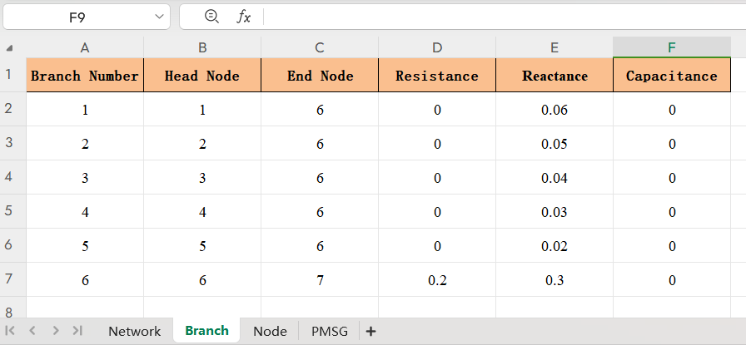

***4 Instruction for the file int5.m in Folder A***

File named int5.m is used for the initialization of the simulation model.

Step1: Click File of the simulation model:

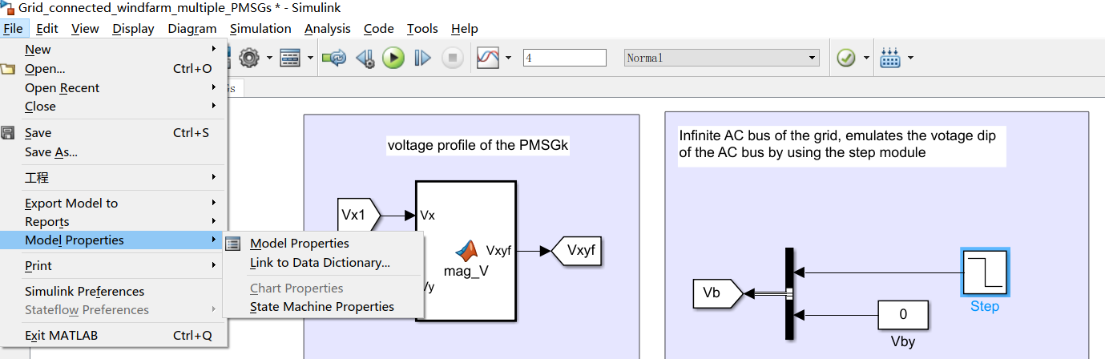

Step2: click Model Properties and then following window is shown:

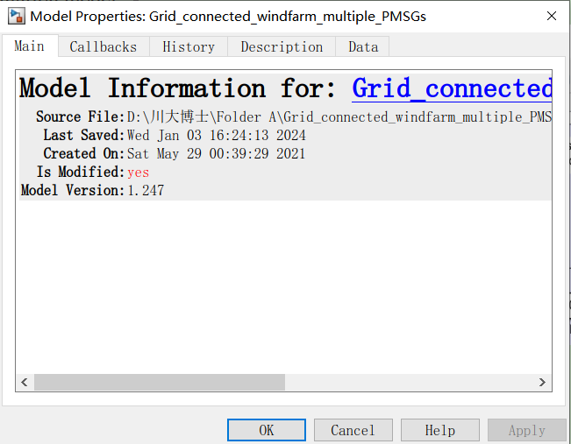

Step3: Select Callbacks icon and click InitFcn* icon in the list table, the file name of int5 can be found.

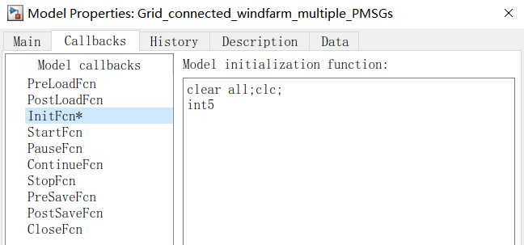

Step4: The function of in5.m can be seen by open in5.m file in Folder A by using the Matlab software:

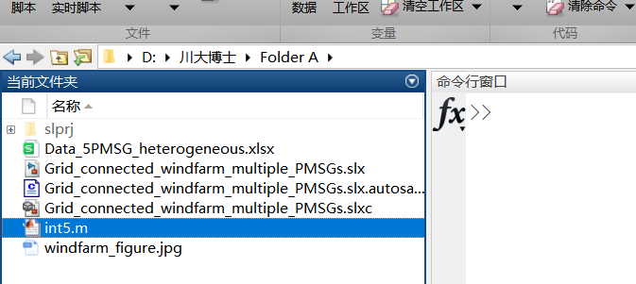

Step5: click int5.m file, then the codes can be seen. Main function of int5.m file is parameters uploading and simple calculations based on our need.

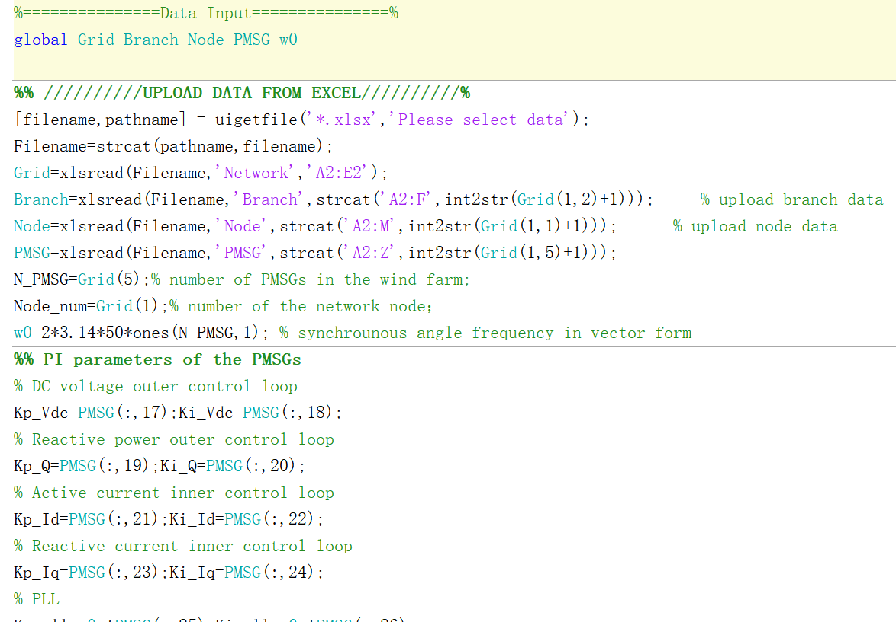

***5 Vector model of the multiple PMSGs***

The vector model of the multiple PMSGs in the simulation model is shown as follows.

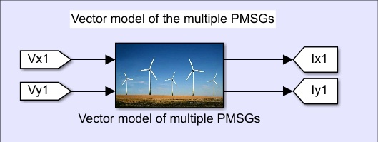

The large-signal math models and the modelling method is illustrated as follows:

Click the vector model of multiple PMSGs, following blocks can be seen:

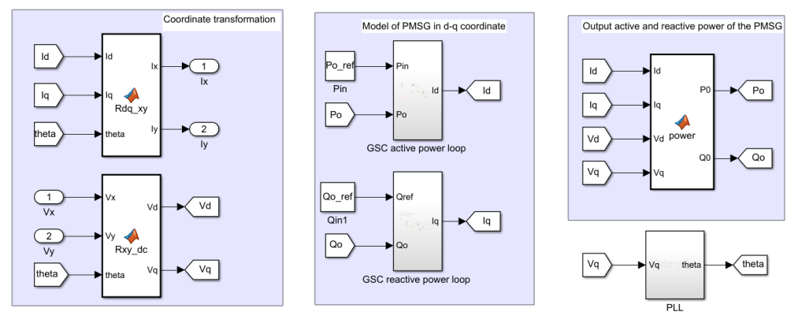

The vector model of the PMSGs includes Coordinate transformation block Model of PMSG in d-q coordinate block, Active and reactive power block and the PLL block.

The variables in the vector model of the PMSGs are vector, for example

Variable Id and Po_ref in the simulation model is

Id=[Id1, Id2, Id3, Id4, Id5]

Po_ref=[Po_ref1, Po_ref2, Po_ref3, Po_ref4, Po_ref5]

Thus we can modelling the multiple PMSGs in the form of single PMSG by using the vector modelling method.

* The topology of the simulation model is shown in Fig. 3 in the paper and copied as follows:



Fig. 3. Diagram of the grid-integrated wind farm composed of multiple aggregated wind turbines in parallel connection.

* The control system’ model of GSC is given in Fig. 4 in the paper and copied as follows:



Fig. 4. Block diagram of the control systems of the GSC*k* with the FRT capability.

* The PLL’s model is given in Gig. 5 in the paper and copied as follows:



Fig. 5. Control diagram of the PLL*k*.

* The model of MSG can be equivalent to an active power source and explained as follows:

Under the fixed wind speed condition, the output active power of the machine-side converter (MSC) can be equivalent to a current source [1] and the large-signal disturbance caused by the ac-side fault have no influence on the dynamics of the MSC. The reason of ignoring the dynamic of the MSC during the fault can be explained as follows.

* Control system of the machine-side converter (MSC)

The block diagram model of the MSC’s controller is displayed in Fig. R1-1.



Fig. R1-1 Block diagram model of the MSC’s control system [2].

The wind turbine is working on the MPPT mode, the generator speed reference is set by the power characteristics curve when the wind speed and the pitch angle is given. For example, when the base wind speed is 12m/s, the nominal mechanical output power is 2.0 MW, pitch angle is set to zero, the maximum power at base wind speed is set to 0.73, and the base rotational speed is set to 1.2, the corresponding wind turbine power characteristics curves are displayed in Fig. R1-2.



Fig. R1-2 Illustration of wind turbine power characteristics.

* Pitch angle control system

The pitch angle and the speed control scheme is shown in Fig. R3-5, as follows.



Fig. R1-3 Pitch angle and speed control system [3].

Suppose the wind speed is at the maximum wind power tracking zone in this paper, thus the pitch angle is fixed to zero at the MPPT mode.

The rotor motion equation of PMSG’s shaft can be described as follows.

 (R1-1)

where *Jr* is the inertia constant of the generator’s shaft; *Tm* and *Te* is the input mechanical and output electric torque, respectively;*ωr* is the rotor speed;  and  is the stator flux in d-axis and q-axis respectively; *Isd* and *Isq* is the stator current in d-axis and q-axis respectively.

Flux equations of the stator are given below.

 (R1-2)

where *Xd* and *Xq* represents the d-axis and q-axis reactance of the PMSG;  is the rotor flux of the permanent magnet, witch is a constant.

The model of the stator voltage in d-q coordinate can be described as follows.

 (R1-3)

Ignoring the active power loss, the output active power of the MSC delivered to the dc- link can be expressed as follows.

 (R1-4)

Substituting（R1-2）into the second equation of（R1-1）, yields

 (R1-5)

Substituting（R1-2）into（R1-3）, yields

 (R1-6)

Substituting（R1-2）into（R1-4）, yields

 (R1-7)

From Fig. R1-1, the stator voltage of the PMSG can be expressed as follows.

 (R1-8)

where，*G*1(s)，*G*2(s) and *G*3(s) represents the transfer function of the PI controller in rotor speed control outer loop, stator current inner control loop in d-axis and q-axis, respectively.

Substituting（R1-2）into（R1-8）, yields

 (R1-9)

Combining the first equation in (R1-1), (R1-6), (R1-7) and (R1-9), the block diagram model considering the dynamics of the wind turbine and the MSC’s control systems can be derived as shown in Fig. R1-4.



##### Fig. R1-5 Block diagram model considering the dynamics of the wind turbine and the MSC’s control systems.

From Fig. R1-5, when the wind speed is unchanged during the fault, the input mechanical torque is a constant. As a result, the output active power of the MSC is a constant during the fault which means the ac-side fault will not influence the dynamic of the MSC’s active power. Therefore, the output active power of the MSC can be seen as a constant active power source when analyzing the TSS of the island 100% RPG system during the fault. This equivalent model of the PMSG can be also found in the simulation studies of Prof Xiongfei Wang’s work in [1].



Fig. R1-6 Equivalent circuit model of the PMSG in the paper and reference [1].

[1] Y. B. Li, X. F. Wang, J. B. Guo and et al, “PLL synchronization stability analysis of MMC-connected wind farms under high-impedance

AC faults,” IEEE Transactions on Power Systems, vol. 36, no. 3, May. 2021

[2] C. Zhang, X. Cai, A. Rygg, and M. Mlinas, “Modeling and analysis of grid-synchronizing stability of type-IV wind turbine under grid faults,” Int. J. Elect. Power, 117.: 105544, 2020. DOI: 10.1016/j.ijepes.2019.105544.

[3] Siegfried Heier, “Grid integration of wind energy conversion systems,” John Wiley&Sons Ltd, 1998, ISBN 0-471-97143-X.